Scanning 35mm transparencies with CanoScan 9950F
The CanoScan 9950F provides a variety of settings for scanning batches of up to twelve 35mm transparencies and storing the scanned images as BMP, JPG or TIF format files in dated subfolders in a previously created folder such as “35 mm slides” in the following example. Files may then be selected from for processing/enhancing with Paint Shop Pro, PhotoShop, PhotoStudio or similar. First then create a folder to receive the files for the scanned transparencies as for example C:\My Pictures\35mm slides. Then remove the white cover of the Film Adapter Unit , place the slide holder on the surface and load with up to 12 transparencies to columns commencing at top of the right hand column.

The following procedure is selected from the many described in the “CanoScan 9950F User’s Guide” – Electronic Manuals>Scanning Guide on the CanoScan Setup CD-ROM. Note to use the scanner buttons requires installation of programs from the Setup Utility CD-ROM (p.10 Quick Start Guide).

Shortcut
For convenience use a desktop shortcut to the CanoScan Toolbox, that is to CSTBox.exe. The default location on my PC is C:\Program Files\Canon\CanoScan Toolbox Ver4.9\ CSTBox.exe .

Settings for scanning with the Toolbox Scan-2 button

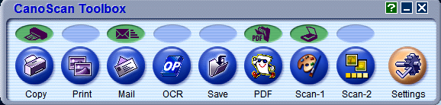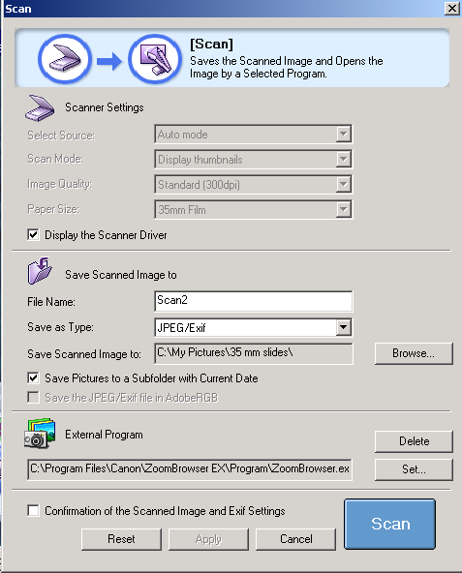
1
2
3
4
5
6
7
8

- With appropriate settings, routine scanning of transparencies requires only the clicking of the Scan-2 button of CanoScan Toolbox and then clicking Scan, Preview and Scan in the successive displayed windows. (By default the Scan-1 button is for scanning documents or prints on the CanonScan platen.) Click Scan-2 to bring up the Scan page for the choice of settings for this procedure.

- On the Scan page click to put a tick in the box  for Display the Scanner. This will grey out the 4 Scanner Settings and provide instead a choice of settings on the Advanced Mode page as described below.
- Enter appropriate values in the Save Scanned Image section. The default for “Scan2” is for file names Scan200001.TIF, Scan200002.TIF, … but alternative descriptive File Name can be used such as for example BlueMtns.
Alternative file types are BMP, JPEG/Exif and TIF. With the compression algorithm used by CanoScan for JPEG files loss of quality seems imperceptible. TIF files are much larger.
- Use the Browse button to find and install the path to the subfolder (35mm slides or whatever). Alternatively, to save images to a memory stick, use a path to a USB port, for example H:\ for a stick in drive H.
-  to Save Pictures to a Subfolder with the Current Date for its name.
- Use Set to choose a convenient available external program such as i_view32.exe for Irfanview or Canon’s ZoomBrowser.exe as for this example.
- A  for Confirmation … to avoid the display of the last scanned image after scanning a batch.
- Click Scan to go to next page and select Advanced Mode. My choice of options is:

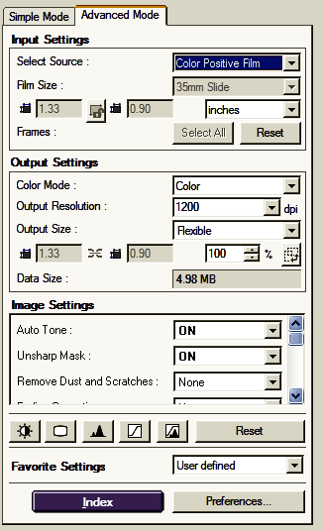
9
10
11

- Note 1200dpi is plenty adequate for printing images to A4 size even with image cropping to about half size. 2400 or 4800 could be chosen for poster size prints producing image files 4 and 16 larger but large files may result in storage problems or make some editing operations painfully slow.
- Various image settings can be chosen to enhance scanned images but each of these will slow up the scanning process. Corresponding enhancing processes are provided by PhotoShop or Paint Shop Pro and with these programs the processes may be applied more conveniently to all files in a folder (such as 35mm slides folder for 4) by a batch process in conjunction with other processes as for example to convert the file type recommended by these programs for enhancing images.
- For routine scanning Preferences provides Automatically Execute Preview to replace step 12.

Scanning
After selecting settings as above, routine scanning is carried out by simply clicking the Scan-2 button of CanoScan Toolbox, followed by Scan, Preview and Scan on the successive displays with the following adjustments if desired.
13
12

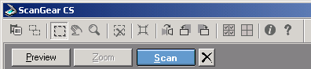
14

- Click the first button on the toolbar to toggle for thumbnails of the transparencies in the scanner.
- Click the button on the top toolbar to tick/select all files for scanning.
- Click Scan to start the scanning putting and store the scanned images in the dated folder as specified in step 3.

With completion of this scanning the scanned files are stored in the date-named folder in My Pictures\35 mm slides. They can then be enhanced as by using the Script-Batch procedure of Pain Shop Pro.

