1

Managing Music with Windows Media Player
Microsoft Windows XP includes everything you need to turn your computer into a digital jukebox. You can play CDs directly, using your computer’s sound card and speakers for playback. You can also copy songs from your CD collection to a local disk drive and download tunes from the Web. Using Windows Media Player, you can mix and match tunes to play disk jockey, creating custom playlists and even burning your favorite tunes to custom CDs that you can play back in a CD player in your home or car.
In this lesson, you’ll learn the ins and outs of Windows Media Player, with a special emphasis on its musical capabilities.

Windows Media Player at a Glance
Windows Media Player does an amazing number of things. Most people learn all they need to know by clicking on various buttons and watching what happens. If you feel like exploring, go ahead. To open Windows Media Player, click its icon on the Quick Launch toolbar, just to the right of the Start button; if the Quick Launch toolbar is hidden, you’ll find the Windows Media Player shortcut by clicking Start, clicking All Programs, and then choosing Accessories and Entertainment.
Note These lessons use Windows Media Player version 9, which is included with Windows XP and is not available for any earlier Windows versions. If you have Windows Media Player version 8, it will look and act much like version 9, although you might discover some features that work differently from those described here. You can find out which version you’re using by choosing About Windows Media Player from the Help menu.

To switch among the different functions and features available in Windows Media Player, use the buttons on the Features taskbar on the left side of the Windows Media Player window. Each of these eight buttons has a specific role:
- Now Playing When you click this button on the Features taskbar, the central pane displays content that’s appropriate to whatever you’re watching or listening to, as in the example shown below. If you’re watching a broadcast from the Web or playing back a saved video file or a DVD, the Now Playing pane shows your movie or video clip. If you’re listening to a CD, the pane shows information about the album, including its title and the name of the artist, as well as any cover art that Windows Media Player downloaded from the Internet. This is also where you can see visualizations, which are splashes of color and geometric shapes that whirl and dance about in time with the music, like a light show from a 1960s rock concert.
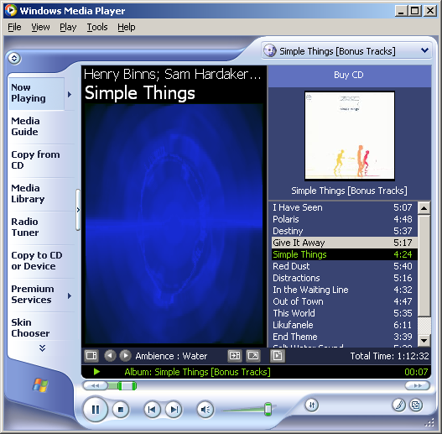
Tip To view a visualization, right click the radio icon in the left corner of the screen, choose Visualizations from the drop down menu, and then select any entry from the long list of available visualizations. If you get tired of the built-in visualizations, choose No Visualizations or Download Visualizations from the same menu.
- Media Guide This link turns the main window into a Web browser that displays content from Microsoft’s WindowsMedia.com. You’ll find music and video downloads, links to movie previews, and much more here, all updated regularly.
- Copy From CD Use this button to transfer songs from a CD to digital music files on your computer. You will learn exactly how to do this in the upcoming section called “Copying CDs”.
- Media Library All your downloaded music files and songs you copy from CD are organized neatly here, along with custom playlists you can create by mixing and matching tracks from the collection. You will learn how to use this part of Windows Media Player in the section called “Organizing Your Music Collection.”
- Radio Tuner No antenna required! Instead, click the links here to find radio stations that “broadcast” their signals over the Internet. The Featured Stations list includes links to stations picked by WindowsMedia.com. You can also use the links and Search box in the Find More Stations list to scroll through hundreds of stations, ranging from news and talk to world music and alternative rock. After you select a station, click the Play link to begin listening. If you like it, click the Add To My Stations link, as shown below, to add it to your My Stations list, which appears just below the Featured Stations list after you click the link.
- Copy To CD Or Device Click this button to begin transferring songs from a CD to your local disk drive, or to copy songs you’ve already recorded onto a custom CD or a portable music player. More details on this are in the later section, “Creating Your Own CDs.”
- Premium Services Using the subscription services listed on this page you can get digital media delivered to you. To subscribe, click on any of the links listed. This feature is not available on Windows Media version 8.

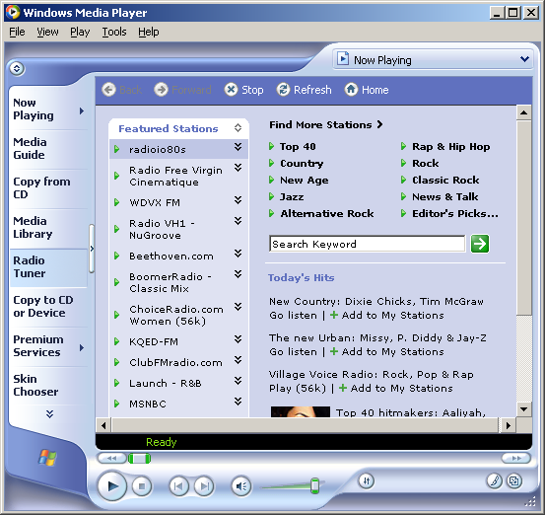
- Skin Chooser Don’t like the look of Windows Media Player? Change it! By selecting a skin from the list here (or downloading additional skins from the Internet), you can completely change the look and feel of Windows Media Player. After you select a skin from the list, look at the preview to the right of the list. If you like the look, click Apply Skin. To switch between the full Windows Media Player view and the “skinned” view, use the options on the View menu. Or use the keyboard shortcuts Ctrl+1 (Full Mode) and Ctrl+2 (Skin Mode).
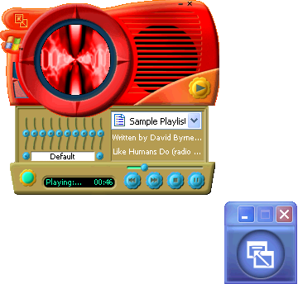

Playing Music CDs on Your Computer
When you slide a music CD into your computer’s CD drive, Windows Media Player should open and begin playing the CD immediately. If this doesn’t happen, adjust your CD AutoPlay settings so that Windows automatically recognizes the new CD and starts Windows Media Player. If this is the first time you’ve played a music CD, Windows displays the Audio CD dialog box shown here and asks you for instructions.
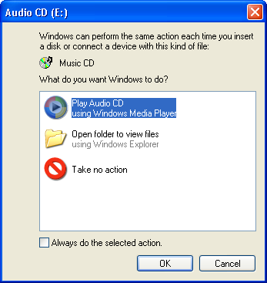
Choose Play Audio CD Using Windows Media Player, select Always Do The Selected Action, and click OK. If the dialog box doesn’t appear automatically, you can adjust AutoPlay settings for music CDs by following these steps:
- Open the My Computer window, right-click the CD drive icon, and choose Properties.
- On the AutoPlay tab, choose Music CD from the drop-down list at the top of the dialog box.
- In the Actions box, click Select An Action To Perform and choose Play Audio CD Using Windows Media Player.
- Click OK to save your changes.
Tip If you install a music playing program other than Windows Media Player, you have the option of setting it as your preferred player for CDs and songs that you save in digital format. In the AutoPlay Properties dialog box, select the option for using that program to play music CDs.

When Windows Media Player opens and begins playing a CD, you see a window like the one shown in Figure 1-1.
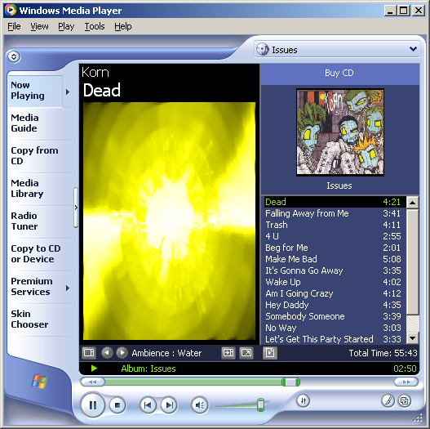
Figure 1-1.
Use these Windows Media Player controls to control playback and view album information.
The Now Playing button at the top of the Windows Media Player taskbar should be selected, and your CD drive icon should appear at the top of the playlist. (If it isn’t visible, use the drop-down list to select the CD drive.) If you’re connected to the Internet, Windows Media Player automatically downloads the album title and the names of all the tracks on the CD and displays them for you. The next time you play the same CD, Windows Media Player finds the saved information and displays it, even if you’re not connected to the Internet.
Use the playback controls, shown in Figure 1-2, to start, stop, and pause the CD, adjust the volume, and skip from song to song.
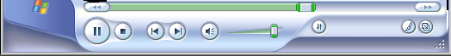
Figure 1-2.
These playback controls work just like the ones on the CD player in your home audio system.
What do you do when you’re listening to a CD and the phone rings? The Play button becomes a Pause button while Windows Media Player is playing music; click this button to stop the CD playback. When you’re ready to resume listening, click Play to pick up right where you left off. To turn the sound down to a low volume, slide the Volume control to the left. You can also click Mute to silence the speakers temporarily while the CD continues to play. Click Mute again to restore the audio.
Don’t like a particular song? Skip right past it by clicking Next. You can also drag the Seek slider left or right to jump to a different part of the song that’s currently playing.
Windows Media Player plays all the tracks on your CD, in order, unless you turn on Shuffle or Repeat (or both):
- Click the Shuffle button (or press Ctrl+H or choose Shuffle from the Play menu). With Shuffle turned on, Windows Media Player moves through the contents of the CD in a random order. The order is different each time you play the CD.
- If you want the current CD to play continuously, choose Repeat by pressing Ctrl+T or by choosing Repeat from the Play menu.

Managing a Digital Music Collection
Using Windows Media Player to play your CD collection is all well and good, but it requires that you keep your CD collection close at hand, and it doesn’t give you the freedom to play disc jockey. If you want to play two tracks from one CD, another three tracks from a different CD, and two more tracks from yet another CD, you can spend more time flipping CDs and clicking track titles than actually listening to the music. Fortunately, you have an alternative: Use Windows Media Player to copy tracks from your CD collection and store them in digital format on your disk drive, where you can listen to them any time in any order.

Copying CDs
Using Windows Media Player, you can copy tracks from a music CD and store them on your hard disk—a process sometimes referred to as “ripping” tracks to disk. Later, you can listen to the saved tracks, download them to a portable music player, or create a custom playlist and burn your own CD. To copy one or more CD tracks to your hard disk, insert the music CD into your computer’s CD drive and then choose Copy From CD on the taskbar in Windows Media Player.
Note Did Windows Media Player start playing your CD as soon as you inserted it? No problem; you can play and copy a CD at the same time.

Using your Internet connection, Windows Media Player retrieves details about the CD you inserted, including the album title, the name of each track, the performer, and the genre. (If you weren’t connected to the Internet when you inserted the CD, don’t worry. After making a connection, click Get Names on the Copy From CD screen.) Figure 1-3 shows the resulting display.
Tip The online music guide has listings for more than half a million CDs, so your CD is probably there. If the listings are incorrect or if Windows Media Player doesn’t recognize your CD, you’ll see generic titles, such as Track 1. In that case, enter details for each song (title and artist, in particular) manually before recording. Press Ctrl+A to select all the songs in the list, right-click, and choose Edit from the shortcut menu. Use the Tab key to jump to the next field after entering each bit of information.

By default, Windows Media Player selects all the songs on your CD. If you just want to copy one or two tracks from the CD (or if you want to skip that one annoying song on an otherwise wonderful CD), click to clear the check boxes to the left of the songs you don’t want to copy. After you’ve made your selections, click Copy Music to begin copying the selected tracks to your local drive. Look at the Copy Status column in the track listings to see how the task is progressing.
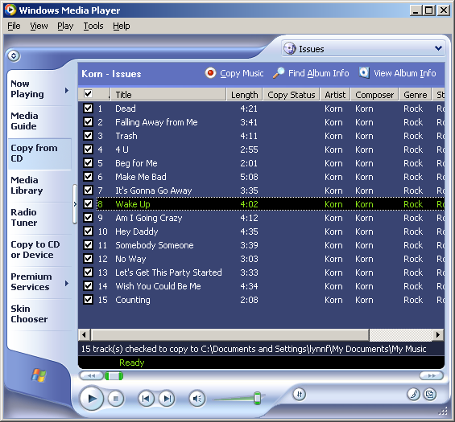
Figure 1-3.
Don’t want to copy one of these tracks from CD? Clear the box to the left of the song’s title.
Tip By default, Windows Media Player copies tracks to the My Music folder, which is in your personal profile. If you share your computer with other people and you want everyone to have access to the same music collection, choose Options from the Tools menu, click the Copy Music tab, and click Change under Copy Music To This Location. In the Browse For Folder dialog box, choose My Computer, then Shared Documents, and finally Shared Music. Click OK to save your changes. You can also use this technique if you’re running out of room on your primary disk drive and you want your recordings to be stored on a secondary disk drive that has more capacity.

The first time you copy tracks from a CD, Windows Media Player displays the dialog box shown on the next page. If you click OK at this point, all your saved tracks will be copy protected. This makes it difficult to copy them to a portable music player and nearly impossible to share with other people. Furthermore, if you ever have to reinstall Windows, you’ll find that your saved tracks will not play back on your new installation, even if it’s the same computer! To avoid all these hassles, clear the Do Not Protect Content check box and then click OK.
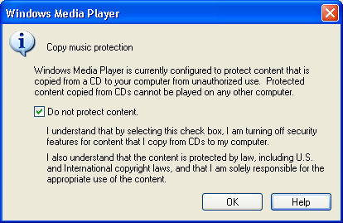

Choosing a Music Format
When you copy CD tracks using Windows Media Player, the saved files are stored using the Windows Media Audio (WMA) format at 64 kilobits per second (Kbps). Although Windows Media Player refers to this setting as CD quality, most audio aficionados would disagree. The 64 Kbps setting is efficient, and it sounds good enough on the small speakers that most people attach to their computers or the headphones used with a portable audio player. However, if your PC audio components are better than average, or if you want to burn your recorded tracks to a CD and play it back on a high-quality home audio system, you’ll want to increase the quality level. Just keep the tradeoffs of quality versus storage in mind: Higher bit rates equal higher audio quality, but they also require more room on your disk drive.
To adjust quality settings for all subsequent recordings, choose Options from the Tools menu in Windows Media Player. On the Copy Music tab of the Options dialog box, shown on the next page, move the slider control under Copy Settings—to the right for higher quality, to the left for more efficient storage at the expense of audio quality.
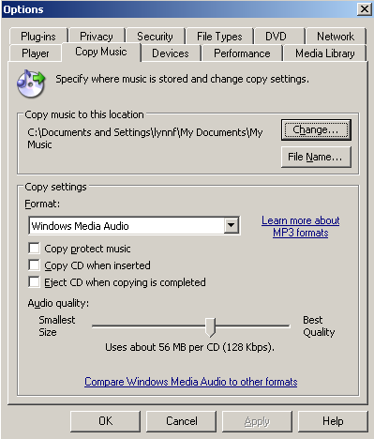
What if you prefer the MP3 audio format? Microsoft’s goal in developing the Windows Media Audio format was to devise a way to store music that sounds great without consuming your entire disk drive. As a result, the WMA format is more efficient than the MP3 format. If you want to use Windows Media Player to record tracks using MP3 format (so you can share them with devices or programs that don’t recognize WMA format), you’ll need to purchase an audio plug-in for this purpose. On the Copy Music tab of the Options dialog box, click the Learn More About MP3 Formats link to visit a Web site where you can learn more details.

Changing Song Title Formats
When you rip tracks from a music CD using the default settings in Windows Media Player, the saved tracks appear in your My Music folder. Each artist gets a subfolder, and each album gets a subfolder within the artist’s folder. Each recorded track file is saved using the track number, followed by a space and the song title (which might also include one or more spaces), as downloaded from the Internet. Normally, this level of detail is fine. In fact, additional details about each track are stored within the saved file itself, and you can view these details any time by opening Windows Explorer and looking at the contents of the folder that contains your songs.
As Figure 1-4 shows, the contents of subfolders in the My Music folder appear in Tiles view by default. This lets you see the artist and album name beneath the name of each track. If that’s not enough detail, aim the mouse pointer at a track icon and wait for a Screen Tip to appear, with even more details about the track, including the bit rate at which it was recorded.
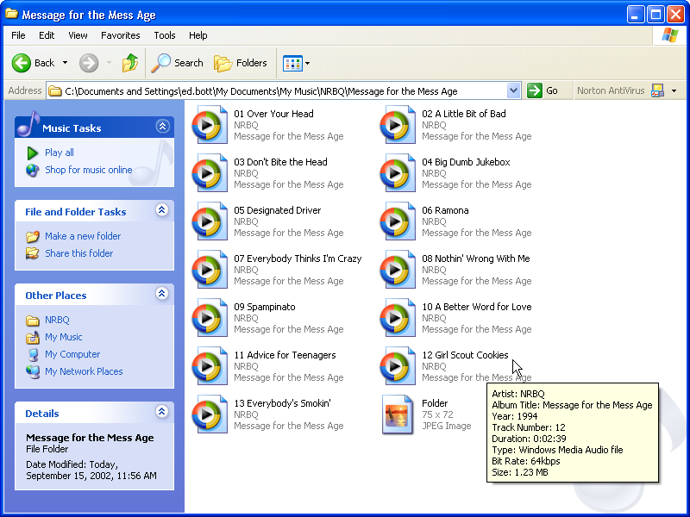Figure 1-4.
Aim your mouse pointer at any recorded CD track to see additional details about the song and the recorded file.
If you share music files with other people who don’t use Windows XP, or if you want your file listings to include more information, you can set up Windows Media Player so that it automatically names your files differently. Follow these steps:
- Choose Options from the Tools menu and click the Copy Music tab.
- Click the File Name Options button.
- In the File Name Options dialog box, shown below , select the check boxes for the information categories that you want to include in your file names and clear the other check boxes. Use Move Up and Move Down to change the order in which the selected pieces of information appear.
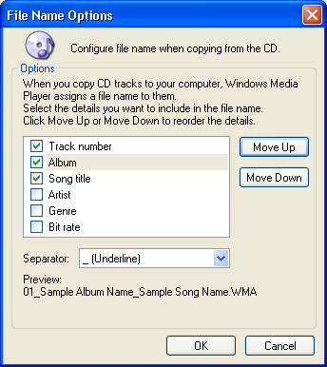
- If you don’t want spaces in your file names, use the Separator list to choose a different character (dashes, dots, or underlines) to separate elements of the name.
- Use the Preview area to see how the names appear using your new format. When the results are satisfactory, click OK.

Downloading Songs from the Web
The Web is an amazing source of content, and music is one of its strong suits. With even a simple search, you can probably find dozens of sites that allow you to download music that you can integrate into your Media Library. Some of these sources are commercial—for instance, many online CD sellers provide song files that you can download as a try-before-you-buy sample. You can also purchase songs from authorized sources, paying for the rights to download and play the tunes in your collection. Windows Media Player includes a set of technologies to help you manage these digital rights. Finally, you can exchange music files directly with other people, either one-on-one or through online file sharing services.
Caution When downloading music to your collection, make sure you don’t inadvertently get more than you bargained for, including viruses and Trojan horse programs. You should be especially suspicious of underground file-sharing services, because no central authority has the responsibility for scanning and checking the files available through these channels to make sure they’re safe. It’s especially important to use an up-to-date virus scanner when using services such as these.

When you click the Media Guide link in the Windows Media Player taskbar, you can go to Microsoft’s Web site and search for downloadable songs. The selection, organized alphabetically by artist, is huge. If you need a digital license to play back the song, Windows Media Player handles the details for you. (You might need to download and install an updated Windows Media Player component first.) After you fill in a few blanks, you see a dialog box like the one shown here.
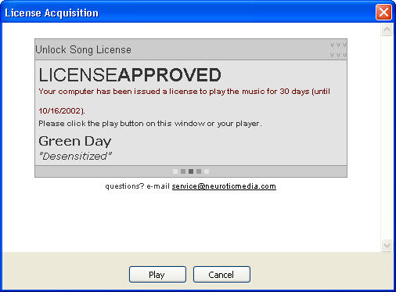

Organizing Your Music Collection
Whenever you add a music file to your collection, either by recording it from a CD or downloading it from the Web, Windows Media Player adds it to your Media Library. This outlined list makes it easy to locate music and video files for playback (or for other uses, such as copying to a CD). Each album that you record automatically appears in Media Library, categorized by album title, by artist, and by genre. In addition, you can create custom playlists of your favorite tracks.
To view the contents of your Media Library, click the Media Library link in the Windows Media Player taskbar. As Figure 1-5 shows, this list consists of two panes: on the left is an outline, showing albums, video clips, custom playlists, and radio tuner presets; on the right is a detail pane, which shows the contents of the item that is currently selected in the left pane.
A playlist is a customized collection of media files that Windows Media Player can play back in the order you select. Each album listed in Media Library’s left pane is a playlist. When you choose a name from the Artist category, the playlist consists of all tracks from all albums in your Media Library by that artist. Likewise, you can see all tracks in a particular genre by selecting an item from the Genre category.
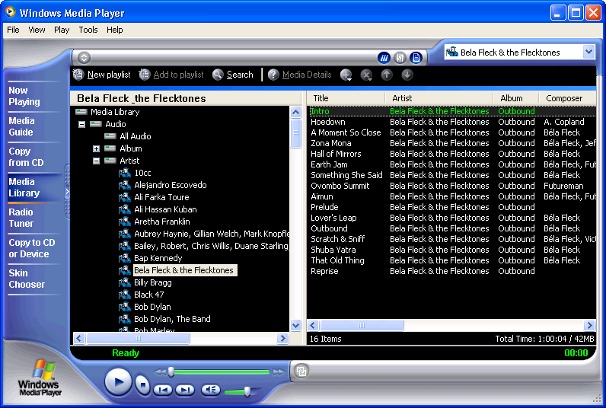Figure 1-5.
The Media Library appears as an outline list, organized by album, artist, and genre.
You can create custom playlists to combine your favorite tracks, to reorder tracks on a favorite album, or to mix and match tracks for use in a custom CD. Follow these steps to create a custom playlist.
- Click New Playlist at the top of the Media Library window.
- In the New Playlist dialog box, enter a descriptive name for your playlist, and then click OK.
- Select one or more tracks from the right pane of the library and drag them to the new playlist entry in the left pane.

Playing DVDs
Windows Media Player can play back more than music. It can also turn your PC screen into a personal theater capable of playing movies from DVD disks—but only if you have a DVD drive and a decoder. If you purchased your PC with a DVD drive and Windows XP already installed, you might already have both of these pieces. If you upgraded an older computer to Windows XP, however, you might need to download and install a software decoder from the Internet. Does your PC have what it takes? For starters, make sure you have a DVD drive. You can’t always tell just by looking at the drive itself, because CDs and DVDs are identical in size and shape. To make sure, look for a DVD label on the drive icon in the My Computer window, or inspect its Properties from the Device Manager window. To find out whether you have a decoder installed, pop a DVD disk into the drive. If the decoder is missing, Windows Media Player displays an error message with a link to its DVD Troubleshooter. Follow this link to locate a list of compatible decoders.
Playing a DVD movie in Windows Media Player is similar to playing a music CD. Your DVD movie should start playing automatically as soon as you insert the disk. If it doesn’t, start Windows Media Player, choose DVD Or CD Audio from the Play menu, and choose your DVD drive from the submenu.

Creating Your Own CDs
If you’ve created a custom playlist from music tracks saved on your computer, you can burn the songs to a CD using Windows Media Player. Naturally, you need a CD-R or CD-RW drive that is compatible with Windows XP to do this, and you’ll need a blank CD as well. You don’t need any additional software or hardware.
Should you use Windows Media Player to make CDs? Although this method is convenient, it might not be the best choice, especially if you have a third-party CD burning program that has more capabilities. Ask these questions before you begin burning:
- Do you want to make an exact copy of a CD? If so, use your third-party software instead. Using Windows Media Player converts the file twice, first into WMA format and then back into the format used on music CDs, causing a loss in quality. Most third-party programs can copy a CD more quickly, without any loss of quality.
- Do you mind a two-second gap between songs? Windows Media Player automatically adds this gap between tracks, and this setting cannot be changed. Most third-party programs allow you to eliminate this gap.

To begin creating a CD, select the playlist you want to use and then click Copy To CD Or Device in Windows Media Player’s taskbar. A window like the one below opens. Your playlist appears in the left pane, with all tracks selected. This list also shows the total playing time for the selected tracks. The right pane shows the current content of the CD, if any.
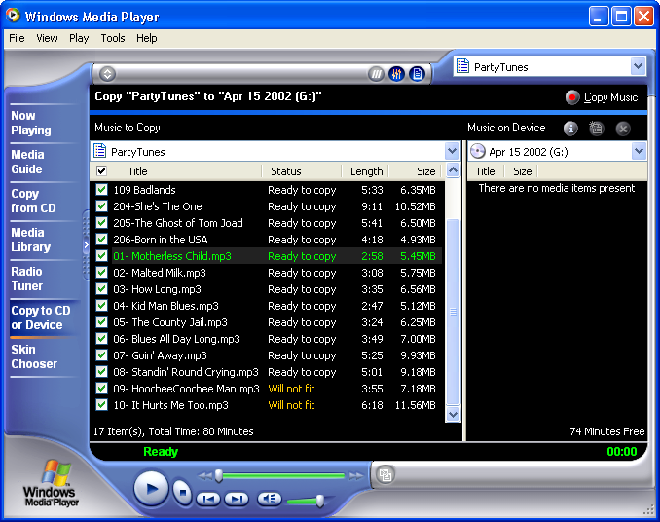
Compare the total time figure at the bottom of the left pane with the available time figure at the bottom of the right. If the total time exceeds the available time, the Status column displays the message Will Not Fit for some tracks. Clear the check box to the left of one or more tracks to adjust your selection until all the tracks fit.
When you’re ready to copy, click Copy Music in the Copy To CD Or Device window. The CD-burning process might take longer than you expect: Windows Media Player checks the license for each track, converts it to a temporary file (in uncompressed CD Audio format), and then burns the contents of the playlist to your CD.

