5

Sharing Your Digital Photos
Digital photography offers the photographer many venues to share their snapshots. Here we’ll show you how to print, create a slide show, send photos via e-mail, post them to the Web.

Printing Your Photos
Digital pictures are great for e-mail, but how do you show them off when you run into a friend at the market or the mall? With an inexpensive color printer and some high-quality paper, you can turn out good-looking images that are suitable for framing.
Printing digital photos on a color printer isn’t that different from printing any document on any printer. The unique challenge with color printers, however, is to keep costs down by making the most efficient use possible of expensive color ink and glossy photo-finishing paper. Windows XP can help. When you send a digital photo to your printer, Windows offers a handy wizard that lets you choose exactly which size image you want and squeeze as many pictures as possible onto that expensive paper.
To use the Photo Printing Wizard, perform the following steps:
- Select one or more images from the My Pictures folder and in the Picture Tasks list, click Print This Picture or Print The Selected Pictures. The Photo Printing Wizard opens.
- Click Next to skip the Welcome page.
- On the Picture Selection page, use the check boxes above each image to confirm that you’ve selected the right pictures to print, and then click Next.
- Use the selections on the Printing Options page to choose a printer. If your color printer lets you choose from several paper types, click Printing Preferences and choose the correct one. (In the example shown on the following page, We’ve selected HP Premium Photo Paper for my Hewlett-Packard color inkjet printer; if you have a different printer, your options will probably be different.) Click Next to continue.
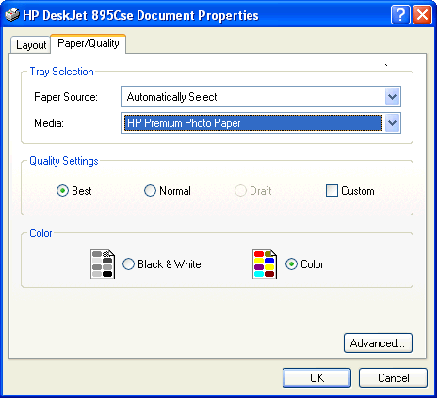
- On the Layout Selection page, choose the way you want to arrange your photos on the printed page. You can take your choice of a wide range of layouts, as shown in Figure 5-1. Click Next to send the job to your printer.
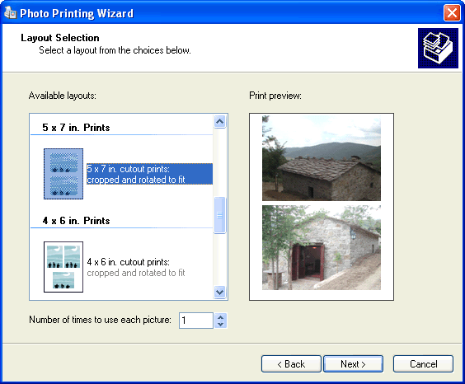
Figure 5-1.
Choose the right layout to make sure you use paper and ink efficiently.

Creating a Slide Show
After you’ve built up a big enough collection of digital photos, you might want the option to display those photos on the screen using something other than Windows Explorer. In addition, you might want to create slide shows for special occasions, taking a group of images and converting them to a format that you can display one after the other, using the entire screen, without requiring any input from the viewer.
For these tasks, Windows offers two useful tools. The first gives you the ability to create a slide show on the fly, using a group of pictures you select. To choose this option, open the My Pictures folder and select the images you want to use for your slide show. Then, in the Picture Tasks list, click the View As A Slide Show option. The first image you selected appears on the screen, with each additional image following a few seconds after the previous one. The slide show view is cool because it adds a dramatic black border around each image, clearing away all the normal Windows screen elements. As Figure 5-2 shows, you can use the VCR-style controls to start or pause the slide show and to move through the pictures one at a time.
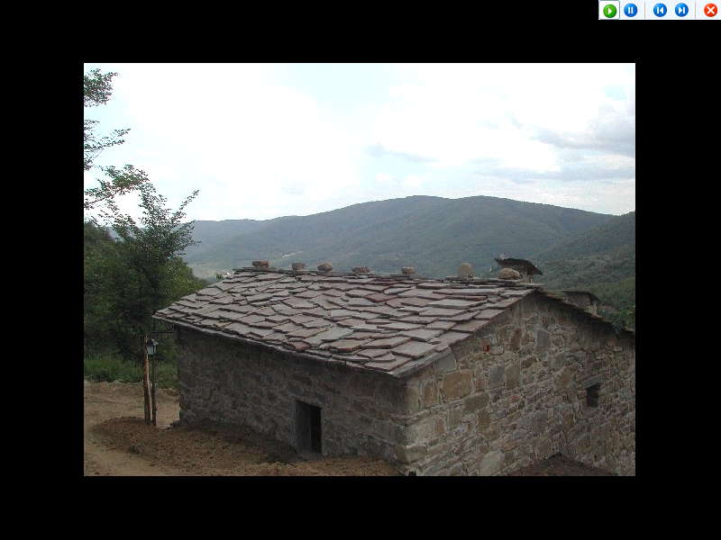
Figure 5-2.
If these play controls aren’t visible in your slide show window, just move the mouse pointer.
You can also use your photo editing program, which might have a built-in slide show feature to create a slide show. Typically this involves either creating an album within the program and inserting the photos for the slide show into the album, or simply creating a folder on your disk and moving the photos to the folder. To see the slide show, you first open the particular album or move to the particular folder from within the program. Then you give the command to show the slide show.
Typically, photo editors have a slide show control toolbar in the upper left corner of In addition to buttons to let you go forward or back by one slide, advance the slides automatically, and stop the automatic advance, there’s also an Options button that opens a dialog box with a few basic options. You can, for example, specify the number of seconds between pictures when you have the automatic advance on.
If the photo editor you have doesn’t have a slide show feature, that’s no reason to do without slide shows. There are any number of programs you can get that will give you the same capability and more. One obvious choice is Microsoft PowerPoint. Among other benefits, PowerPoint can give you far more control over details than the slide show features we’ve seen in photo editing programs for things like adding a soundtrack or animating transitions—the change from one slide to the next—with special effects.
If you’ve ever used PowerPoint, or seen a PowerPoint presentation, you may think of PowerPoint slides as centering around text, but there’s no reason why you can’t ignore text and insert a photo—and nothing but a photo—in each slide. This is not the place to give a tutorial for using PowerPoint, but it is worth pointing out that inserting a photo in a PowerPoint slide is easy. What you want to do is insert a picture from a file. To do it, you choose the Insert menu, then chose Picture, then choose From File. You then find the picture on your disk, and double-click on it or highlight it and choose Insert. After that you can resize the photo, add text if you like, define the transition to the slide, add sound, and so on.
Try This!
If you have a collection of especially good looking pictures, why not use them as your screen saver? One of the choices in the list of built-in Windows XP screen savers is called My Pictures Slideshow. Follow these steps to customize it for maximum results:
- Click Start and then click My Pictures on the right side of the Start menu.
- In your My Pictures folder, click Make A New Folder from the File And Folder Tasks list in the left pane. (If this link isn’t available, choose New and then Folder from the File menu.)
- Give the newly created subfolder a descriptive name, such as My Screen Saver.
- Select the photos you want to appear in your screen saver and move or copy them into the newly created folder.
- Click Start and open Control Panel. Click the Appearance And Themes category and then click Choose A Screen Saver from the Pick A Task list. (If you’re using the Classic view of Control Panel, double-click Display and click the Screen Saver tab to reach the exact same place.)
- On the Screen Saver tab of the Display Properties dialog box, choose My Pictures Slideshow from the Screen Saver list and then click Settings.
- In the My Pictures Screen Saver Options dialog box, shown below, select the options you want for your screen saver. If you’re not sure what an option does, click the question mark icon in the top right corner of the dialog box and then click the option to see a pop-up help message.
- Click Browse, select the subfolder you created at the beginning of this procedure, and click OK.
- Click OK again to close the My Pictures Screen Saver Options dialog box.
- In the Display Properties dialog box, adjust the Wait time, if necessary, and then click OK to save your changes.
Now, keep your hands off the keyboard and mouse for a few minutes and wait for your screen saver to kick in. When it does, you’ll see the pictures from your new subfolder, with nifty transition effects and a tasteful black border.

E-Mailing Photos to Friends and Family
Today’s digital pictures can capture a staggering amount of data. With 5 megapixels or more of resolution, they even approach the quality of conventional film. The problem with those super-high-density images, of course, is that the resulting image files are huge! That poses special problems when you want to send a photo to a friend or family member. If you attach the file to an e-mail message, you run the risk that the message will be rejected by one or more mail servers along the line. Not only that, but when the recipients open the attached file, they might discover that it’s too large to view comfortably, especially if they’re using an older version of Windows and their system is configured to open images in Internet Explorer.
So how do you shrink the pictures to a manageable size that’s safe for sending? No problem. Just perform the following steps:
- From the My Pictures window, select the image or images you want to send.
- Right-click and choose Mail Recipient from the Send To menu.
- In the Send Pictures Via E-Mail dialog box, click Show More Options. This expands the dialog box so that you see the three choices under Make My Pictures This Size, as shown below. (To restore the smaller, simpler dialog box, click Show Fewer Options.)
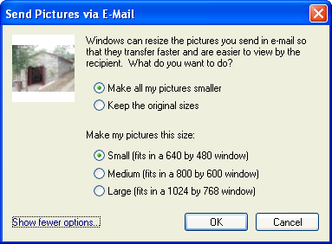
- Select the size you want to use for the converted images. When in doubt, choose the Small option.
- Click OK. After a brief pause as the files are converted, a blank e-mail message window opens, with the selected (and now shrunken) images attached.
- Address the message, add any text to the body of the message, and click Send.
When you use this trick, your files are converted, if necessary, to JPEG format, shrunk in size, and compressed. The results can be very impressive. When we used this option on an original digital image in bitmap format, it went from more than 800 kilobytes (KB) in size to approximately 56 KB, a reduction of more than 90 percent!
Tip Using this technique causes some loss of image quality in the shrunken copy. If you’re intent on sending the best possible copy, use the Compressed Folder feature, found on the Send To menu, to zip the picture or pictures and send that zipped archive through e-mail. You won’t save as much space, but the recipient can see the full, original image with no loss of detail.

Posting Your Pictures on the Web
When you want to share a collection of photos with a group of people, e-mail is a woefully inefficient distribution mechanism. Instead, post the pictures to a free or inexpensive Web-based service and send a link to that site through e-mail. This technique offers several advantages over the e-mail route: You can use thumbnails to let your audience quickly preview pictures and then download the larger, high-resolution versions of only those they’re really interested in. Your audience can view the pictures from any Web browser, even if they’re away from the computer where they receive e-mail. In most cases, you can restrict access to the Web site to only those persons you select, by using logon credentials and a password to protect the site.
The Web Publishing Wizard built into Windows XP lets you post pictures directly to either of two Web-based services: MSN Groups (a free service) or XDrive Plus (a paid service). (By the time you read this, additional options might be available.) In either case, you must sign on with a Microsoft Passport to access the account. If you select the MSN Groups option, you can choose to upload your files to a private folder, or you can create a new group and make it visible in the public directory, where others can find it and view it.
The wizard’s steps are straightforward. Before uploading the photos, it offers to adjust the sizes of your pictures, as shown on the next page. This process is similar to the wizard you use to shrink and compress images for sending through e-mail.
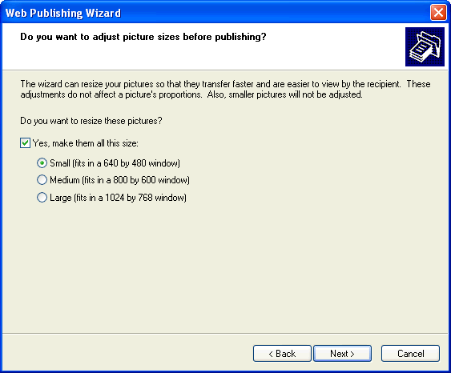
Tip As a general rule, we recommend resizing images to 800 × 600 resolution for posting on the Web. A large number of Windows users have their screens set to this resolution, so if you choose the larger 1024 × 768 size, they’ll be forced to scroll to see the entire image.

When you’re finished with the Web Publishing Wizard, your photos are available for you at the URL listed on the wizard’s final screen. Using options at this address, you can share the site with other people.

