6

Making, Editing, and Sharing Digital Video Movies with Windows Movie Maker
You can use Windows Movie Maker to capture audio and video to your computer from a video camera, Web camera, or other video source, and then use the captured content in your movies. You can also import existing audio, video, or still pictures into Windows Movie Maker to use in the movies you create. After editing the audio and video content in Windows Movie Maker, which can include adding titles, video transitions, or effects, you can then save your final movie and share it with friends and family.
You can save the movies you create to your computer or to a recordable (CD-R) or rewriteable (CD-RW) CD (depending on your CD recorder). You may also choose to share it with others by sending the movie as an attachment in an e-mail message or by sending it to the Web. If you have a digital video (DV) camera connected to your computer, you can also choose to record the movie to a tape in your DV camera and then play it back on the DV camera or on a TV.

Windows Movie Maker at a Glance
The Windows Movie Maker user interface is divided into three main areas: the menu bar and toolbar, the panes, and the storyboard and timeline.
- You use the menu bar and the toolbar to perform tasks in Windows Movie Maker.
- You use the collections panes to view your collections perform common tasks when editing a project and making a movie.
- You use the storyboard/timeline to work with clips in the current project.

The illustration on the following page shows the basic areas of the Windows Movie Maker user interface.
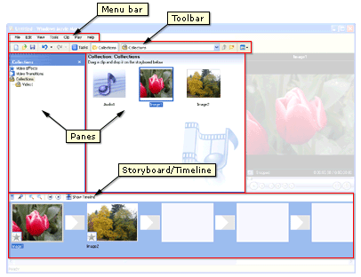

Understanding Collections, Projects, and Movies
The terms collection, project, and movie are used throughout this lesson and in the online Help. The following sections explain these terms and their usage.
- Collection A collection contains audio clips, video clips, or pictures that you have imported or captured in Windows Movie Maker. A collection acts as a container for your clips, which are smaller segments of audio and video, and helps you organize the imported or captured content. Collections appear in the Collections pane of Windows Movie Maker.
- Project A project contains the arrangement and timing information of audio and video clips, video transitions, video effects, and titles you have added to the storyboard/timeline. A saved project file in Windows Movie Maker has an .mswmm file name extension. By saving your projects, you can open the project file later and begin editing it in Windows Movie Maker from where you last saved.
- Movie A movie is the final project you save by using the Save Movie Wizard. You can save a movie to your computer or to a recordable CD, send it as an attachment in an e-mail message, or save and send it to the Web.
The saved movie can be watched in a media player, such as Microsoft Windows Media Player, or in a Web browser. If you have a DV camera connected to your computer, you can also record your movie to a tape. You and others can then watch the movie on the DV camera or on a TV.

Before you get started, check to see that your computer meets the minimum system requirements listed below.

System Requirements
To use Windows Movie Maker the following minimum system configuration is required:
- Microsoft Windows XP Home Edition or Windows XP Professional
- A 600 megahertz (MHz) processor, such as an Intel Pentium III, Advanced Micro Devices (AMD) Athlon, or equivalent processor
- 128 megabytes (MB) of RAM
- 2 gigabytes (GB) of free hard disk space
- An audio capture device (to capture audio from external sources)
- A DV or analog video capture device (to capture video from external sources)
- An Internet connection (to save and send a movie to the Web or to send a movie as an attachment in an e-mail message)

To optimize the performance of Windows Movie Maker, the following system requirements are recommended:
- A 1.5 gigahertz (GHz) processor, such as an Intel Pentium 4, an AMD Athlon XP 1500+, or equivalent processor
- 256 megabytes (MB) of RAM

The following software is required to play back a movie:
- Microsoft Windows 98 or later or Windows NT 4.0 or later
- Software that can play Windows Media Video (WMV) files, such as Microsoft Windows Media Player 7.0 or later (Windows Media Player 9 Series is recommended to optimize movie playback)

Capturing Video
You can capture video and audio to your computer by using Windows Movie Maker. To begin capturing, a video capture device must be connected properly and detected on your computer by Windows Movie Maker. A capture device is hardware that transfers video and audio from an external source to your computer. For many video capture devices, the name of the device is listed according to the hardware manufacturer’s name and device name. For example, when capturing video from an analog camera attached to an analog capture card on your computer, you would choose the analog capture card as the capture device for this option. Some audio and video capture devices and sources that you can use include a digital video (DV) or analog camera or VCR, a Web camera, a TV tuner card, or a microphone. You can capture content live or from video tape.
Modern DV cameras were designed to talk to a computer. All DV cameras support IEEE 1394 or FireWire as it is commonly referred to. This allows for an easy Plug and Play connection between your PC and DV camera. Windows XP will recognize the camera, and even if you have no other software installed, you can use Windows Movie Maker to transfer the video. The steps are listed below.

When capturing video and audio in Windows Movie Maker, the Video Capture Wizard proceeds as follows:
- Select the capture devices you want to use.
- Specify where you want your captured audio and video file to be saved.
- Choose the video setting.
- If you are capturing audio and video from a video tape in a DV camera or DV VCR, choose the method you want to use to capture video and audio.
- Capture the video and audio.

Note: If you have a DV camera connected to an IEEE 1394 port, the camera must be turned on for it to be detected by Windows Movie Maker.

To capture the entire video from a tape in a DV camera
- Make sure your DV device is connected properly to an IEEE 1394 port, and then set the camera mode to play recorded video (often labeled VTR or VCR on a DV camera).
- On the File menu, click Capture Video.

–or-
- In the Movie Tasks pane, under Capture Video, click Capture From Video Device.
- On the Video Capture Device page, in Available Devices, click the DV camera.
- In the Enter A File Name For Your Captured Video box, enter a file name for your captured video file. Then, in the Choose A Place To Save Your Captured Video box, select the location where you want your video to be saved or click Browse to select a location.
- On the Video Setting page, choose the video setting you want to use for capturing video and audio.
- On the Capture Method page, click Capture The Entire Tape Automatically.
The tape in the DV camera rewinds. Capturing begins automatically and ends when the video tape ends.
- Select any of the following commands:
- To separate the video into smaller clips, select the Create Clips When Wizard Finishes check box.
- To stop capturing before the end of the video tape, click Stop Capture, then click Yes in the dialog box to save the video that has been captured.
- To close the Video Capture Wizard, click Finish.

The captured content is imported into a new collection with the same name as the specified video file.

To capture live video
- Make sure the capture device is connected properly. If you are using a DV or analog camera, set the mode on your camera to capture live video and audio (often labeled Camera).
- On the File menu, click Capture Video.

–or-
In the Movie Tasks pane, under Capture Video, click Capture From Video Device.
- On the Video Capture Device page, do the following:
- In Available Devices, click the analog device you want to use to capture video, and then, in the Video Input Source list, click the input line you want to use.
- If you want to adjust and configure the video capture device settings, click Configure.
- In the Audio Device list, click the audio capture device you want to use, and then, in Audio Input Source, click the input line that you want to use.
- To adjust the volume of your captured audio, move the Input level slider to the level you want to use.
- In the Enter A File Name For Your Captured Video box, enter a file name for your captured video file. Then, in the Choose A Place To Save Your Captured Video box, select the location where you want your video to be saved or click Browse to select a location.
- On the Video Setting page, select the video setting you want to use for capturing video and audio.
- To separate the video into smaller clips after the wizard completes and the video is captured, select the Create Clips When Wizard Finishes check box.
- To prevent audio from playing over your speakers while capturing video, select the Mute Speakers check box.
- To automatically stop capturing after a time period has elapsed, select the Capture Time Limit check box, and then type or select the length of time you want to capture. Time is displayed in the form of hours:minutes (h:mm).
- To begin capturing, click Start Capture.
- Do one of the following:
- To stop capturing, click Stop Capture.
- If you have selected the Capture Time Limit check box, wait for the specified amount of time for video to be captured.
- Repeat steps 9 and 10 to capture another segment of live video.
- Click Finish to close the Video Capture Wizard.

The captured content is imported into a new collection.
Note: If you are using a DV camera that is connected to an IEEE 1394 port to capture live video, the audio and video input sources do not appear.

Importing Existing Digital Media Files
You can import existing digital media files that are supported by Windows Movie Maker to use for your project. The files you can import might be stored on and imported from your hard disk on your computer, a shared network location, a CD, or on removable media. When importing files in Windows Movie Maker, you can import one file or multiple files at one time.
You can import files with the following file name extensions into Windows Movie Maker to use in your project:
Type of File | Extension
Audio files | aif, .aifc, .aiff .asf, .au, .mp2, .mp3, .mpa, .snd, .wav, and .wma
Picture files | bmp, .dib, .emf, .gif, .jfif, .jpe, .jpeg, .jpg, .png, .tif, .tiff, and .wmf
Video files | asf, .avi, .m1v, .mp2, .mp2v, .mpe, .mpeg, .mpg, .mpv2, .wm, and .wmv
A source file you import remains in the same location from which it was imported. Windows Movie Maker does not store an actual copy of the source file; instead, a clip that refers to the original source file is created and appears in the Contents pane. After you import files into your project, don’t move, rename, or delete the original source files. If you add a clip to a project after the corresponding source file has been moved or renamed, Windows Movie Maker attempts to automatically locate the original source file. If the source file is deleted, it must be placed on your computer, or on a location your computer can access, again.
Note: Digital media files that have been protected using digital rights management cannot be imported into Windows Movie Maker

- On the File menu, click Import Into Collections.
–or-
Do one of the following, depending on what type of digital media file you want to import:
- In the Movie Tasks pane, under Capture Video, click Import Video.
- In the Movie Tasks pane, under Capture Video, click Import Pictures.
- In the Movie Tasks pane, under Capture Video, click Import Audio Or Music.

- In File Name, enter the path and file name of the file you want to import, and then click Import.
- If you want selected video files to be separated into smaller clips, select the Create Clips For Video Files check box.

You can import several files at one time. For consecutive files, click the first file in the list, press and hold down the SHIFT key, and then click the last file in the list. For files that are not consecutive, press and hold down the CTRL key, and then click each file that you want to import.

Saving a Project
Saving your project lets you keep your current work, and then later open the file in Windows Movie Maker to make further changes. You can continue editing your project from where you left off when you last saved the project. When you save a project, the arrangement of clips added to the storyboard/timeline, as well as any video transitions, video effects, titles, credits, and any other edits you made are retained.
A Windows Movie Maker project file is saved with a .mswmm file name extension.
You can also save an existing Windows Movie Maker project file with a new name. This enables you to use the saved project as the basis for other new projects. For example, if your current project contains a short introduction to a movie, you can save the existing project with a new name and then continue editing. When you wanted to create a new movie that includes the same short introduction, you can then open the original project file that contains only the introduction, and then make additional edits without needing to re-create the introduction of your movie.
To save a project:
- On the File menu, click Save Project.
- In the File Name box, type the file name, and then click Save.

Editing Projects
To start a project and begin creating your movie, you need to add any imported or captured video, audio, or pictures to the storyboard/timeline. The clips on storyboard/timeline become the contents of your project and future movie.
You can use the storyboard/timeline to create and edit projects. The storyboard and timeline both display your work in progress, but each provides a different view of your work:
- The storyboard displays the sequence of clips.
- The timeline displays the timing of clips.

You can switch between the storyboard and timeline as you work on a project.
After you add clips to the storyboard/timeline to create a project, you can do the following:
- Rearrange the clips in the sequence you want.
- Create transitions between clips.
- Add video effects to video clips and pictures.
- Trim the clips to hide unwanted segments (on the timeline view only).
- Split and combine clips.
- Add narration that synchronizes with the clips (on the timeline view only).

As you work on a project, you can preview it in the monitor at any time to get an idea of the end result. You can save your work-in-progress as a project and return to work on it again.
Before you can send a project as an attachment in an e-mail message, to a Web server, or record it back to tape in a DV camera, you must first save it as a movie.

To switch the view of a project
On the View menu, do one of the following:
- To view your project on the storyboard, click Storyboard.
- To view your project on the timeline, click Timeline.

To add a clip to a project
- In the Collections pane, click the collection that contains the clip you want to add to your project. Then, in the Contents pane, click the clip you want to add.
- On the Clip menu, click Add To Storyboard or Add To Timeline (depending on the view you are working in).
Note: To quickly add a clip to your project, drag the clip (or multiple clips) to the storyboard/timeline. For consecutive files, click the first clip in the list, press and hold down the SHIFT key, click the last clip in the list, and then drag the selected clips to the storyboard/timeline. For files that are not consecutive, press and hold down the CTRL key, click each clip that you want to add, and then drag the selected clips to the storyboard/timeline.

You can copy and move files and clips in the storyboard/timeline to other parts of the storyboard/timeline. By moving a clip, you can change its position on the storyboard/timeline without having to delete it, and then add it to the storyboard/timeline again. You can include the same content multiple times in your project by copying a clip. For example, you might have a short video clip at the beginning of your project that you want to repeat two times before playing the main content in your project.
When you copy or move a video clip or picture on the storyboard/timeline, any added video effect is also copied, and it will appear in the new location.

Editing Clips
You have several options for editing clips:
- Splitting a clip You can split a video clip into two clips. This is useful if you want to insert either a picture or a video transition in the middle of a clip. You can split a clip that appears on the storyboard/timeline of a current project, or you can split the clip in the Contents pane in the following way.
- In the Contents pane or on the storyboard/timeline, click the clip you want to split.
- On the Play menu, click Play Clip, and then click Pause Clip on the Play menu to pause the video at the point you want to split the clip.

–or-
On the monitor, move the playback indicator on the seek bar to the point you want to split the clip.
- On the Clip menu, click Split.

- Combining clips You can combine two or more contiguous video clips. Contiguous means the clips were captured together so that the end time of one clip is the same as the start time of the next clip. Combining clips is useful if you have several short clips and you want to view them as one clip on the storyboard/timeline. Similar to splitting a clip, you can combine contiguous clips in the Contents pane or on the storyboard/timeline by following these steps.
- In the Contents pane or on the storyboard/timeline, hold down the CTRL key, and then select the contiguous clips you want to combine.
- On the Clip menu, click Combine.

The name and property information of the first clip in the group is used for the new clip and the time is adjusted accordingly.
To select consecutive clips, click the first clip, press and hold down the SHIFT key, and then click the last clip. To select one clip at a time, press and hold down the CTRL key, and then click each clip that you want to combine.

- Trimming a clip You can hide parts of a clip you do not want in your project. For example, you can trim the beginning or end of a clip. Trimming does not remove the information from the source material; you can clear the trim points to return the clip to its original length at any time. Clips can only be trimmed after they have been added to the storyboard/timeline. You cannot trim clips in the Contents pane. The following steps show you how to trim a clip.
- On the View menu, click Timeline.
- In the Collections pane, click the collection that contains the clip you want to add, and then click the clip you want to trim in the Contents pane.
- On the Clip menu, click Add to Timeline.
- On the timeline, select the clip you want to trim.
- On the timeline, click the playback indicator and drag it to the point where you want to trim the clip.
–or-
Use the playback controls on the monitor to go to the point where you want to trim the clip:
- When the playback indicator is at the point where you want the selected video or audio clip to start playing back, on the Clip menu, click Set Start Trim Point.
- When the playback indicator is at the point where you want the selected video or audio clip to stop playing back, on the Clip menu, click Set End Trim Point.

You can also drag the trim handles to set the start and end trim points as shown here. The trim handles appear when the clip is selected on the timeline.
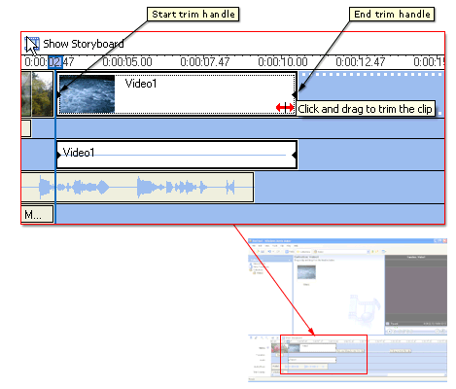
- Creating clips You also create clips from video clips after they have been imported or captured in Windows Movie Maker. This lets you create clips at any time when working in Windows Movie Maker. By separating video clips into smaller clips, you can easily find a particular part of your captured or imported video to use in your movie. To create clips for an existing video clip follow these steps:
- In the Contents pane, select the video clip for which you want to detect clips.
- On the Tools menu, click Create Clips.
The video clip is divided into clips according to the video source. If the video clip is from a DV camera, clips are created based on the time stamps inserted by the DV camera. If time stamps or other file markers are not present, clips are based on each significant frame change in the video. If the video clip is from an analog source, clips are created based on each significant frame change in the video.

Using Video Transitions, Video Effects, and Titles
You can enhance your movies by adding different elements to your movie, such as the following:
- Video transitions A video transition controls how your movie plays from one video clip or picture to the next. You can add a transition between two pictures, video clips, or titles, in any combination, on the storyboard/timeline. The transition plays before the one clip ends and while the other clip starts to play. Windows Movie Maker contains various transitions you can add to your project. Transitions are stored in the Video Transitions folder in the Collections pane.
- Video effects A video effect determines how a video clip, picture, or title displays in your project and final movie. Video effects let you add special effects to your movie. A video effect is applied for the entire duration that the video clip, picture, or title displays in your movie. You can add any of the video effects that appear in the Video Effects folder in the Collections pane.
- Titles and credits Titles and credits let you enhance your movie by adding text-based information to your movie. You can add whatever text you want, but you may want to include information such as the title of your movie, your name, the date, and so forth. You can change the appearance of the title or credit, in addition to changing the title animation, which determines how your title or credit displays in your movie.

Creating Video Transitions
A video transition controls how your movie plays from one video clip or picture to the next. You can add a transition between two pictures, video clips, or titles, in any combination, on the storyboard/timeline. The transition plays before the one clip ends and while the other clip starts to play. Windows Movie Maker contains various transitions you can add to your project. Transitions are stored in the Video Transitions folder in the collections pane.
You can change the playback duration of a video transition up to the duration of the shorter of the two adjacent clips. If you drag the video clip or picture on the timeline that you want to transition to over the clip or picture that you want to transition from, a cross-fade is added as the default transition between the two clips. There will be a straight cut (no fade) between two clips if you do not create a transition.
Any transitions you add appear on the Transition track of the timeline. To see this track, you must expand the Video track. The video transition length is determined by the amount of overlap between two clips. The following illustration displays a project on the timeline with an added video transition.
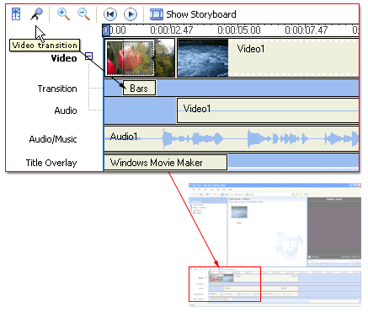
The following illustration displays a project on the storyboard with a video transition. Any transitions you add appear in a transition cell between two video clips or pictures.
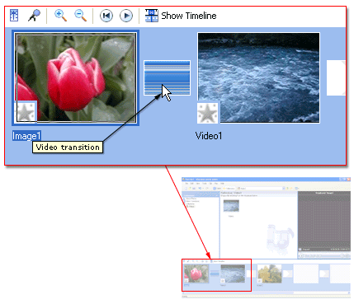

Creating Video Effects
A video effect determines how a video clip, picture, or title displays in your project and final movie. Video effects let you add special effects to your movie. For example, you might have video that you captured that you want to age, so it has a classic, old-time movie look. You can add one of the Film Age video effects to a video clip or picture. A video effect is applied for the entire duration that the video clip, picture, or title displays in your movie. You can add any of the video effects that appear in the Video Effects folder in the Collections pane.
Video effects are maintained when you split, cut, copy, or move a video clip or picture. For example, if you add the Grayscale video effect, and then split the clip, the Grayscale video effect is applied to both clips. However, if you combine two video clips, the video effects that were associated with the first clip are applied to the new combined clip, and the video effects that were associated with the second clip are removed.
The following illustration shows a project on the timeline with an added video effect. An icon appears on the video clip or picture that you applied the effect to on the Video track.
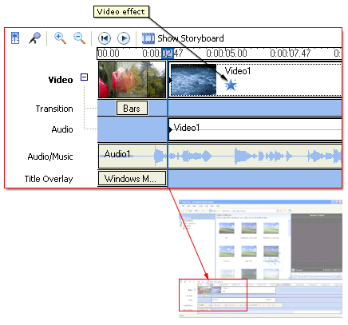
The illustration on the following page shows a project on the storyboard with an added video effect. An icon, highlighted in the square, appears in the video effects cell to indicate that a video effect is applied.
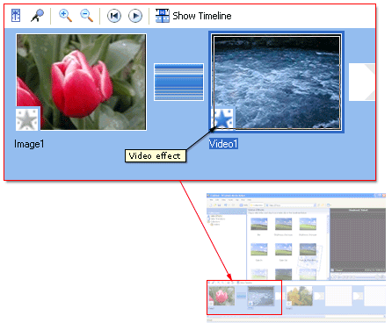

Adding Titles and Credits
Titles and credits let you enhance your movie by adding text-based information to your movie. You can add whatever text you want, but you may want to include information such as the title of your movie, your name, the date, and so forth.
You can add a title to various places in your movie: at the beginning or end of a movie, before or after a clip, or overlaying a clip. The title plays for the specified amount of time, and then the video clip or picture displays in your movie.
When adding titles or credits to a movie, do the following:
- Select where you want your title to appear in your movie.
- Enter text for the title.
- Select an animation style for the title.
- Select the font and colors for your title.
- Add the title to your movie.

The following illustration shows a project that contains a title that displays before a video clip.
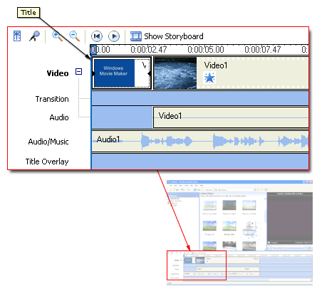
The following illustration shows a project that contains a title that displays as a title overlay over a video clip.
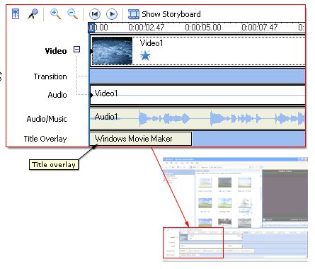
The following illustration shows a project that contains credits that display at the end of the project.
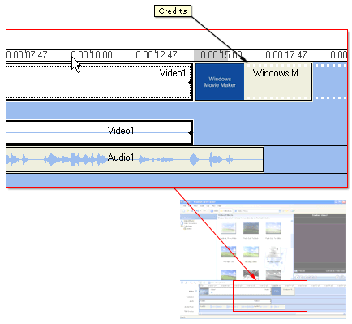

Working with Audio
Windows Movie Maker lets you work with audio in a variety of ways. Some of the different audio-related tasks you can perform in Windows Movie Maker include the following.
- Narrate the timeline Add an audio narration to narrate the video clips or pictures that appear on the Video track of the timeline. Your audio narration is automatically synchronized with the video, so the narration describes the action or event in your movie as it plays back.
- Adjust audio levels Adjust the audio levels so you can determine the audio balance and playback when you have audio that appears on the Audio and Audio/Music tracks on the timeline.
- Add audio effects Add different audio effects such as a fade in, fade out, or mute.
- Adjust the volume of audio clips Adjust the volume of audio for audio-only clips or the audio portion of a video clip. This lets you adjust the volume of the audio for clips so that it can be clearly heard or not heard, depending the volume level you specify for the audio clip.

Narrating the Timeline
You can capture an audio narration to synchronize with video clips, pictures, titles, or other items that you have added to the storyboard/timeline. Before you can begin capturing an audio narration:
- The playback indicator on the timeline must be at a position where the Audio/Music track is empty.
- You must be in the timeline view.

Capturing an audio narration lets you describe, in your own words and voice, what is displayed in the video, pictures, or titles as the items are shown in your project and, ultimately, in your final saved movie. Narrating the contents of the timeline serves as another way for you to enhance your movie.
The narration you capture is saved as a Windows Media Audio file with a .wma file name extension. By default, the audio narration file is saved in the Narration folder under My Videos on your hard disk.

Saving and Sending Movies
The Save Movie Wizard lets you quickly save your project as a final movie. The timing, layout, and contents of the project are saved as one complete movie. You can save and store the movie on your computer or on a recordable CD, or you can send it as an attachment in an e-mail message or to a video hosting provider on the Web. In addition to these choices, you can choose to record your movie to a tape in a DV camera.
This page of the Save Movie Wizard lets you select which movie saving option you want to use, depending on what you want to do with the final movie.

Saving a Movie to My Computer
The My Computer saving option lets you save your movie for playback on your local computer. When you select this option, the final movie is stored in the specified location on your computer or on a shared network location.
If you click the My Computer option, the Save Movie Wizard proceeds as follows.
- Specify a movie file name and place for your movie to be saved.
- Choose a movie setting for saving your movie
- Wait for your movie to be saved.
- Complete the Save Movie Wizard.

Saving a Movie to a Recordable CD
Specifies that you want to save your movie to a recordable or rewriteable CD (CD-R or CD-RW). Choose this option if you have a rewriteable or recordable CD drive attached to your computer and you want to save your final movie to a recordable or rewriteable CD.
The Recordable CD saving option lets you save your movie for playback on a recordable or rewriteable CD (CD-R or CD-RW). When this option is selected, the final movie is saved to a recordable or rewriteable CD in the Save Movie Wizard.
In Windows Movie Maker, movies saved to a recordable CD are saved by using Microsoft HighMAT technology. A HighMAT (High-performance Media Access Technology) CD can contain audio, video, and pictures. HighMAT-compatible consumer electronic devices recognize how the content is organized on the CD, and enable users to play content using the displayed menus. The recordable CD can be played back on a computer as well. For more information about HighMAT, go to this Microsoft Web site: http://www.microsoft.com/windows/windowsmedia/consumelectronics/highmat.aspx. Consumer electronic devices that can play back HighMAT CDs created in Windows Movie Maker have the following logo.
You can choose to save one or more movies to a recordable CD, which typically holds up to 650 MB. Therefore, you may have one large movie or several smaller movies on the same CD. You can save several movies to the same recordable or rewriteable CD at different times. This lets you add more movies to a recordable CD as you create and save more movies at different times in Windows Movie Maker
If you click the Recordable CD option, the Save Movie Wizard proceeds as follows.
- Specify a movie file name and CD name.
- Choose a setting for saving your movie.
- Wait for your movie to be saved.
- Complete the Save Movie Wizard.

Sending Your Movie as an E-mail Attachment
Specifies that you want to save your movie as an attachment to send in an e-mail message. Choose the option to share smaller movies with others by sending them in e-mail by using your default e-mail program.
The E-mail saving option lets you save your movie and then send it as an attachment by using your default e-mail program. When this option is selected, the final movie is saved to a temporary location, and then sent as an e-mail attachment.
If you click the E-mail saving option, the Save Movie Wizard proceeds as follows.
- Wait for your movie to be saved.
- Complete the Save Movie Wizard.

Putting Your Movie on the Web
Specifies that you want to save your movie and then send it to a video hosting provider on the Web. A video hosting provider is a third-party provider on the Web that provides a Web server location and hosts the movies you save in Windows Movie Maker. Choose this option if you want to save your movie so family and friends can watch your movie on the Web.
The Web saving option lets you save your movie and then send it to a video hosting provider on the Web. The hosting providers are third-party companies that let you store your movies on their Web server. In Windows Movie Maker, you can choose from a variety of hosting providers. After your movie is sent to the Web server, you can provide your family and friends with the Web address so they can watch your movie on the Web.
When using The Web saving option, the Save Movie Wizard proceeds as follows.
- Specify a movie file name.
- Choose a setting for saving your movie.
- Wait for your movie to be saved.
- Wait for the most current video hosting provider information to download from the Web.
- Select a video hosting provider, and then enter your account sign-in information.
- Wait for your sign in account information to be verified.
- Wait for your movie to be sent to the video hosting provider that you specified.
- Complete the Save Movie Wizard.

Note: If you do not have an account with a video hosting provider already, you can sign up with one through Windows Movie Maker.

Sending Your Movie to a DV camera
Specifies that you want to send your movie to a tape in your DV camera. This option is available when you have a DV camera connected to an FireWire port. Choose this option if you want to save your movie to a tape so you and others can watch it on the DV camera or on a TV (when you connect the camera to a TV).
The DV Camera saving option lets you record the movie you create to a tape in a DV camera through Windows Movie Maker. This lets you or others watch the final movie on a DV camera or on TV when you connect the camera to a TV. When you choose this option, the movie is recorded to the tape in your DV camera, so it appears on the tape with existing video you might have recorded back to tape or recorded with your DV camera.
To record your movie to tape, your DV camera needs to be in the playback mode (often labeled VCR or VTR on your camera).
If you click the DV Camera saving option, the Save Movie Wizard proceeds as follows.
- If you have more than one DV device connected to your computer and powered on, select the DV device on the DV Camera page that contains the tape that you want to record your movie to.
- Set your camera to playback mode, and then rewind or fast-forward the tape to the point where you want your movie to be recorded.
- Wait for your movie to be created and then recorded to tape..
- Complete the Save Movie Wizard.

Note: In addition to recording a movie to tape in a DV camera, you can also record movies to a tape in a Sony Digital8 Handycam or Hi8 Handycam cameras.

