Creating and Shaping Web Text
Lesson 2

After completing this lesson, you will be able to:
- Describe what makes a good Web page “scannable.”
- Identify the key textual elements of a Web page.
- Create text for the Web that is clear, concise, and readable.
- Choose various techniques for using typography as a design element.

When people contemplate building Web pages, they usually think of design first—that is, how the page will look rather than what it should say. And that’s understandable as well as desirable. In fact, quite a bit of this book is devoted to Web page design. But at the heart of every Web page is content. After all, most people build Web pages because they have a message they want to share—even if that message simply proclaims, “Look what I’ve been up to lately!”
To be successful, your Web page must provide information that quickly captures viewers’ attention; otherwise, viewers won’t stay more than a couple of seconds and probably won’t return. Therefore, you should start to think about your Web page’s content before you get too far into its design.
If you follow along with this text, you’ll be well on your way to having your Web pages’ content fully spelled out and formulated by the end of this lesson. But even if you don’t progress that far in creating content for a particular Web site, you’ll be able to identify and create good Web text in general. Furthermore, you’ll know how you can maximize the use of text on your future Web pages. With this know-how in mind, you’ll be able to ease into blending content and design when you start to build your Web pages.
Now, back to the matter at hand—online text. Reasonably enough, you might be thinking that you’re quite capable of using words so you don’t really need to read about Web page text. But rest assured, even if you’re a full-time writer, you can benefit from the tips in this lesson. Although good online text has a lot in common with good printed text, it also varies from printed text in a number of key ways. You’ll see as you progress through this lesson that creating effective online text involves mastering and blending the arts of clarity, marketing, visual appeal, technological limitations, and a little reader psychology.

Readers’ Approach to Online Pages
The first concept you need to address is that readers respond to Web pages differently from the way they respond to printed pages. In early studies, Web experts found that reading a block of text online took approximately 25 percent longer than reading the same text on a printed page. In other words, in the amount of time you spend reading 75 words online, you could read 100 words on a printed page. Experts now debate whether online reading speeds are on the rise due to improved monitors, use of color, or general increased familiarity of reading online text. Regardless of exact percentages, the majority of experts agree—people’s reading speeds slow down significantly when they read online text (as compared to hard copy text), even though many people are getting better at reading online. One way people have adapted to the slowness of online text reading is that they frequently scan Web page text instead of reading every word that flashes across the monitor.
Basically, a user scans a Web page to find an item of interest that encourages the user to click a link or back up and read the content in more depth. If a Web page doesn’t grab a user quickly—within 10 seconds (according to most usability studies)—the user will very likely move on to another page (or another site altogether). Creating easily scanned pages also increases your Web page’s credibility as well as improves the page’s chance of being ranked higher by search engines (because your Web page’s main ideas are easier to identify). Therefore, whenever you create content for a Web page, keep the scanning concept in the forefront of your thought processes. In this lesson, we describe a variety of methods you can employ to improve your Web pages’ scannability.
On average, most visitors determine within 10 seconds if a Web page contains the information they want or need. If the Web page seems to fulfill their need, most
users will still spend less than 30 seconds viewing the Web page.
To illustrate the scanning concept, compare Figures 2-1 and 2-2. Figure 2-1 shows a Web page that doesn’t adhere to good online-text practices, whereas Figure 2-2 follows the textual advice presented in this lesson. Notice how much faster you can identify the text’s main points in Figure 2-2 than in Figure 2-1. The upcoming text explains why and provides pointers for you to use when creating your own online text.
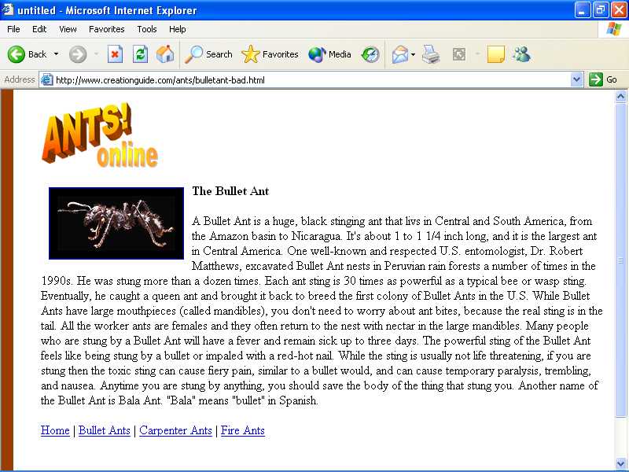
Figure 2-1.
An ineffective presentation of Web page text can send readers off packing before they read a word of your content.
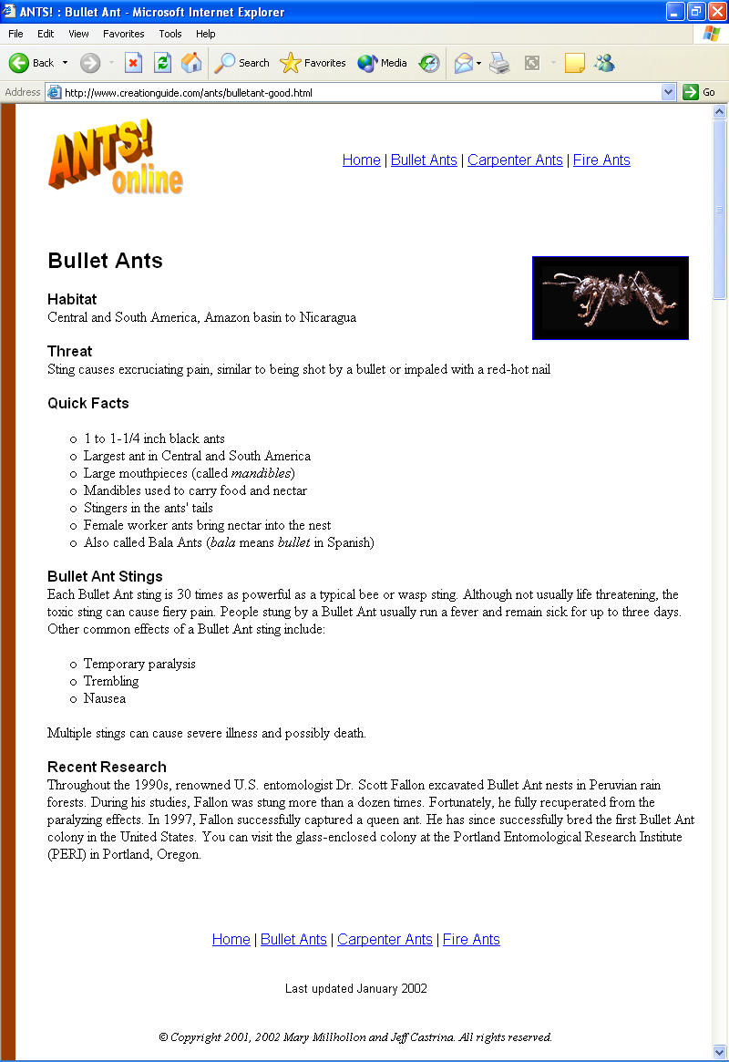
Figure 2-2.
An effective presentation of Web page text provides a high level of scannability, making it easy for readers to find the information they need.
Now that we’ve made a case for thinking about your text and recognizing how readers approach Web pages, let’s briefly look at the fundamental roles text plays on a Web page. Then we’ll discuss the details involved in shaping and streamlining online text.

Textual Elements of a Web Page
Most Web pages use a variety of textual components, as illustrated in Figure
2-3. As you can see in the figure (as well as on most Web pages), the textual elements described in the following subsections appear on Web pages.
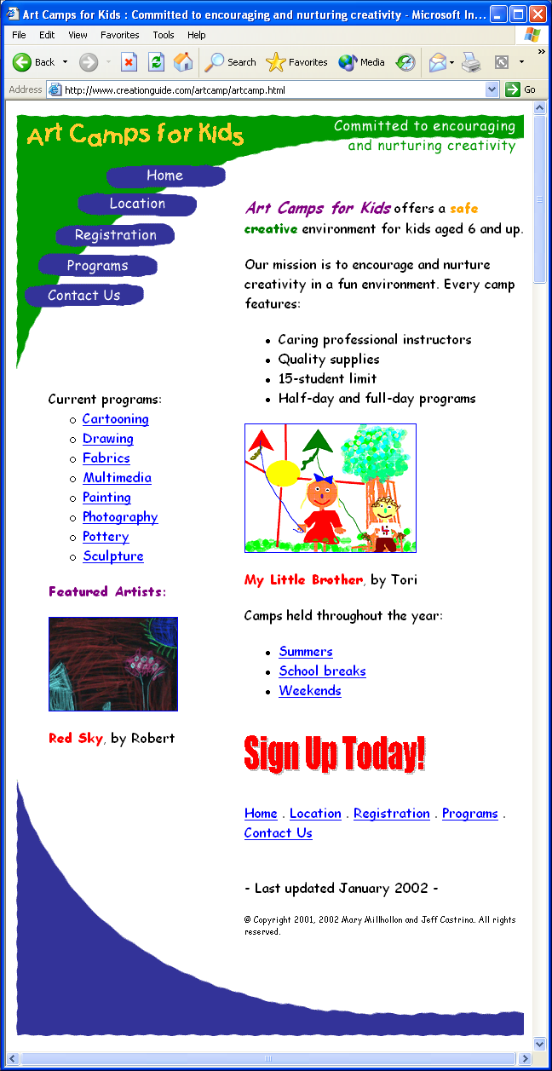
Figure 2-3.
Effective Web pages contain a number of common textual elements.

Title Bar
When you create a Web page, you create the text that appears in a browser window’s title bar. The key to title text is to make it concise, clear, and useful. Notice that when you open a Web page, the Web page’s title text also appears in your Microsoft Windows taskbar. Taskbar text simplifies a user’s job when switching among a number of open windows. Therefore, although you can insert clever or witty title text if you want to, you should generally lean toward useful and clear instead. Notice the lame vs. helpful title bar text shown earlier in Figures 2-1 and 2-2.
Tip
For added clarity (on taskbar buttons especially), skip leading articles (the, a, an) in a Web page’s title bar text. Using snappy, descriptive titles helps your pages stand out within users’ workspaces as well as stand out in search engine results that organize Web pages by title.

Content
A Web page’s content refers to its substance—the reason people are visiting the site. As described in the next few sections, a Web page’s content should be clear, brief, easy to scan, informative, timely, and grammatically correct (among other qualities). Keep in mind that no matter how beautiful a Web site, the Internet’s most engaging feature is text. After all, in addition to Web sites, a few hundred million people regularly rely on online text to send e-mail messages, chat using instant messaging, and post to discussion groups.
Tip
One way to obtain content for your Web pages is to take advantage of Web content providers. A number of news bureaus, media centers, special interest groups, private contractors, and other information specialists provide Web content to Web sites on a regular basis, usually for a fee. To find a content provider, visit your favorite search engine (we like www.google.com) and search for Web content providers.

Hyperlinks
Hyperlinks provide form and clarity to a group of Web pages (or one long Web page) by linking your home page (as well as ancillary pages) to areas that contain specific related information. In other words, hyperlinks help you to organize your information, and they enable others to access your information quickly and easily. Textual hyperlinks should be clear, consistent, and appropriately placed, as we discuss later in this lesson.
You’ll notice that we use the words link and hyperlink interchangeably.

Logos, Graphical Text, and WordArt
You can use logos, graphical text, and WordArt to add a professional look to your Web pages. As we explain in Lesson 3, you can use graphical text to add a consistent look and feel to a group of related Web pages. Having all the parts of your Web site appear interrelated clearly indicates to users that they are still within the realm of your Web site even as they click from page to page. Furthermore, logos, graphical text, and WordArt are frequently used to provide a consistent graphical link to a site’s home page. You might have discovered while surfing the Web that you can usually click a company’s logo to return to the site’s home page. (If you haven’t discovered this secret, you should test it out during your next Web surfing session.) Whenever possible, take advantage of this practice by linking your logo to your home page throughout your Web site.
Lingo: Graphical text is a general term that refers to text used to create graphical elements on your Web pages, including stylized buttons, banners, titles, and so forth. WordArt is a Microsoft Word feature that enables you to create stylized text-based graphics, such as custom headings and logos. For example, in Figures 2-1 and 2-2, we created the “Ants! Online” logo element using Word’s WordArt feature, and in Figure 2-3 the “Sign Up Today!” graphical text is a WordArt element.

Plain-Text Navigational Options
Many Web designers opt to format their menu bar and navigation elements (buttons) only as graphics (in Figure 2-3, the buttons in the top-left area essentially serve as the home page’s navigation bar). Using graphic navigation elements is fine, but we recommend that you also display your navigation hyperlinks as plain text in conjunction with your graphic elements. If your Web page’s design uses a graphical menu bar or buttons, you can avoid disrupting the layout of your Web pages by showing textual hyperlinks along the bottom of your page. Offering an alternative to graphics-based links is useful because some viewers turn off their browser’s graphics capabilities to expedite Web page downloads. If you don’t provide text-based navigation components, some users might not discover how to get to your site’s ancillary pages.
Tip
As an added bonus, adding text-based navigation links to the bottom of your Web pages helps users move to other pages in your Web site without having to scroll to the top of the current page to access the main navigation links.

Date or “Last Modified” Information
Generally, you should include a date element on your Web pages. The date can be as nondescript as a small line of text located near the bottom of your page. If regularly updated content is one of your page’s main selling points, however, you might want to make the date much more noticeable by placing it higher on your page and nearer the “prime” upper-left area. On the other hand, if you don’t plan to update your site regularly, you might opt to omit publishing a last-modified date. (Frankly, we don’t recommend that you plan on not updating your site, but in some circumstances you might be able to get away with a static page or two within your site.)

Copyright Information
You own the copyright to all original text and graphics you create. Therefore, to protect your property, you should add a copyright notice to your Web pages. Keep in mind that if you use freeware (such as copyright-free graphics that you’ve downloaded from another Web site) on your Web page, the freeware is free for anyone else to use as well.
When you add copyright text, the information can be as simple as © Copyright 2002 Your Name or Company Name. All rights reserved. Furthermore, the copyright information should be placed near the bottom of the page and in a font size that’s noticeably smaller than the Web page’s body text.
To create © in Microsoft Word, press Ctrl+Alt+C.
Now that we’ve touched on the basic textual elements of Web pages, you’re ready to shape and write Web page content.

Treating Text as a Design Element
As you know, text on a Web page informs as well as adds to a page’s overall design. (Refer to Figure 2-3.) You should start to mull over basic text-design issues while you’re pulling your text together. Therefore, while you create your content and read Lesson 3, keep the following text-design issues in mind:
- Create graphical titles and headings for added artistic effect.
- Display pull-quotes and sidebars to lighten text-heavy pages.
- Add WordArt, logos, graphical text, and banners to create a consistent look and feel throughout your site.
- Use easy-to-understand icons in place of words, similar to the “new,” “hot,” and “home” icons that are sprinkled throughout the Web.
- Judiciously apply color or other typographical formatting (such
as boldface or italic) to draw attention to important words and
concepts.
- Use drop caps or hung initials (larger first letters in a paragraph) to indicate the beginning of a section.
- Ensure that backgrounds don’t interfere with the text’s readability.
- Include important data (such as contact information, company name, and so forth) as text, even if the information appears in graphical form elsewhere on the page. Some people turn off their graphics to speed up surfing, which means they’ll miss graphical
information provided on your page.
- Avoid tiny print—if in doubt, let the users define the text’s size through their default browser settings.
- Use easy-to-read, cross-platform compatible fonts. Currently, the fonts most compatible with Windows-based and Apple Macintosh machines include Arial, Arial Narrow, Comic Sans, Courier New, Times New Roman, and Verdana.
Finally, as a parting text tip after all the dos and don’ts outlined in this lesson, we want to suggest that you have fun with your Web page’s content. The Web grants you the freedom to quickly and creatively impart information in new ways. Think about exactly what you want to say, and then write your message as clearly and actively as possible. Once you start to write strong concise sentences, you’ll be hooked.
Key Points
- Users scan Web pages instead of reading them linearly.
- Titles, contents, hyperlinks, logos, WordArt creations, graphical text elements, forms, menus, navigation options, last-modified dates, and copyright information represent typical uses of Web page text.
- The text on a Web page attracts users’ attention before the graphics do.
- Web page information should loosely emulate the traditional inverted pyramid news-style writing methodology.
- Brainstorm to clarify your Web page’s main points, headings, and links.
- Write clear, active sentences and well-formed, concise paragraphs.
- Keep headings and hyperlinks clear and descriptive.
- Use bulleted lists and a heading hierarchy to help readers quickly identify key points.
- Include important information as text to cater to users who opt not to download Web graphics.
- Spell-check, spell-check, and then spell-check again (and don’t forget to print and read the text aloud).
- Check your grammar.
- Start to think about text design elements, including typographical formatting, color, and graphical text elements.
- Most of all, after taking into account the strengths and limitations of Web writing, allow the writing experience to be an enjoyable and creative process.

