Creating and Using Art on the Web
Lesson 3

After completing this lesson, you will be able to:
- Comprehend the basics of Web graphics.
- View and manipulate Web graphics in a graphics program.
- Describe the different types of graphics file formats.
- Choose “safe” colors for the Web.
- Crop a graphics image.
In this lesson, we simplify the topic of Web graphics. In a perfect world, we’d dedicate pages and pages to the nuances of using graphics on the Web (mostly because we like graphics), but then you’d never get to the rest of the lessons. We also don’t want you to feel overwhelmed when it comes to using Web graphics. As you might have discovered, you can easily find an overabundance of information about advanced graphics by looking on the Internet and in bookstores everywhere. Fortunately, you can use Web graphics effectively without immersing yourself in gamma theory and rasterizing. Therefore, we’ve opted to take the practical approach of presenting what we deem to be the most significant and fundamental information about Web page graphics. Think of this lesson as your personal crash course in Web art. By the time you reach the “Key Points” section at the end of the lesson, you’ll have plenty to think about, a few tricks up your sleeve, a cocktail party quip or two, and a number of places to turn to during your search, acquisition, creation, and preparation of Web art.
Practice files for this lesson can be found in the Lesson03 folder in the Web Design Fundamentals Practice folder that is located on your hard drive. The files used in this lesson include the following: apples.jpg. cherries_photo.jpg, cherries.gif, firebreath.gif, palette216.gif, fruit_standard.jpg, fruit_compressed72.jpg, fruit_progressive.jpg, and fruit_progressive_compressed72,jpg.

Mechanics of Web Graphics
Before you start flipping through this lesson to check out the pictures and unearth the addresses to our online examples, you really need to read this section to make sure you understand a few key Web graphics issues. As you know, Web graphics look fairly similar to printed graphics, but some Web-specific factors come into play when you’re creating and using graphics on the Web. Specifically, online graphics require you to consider color limitations, file formats, and file sizes as well as possible transparency, downloading, and animation issues. Acquiring an awareness of three main factors—colors, file types, and file sizes—enables you to begin using graphics on your Web pages and provides a jumping-off point for further graphics study. Therefore, the overall plan of attack here is to tuck some Web graphics fundamentals into a cranial corner or two before opening your mind to the more creative (and fun) prospects of using, gathering, and creating Web graphics. Let’s get started by looking at how graphics display color.

Pixels, Palettes, and Colors
First and foremost, every online graphic consists of a bunch of tiny colored squares working together to form an image. In a way, online graphics emulate a painting technique called pointillism. Pointillism, introduced by French painter Georges Seurat (1859–1891), is the art of painting pictures one dot (or tiny brush stroke) at a time. Through pointillism, Seurat broke each image on his canvas down into tiny dots of color. When you look closely at a pointillist painting, you can see each dot. As you move away from the painting, the dots blend together to create a picture. Computers display pictures using a technique similar to pointillism, except that instead of painted dots, computers divide pictures into colored squares, called pixels. For example, take a look at the cherries in Figure 3-1. Figure 3-1 could be any graphic displayed on your screen. As you can see, the graphic looks like most other pictures online (or in printed material, for that matter), and there are no blatant signs of dots, squares, or
pixels.
Lingo: A pixel is one square on a grid of thousands of squares that are individually colored to create an image.
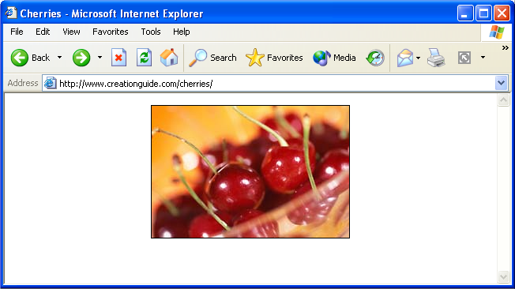
Figure 3-1.
A couple cherries stand in as a typical graphic.
Now let’s look at the graphic a little more closely. In the Lesson03 practice files folder for this course, locate cherries_photo.jpg and open it in a graphics editing application such as Jasc Paint Shop Pro, Adobe Photoshop, or Microsoft Paint. If you then dramatically magnify the image, you’ll be able to see the actual squares (pixels) that make up the picture, as shown in Figure 3-2. If you magnify the cherries on your monitor, you’ll see that the picture’s colors and shades vary from pixel to pixel, or square to square.
Tip
If you don’t have a graphics editing application on your system or if you want to test-drive a popular “full-service” graphics editing application, visit www.jasc.com and download a free trial version of Paint Shop Pro. We have more to say about graphics editing applications later in this lesson.
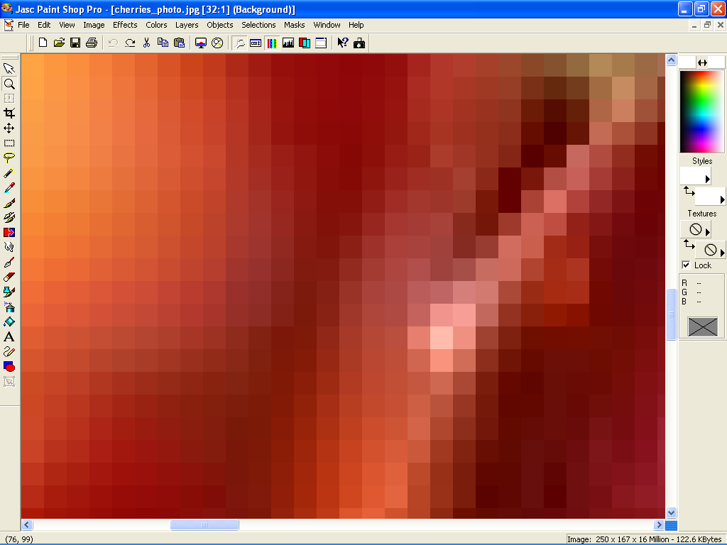
Figure 3-2.
When you magnify an online image, you can see the image’s pixels.
Try This!
With cherries_photo.jpg still open in your graphics program, enlarge the picture by using your graphics program’s Zoom Tool or Magnifying Glass. To further illustrate how pixels work, incrementally decrease the image’s view (or “zoom out”) to a slightly more viewable size, as shown here:
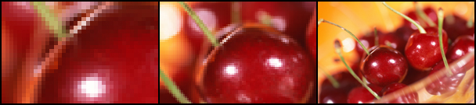
If you zoom out slowly, you can see how the pixels start to blend to create a clear image.
Now that you know about pixels, we can talk a little about palettes. A palette is simply the table of colors used in a graphic. Some Web graphics (namely, graphics saved using the GIF file format, as described in the next section) use a limited collection of colors. You can assign a palette to an image, or you can let your graphics program generate a palette automatically as you create and edit an image. A GIF palette can hold up to 256 colors, but many images use fewer colors than that. For example, looking at Figure 3-3, the cherries graphic uses 8 colors and the hot pepper graphic uses 128 colors. Notice the pictures’ sizes—the cherries graphic is 3 KB (very small), and the hot pepper graphic is 7 KB (almost as small as the cherry GIF graphic).
Lingo: A palette holds the set of colors used in a graphic.
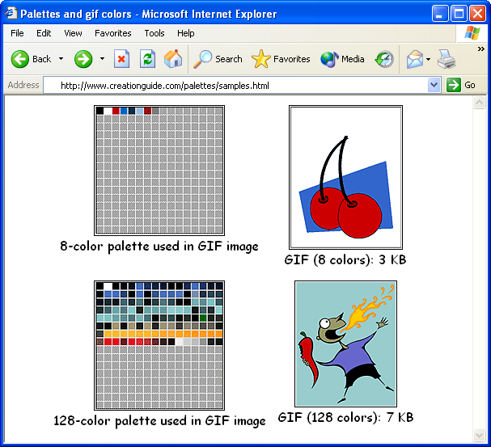
Figure 3-3.
The cherries graphic’s palette contains 8 colors, and the hot pepper graphic’s palette contains 128 colors.
Generally, most graphics applications enable you to view the colors included in a GIF graphic’s palette. Furthermore, you can reduce the size of a GIF image by reducing or limiting the number of colors in the picture’s palette. And, as you probably know, smaller file sizes equate to quicker download times on the Web.
Lingo: In some Web graphics applications and documentation, a palette is also referred to as a color look-up table (CLUT) or simply a color table.
Try This!
In the Lesson03 practice files folder for this course, locate cherries.gif or firebreath.gif and open either graphic in a graphics editing application such as Jasc Paint Shop Pro, Adobe Photoshop, or Microsoft Paint. To display the image’s palette in Paint Shop Pro, select Edit Palette from the Colors menu. In Photoshop, select Mode from the Image menu, and then select Color Table. (We realize that every graphics package has its own menu options; we provide the preceding two commands to give you an idea of the type of command you should look for in your graphics application.)
As we just mentioned, palettes come into play when you use GIF images. We realize we haven’t defined GIFs yet—or any Web-friendly image formats for that matter. Now that you have a feel for the nature of pixels and palettes, however, let’s move on and discuss graphics file formats that you can use on the Web. We’ll talk more about palettes when we discuss GIFs later in this lesson.

Graphics File Formats
As you might recall, in Lesson 1 we said that every graphic on a Web page is stored as a separate file. As a refresher, turn again to Figure 1-4 in Lesson 1. Notice the names of the two image files used in Figure 1-4.
The title bar figure’s file name ends with a .gif file extension (afs_title.gif), and the other figure’s file name ends with a .jpg file extension (4members.jpg). Graphics file extensions work on the same principles as other file formats. For example, if you see a file on your desktop named holiday_gift_list.doc, you know by the .doc extension that the file is probably a Microsoft Word document, and you’ll want to open the document in Word (especially if you suspect that you’re one of the people listed on the holiday gift list!). Similarly, if you see a file on your desktop named bills.xls, you know the .xls indicates a Microsoft Excel document, so you could open the file in Excel (although you might want to avoid files named bills). In relation to Web graphics, your Web pages can include graphics images that use the .gif and .jpeg (or .jpg) file extensions because most popular Web browsers can display GIF and JPEG (pronounced “jay-peg”) files.

GIFs
GIFs are the most widely supported graphics type on the Web (which means that almost all browsers—old, new, and in-between—can display GIF images). GIF stands for Graphics Interchange Format. CompuServe created this format in the 1980s as an efficient means to transmit images across data networks. The GIF format’s main strength is that GIF images are usually small, which means that they download and display quickly.
Lingo: GIF (Graphics Interchange Format) is a graphics file format used to create images for use on the Internet. GIF images can contain up to 256 colors.
As we mentioned earlier in this lesson, GIF images use palettes and support up to 256 colors (which makes them 8-bit graphics). Because GIFs support a limited number of colors, you should use GIFs for flat color areas, logos, line art, icons, cartoonlike illustrations, buttons, horizontal rules, bullets, backgrounds, and other graphical elements that require few colors. Figure 3-4 shows some examples of typical uses of GIF images.

Figure 3-4.
Line art, horizontal rules, buttons, bullets, and graphical text are typical uses of GIF files.
In addition to being palette-reliant, small, and efficient, GIFs perform three
special tricks—interlacing, transparency, and animation.
- Interlaced GIFs Normally, a GIF image appears on screen row by row, from top to bottom of the image, like pulling down a window shade. If you want to, you (as a Web page designer) can change how a GIF downloads onto viewers’ monitors by saving your GIF file as an interlaced GIF file. An interlaced GIF graphic displays on users’ screens as blurred or jagged at first and then gradually becomes clearer. Figure 3-5 shows an interlaced GIF in the midst of downloading. The figure on the left shows the image before it’s fully downloaded, and the figure on the right shows the fully downloaded image.
If you’re using a fast Internet connection, such as a cable modem, you probably won’t see the effects of interlacing.
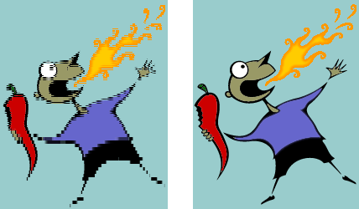
Figure 3-5.
On slower Internet connections, you can see how an interlaced GIF displays blurred before downloading completes.
Interlaced GIFs are good to use when you want to transmit an image’s main idea to readers while they wait for the complete download. The drawback of interlaced GIFs is that they have slightly larger file sizes than conventional (noninterlaced) GIF images. Therefore, for buttons, icons, and small graphics, you’re better off sticking to the conventional GIF file format.
- Transparent GIFs Transparent GIFs (GIFs that use the GIF89a format) enable you to design icons, logos, and other elements that appear to be cut out, thereby allowing the Web page’s background to show through areas of the image. For example, as you can see in the right side of Figure 3-6, the background shows through in the transparent GIF to create the illusion of a nonrectangular image.
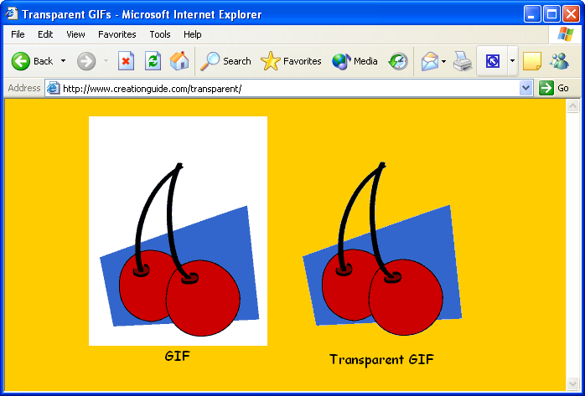
Figure 3-6.
Comparing a standard GIF with a transparent GIF shows how transparency allows a Web page’s background color (or pattern) to show through.
When you create a transparent GIF, you essentially specify a unique color in your image to serve as your transparent color. For example, you could color the background of your picture hot pink and then assign hot pink to be the picture’s transparent color—just make sure hot pink doesn’t show up elsewhere in your image or you’ll create unwanted transparent spots. When a browser encounters the transparent color, the browser doesn’t show any graphics information in the color’s area, which enables the Web page’s background to show through.
If a GIF’s background color matches your Web page’s background color—such as an image with a white background on a Web page with a white background—you automatically achieve the illusion of transparency.
- Animated GIFs The last GIF “trick” involves animation. Using GIF animation tools and graphics editing programs, you can layer GIFs and save the layers in a “stack” to create simple animations. When a browser displays the stacked GIF images, it displays each image one after the other. This technique is similar to the old flip-card “movies” that were popular long before most of us came into existence. Moving icons, rollover buttons, and some banner ads are prime examples of animated GIFs. Figure 3-7 illustrates the theory behind animated GIFs. As you’ll see later in this lesson, you can download free animated GIFs and GIF animation tools from the Web.
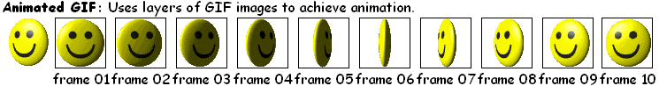
Figure 3-7.
A series of GIF images can display in succession to create animations.
Tip
The Clip Art in Microsoft Office XP includes animated GIFs as well as transparent GIFs that you can use on your Web pages. To identify a Clip Art item that’s an animated GIF, look for a gold star in the lower-right corner of the thumbnail image in the Clip Organizer. To identify a Clip Art item that has a transparent background, look for items that appear to be “cut out” in the Clip Organizer. You can test an image’s transparency by inserting the image into a Word document that has a color background.
“Safe” Colors for the Web
As you know, all computer systems are not created equal. Many people have a heck of a time keeping up with the computer industry’s rapid pace of hardware development. Therefore, when you design Web pages, you should keep in mind that not all people will be able to access your pages if your pages require the latest and greatest display hardware. In fact, approximately 10 percent of all Web surfers are restricted to viewing Web pages in 256 colors (although most new systems display millions of colors, so the 256-color design issue will probably soon be a design consideration of the past). Therefore, for the next couple years, when you design your Web pages and create GIF images, you might consider relying on colors that 256-color monitors can display without a hitch. The universal colors are referred to as the Web-safe or browser-safe colors. If your Web page uses colors other than Web-safe colors, systems that support only 256 colors will resort to dithering the nonstandard colors.
Lingo: Dither refers to the random dot pattern that results when colors are approximated by mixing similar and available colors from a limited palette.
To avoid dither, stick to the 216 Web-safe colors. (The other 40 colors out of the 256 are reserved for the computer system’s use.) To see the Web-safe color palette, open palette216.gif in your graphics program. This file is located in the Lesson03 folder for this course on your hard drive. To see the colors in color chart format, visit www.creationguide.com/colorchart. Graphics editing programs usually provide a Web-safe palette that you can load when working with GIF images.

JPEGs
In addition to GIF graphics, your Web pages will probably include JPEG images. The JPEG image file format was created by and named after the Joint Photographic Experts Group. This image format supports millions of colors, and JPEGs are almost universally supported by browsers. (Technically speaking, JPEGs support 24-bit color, which is also referred to as full color or true color.) Because JPEGs can contain millions of colors, JPEG graphics frequently display photographic images online.
Lingo: JPEG (Joint Photographic Experts Group) is a graphics file format used to display photographic-quality and other high-color images on the Internet. The JPEG file format can support millions of colors.
When you’re working with JPEGs for your Web pages, you can specify whether you want to save your JPEGs as standard or progressive:
- Standard When you save an image as a standard JPEG file, the image loads line by line from the top of the screen down, similar to how GIFs download by default.
- Progressive When you save an image as a progressive JPEG file, the image first appears blurry and then becomes more focused as the image data is downloaded (similar to interlaced GIFs). With fast Internet connection speeds, the progressive rendering might not be readily apparent to viewers; instead, after a delay, the image will seem to “pop up” onto the page. In our experience, progressive JPEGs seem to create smaller file sizes and download slightly quicker than standard JPEG files.
When a JPEG image displays on a system that supports only 8-bit color (256 colors), the browser reduces the colors in the image to the Web palette and some dithering will occur.
Another JPEG configuration parameter that you can use to your advantage is compression. Compression is a process that reduces an image’s file size by throwing out some color information. JPEG compression is called a “lossy” compression scheme because once you compress an image the deleted information is lost. Fortunately, if you’re careful, people viewing the image online can’t easily discern the information loss.
Tip
When increasing a JPEG image’s compression, always save a copy of the original image first. Then, use the Save As command whenever you further compress the file to create a new file. Once an image is compressed using JPEG’s compression scheme, the information that’s removed is lost.
Keep in mind that the more you compress an image, the smaller the image’s file size becomes, but the resulting image won’t be as sharp as a less compressed image. Therefore, you should experiment with various compression settings when configuring JPEG images for your Web pages.
At this point, you should be comfortable with the idea of progressive and compressed JPEG files, but we haven’t yet explained how to configure these types of settings for a JPEG image. Fortunately, most image editing programs make specifying JPEG file parameters fairly easy. To access JPEG file settings in Paint Shop Pro, follow these steps:
1 Open your JPEG image in Paint Shop Pro. (Feel free to practice with any of the fruit.jpg images provided for this course and located in the Lesson03 folder on your hard drive.)
2 Choose Save As from the File menu to display the Save As dialog box.
3 Enter a new filename, and then click Options to access the Save Options dialog box, shown in Figure 3-8.
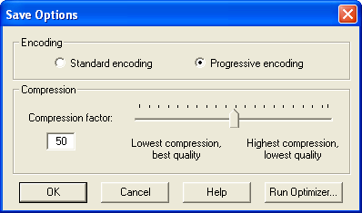
Figure 3-8.
The Save Options dialog box enables you to configure JPEG compression and render settings in Paint Shop Pro.
4 Specify an encoding option (Standard or Progressive), select a compression setting, click OK, and then click Save.
To configure JPEG settings in Photoshop, follow these steps:
1 Open your JPEG image in Photoshop.
2 Choose Save from the File menu.
3 Enter a file name, and click Save. The JPEG Options dialog box opens. Specify compression settings by moving the Quality slider in the JPEG Options dialog box, and then click OK.

PNG
The third (and final) graphic type we address in this lesson is the PNG file format. PNG (pronounced “ping”) stands for Portable Network Graphics. Similar to GIFs, PNG files are small, they load quickly, and they support transparency. PNG files transmit faster than GIFs, but only the newer browsers support them.
Lingo: PNG (Portable Network Graphics) is a graphics file format designed to replace GIF images on the Internet.
Initially, the PNG file format was devised because Unisys, the makers of the GIF compression algorithm, decided to enforce the patents for that algorithm—meaning that software vendors had to pay to use it. But you really don’t need to know the details about the PNG vs. GIF debate. Just know that newer major browsers (including Microsoft Internet Explorer 5 and later) can display PNG images, but most Web designers don’t use PNGs in deference to users who surf the Web with older or less technologically advanced browsers. At this point, your Web pages probably shouldn’t use PNGs either.
Note
Internet Explorer for Microsoft Windows began to incorporate some PNG support in 1997 and began providing PNG support in Macintosh versions of Internet Explorer in 2000. Therefore, the PNG file format is slowly starting to catch on as developers watch the percentage of users who have access to the most up-to-date or most technologically advanced browsers. From a developer’s perspective, there’s currently no reason to risk losing viewers by using a PNG file format when the GIF file format is readily available, just as easy to use, and widely recognized in almost all browsers (regardless of version).

Size Matters
The last major “technical” Web graphics consideration that we cover in this lesson is file size, which is directly related to download speeds. As a Web surfer, you’ve probably caught yourself drumming your mouse impatiently while waiting for pages that take longer than 10 seconds to display (or, even more likely, clicking away before the slow page ever fully displays). As a Web designer, you need to hold on to that impatient feeling. When you design Web pages and use Web art, you should always keep one eye on your design and another eye on the user’s perspective. (That almost sounds painful!)
When you use Web art, you can take advantage of a few techniques that will help keep your file sizes manageable. We already covered a few key topics earlier in this lesson that can help to reduce file sizes and speed download times, including these:
- Avoid dither in GIF images by using Web-safe colors whenever possible, especially in large, flat color areas. (Just think—before reading this lesson, that sentence wouldn’t have made a bit of sense to you.)
- Configure JPEG images to render progressively.
- Compress JPEG images to reduce file sizes.
In addition to using the three preceding graphics file techniques, you can control download speeds by resizing your images, cropping images, and using thumbnails. We briefly describe each technique in the following sections. Please keep in mind that the actual mechanics of accomplishing certain tasks vary among graphics editing tools.

Resizing Graphics
One of the best ways to conserve download time is to physically resize your images in a graphics editor. Note that we’re talking about resizing the image, not simply changing your view. Zooming in and out changes your view of an image, but it doesn’t affect the file’s actual size or dimensions. Try to size your images to the approximate size you want to display them on your Web page. Figure 3-9 shows the Resize dialog box you use in Paint Shop Pro to resize an image. To access the Resize dialog box, open the image and then select Resize from the Image menu.
Usually, you’ll want to ensure that the Maintain Aspect Ratio option (or its equivalent in your graphics program) is selected when you resize graphics; otherwise, you could distort your images.
Keep in mind that smaller images result in smaller file sizes, which result in quicker download times.
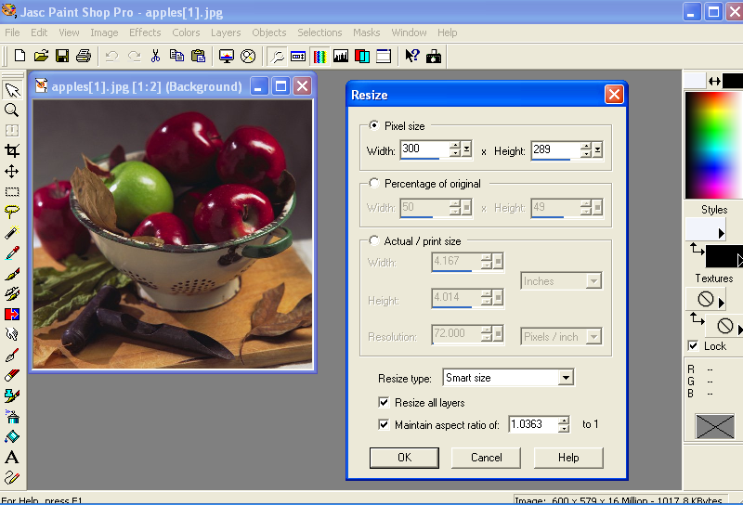
Figure 3-9.
Resizing images to actual sizes in Paint Shop Pro helps to minimize download times.
Try This!
To experiment with resizing images, open a JPEG image in your graphics editor and then change the image’s width or height setting. Use the apples.jpg image in the Lesson03 folder for this course on your hard drive. Save the JPEG image, and then repeat the process a number of times using various measurements, renaming each version with a unique, meaningful name (such as apples400w.jpg for a picture that’s resized to 400 pixels wide). After you’ve created a few variously sized images, view the images locally in your browser window—that is, either navigate to the figures by using your browser’s
Address toolbar or drag the JPEG images’ file name icons into your browser window.
Sizing Images Just Right—A Quick Trick
When you first start to design Web pages, you might not know what sizes your graphics should be. To help you resize a graphic to the size you want it to appear on your Web page, you can use a Web editing program, such as Microsoft FrontPage.
To determine the optimal size for a Web graphic, follow these steps:
1 Insert the graphic into a blank Web page in FrontPage (for example) and resize the picture by dragging the image’s selection
handles.
2 After the image is sized to your liking, display the image’s properties (in FrontPage, right-click the graphic and select Picture Properties on the pop-up menu), and note (and then write down) the image’s height and width parameters.
3 Reopen the image in your graphic’s editing program and then resize the graphic by entering the numbers you copied from FrontPage (or other Web editing program) into the appropriate dialog box. For instance, in Paint Shop Pro, you open the Resize dialog box by choosing Resize on the Image menu, and, in MS Paint, you open the Attributes dialog box by choosing Attributes on the Image menu.

Cropping Images
In addition to resizing an image, you can crop an image to reduce its size. When you crop an image, you cut out the portion of the image that you don’t want to use. Cropping is frequently used to remove any unwanted or unneeded portions of your photograph. For example, you might want to crop the apples.jpg image shown in Figure 3-9 to show a closeup of the green apple amidst the red apples in the colander. Figure 3-10 shows crop lines (the dashed lines that surround the portion of the image you want to retain) in the apples.jpg image, which is 50 KB, and the result of cropping apples.jpg. The cropped version is only 6 KB.
Lingo: Cropping refers to cutting off a part of an image, such as unnecessary portions of a graphic.
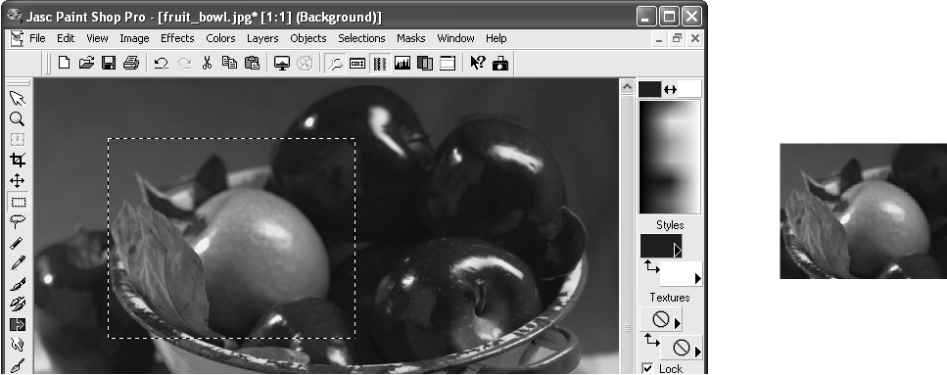Figure 3-10.
The crop marks indicate the portion of an image that will be used as a Web graphic. The cropped image contains only the information you bounded by the crop marks.
Try This!
To crop an image, follow these steps:
1 Open an image in your graphics editor.
2 Click the selection tool (which usually looks like a dashed rectangle or square in the application’s toolbar).
3 Click and drag in your image to outline the area of the image you want to retain. (If you outline the wrong area, press Esc and try again.)
4 After you have an area selected, choose Crop To Selection (in Paint Shop Pro) or Crop (in Photoshop) from the Image menu, or select a similar command in your graphics editing program.

Using Thumbnails
After you master the art of resizing and cropping images, you’re ready to use thumbnails. A thumbnail is a small picture that links to a larger image. (The larger image is usually the same as the thumbnail, but we’ve seen some creative uses of thumbnails in our day.) When you use thumbnails, viewers can choose to view the small image and be done with it or they can click the thumbnail to view the larger image. In other words, when you use thumbnails, you grant viewers the option to download large images if they’re willing to endure the longer download times.
Lingo: A thumbnail is a miniature version or small portion of a graphic. Frequently, on Web pages, thumbnail graphics are hyperlinked to larger versions of the graphic.
The trick to using thumbnails is to create two graphics with different names. Usually, you use the same image for both graphics, and you make one image small with a quick download time and the other image (while optimized to the best of your ability, of course) larger with a longer download time. Then you display the small image on your Web page, and you link the small image to the larger image. Figure 3-11 shows two thumbnails. The left thumbnail displays the entire linked image, and the right thumbnail shows a cropped portion of the linked graphic. Figure 3-11 also shows the larger graphic that’s linked to the thumbnails. By clicking either thumbnail shown in Figure 3-11, you can open a window displaying a large view of the apples.jpg image.
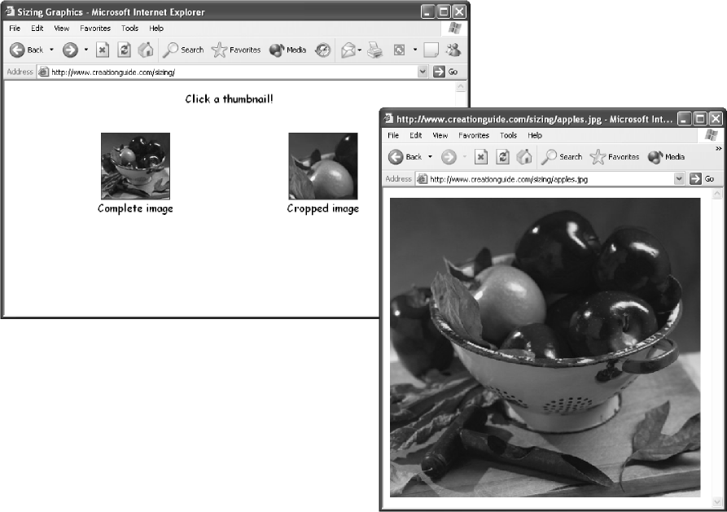
Figure 3-11.
Both thumbnails of the apples link to a sizable rendition of the apples.jpg
image.

Using Photographs
You probably have at least one boxful of prime Web art resources lying around your home—photographs. You can use new and old photographs to add art to your Web pages. The trick is getting the hard-copy picture turned into information your computer can understand. To do that, you can use any of the following options:
- Scanners Basically, a scanner takes a picture of your photograph and saves the picture information as a file on your computer. After you have a scanned picture, you can manipulate the file just as you manipulate other graphics files. You can use any flatbed scanner on the market to create Web graphics. You don’t need to get a top-of-the-line machine, either. We use moderately priced scanners to scan most of our pictures. If you don’t have a scanner and you aren’t planning to purchase one, you can pay others to scan your pictures for you. For example, many copy centers also scan pictures for a small fee.
- Film developers and online photo services The next time you drop off a roll of film for development, check out the services that the film developer offers. Many film developers can develop your film on CD, post your pictures to the Web, send your pictures through e-mail, create quality prints from digital pictures, and provide numerous other digitizing services.
- Digital cameras A third option for obtaining photographic images is to use a digital camera. Digital cameras enable you to snap a photo and then instantly send the picture into your computer. If you’re thinking about buying a digital camera, here are a few issues to consider:
- Cost Know your budget before you shop; most people don’t need a top-of-the-line digital camera to get the job done. But, with that said, don’t settle for “last year’s” model just for the sake of saving a few bucks. Manufacturers are responding to the growing demand for digital cameras; thus, they’re producing more cameras (which lowers per-unit cost) and improving the cameras’ features. So buying a new camera at a camera shop can often result in a better value than buying an older model at a discount store.
- Features Digital camera features run the gamut, but if you’re a beginner, make sure your camera has automatic and manual features. You’ll probably want to use the automatic features at first to get the hang of digital photography. Then, after you’re comfortable using your camera, you can start to experiment with the manual settings. Also, if you’re buying the camera only for Web pictures, you can get away with a 1-megapixel (or lower) camera, but if you want to be able to use your pictures online and in print, consider getting at least a 1-megapixel (preferably at least a 2-megapixel or 3-megapixel, if you can swing it) camera. Higher megapixel cameras create better quality pictures and enable you to print quality pictures at sizes larger than the standard snapshot size.
Lingo: A megapixel refers to one million pixels, and it’s a term used in reference to the resolution of graphics devices, such as scanners, digital cameras, and monitors.
Finally, remember that digital cameras are basically handheld computers. If you’re going to be taking pictures under all sorts of circumstances and conditions, make sure you choose a camera that’s built to withstand the torment. If you’re planning for some truly extreme photography, consider checking out some of the “weatherproof” models.
- File Format Last but not least, a major point to consider when purchasing a camera is to determine how easy it’s going to be for you to get the pictures out of the camera and into your computer. Will you need to use cables? Can you use infrared ports? Does the camera store the pictures on a CD? Make sure you know how the camera transfers pictures and that you’re happy with the method before you buy.
Finally, as the last bit of advice in this lesson, regardless of how and where you obtain your Web page graphics, remember to optimize your images and save them as GIF and JPEG files. Make sure your images’ file sizes are as small as possible without compromising quality. Furthermore, store your images in a central location on your hard disk, and don’t forget to give every graphic a unique and meaningful name.
Key Points
- Online graphics are made up of pixels.
- Most browsers support GIF and JPEG images.
- GIF images are small, limited to a 256-color palette, and quick to download.
- GIFs can be interlaced, transparent, or animated.
- JPEG images can contain millions of colors and are frequently used to display photographs.
- By default, GIFs and JPEGs display line by line from the top down, but you can change the default by creating interlaced GIFs or progressive JPEGs.
- JPEG’s compression scheme enables you to reduce the size of JPEG images, but the compression is “lossy,” so compress with care (remember, the more you compress, the lower your picture quality).
- Size graphics in your graphics editing program to help make your Web page’s graphics files as small as possible.
- Cropping images reduces file sizes.
- Consider using thumbnails to link to large online graphics.
- Graphic Web page elements include photographs, illustrations, buttons, logos, icons, bullets, horizontal rules, graphical text, and backgrounds.
- You can acquire Web graphics from clip art collections on CD-ROMs, online freeware, online art vendors, and graphic designers.
- You can create custom art by using various software programs as well as by scanning hand-drawn art.
- Photographs can be converted to image files by means of scanners, film developers, and digital cameras.

