Stockpiling the Goods
Lesson 4

After completing this lesson, you will be able to:
- Comprehend what you will need to display your Web pages online.
- Find server space on the Web for your web site.
- Choose software for creating, editing, and manipulating Web pages.
- Test your Web pages on various browsers.
When you create Web pages, you need to have at least a couple (probably more) Web page creation tools on hand. Mind you, we’re not talking about hardware—we’re sure you’ve realized the importance of having a computer as well as possibly having access to a scanner, printer, and camera (digital or standard). In this lesson, our focus falls on the array of software that you can use to create, edit, and manipulate Web pages. As we show you in the next few lessons, you can create, edit, and publish Web pages by using a number of software applications and tools, and we find that we frequently mix and match our weapons of choice. Likewise, knowing your choices will help you create a working environment that best suits your needs and personal style.
To get started, let’s look at two of the most basic “tools” you’ll need during your Web creation endeavors—an Internet connection and server space.

Internet Connectivity and Server Space
No matter how astounding your Web page, it will live in virtual anonymity if you can’t connect to the Internet and transfer the page’s files to a server. (Recall from Lesson 1 that a server is a powerful computer that is connected to the Internet’s backbone data lines, stores Web page files, and responds to users’ requests to view the stored Web pages.) You must be connected to the Internet or have access to an Internet connection before you can achieve an online presence. Granted, you can create most Web pages without an Internet connection, but you’ll be dead in the water when it comes time to publish your pages online.
Tip
If you use your computer to surf the Web, rest assured—you have an Internet connection. Using a standard dial-up Internet connection, you can copy Web page files from your computer onto a server that’s connected to the Internet.
In addition to the basic prerequisite of Internet connectivity, you might need to purchase some space on a server for your Web files. We say might because in a lot of cases server space is freely given away or provided in addition to other paid services. For example, your Internet service provider (ISP) might give you 30 MB (give or take 20 MB) of free server space in addition to your Internet connection. The notion of free server space catches many people by surprise—but it’s out there, and it’s a thriving online practice. Not surprisingly, though, you’ll find benefits in purchasing server space as well as using free space.

Free Space Online
It’s true. You can create and display a Web site at this very moment for free, as in $0. All you need to spend is a little time and creative effort. You don’t need any additional software or fee-based Internet accounts—nothing but your text and a few pictures, if you want to include them. Of course, you face a couple of minor limitations when you take this approach (such as a long Web address and possibly limited page-layout options), but depending on your ultimate goal, the limitations might not affect you all that much. So consider yourself informed—free Web space is readily available. As we mentioned, we’ve run into more than a few people who were sincerely amazed to discover this fact.
The number-one way to become the proud owner of a free Web page is to turn to an online group or community. One of the benefits of joining an online group or community (other than the “free” factor) is that most online groups and communities enable you to create Web pages by providing templates or wizards that you can use.
Lingo: An online group or community is a virtual area on the Web where people with similar interests gather and share information.
Among the many free online groups and communities, three popular ones come quickly to mind:
Most companies who sponsor online groups and communities make their money through advertising and selling upgrades and add-on features and services.
- MSN Web Groups (http://groups.msn.com)
- Lycos Tripod (http://www.tripod.lycos.com)
- Yahoo! GeoCities (http://geocities.yahoo.com)
The biggest drawbacks of online groups and communities are that your Web address is usually fairly long, you generally have a limited amount of server space, your choices of page layouts are usually somewhat limited or controlled, you might have to tolerate pop-up advertisements each time you visit your page, and, if you don’t want to use a group’s or community’s templates, customizing your page can sometimes be tricky.
Similar to online groups and communities, another free way to get on the Web is to create site-specific pages. During your surfing, you might find that some Web sites offer free Web space to registered members. For example, you can create an About Me page on eBay (an online auction site located at www.ebay.com) if you’re a registered site participant. The purpose of eBay’s About Me pages is to introduce eBay users to other people who visit eBay.
Yet another type of “free” online Web space—which technically isn’t free—is Web space that you get from your ISP. Because you most likely cut a check to your ISP on a regular basis (or at least record an automatic payment), we can’t exactly label ISP server space as free; it’s more like prepaid, available space. When you signed up with your current ISP (assuming you have one), they probably informed you in an excited voice or a sentence ending in an exclamation point that you get “X megabytes of free server space!” At the time, you probably didn’t know what that meant, so you might have just thought “Oh, that’s nice” and moved on to the next detail. Now that you’re thinking about creating a Web page, you should revisit the “free server space” component of your ISP agreement. Most likely, you’ll find that you have anywhere from 10 MB to 50 MB of server space at your disposal.
Try This!
To find free Web space, type free Web space in any search engine—you’ll be rewarded with a slew of sites offering to host your page. Or check out the 100 Best Free Web Services Web site at www.100best-free-web-space.com. This site provides reviews and site rankings, which makes it a great resource for locating and reviewing free Web hosting services.
The upside of ISP server space is that you’re already paying for it, so you might as well use it. The downside is that you’ll probably have to live with a cumbersome Web address, similar to online group and community Web addresses. For example, a couple of our ISPs (we have several) grant “free” server space, but the Web addresses’ formats are www.domain.com/~username/filename.html and members.domain.net/ username/filename.html. For most people, the preceding naming formats are a little long and not easy to remember. Another advantage of ISP server space over online groups and communities is that you generally have greater freedom regarding how you create and display your pages (which could be a disadvantage if you prefer to work with the preconfigured templates that seem to be standard fare on many online community sites).
All in all, the main point about free online sites is that Web space is instantly available to you. And as long as you don’t mind a longish home page Web address, some design limitations, and possibly pop-up advertisements, then free space is a great way to initiate yourself to the Web.

Purchasing Server Space
In contrast to using free Web space, you can shell out a few clams for a Web page that uses the Web address of your choice as long as someone hasn’t beaten you to the name. When you take this route, you have the following two main considerations: choosing and registering a Web address name (such as creationguide.com), and signing up with a provider that will host (or store) your Web pages (unless you’re going to run your own server—but that topic is best saved for more advanced books). Let’s look at how to register a Web address and obtain a hosting service.

Registering a Web Address
Before we go any further, let’s nail down some simple vocabulary. Namely, instead of Web address, we really should say domain name. Loosely speaking (very loosely), a domain name is a Web address. As you may or may not know, all Web addresses are actually groups of numbers (called Internet Protocol, or IP, numbers) that serve as Internet addresses. Being a human, you probably also know that, for most people, remembering a meaningful name is much easier than remembering a series of numbers divided by dots. Therefore, the Domain Name System (DNS) came into existence. Fundamentally, DNS simply assigns textual names (such as creationguide.com) to numbered Internet addresses (such as 207.155.248.5). Thus, to appear as if you know what you’re doing, you should use the term domain name in place of Web address.
When you’re ready to obtain your own domain name, you can pick a domain name (such as creationguide.com—although we can tell you right now that the name is already taken), see whether it’s available, and, if it is, register the domain name as your very own for a nominal annual fee. By nominal, we mean somewhere around the price of a good meal or slightly more per year.
Choosing and registering a Web domain name is straightforward after you access a legitimate registration site. Fortunately, InterNIC (which is under the umbrella of the U.S. Department of Commerce) hosts a Web page that lists all the acceptable domain name registration Web sites. Many hosting sites also offer name registration services (as we discuss in the next section). To see the official list of domain name registrars, visit www.internic.net/alpha.html.
While visiting the InterNIC site, check a few registration sites to review their pricing schedules and policies (or visit www.creationguide.com/resources, and we’ll link you to a couple of our favorite hosting services). When you’ve found a site you like, you can generally type your proposed domain name in a text box. Then, the site will inform you whether the name is available. If it is, you work out a payment arrangement (usually by credit card) and the site registers your domain with InterNIC. Your next step is to find an ISP that will host your domain name and Web pages.

Finding Space for Your Domain
If you don’t run your own server—and most people don’t—your next step is to find an ISP or hosting service that’s willing to provide a home for your domain name, that is, if you didn’t complete this step during your domain registration process (as described in the preceding section). You can find numerous hosting services online—type Web hosting in any search engine and you can have a field day researching various Web hosting providers. Or better yet, visit http://hostindex.com, a comprehensive site devoted to providing information about numerous aspects of hosting services, including a monthly list of the top 25 hosts. Finally, as mentioned a moment ago, you can visit www.creationguide.com/resources for links to hosting services and domain name registrars. Regardless of how you conduct your research into finding server space, remember to check a few key facts, including fees, network configuration, Microsoft FrontPage Server Extensions (if you’re using FrontPage features), and reliability. On average, basic Web hosting services charge a nominal monthly fee along with a one-time setup fee (see each hosting service’s Web site for specific prices). Unless the rates seem outrageous, don’t let the fees rule your decision. Before signing on with a Web hosting service, find out how the host handles the following features:
- Bandwidth Most hosting companies are connected to the Internet by T1 and T3 lines; anything less and you might as well choose another company. Basically, a T1 line can carry up to 1.5 megabits of data per second, and a T3 line can carry 45 megabits per second. Thus, a T3 connection provides much more bandwidth and speed. In addition to Internet connections, you should check to see how many clients are hosted on each machine. If a hosting service overloads its machines, performance will be slow despite high-speed connection lines.
- Space When you sign up for Web hosting services, ISPs and hosting companies assign you a certain amount of server space (just as your computer has a certain amount of disk space that you can use to store files). Most ISPs and hosting services offer more space on their servers than you’ll need (at least initially). However, you should get at least 10 MB of server space. Most hosts provide at least 25 MB.
- Support Technical support is an important element when you’re choosing a Web hosting company—if you run into problems, you’ll want to be able to turn to someone who can help. The most basic support consideration you should look for is the number of hours per day the technical support staff is available. Many sites offer 24×7 support, so look for round-the-clock support when you’re weeding out potential companies. Round-the-clock support is important because you’ll most likely be updating your pages during off hours, so off hours are the times you’ll probably need support the most. Also see whether the site publishes its support response rate. Finally, check to see whether you can readily identify the avenues of support the company offers, including phone numbers (look for 1-800 numbers), fax numbers, e-mail addresses, online informational reports and FAQs, and a snail mail address.
- Extras You might want to check to see what “extras” each company offers to entice customers. For example, most hosting services provide e-mail accounts you can use with your domain name (such as mm@creationguide.com or jc@creationguide.com). You can generally set up anywhere from 5 to 20 e-mail accounts with a single Web hosting agreement. Other features you might check out include the cost of adding space to your site, in case your site grows larger than your originally allotted space; the cost of upping your traffic quota, in case more people visit your site than you anticipated; whether FrontPage Server Extensions (if you’re using FrontPage) and streaming media are supported; and available add-on services, such as adding chat groups and site search features.
Now that you’ve considered your domain name, hosting services, and basic Web space options, we’re ready to move closer to home and talk about desktop applications. In the next section, we take a look at software applications you can use on your system to create, edit, and publish Web pages and Web page elements.

Web Page Creation Tools
In this section, we outline the types of tools you might need to create Web pages, name a few applications we find helpful, and point you down the path of finding other utilities that best suit your needs. As you might imagine, because of the Web’s booming popularity, lots of software vendors have busied themselves by creating Web page creation programs. In this lesson we introduce many tools (but nowhere near all the available utilities), and in the following lessons we show you how to use some of them to create complete Web sites. Ultimately, though, we leave you with the responsibility of choosing the software packages that feel most comfortable for you.
To simplify our approach in this lesson, we’ve divided basic Web page development tools into the following three main categories:
- Text editors and HTML editors
- Graphics applications
- FTP (File Transfer Protocol) utilities

Text Editors and HTML Editors
Overwhelmingly, when you create Web pages, you’ll be spending the greatest amount of time interacting with a text editor or an HTML editor. You use editors to create HTML files that contain display instructions for Web browsers and provide content for your Web pages. When you use an editor, you have the option of working with basic editors, in which you enter HTML code manually, or using more advanced WYSIWYG (what you see is what you get—pronounced wizzy-wig) editors, which create HTML code for you while you type text, insert images, and drag elements around in a Web page layout view. Finally, and not surprisingly, some applications keep a foot in both camps by qualifying as an upscale basic editor but not quite an advanced WYSIWYG editing application—we take a quick look at all three types of editors in the next few pages.
Tip
You can download many of the applications (or demos of the applications) mentioned in this lesson from shareware sites such as www.tucows.com, www.shareware.com, or www.download.com. Shareware can be best summed up as “try before you buy.” When you download a shareware program, you try it out for a while for free. If you like it, you send the developer the requested fee. Too bad all merchandising isn’t so user friendly!

Basic Text and HTML Editors
When you use a basic text editor, you type in all the HTML commands and your Web page’s text into a blank document. The most basic of the basic text editors is the Notepad application that comes with the Microsoft Windows operating system. Figure 4-1 shows Notepad containing some HTML text.
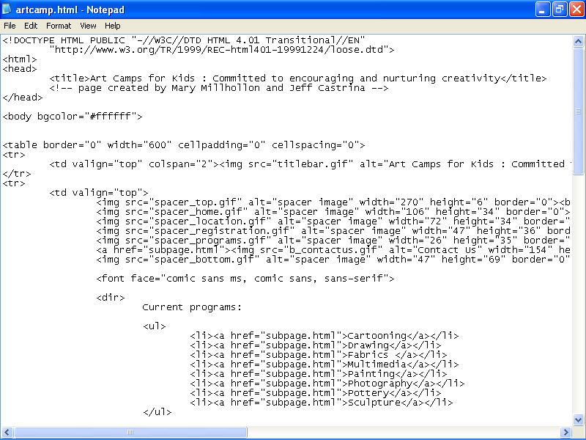
Figure 4-1.
Many Web designers turn to Notepad when hand-coding HTML documents.
You might wonder why Web designers would opt to manually code their Web pages. The answer varies, but, for the most part, Web designers hand-code their Web pages for some of the following reasons:
- Control Hand-coding enables you to use the codes you want instead of the codes a WYSIWYG editor inserts. For example, you might want to use two blank line breaks, but a WYSIWYG editor might insert a paragraph marker. Furthermore, some WYSIWIG editors create “messy” code; hand-coding can keep code orderly and easy-to-read, with code alignment set to the designer’s preferences.
- Quick fixes Knowing how to manually create and modify HTML code enables Web designers to make quick changes to a Web page, regardless of how the Web page was initially created. For instance, if you want to update your site’s copyright date, you can update and save the change in a text editor in less time than it would take to simply open the page in a WYSIWYG editor.
- Code cleanup Many advanced HTML editors (as discussed later in this lesson) add extra code to documents. If you know how to create and edit standard HTML code, you can clean out extra code and reduce the size of your HTML files. And remember—on the Web, size matters, and the smaller the better. Furthermore, because HTML editors are only designed by humans, at times HTML editors might miscode your page. In those instances, you can save yourself lots of time and aggravation by changing the HTML directly instead of hunting down the proper dialog box setting in the HTML editor.
- Fine-tuning Another habit of advanced HTML editors is that they sometimes use HTML tags that not all browsers support. You can use text editors to modify HTML code so that it conforms to the capabilities of most browsers.
Of course, learning HTML is a prerequisite to creating your pages in a text editor. In Lesson 6, we walk you through the process of using HTML to create a Web page to give you an idea of HTML’s form. (Don’t worry—you can do it.) That lesson is just an introduction, however. You’ll need to access additional resources if you really want to get serious about HTML. If you’re interested in learning HTML or having an HTML reference nearby, you’ll find that a generous collection of HTML books line the shelves at your local bookstore. You can also find pages and pages of helpful information online. (We’ve also listed some HTML references at the end of Lesson 6.)
Text editors can range from barely offering you a hand to coming fully equipped with customized HTML-specific features. To help illustrate the range, we’ve provided short descriptions of some of the most popular text editors in use today:
- BBEdit (www.barebones.com/products/bbedit.html) This HTML editor from Bare Bones Software is popular among Macintosh Web developers. BBEdit enables you to edit, search, transform, and manipulate text. Like the other HTML editors, BBEdit provides an array of general-purpose features as well as many features specifically developed to meet the needs of HTML authors.
- HomeSite (www.macromedia.com/software/homesite) Macromedia HomeSite is a popular code-only HTML design tool used by many professional Web developers. This text editor includes HTML-specific features to help you create effective, clean HTML pages. For example, it includes an HTML Tag Inspector, split-window editing, an image map utility, and more. You can download a 30-day trial version to test the product.
- Notepad Notepad comes with the Microsoft Windows operating system and is about as bare bones as it comes when talking about text editors. Beware, though: if you’re working on a very long document, you won’t be able to use Notepad. For longer documents, you’ll have to use WordPad (described later in this list) instead.
- NoteTab (www.notetab.com) The NoteTab text editor, by Fookes Software, is Notepad on steroids. This program includes a number of features that can simplify your job of hand-coding Web pages. For instance, you can display HTML utilities along the left side of the window pane in the Clip Bar. Then, you can insert HTML code by double-clicking menu items, including clicking the New Web Page menu item to insert the basic code structure for an entire HTML document. One drawback, which is typical of many text editors, is that the free trial program only supports one level of Undo; if you want to undo a number of actions, you’ll have restore the information manually.
- TextPad (www.textpad.com) TextPad, created by Helios Software Solutions, serves as yet another beefed up version of Notepad. In TextPad, you can view an HTML tag menu while you work as well as keep tabs on the documents you’re currently working on. TextPad supports multiple Undo actions, which can come in handy when you’re playing with HTML.
- UltraEdit (www.ultraedit.com) IDM Computer Solutions provides UltraEdit to serve as a text-editing package that you can use on a trial basis for 45 days. After you download and install the application, click About UltraEdit on the Help menu and then close the Help window to activate the program. Although this application is designed for somewhat advanced users (such as programmers), it includes features that you might find handy. For instance, you can easily preview your pages in your browser and use the accompanying dictionary to spell check your documents.
- WordPad WordPad is a step up from Notepad. If you’re running Windows, you can open WordPad by clicking Start, pointing to Programs and then Accessories, and then clicking WordPad. WordPad offers more word-processing features than Notepad, and it supports longer documents. Figure 4-2 shows an HTML document in
WordPad.
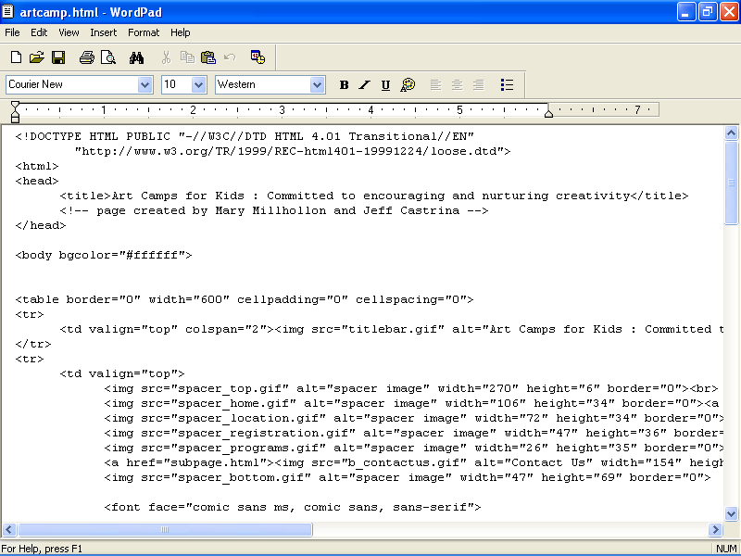
Figure 4-2.
WordPad serves as a good text editor when the document you’re working on is too long for Notepad to handle.
Try This!
Display any Web page of your choice in your browser, and then click Source (or View Source) on your browser’s View menu. A Notepad document opens that displays a text version of the Web page’s HTML code.

Midrange Text and HTML Editors
The next level of HTML editors starts to enter the realm of WYSIWYG. We could call midrange text editors WYSIWYG-lite applications because the applications offer text editor features along with a limited amount of advanced HTML editor capabilities. Because most applications are either text editors or full-fledged HTML editors, we recommend just one main application in this category—Microsoft Word version 2002.
Similar to Word version 2002, other Office XP (version 2002) programs—such as Microsoft Excel and Microsoft PowerPoint—also let you save your documents as Web pages.
Word 2002 enables you to use a familiar word processing interface to create HTML documents through the Save As command. When you save a Word document as a Web page, Word automatically creates the HTML source code for the document. Figure 4-3 shows an HTML document in Page Layout view as well as in the HTML Source view.
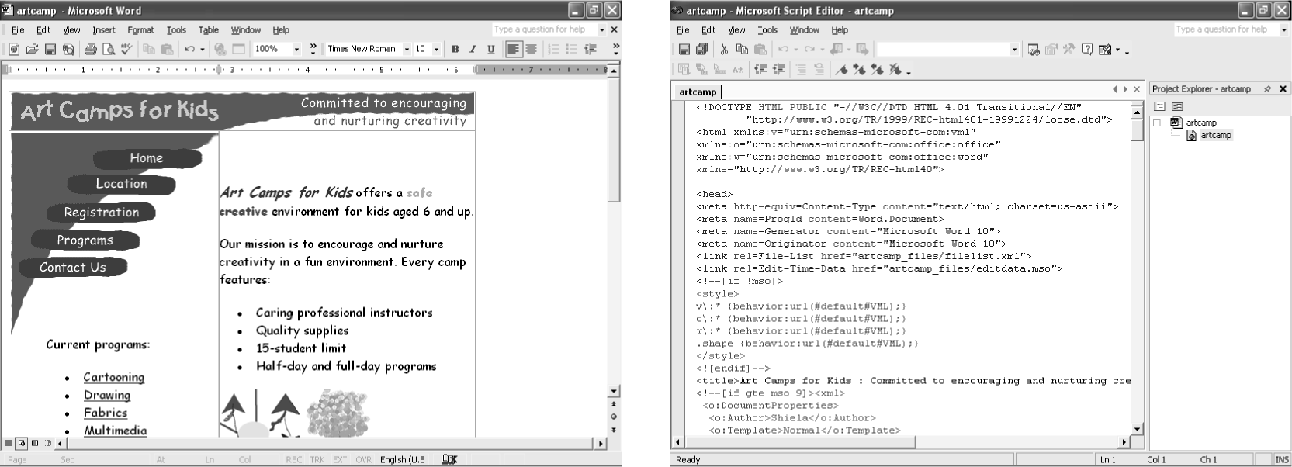
Figure 4-3.
Word 2002 offers a Web Layout View as well as the HTML Source View.

Advanced HTML Editors
The third group of HTML editors includes the advanced applications that enable you to create and edit Web pages by using graphical interfaces. In most advanced editors, you can view and edit the HTML source code directly as well as work in the WYSIWYG interface. Furthermore, most advanced editors provide a preview feature, which enables you to view how a Web page will display online before you view the page in your browser. Web-specific features are frequently incorporated into advanced HTML editors as well. (We know that last bit sounds a little vague, but when we create a Web page in FrontPage in Lesson 7, we introduce you to a few high-end Web-specific tools so you’ll know what we mean.) Popular advanced HTML editors are well documented online, so instead of wasting page space here summarizing online statistics, we’ve provided pertinent URLs for the Web sites that offer the applications appearing in our short list. Although other editors are readily available, these six are some of the most popular programs. (Check each product’s Web site address to assist you in comparing features and prices.)
- Adobe GoLive (www.adobe.com/products/golive/main.html)
- CoffeeCup HTML Editor (coffeecup.com/editor)
- HotDog Professional (www.sausage.com/professional/overview.html)
- HoTMetaL Pro (www.hotmetalpro.com)
- Macromedia Dreamweaver (www.macromedia.com/software/dreamweaver)
- Microsoft FrontPage 2002 (www.microsoft.com/frontpage); also comes with the Microsoft Office 2000 XP Developer suite
- NetObjects Fusion MX (www.netobjects.com/products/html/nfmx.html)
Note
In addition to HotDog Professional, Sausage Software offers a WYSIWYG HTML editor for beginners, called HotDog PageWiz, and an HTML editor for kids ages six and up, called HotDog Junior. Surf around the Sausage Software home page to find other useful Web page creation utilities. After all, if you ask us, any company named Sausage Software that offers HTML editors named HotDog deserves a little extra attention.
Among the preceding applications, Dreamweaver is probably the most popular (yet most challenging to learn) Web editor among design professionals for a number of reasons, including the fact that it maintains hand-written code, enables users to preview pages in various browsers, and automatically checks for browser conflicts. On the other hand, FrontPage (shown in Figure 4-4) is the easiest advanced HTML editor for beginners to learn and provides nice clean HTML code. Furthermore, FrontPage is popular with the business community. As we mentioned, you’ll get a feel for creating Web pages in FrontPage in Lesson 7.
Note
Keep in mind that your Web page creation environment doesn’t have to be an either/or kind of setup. At times, we find it’s quicker to use an advanced WYSIWYG application (especially when resizing tables), but at other times a quick edit in Notepad serves us best.
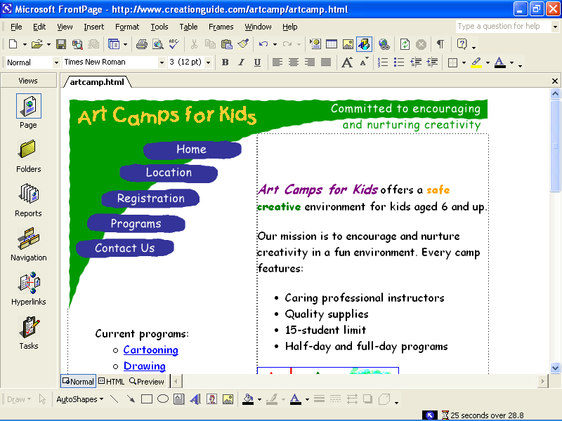
Figure 4-4.
Microsoft FrontPage is a popular high-end Web development program that’s fairly easy to learn.

Graphics Applications
When it comes to Web page development, graphics applications come in a strong second behind the all-important text or HTML editor. After all, most pages use graphics, and you’ll want to either create or tweak the graphics you use on your Web pages. Therefore, you’ll need to have a graphics package installed on your system. Our personal favorites (or at least the programs we seem to use most frequently) are Jasc Paint Shop Pro and Adobe Photoshop—both appear in the graphics application list that you’re about to run into after the next paragraph.
Regardless of your graphics package, the five main skills you’ll need to acquire when using a graphics program are cropping, cutting, resizing, recoloring, and saving as a different file format. So check your application’s help files to brush up on your technique. Now, here are five popular graphics programs along with their Web addresses (we recommend that you visit the listed Web sites for product details and pricing):
- Fireworks (www.macromedia.com/software/fireworks) This application is easy to use and especially convenient when you need to create buttons and other basic Web site graphics. Macromedia developed Fireworks specifically for creating Web graphics.
- LView Pro (www.lview.com/index1024.htm) LView Pro is a popular shareware graphics program. It includes typical graphic features as well as Web page utilities, such as a tool to create online photo gallery pages.
- Paint Microsoft Paint is a graphics program that comes with Windows. Paint is a scaled-down graphics package compared to other graphics programs, but it serves as a handy graphics tool when you’re in a pinch or want to quickly make minor adjustments.
- Paint Shop Pro (www.jasc.com/products/psp) Paint Shop Pro is an affordable, all-purpose graphics program used by many designers. Visit the Jasc Web site to download a free trial demo.
- Photoshop (www.adobe.com/products/photoshop) Photoshop is probably the leading image-editing program. It can be a little tricky to use when you’re first learning it, but once you get the commands mastered, you’ll be highly satisfied with the application’s flexibility. We frequently mock up sites using Photoshop before we create actual Web pages in an HTML editor. The overriding drawback of Photoshop is that it’s fairly pricey for casual designers.
In addition to the preceding graphics applications, you can also use illustration programs to create vector-based graphics. In a vector-based graphic, you can move, resize, and otherwise manipulate an image’s elements (such as moving an entire shape around within an image). Vector-based illustration programs that frequently come in handy when creating Web pages include Adobe Illustrator (www.adobe.com/products/illustrator), Macromedia Freehand (www.macromedia.com/software/freehand), and CorelDraw (www.corel.com).
Lingo: Vector-based graphics are images made with lines and shapes instead of shaded computer pixels.
Try This!
If you want to include an animated GIF on your Web page but you aren’t itching to build one from scratch, you’ll be glad to hear that the Office XP media CD-ROM contains a number of small animations you can use on Web pages. To insert an animated GIF:
1 Open Word (or other Office application), display the Insert menu, choose Picture, and click Clip Art.
2 In the Insert Clip Art pane, search for a clip art item, and double-click an item that displays with a gold star.
3 To see the animation in action, open the File menu and click Web Page Preview.
As we’ve suggested before, insert animated components in moderation. Animation can quickly become overly distracting, which will detract from your page rather than add to its appeal.
GIF Animators, Image Map Applications, Banner Programs, and More
Web pages incorporate all kinds of specialty knickknacks—including elements created with “mod” sounding technologies such as Active Server Pages, Java, Flash, and so forth. In addition, you can create audio and video files for use on the Web. Although we’re just as fascinated with these topics as with basic Web page design techniques, creating those elements is beyond the scope of these lessons. Our goal is to get you up and running on the Web. Therefore, we’ll save the “fancy” stuff for another course. If you’re itching to acquire some extra-credit Web page creation skills, we suggest you start by creating animated GIFs, image maps, and banners. Following are some sites you might find useful:
- Animated GIFs (www.mindworkshop.com/alchemy/gifcon.html) The GIF Construction Set Professional uses wizards to walk you through the entire process of creating an animated GIF and consistently earns top ratings from reviewers.
- Banners (www.animation.com) The Animation.com site enables you to instantly create advertising banners.
- Image maps (www.globalscape.com/products/cutemap) GlobalSCAPE CuteMAP is a shareware application that simplifies creating image maps. You can download a free trial version.
Keep in mind that you can find quite a few animated GIF builders, banner creation utilities, and image map creators online. Furthermore, some of the graphics programs we mentioned earlier in this lesson (such as Fireworks and Paint Shop Pro) have built-in animated GIF and image map features. The preceding three applications are mentioned merely as samples to help get your search rolling.

FTP Utilities
Last but not least, you might need one of those mysterious FTP utilities. Actually, FTP utilities aren’t at all mysterious, but whenever we mention “FTP” to people who’ve never heard of it before, the color seems to drain from their faces. Basically, FTP utilities are programs that allow you to copy entire files from your computer to another computer across the Internet. For example, whenever we complete a lesson, we FTP the lesson’s graphics to Microsoft Press in Redmond, Washington, even though we’re in (overly) sunny Arizona and (overly) rainy Oregon.
Tip
You might not need to use an FTP program if you’re creating an online group or community Web page. Furthermore, if you’re using Microsoft’s Web Publishing Wizard, Network Places, or an advanced HTML editor’s publishing utility to upload pages, you won’t need to use an FTP program up front. Eventually, though, you might want to use an FTP utility to delete, copy, and otherwise manage online files. In Lesson 8, we fill you in on the details of online file management, where being comfortable with an FTP application can come in handy.
You can find numerous FTP programs online, many of which are shareware programs. Popular FTP programs include the following:
- BulletProof FTP (www.bpftp.com) BulletProof provides an intuitive drag-and-drop interface, similar to other top FTP programs.
- CoffeeCup Direct FTP (www.coffeecup.com/software) This program serves as an FTP application that also lets you edit HTML pages online. On the site’s Download page, you’ll find that CoffeeCup Software also provides image map, button creation, and animated GIF applications, among other products.
- CuteFTP (www.globalscape.com/products/cuteftp) This easy-to-use and popular FTP application has been around for a while, and it’s our personal favorite for the PC. Using CuteFTP, you can drag-and-drop files to transfer files from your machine to a remote machine and vice versa. Among other applications, GlobalSCAPE also offers an HTML editor (CuteHTML) and an image map application (CuteMAP).
- Fetch (www.fetchsoftworks.com) Recently, Fetch was updated to version 4.0.2 (before that, it hadn’t been updated since 1997!). Fetch is designed to make accessing FTP sites as simple as possible. It’s available free of charge to educational institutions and nonprofit organizations; others should pay the shareware fee.
Now that you know vaguely what FTP programs do and that you can download them from the Web, don’t worry too much about them. At this point, knowing that they exist is enough—if you’re really gung ho, you can download an FTP application so that you’re ready to upload pages after you create them, but you don’t need to do that now. We’ll help you out with FTP programs and file management later in Lesson 8. But before we do that, we want to tackle the fun stuff in the rest of the lessons.

A Bit about Browsers
We’d be completely remiss if we wrapped up this lesson without addressing the most obvious software application tool of them all—a browser. You need to have a browser (or a few browsers) installed on your computer so that you can preview your pages before you publish them online. Remember that browsers are applications that interpret HTML pages. Unfortunately, not all browsers interpret HTML in exactly the same way. Therefore, a page you design and then view in Microsoft Internet Explorer could very easily display as a shocking mess in another browser. Even well-designed pages appear slightly differently in various browsers. To see an illustration of this phenomenon, view the various screen shots in Figure 4-5.
No two browsers (or browser versions) process HTML code in exactly the same way; therefore, when you design Web pages, view your pages in as many browsers as possible before publishing your site.
In Figure 4-5, you can see the following anomalies:
- The default bullets in Netscape Navigator are bigger on both PC-based and Macintosh machines than those in Internet Explorer.
- The margin spacing (or offset) around page perimeters varies by browser. Notice that the Internet Explorer browser windows leave more margin space around the top-left graphic than do the Navigator browser windows.
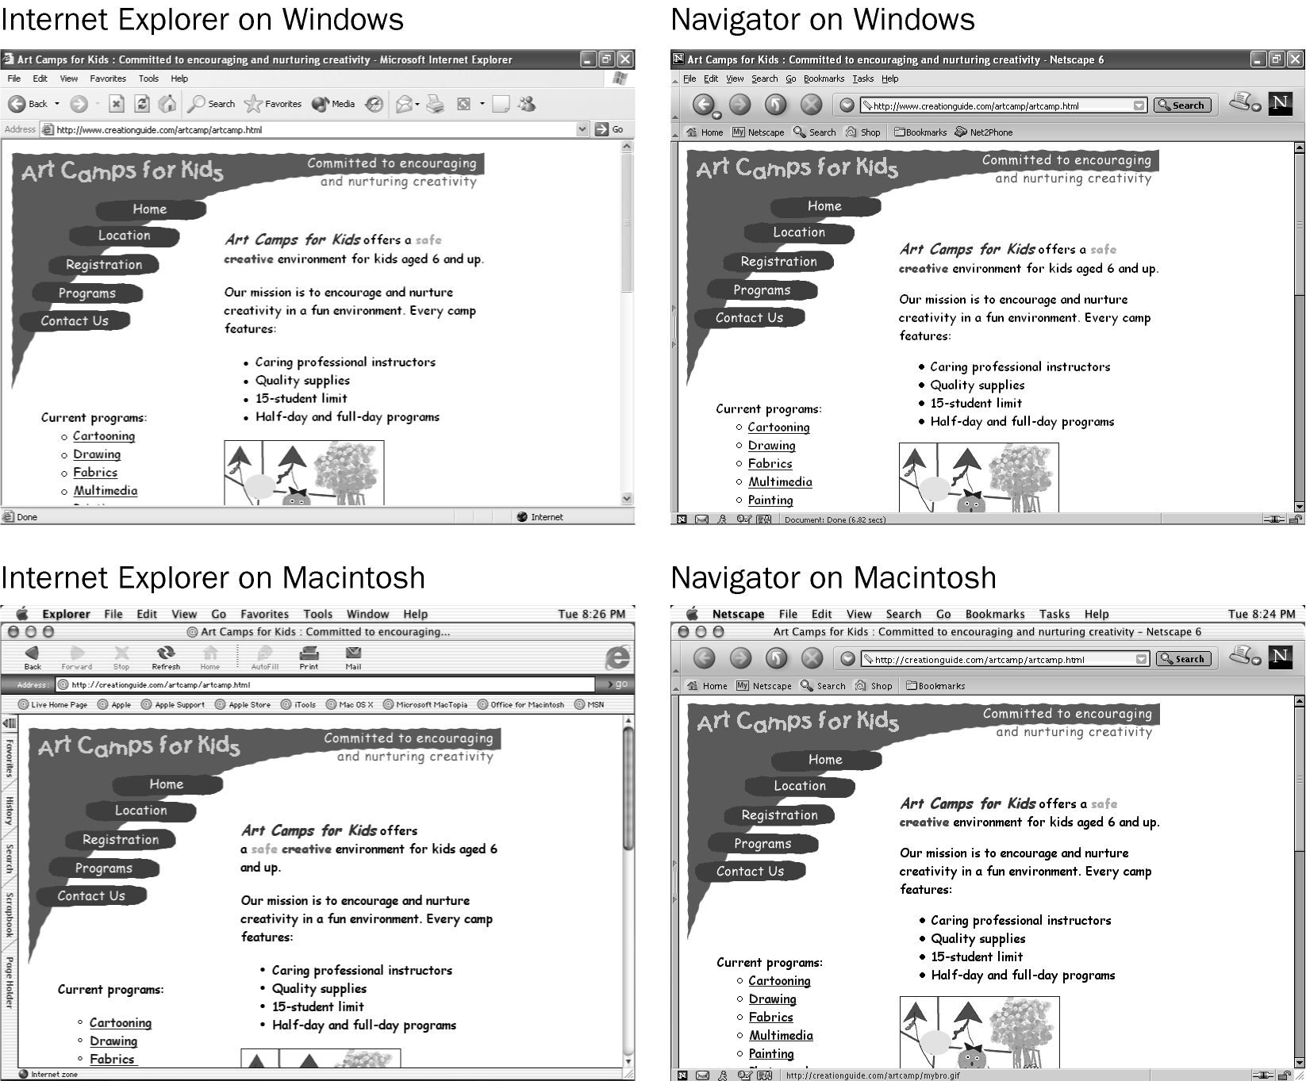
Figure 4-5.
Viewing the same Web page in various browsers demonstrates the small anomalies that crop up in your pages when they’re viewed online
- The default font size is smaller on PCs than on the Macintosh in both Internet Explorer and Navigator, which can affect how text displays and wraps.
- Due to font and spacing size differences, varying amounts of information appear above the Web page’s “fold.”
- Browser window widths vary. Notice how the title bar graphic spans the entire window in a couple instances and it appears with extra white space in the other instances.
We designed the Arts Camps for Kids page to work cleanly in both Internet Explorer and Navigator, but you can see that slight differences remain that are beyond a designer’s control.
A number of browsers exist on the Web. You may or may not want to verify that your pages display appropriately in all browsers out there. For most designers, ensuring that pages display properly in the biggies—Internet Explorer and Navigator—is plenty; combined, these two browsers account for over 90 percent of all browsers accessing the Internet. Of course, you must always consider your audience. If you know your viewers will be using Opera browsers, you’d better ensure that your page looks good in Opera. For edification purposes, here’s a short list of additional browsers you can find lurking on the Web:
- America Online uses an adapted version of Internet Explorer (webmaster.info.aol.com).
- Lynx is an all-text browser (lynx.isc.org/current).
- Mozilla is a Web browser designed for people who want to create Mozilla-based products and packages (much of the Netscape Communicator browser is based on Mozilla code), but the general public can use the browser for free as well (www.mozilla.org).
- Opera is a small application with extremely quick download times (www.opera.com/download).
You might want to download additional browsers to see how your pages display in alternate browsers. Previewing your Web pages simply entails displaying your HTML files in a browser window locally—so the process is quick and simple. Most important, though, you should ensure that you have access to at least one version (PC or Macintosh) of Internet Explorer and Navigator for testing and previewing purposes. Don’t worry—we’ll remind you a few more times in the next few chapters about the importance of previewing your Web pages in more than one browser as well as in more than one version of each browser, if possible.
Key Points
- You need Internet connectivity and server space to display a Web page online.
- You’ll find that free Web space is readily available online, particularly in online groups and communities.
- You can purchase a domain name and buy server space to have full control over your Web site and Web address.
- You can use text editors to create Web pages.
- HTML editors range from all-text programs to advanced WYSIWYG interfaces.
- Graphics applications enable you to create Web graphics, edit pictures, and create mock-ups of future Web pages.
- You can find GIF animators, banner creation sites, and image map utilities online (in addition to lots of other freeware and shareware programs).
- FTP programs enable you to copy files from your computer onto a remote computer.
- Not all browsers are created equal—different browsers display the same Web page in various ways.
- You should always view your Web pages in Internet Explorer and Navigator (at least) before publishing your Web pages online.

