Planning Your Attack
Lesson 5

After completing this lesson, you will be able to:
- Define your goals for a Web site.
- Analyze your audience.
- Create a blueprint for your Web site.
- Design your home page and get ready to build your site.
Now that you’re overflowing with Web-centric knowledge from Lessons 1 through 4, we’re going to walk you through a Web site planning process. You’re aware of all the elements you need to consider; now it’s just a matter of consolidating the information into some concrete review questions and checklists. As you’ve probably heard throughout your life, a little planning up front can save more than a few headaches down the road. Not surprisingly, this philosophy holds true with Web development as well—a little preparation and forethought go a long way toward smoothly achieving success on the Web.
We hope that you’ll see this lesson as a bridge between Web theory and practice. In Lessons 1 through 5, we’ve covered a lot of Web design basics; in Lessons 6 through 8, you’ll have a chance to apply what you’ve learned to the hands-on exercises and projects in which you’ll be creating the overall structure of three Web sites (one per lesson).
In Lessons 6 through 8, you can either re-create the Web pages exactly as we describe or use the sample Web pages as templates for custom pages. For each Web site we present in Lessons 6 through 8, we summarize the planning process we completed before we created the actual page. Lessons 6 through 8 also include a short planning section, so you’ll know how each page evolved during the site’s planning phase and where the project is taking you regarding your hands-on page-development actions. If you’re going to customize any of the Web sites we’ve included as samples, you’ll need to do some custom planning as well. Eventually, after you’ve graduated beyond this course (and we have every confidence you will), you’ll need to conduct your own planning sessions. Therefore, we designed this lesson to clearly outline each planning stage succinctly and in an easy-to-reference format. In the future, if you’re ever stumped about setting goals for your Web site, defining your audience, designing your framework, or building your Web pages, grab this course and go to this lesson to help jump-start your thought processes.
To help illustrate the planning process, let’s look at the evolution of the Curiosity Shoppe Web site. Figure 5-1 shows the final version of the shop’s home page (www.creationguide.com/cshoppe). In the upcoming sections, we address some of the issues we considered when planning the Curiosity Shoppe Web site and explain what impact our decisions about those issues had on the final
design.
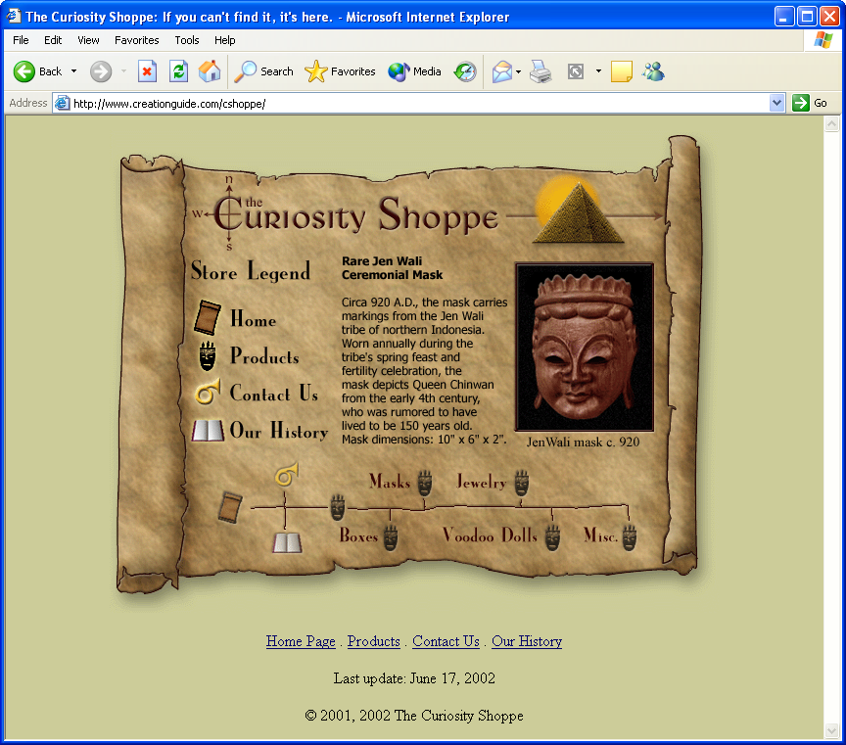
Figure 5-1.
The Curiosity Shoppe home page presents a store front for a collectibles shop’s Web site.

Defining Your Goals
Before you create a Web page or Web site, you must first address the project from a wide-angle perspective. You need to clearly consider your site’s purpose and your goals for your site. Namely, you need to answer the following questions:
- Why do I want a Web page or Web site?
- What are my immediate goals for my Web site?
- What are my long-term goals for my site?
- What is my timeline?
For the Curiosity Shoppe site, the answers to the preceding questions were fairly straightforward. First, the Curiosity Shoppe owners wanted to make their shop easily accessible to more customers through an online presence. The owners’ immediate goals were to inform people about the store, provide a means of contact, and advertise their products and store location. Their long-term plans are to offer their entire line of products for sale online and update the home page daily with a featured item. Finally, the owners’ timeline can be summarized like this: static site online (live) within 2 months of the home page’s
inception; sales feature fully functional within 6 months after the home page has gone live; and a full line of online products available within 12 months from the date the initial home page went live.
Most likely, your goals and timeline will be less complex than those of the
Curiosity Shoppe. For example, your goals might simply be to create an online résumé and have the résumé go live by next month, with updates occasionally added as necessary.

Getting to Know Your Audience
After you’ve outlined your goals for your site, you need to consider who’s going to be visiting your Web pages. In other words, you need to think about your audience. You must have at least some perception of the people you want to visit your Web space. You need to address this planning step early in the process because many design and content decisions are based on your audience.
The best way to get to know your audience is to talk to them, if possible. Consider interviewing or surveying the people who will view your pages. For example, if you’re making a family site, call your family members and find out what they’d like to see on the site. In addition, consider how users will be connecting to your page. Are they typical Web surfers with dial-up connections? If so, keep your page sizes small and your layouts fairly simple. Are you designing a site for online gamers? Then take advantage of high-speed connections and cutting-edge technologies. Designing for kids? Bright colors work well. You get the idea. To help analyze your audience, answer the following
questions:
- Who makes up the core of my target audience? Your answer might include such categories as customers, students, employers, family members, kindred spirits, club members, and so on.
- What does my audience want to find out from my site? This question is different from asking yourself what you want to tell your audience—here’s where you should really listen to prospective site users so you can design accordingly.
- How experienced with the Web are the members of my audience? You’ll need to figure out whether the bulk of your users will be novices, casual Web surfers, or cyberspace champions. Knowing users’ level of expertise is key, because, although experienced users can frequently figure out “what’s going on” in complex or uniquely designed sites, beginning users generally require a little more guidance. For example, if you’re catering to beginning surfers, you should make it a point to clearly and consistently identify the site’s structure through simple navigation elements; save avant-garde designs and navigation schemes for more advanced audiences.
- What types of Internet connections and bandwidth capabilities will my users have? Knowing whether your audience is connected through a simple modem, an internal corporate network (called an intranet), or a high-speed connection such as a Digital Subscriber Line (DSL) will make a difference in how you design your Web site, including the types of elements you’ll incorporate. For example, if you’re certain that your viewers will be accessing your Web site on high-speed connections, you’ll be freer to include video clips and numerous graphics with a minimal risk of losing viewers. If you include video and numerous graphics on a Web site accessed by users with dial-up connections, however, you’ll risk losing those viewers before your site displays because they’ll understandably get tired of waiting for the large elements to download.
- Where is my core audience located? You’ll need to determine whether people will visit your site while at work, on campus, in home offices, in living rooms, at cyber cafés, in your neighborhood, and so forth. This specification relates closely to the preceding question—if you know where your core audience is located, you’ll most likely get a good feel for the types of connections they’ll be using to access your site. Furthermore, location can come into play if you’re designing a regional site versus a national site. For example, a David Bowie site might have an international audience, whereas your Block Watch site would probably cater mostly to your neighborhood. This differentiation is similar to the variations of information found in a newspaper’s front-page section (which would correspond to a nationally or internationally focused Web site) compared to the local section (which would correspond to a locally oriented Web site).
- What’s the typical age group among my audience members? You want to be sure that your site appeals to the age group you’re targeting. This question is rooted in common sense—whether you like it or not, you can make some minor sweeping (albeit conservative) assumptions based on your audience’s age, and these assumptions can help you throughout the Web page creation process. Knowing your audience’s typical age (“typical” being the key word) helps you to make appropriate design decisions. For example, preteen Barbie-pink backgrounds don’t work well on sports sites that target 18–40-year-old males. Furthermore, age parameters help you to choose words (particularly slang and colloquialisms) wisely, such as whether to “dude” or not to “dude.” In addition, age information enables you to create meaningful metaphors—for example, will retirees really know (or care) what it feels like to get kicked in the head in a mosh pit? Finally, age specifics can help you determine the types of information you’ll include on your Web pages. For example, if you’re creating a kid’s site, you wouldn’t feature AARP information, but you might seriously consider including a Harry Potter trivia feature.
- How will users find out about my site? You’ll want to know whether people will hear about your site by word of mouth, from online directories, from hard-copy Web directories or phone books, through links from a “parent” page, as a result of search engines, through paid commercial advertisements on TV or radio, and so on, so that you’ll know best how to advertise and publicize your site.
Tip
After you’ve interviewed, surveyed, and talked to people; listened to feedback; and summarized your data, remember to specifically visualize a real live person instead of a generic profile while you create your Web site and design your Web pages.

Drawing the Blueprints for Your Site
After setting your goals and defining your audience, you’re ready to design your Web site’s framework. If possible, your first step should always be to collect your content before you design. Organizing your content—or at least its main concepts—can help you organize your overall site in a logical manner.
After you gather the main types of information you want to include on your site (don’t worry—your text and graphics don’t have to be polished at this point), you need to figure out how best to present your information. For example, you can organize your site in any number of ways, including the following:
- Alphabetically
- Chronologically
- Graphically
- Hierarchically
- Numerically
- Randomly (not recommended—but it’s out there)
- Topically
By far, most sites are organized hierarchically. A hierarchical site presents a home page that contains catchy introductory text and links to the site’s main pages. This setup is widely used by designers and greatly appreciated by users (who mostly just want to use Web pages—not figure out how they’re organized).
Another critical (though certainly less exciting) aspect of organizing your site involves naming your files. After all, when you boil it all down, your site is entirely made up of files—so organizing your site must include systemizing your files. Before we get to the Site Planning Checklist, let’s take a look at some file-naming practices that you can mull over now and implement later.

Keeping Your Files in Line
As you now know, Web pages usually consist of a few files working together to create the appearance of a single page. Furthermore, a Web site consists of multiple Web pages (which in turn consist of multiple files). Because of this multifile nature of Web pages and Web sites, you’re going to have to come up with a plan for naming and organizing your Web site’s files. (In Lessons 6 and 7, we explain how we’ve organized each site’s files, so you’ll have lots of chances to get the hang of naming and organizing files before the end of this course.) For the most part, a standard Web site can consist of the following simple structure, which is shown in Figure 5-2:
- Main directory Contains HTML files and an images directory. You can provide any name for this directory when designing your pages on your local machine. When you upload your pages to a hosting service, you’ll probably place the main directory folder’s contents into an online folder named “Web” and copy the entire images folder (folder and all) into the Web folder.
- Images directory Contains GIF and JPEG (or JPG) image files used on your Web pages. This directory is usually stored within the main directory.
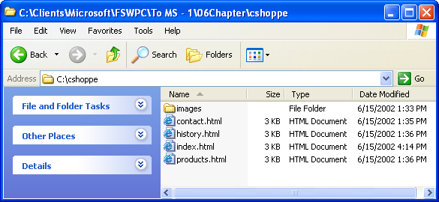
Figure 5-2.
You store directories and files for your Web site locally before you copy them to a server linked to the Internet.
Notice in Figure 5-2 that the main directory currently holds four HTML files—contact.html, history.html, index.html, and products.html—one file for each of the Web site’s main pages. Keep in mind that an HTML file’s name is the name that appears in the Web page’s URL address. For example, to visit the Curiosity Shoppe’s Products page, you would enter www.creationguide.com/cshoppe/products.html. As you can see, the preceding URL consists of the domain name (www.creationguide.com), the directory or folder name (cshoppe), and a filename (products.html).
For most home pages and many subpages, you might’ve noticed that you don’t have to enter a filename. For example, when you visit Microsoft’s home page, you simply type Microsoft’s domain name, www.microsoft.com, or, if you visit the Creation Guide Resources page, you type www.creationguide.com/resources. If no HTML filename is indicated after a domain name or directory (folder) name, most servers will display a particularly named file by default—most likely index.html, although some servers also cater to index.htm, default.htm, or default.html. Ask your hosting service which name you should use for your home page (or test each filename online to see which one works by default); 9 times out of 10 (and probably more frequently than that) index.html is the way to go when naming your home page, and it’s your safest bet when you’re unsure.
Because your HTML filenames will appear within your Web page’s URL, you should follow a few simple rules to keep life simple for you and your users:
Make sure that every HTML filename has an .htm or .html extension and that every image filename has a .gif, .jpeg, or .jpg extension.
- Keep filenames short, simple, and meaningful Users might want to access a subpage directly, so make the URL easy for them to type and remember. For example, use a file named “products.html” instead of “p1-2002m.html.”
- Avoid symbols and punctuation Most people find typing symbols and adding punctuation slows their typing speeds considerably and dramatically decreases their typing accuracy. Furthermore, symbols and punctuation can create new avenues for confusion. For example, if your page is named www.creation-guide.com, users could easily forget the hyphen and type www.creationguide.com (thereby missing your page altogether and visiting ours by mistake!).
- Use an underscore (_) to indicate a space Some older servers don’t recognize spaces, so use underscores instead to indicate blank spaces. Furthermore, you run into the same problem with spaces as you do with symbols and punctuation—spaces are easily forgotten and leave room for errors (lots of them).
- Use all lowercase letters Once again, think “ease of use” for your Web site visitors. Filenames in URLs are case-sensitive, and a randomly uppercased letter can lose more than a few visitors. All lowercase filenames are easy to type and easy to remember.
Naming Images
In addition to naming your HTML files, you’ll need to name your image files. Generally, users don’t access image files directly; instead, HTML pages reference image files whenever they need to be displayed. Therefore, you have more leeway when it comes to labeling your images. One handy image-naming trick that we use is to identify an image’s purpose with a simple prefix incorporated into the file’s name, which helps us to quickly identify and find files when we need them. Specifically, we precede image names with p_, b_, or t_. A p_ image is a picture. For example, p_mask indicates that the image is a picture of a mask. A b_ image is a button. For example, b_products indicates that the image is the navigation bar’s Products button. And a t_ image refers to a title bar. For example, t_contacts specifies that the image is the title bar graphic used on the Contacts page.
By now, you should be realizing that organization plays an important part in Web site planning. You need to streamline your thoughts as well as start to consider how you’ll systemize your files (which, again, are basically your Web site’s Web pages and graphics). You can streamline the site-organization phase by performing the tasks and addressing the issues presented in the upcoming Site Planning Checklist.
After (or while) you address the items on the Site Planning Checklist, you should storyboard your site’s structure. In other words, you should illustrate the relationships among your site’s pages and information to ensure that you’ve created a clear site layout that includes all your information in an easily accessible format. Figure 5-3 shows one of the Curiosity Shoppe’s initial storyboards. You can make storyboards even more detailed than the one shown in Figure 5-3 by including short descriptions of what’s going to appear on each page. For example, in the storyboard shown in Figure 5-3, you could add notes such as, “The contact.html page contains an e-mail link and a map showing the shop’s location.”
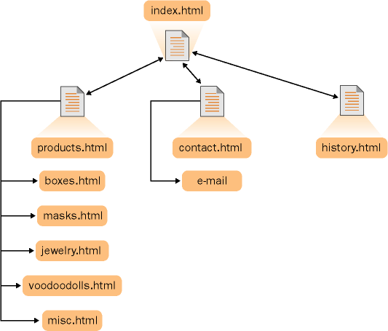
Figure 5-3.
The Curiosity Shoppe storyboard shows the filenames used within the initial site.

Site Planning Checklist
The items on this checklist outline the basic tasks you should perform while planning your Web site. Address each listed task and issue, and sketch your site’s informational relationships as you plan:
- Visit similar sites to see what you like and don’t like, and figure out how you can make your site unique.
- Be sure that your site specifies who you are and (if appropriate) your enterprise’s identity.
- Pick colors that evoke an appropriate emotion for your site. Ensure that your color scheme presents a clear contrast for easy reading, analyze whether the colors work to further your site’s goals, and try to use colors from the 216-color Web-safe palette. For a quick refresher on Web-safe colors, see Lesson 3. To see the Web-safe color palette, open palette216.gif in your graphics program. This file is located in the Lesson03 folder for this course on your hard drive. Verify that the main point of your site is clearly identified up front, not buried a page or two deep into your site or missing, and that each page clearly identifies its purpose. You don’t want readers to visit your home page or find your site through a backdoor and then wonder what they’re supposed to do now that they’ve found your Web site.
- Classify your site to yourself so that you don’t lose your focus. For design purposes, label your site as commercial, informational, educational, entertainment, navigation, community, artistic, or personal, or as some other type of site.
- Design the site to reflect how users will most likely navigate through your pages. You can get an idea of what users want during your audience-analysis stage. Make sure that you include umbrella topics (main topics—not outdoor gear topics) on your home page, and then provide more specific links on each subpage. For example, provide a Contacts link on the home page and provide departmental links on the Contacts page.
- Ensure that your site offers viewers a few ways to contact you—physical address, e-mail address, phone number, carrier pigeon, and so forth.
- Name your files appropriately (as discussed earlier in this lesson).
- Create easy-to-understand button names that clearly reflect your site’s structure. Cryptic buttons might look awesome, but they tend to confuse readers (especially when no explanatory text accompanies your esoteric creation).
- Divide your content into logical units. Don’t divide one page into two just because it seems like the page is getting too long. On the other hand, if you see a logical break in a long page, by all means, divide the page (but make sure you don’t lose the newly created page by burying its link deep within your site).
- Analyze your information, and make your most important information the most prominent and accessible.
- Determine ways in which you can create a unifying look or theme throughout your site. Don’t forget to include a logo and use consistent navigation links on every page. Keep in mind that the nitty-gritty design aspects of your site’s look and theme are addressed more thoroughly in the next planning stage, when you design your home page and subpages.
- Include at least one element that will encourage users to return, such as a daily or weekly updated element or a chat room.
Try This!
Quick—think of three sites you’ve visited recently. Now analyze why and how those three sites made an impression on you. Are there any elements you can adopt and modify for your site? Were those sites easy to navigate? Does an element that you didn’t like stand out in your mind? Use your personal experience to your benefit. After all, you know what you like when you’re surfing the Web.

Laying Your Home Page’s Foundation
After the site-planning dust settles, you can clean off your slate and start to design your home page (and subpages). By now, you should have a very strong idea of what your home page should include—logo, title bar, links to your site’s main pages, and so forth. For the most part, you should have taken care of the practical side of page design, such as determining a file-naming structure, analyzing your audience, determining hardware limitations, and so forth. At this point, your creative juices get to take over while your organizational synapses rest and rejuvenate. In this design phase, focus your attention on how you can creatively present all the necessary home page components in a way that reflects your site’s goals, optimizes your site’s theme, and elicits the proper “emotional” response from users. For example, the Curiosity Shoppe wanted to convey the feeling that the store sells treasures that have been discovered throughout the world. Therefore, we came up with the treasure map theme and the N-S-E-W “C” logo for the Curiosity Shoppe’s owners.
After you start to think of creative ways to present your ideas, start to sketch various layouts and ideas. You’ll begin to see what works best, and ideas will breed off one another until you come up with a page design that does the trick. Figure 5-4 shows a sketch of the Curiosity Shoppe’s home page. Because we designed the home page to make a unique impression, its design is notably different from the layout of the site’s subpages. Therefore, we also sketched the Products page to illustrate how title bars and navigation links would display on subpages, as shown in Figure 5-5. While you’re sketching your home page, refer to the Home Page Planning Checklist later in this lesson to ensure that you’ve covered all your bases.
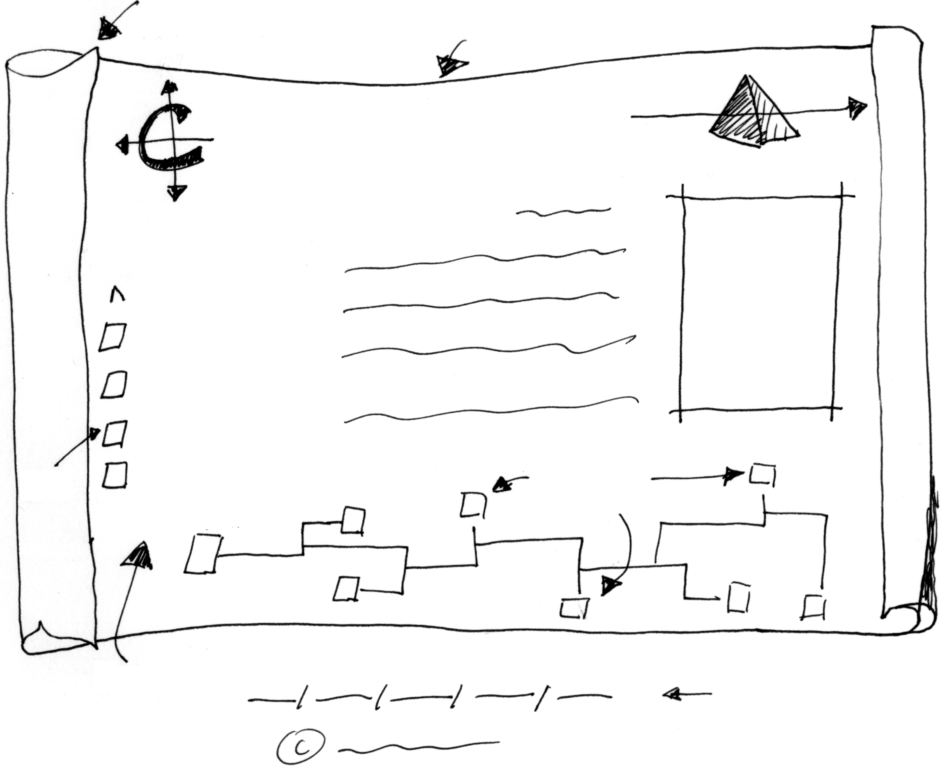
Figure 5-4.
The Curiosity Shoppe home page sketch contains the basic home page information.
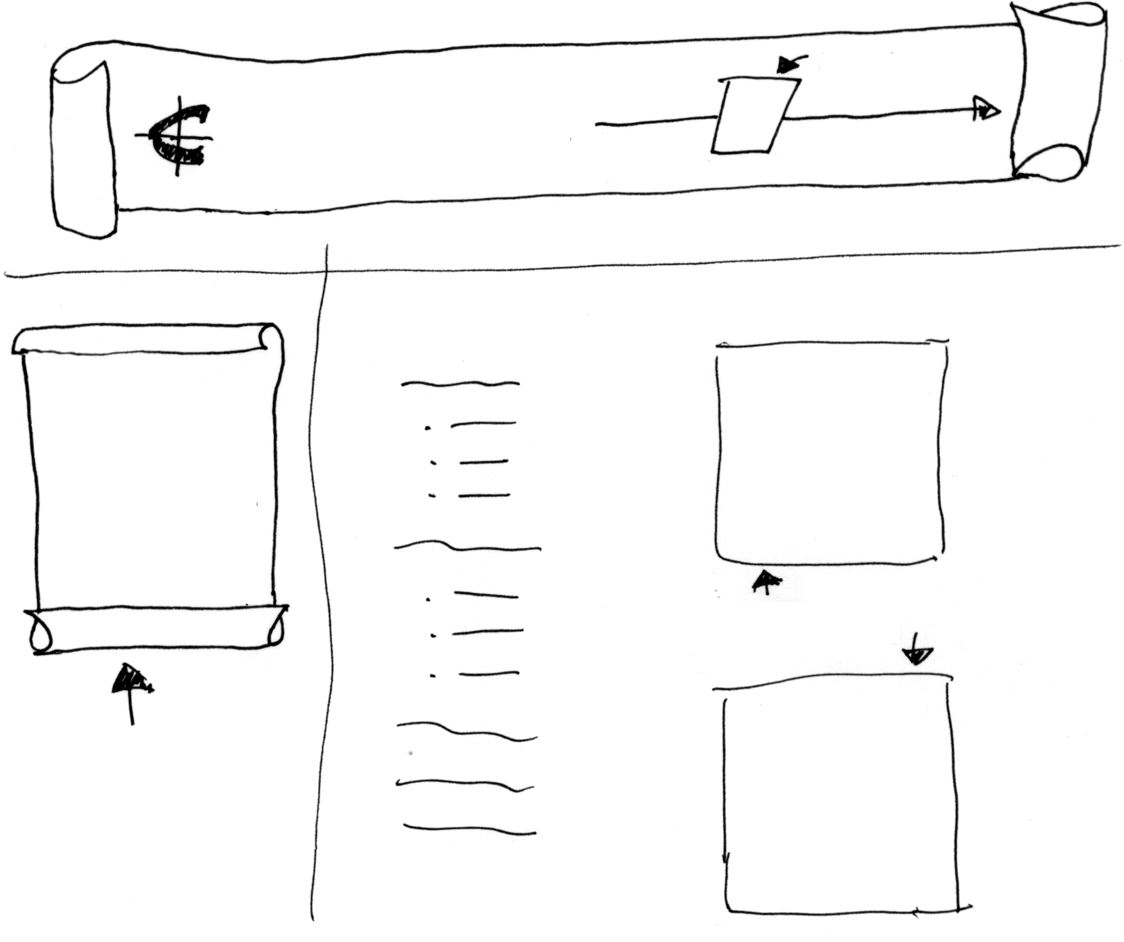
Figure 5-5.
The Curiosity Shoppe Products page sketch shows how subpages in the Web site differ significantly from the home page.

Home Page Planning Checklist
You need to verify that your home page includes the elements listed in the following Home Page Planning Checklist. If you purposely omit certain elements, be sure you understand why. Keep in mind that the list doesn’t weight the importance of elements by order—in fact, the list is alphabetized specifically to avoid promoting any elements over others. (We’re tricky like that.) Make sure that one way or another you address all the following elements in relation to your home page’s design:
- Creation or revision date
- Easily identified and consistently displayed navigation links or
buttons
- Home page icon or logo that can be used throughout the site
- Important information displayed above the fold
- Informative title
- Intentional emotional effect or theme created by means of words, colors, layout, font, and so forth
- Logo or other identifying graphic, such as a family crest or departmental code
- Opening page “hook” to catch viewer’s interest (Home pages generally vary at least slightly from subpages.)
- Quick loading approach (It’s true—gigantic images make extremely poor backgrounds, and you really don’t need to show 90 pictures on your home page.)
- Site’s purpose is clear and viewers know what steps they can take next (beyond clicking the Back button)
- Subheads break up long text (if necessary)
- Text links display along the bottom of the page
- Upper-left corner is put to good use, preferably with your logo
- Your identity or your organization’s identity
Tip
Even though the Home Page Planning Checklist looks lengthy, your home page shouldn’t. At all costs, avoid overloading your home page. You’re better off adding a couple links to your navigation menu instead of cramming information into every corner (and beyond) of your users’ screens.

Gathering Supplies and Preparing
to Build
After you’ve specified your goals, met your audience, organized your site, and designed your home page’s layout, one final planning component remains—rounding up your tools and supplies. This stage includes ensuring that you have well-written and edited text, appropriately sized graphics (which you might have to tweak a little when the actual page design process begins), scanned or otherwise digitized pictures, and the tools to arrange all the items on your Web pages. As you can see, the tasks in this stage are concrete and straightforward, but completing them generally takes a significant amount of time—so plan accordingly. Luckily, although this stage usually takes the longest, we can describe the process fairly succinctly. Basically, before you create your Web page, you need to gather the supplies listed in the following Supplies Checklist.
Note
We’re not trying to discourage you by stating that the supplies stage of the Web game can be time-consuming. It’s just that gathering, creating, and modifying text and graphics almost always seems to take slightly longer than planned (at least that’s been our experience—and not just because we inherently tend to enjoy creating, modifying, and playing with graphics and text!). Fortunately, you don’t need to worry about “gathering supplies” types of delays at this point. Remember, our goal in this course is faster smarter Web page creation. To that end, in Lessons 6 and 7, we’ve listed the supplies necessary to create the lesson’s Web pages. So never fear: the hunting and gathering stages detailed in Lessons 6 and 7 are brief and painless.

Supplies Checklist
Before you start to create your Web pages, you should have the following elements on hand and easily accessible—or at least in the process of being finalized:
- Text—edited, spell checked, and proofread
- Photographs, graphics, and illustrations (including buttons, title bars, and a high-quality logo)
- Page sketches and templates
- HTML editor, text editor, or Web page creation tool (such as an online community wizard)
Remember, if you decide to purchase a domain name, the name should be short, simple, and influenced by your Web site’s purpose.
- Graphics program
- Domain name (either purchased or assigned)
- Server space
Now that the theory and planning phases are fully covered, you’re ready to get your hands dirty and tackle the second half of this course. So roll up your sleeves—it’s time to create!
Key Points
- Define your Web site’s goals.
- Know your audience.
- Outline your Web site’s hierarchy, organizational flow, and overall feel.
- Sketch your home page and subpages.
- Gather your supplies and tools.
- Get ready to create Web pages and go live!

