Sending Your Web Pages into the Real World
Lesson 8

After completing this lesson, you will be able to:
- Transfer your files to the Internet.
- Choose a method for posting your Web pages.
- Use Microsoft’s My Network Places to maintain your Web site.
- Review your Web pages after transferring them to the Internet.
When you create Web pages, you’ll eventually be ready to display your pages online. That’s what this lesson is all about—moving your pages off the “for your eyes only” desktop and onto the “for everyone to see” Internet. Most likely, you’ve built Web pages so that you can create a Web presence—not just as an intellectual exercise—so we’ll go with that assumption.
The key to going “live” and getting your pages onto the Web is to copy your HTML documents and image files onto a server. In Lesson 4, we go over server space, domain names, and ISPs in detail, so we won’t rehash those subjects here. If you need an in-depth refresher on those topics, refer to Lesson 4. If you feel comfortable moving on, here’s a short list of items you’ll need to gather before your Web pages can go live:
- HTML and image files, properly named and organized.
- Server space. (You can pay a monthly fee to a hosting service for server space, you can use free server space, or you can use server space your ISP provides as part of your Internet connection account.)
- A software application that enables you to transfer files from your computer to a server. (We discuss this requirement later in this lesson.)
- A Web address. (You need to purchase a domain name and register it with a hosting service, or you need to set up a Web address on a free server, or you need to obtain your Web address from your ISP—ISP server space is usually based on the ISP’s domain name followed by your username.)
At this point in the course, the preceding list shouldn’t sound too daunting. Furthermore, in just a bit, we describe exactly which file transfer applications you can use and how you can copy files onto a server. So even if you have a few questions about the preceding requirements, hang on—we’ll address each requirement shortly.
In addition to transferring your files to a server, you have a couple other tasks to attend to. Namely, you’ll need to check your Web pages after you transfer your files to a server, and you’ll need to let others know that your site is available for viewing.
These three “post production” tasks—transferring files, checking live Web pages, and getting the word out—are the main points we touch on in this lesson. If you have all your files, an Internet connection, and some server space on hand, your site can be available online by the end of this lesson.

Transferring Your Files to the Internet
Having HTML and image files as well as some server space and an Internet connection means that you’re ready to post your Web pages. You can transfer files across the Internet in several ways. Here are some of the methods you can use to transfer files:
- FTP programs
- Web Folders and My Network Places
- Web publishing wizards
- ISP interfaces and HTML editors
- Browsers
There’s really no way around it—you’re going to have to use some method to post your pages. After all, one of the most common transactions a Web designer has with a server is to upload HTML documents, images, and media files. Therefore, read on. Uploading is pretty straightforward as long as you keep in mind the process’s main goal, which is moving files from your computer to a server in an organized manner.
Lingo: Uploading refers to the process of copying files from your computer to a server. Downloading refers to copying files from a server to your computer (such as when you downloaded graphics from the Creation Guide Web site to complete the projects in Lessons 6 and 7 of this course).
Whenever you upload files from your desktop to the Internet, you use FTP. The trick to transferring files using FTP is to use an application or interface that’s designed specifically to serve as an FTP agent. Although that “trick” doesn’t seem too profound, stating the obvious is well worth the space necessary to clarify what it means to use FTP. We’ve seen people’s eyes glaze over as soon as we’ve uttered those three mysterious letters—F-T-P. Fortunately, as with many other Web page creation technologies, using FTP to upload Web page files isn’t at all intimidating after you’ve gotten up to speed on a few basics.
Lingo: FTP is a client/server protocol that enables you to use a computer to transfer files between computers over the Internet.

FTP Applications
We think standard FTP applications provide one of the easiest and most straightforward methods of uploading files to the Internet. Apparently we’re not alone in this thinking because zillions of FTP applications are available as freeware, shareware, and commercial software. For the most part, we use a program named CuteFTP for Microsoft Windows-based PCs and Fetch for Macintosh computers. But you can find numerous other FTP applications online (free for download as well as available for purchase) and at computer software retailers.
Tip
You should be able to buy a good FTP program for a very reasonable price. Generally, purchasing an FTP application means you’ll have added functionality compared to most barebones freeware and shareware utilities. Keep in mind that you probably received an FTP application from your ISP with your startup package. If so, contact your provider or leaf through your ISP documentation for application-specific instructions.
Figure 8-1 shows the interface of CuteFTP, which is a fairly typical FTP application interface.
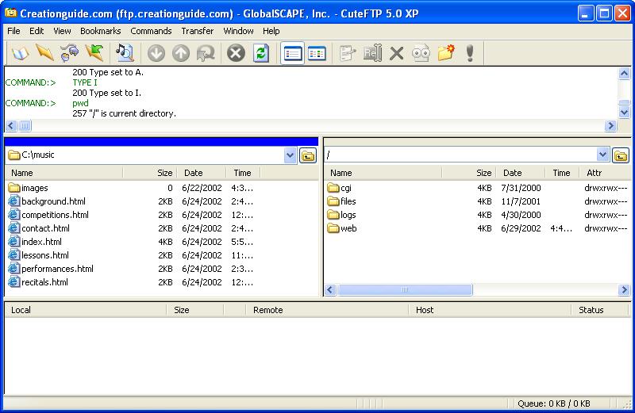
Figure 8-1.
Using CuteFTP, you can drag files from your computer into a directory on your server.
The beauty of most newer FTP applications is that you can drag and drop the files you want to upload from one window into another. For example, in CuteFTP, you can display a local folder in the left pane (Figure 8-1 shows the music folder created in the Lesson 6 project) and display your server space in the right pane. To upload your Web page files, you simply select and drag the files or folders from the left pane into the right pane.
We’ve heard from a number of users that the most intimidating part of using an FTP application is configuring the initial connection. Fortunately, after you initially configure a connection, most FTP applications keep the connection data “on file” for future use.
Caution
Beware—if you’re using a shareware program and your allotted trial time runs out, you risk losing the configuration information for your FTP connections. If this happens, you have two options: You can purchase a full-fledged copy of the shareware program, or (in some cases) you can temporarily backdate your system clock so that you can open the shareware application and retrieve your configuration information.
Even though every FTP application has a custom interface for gathering account information, you’ll need to provide a few basic types of information to establish an FTP connection to a server no matter which application you use:
- FTP site label A name you provide for the FTP account you’re creating. The sole purpose of the site label is to help you remember which FTP account goes with which server. So be sure to name your connections logically.
- FTP host address The address of your server space. For example, the Creation Guide site’s host address is ftp.creationguide.com.
- FTP site username The username you use to access your server space. An FTP site username is generally the same as your e-mail address, such as admin@creationguide.com. Some providers allow you to enter your username without the @domain.com portion, in which case only admin would be necessary in the preceding example.
- FTP site password A password associated with your username that enables you to access your server space.
Try This!
Visit www.tucows.com or www.download.com to find listings of available FTP programs. Download and install an FTP program of your choice, and then put the application through its paces. You can always uninstall the FTP program you downloaded and try some others if the one you chose doesn’t suit your working style. If you do find a shareware program that you like, be sure to register it.
On many FTP connection forms, you’ll also be asked whether you want to transfer information in ASCII, binary, or auto-detect. The default is usually auto-detect (or some variation of that term), and we recommend that you retain the default setting whenever possible.
Note
You might want to write down your password and store it somewhere safe (in a place other than on your computer). When you enter your password in FTP applications and most Web publishing wizards, dots generally display in place of your password.
To create an FTP connection, you insert the proper information into the respective fields (in CuteFTP, in the Site Settings For New Site dialog box) and finalize the configuration by clicking OK, Finish, or Connect (depending on your application). After you configure an FTP connection to your server space, you can connect to the Internet, activate the FTP connection, and upload your pages. (Call your ISP or visit your ISP’s help pages if you have trouble connecting.)
Note
HTML files should be transferred in ASCII, text, or DOS text mode. All other files, including images, sounds, and videos must be transferred in binary mode. Ensuring that the Auto, Auto-Detect, All Files, or Raw Data option is selected in your FTP application’s options generally means that the application can differentiate between the common file types, so you won’t have to worry about specifying between images and HTML files. By default, CuteFTP (as well as most other FTP applications) is configured to auto-detect common file types.
At this point we want to mention a couple uploading rules you need to follow religiously when you copy your Web page files to a server. You can’t copy files and folders willy-nilly—you have to keep the process orderly; otherwise, you’ll risk creating broken links and erroneously overwriting files that have the same name. (For example, most subfolders contain a file named index.html—if you don’t upload your files into the proper folders, you might inadvertently replace one index.html file with another, unrelated index.html file.) Here’s the key point to remember when you’re actively uploading Web pages: Retain the file and folder structure of your Web pages.
In other words, if your Web page consists of one index.html document and a folder named images, make sure that you upload the index.html file and then copy or re-create the images folder in your server space and copy the graphics stored in your local images folder into the online images folder. As mentioned, retaining your site’s structure is crucial to avoiding broken links on your pages.
Here’s another extremely important point: Name your online folders with exactly the same names as your local folders. Don’t rename any folders or files when you’re uploading—especially don’t rename any folders that contain Web page images. (By the way, accidentally creating a folder named image when it should be images constitutes renaming a folder; furthermore, altering capitalization and adding or removing spaces within file and folder names also qualifies as an unacceptable renaming practice.) The reason for retaining your existing naming structure is simple—your HTML document probably contains HTML commands that tell browsers where to look for graphics. Image instructions (contained within the <IMG> tag, if you worked through the HTML project in Lesson 6) specifically point to images stored in a particularly named folder. If you change a folder’s name without changing the HTML commands, browsers won’t know where to find your Web page’s graphics and the graphics won’t display on your Web page. To reiterate, uploading is not the time to rename your Web page folders and files. In fact, the opposite is true: Uploading is the time to replicate your local Web page file setup onto a server in as exact a manner as possible.
After you’ve successfully copied your Web page files onto a server, terminate your FTP connection, open your browser, and enter your Web page’s Uniform Resource Locator (URL) in your browser’s Address bar. Your Web page’s URL is similar to the FTP address we mentioned earlier except that www appears in place of ftp (for example, the FTP address for the Creation Guide site is ftp.creationguide.com and the Web address is www.creationguide.com). If you’ve uploaded an index.htm or index.html HTML document into your domain’s root directory, you should be able to access your new home page by entering your URL in your browser’s Address bar without having to type a filename. For example, you can simply type www.creationguide.com instead of www.creationguide.com/index.html to view the Creation Guide home page.
As you can see, most FTP applications serve the sole purpose of providing a means to transfer and manipulate (rename, delete, move, and so forth) files across a network. If you’re looking for other file transfer options or a more automated approach, you’ll find that more than a few applications have built-in FTP capabilities, as you’ll discover in the next section.
Tip
ISPs generally tell you where you should store your Web page files within your server space. On our server space for the Creation Guide site, we copy all our information into the ISP-generated folder named web. Check with your ISP to see whether you must work within similar parameters. Some ISPs simply provide you with the top-level folder that you can use to store your Web page files.

Web Folders and My Network Places
Microsoft provides another method of uploading and managing a Web site’s files and folders—using My Network Places to create and manage network places that contain Web folders and files. My Network Places was introduced in Microsoft Office 2000, and it carries on in Office 2002 (prior to Office 2000, the feature was known strictly as Web Folders and it was a tad more cumbersome than My Network Places). Using My Network Places, you’ll be able use the familiar Windows interface to conduct the file and folder management tasks necessary for you to create and maintain your Web site.
Lingo: My Network Places enables you to create shortcuts on your desktop to files and folders located on an Internet or intranet server.
Caution
Before you can set up a link to your Web space in My Network Places, you must ensure that your Web server supports network places. The network places feature requires the Web Extender Client (WEC) protocol and Microsoft FrontPage extensions, or the WebDAV protocol and Internet Information Services (IIS). Call your hosting service or check the service’s online FAQ pages to see if your Web space qualifies to take advantage of network places technology.

Tip
You might have to activate FrontPage extensions on your hosting service to create a network place. Although this task might sound a little daunting, most likely, it’s a matter of a few mouse clicks (depending on your hosting service’s support Web site). To find out how to turn on FrontPage Server Extensions on your hosting service, perform a quick search in your hosting service’s Support section or call the support number.
Basically, when you use the network places feature, you can create shortcuts to network locations that contain folders stored on your Web space. After you create a link to a network place, you can manipulate the contents of Web folders stored in your Web space (typically, your Web space is the space you purchase on your hosting service’s server) in the same manner you manipulate local files and folders. The difference is that changes made to files in a Web folder are made to the online files when you save your changes. In short, a network place serves as a shortcut to the Web folders (and the folders’ contents) on your server space.
You can access network places and Web folders in a couple ways. Specifically, you can:
- Display your network places directly by double-clicking My Network Places on your desktop or by choosing My Network Places on the Start menu, which enables you to create new network places as well as open existing links.
- Create a new network place or link to an existing network place from within an Office application, such as in Microsoft Word. After you set up or link to a network place, you can save files and folders directly to the network place from within the application.
Note
In views other than My Network Places, Windows also provides the options to Publish This Folder To The Web or Publish This File To The Web (depending on the type of item that’s currently selected), as described later in this lesson. When you select a folder or file and click either of the preceding options, Windows enables you to copy the folder or file to a Web storage space, such as MSN or Xdrive Plus. This feature caters to people who want to share, transfer, and store non-HTML documents on the Web as well as Web pages and images.
As mentioned, you can view your network places by opening My Network Places, as shown in Figure 8-2. Notice that the My Network Places window includes a link named Add A Network Place in the Network Tasks section along the left side of the window. (You can probably guess the purpose of that small gem!)
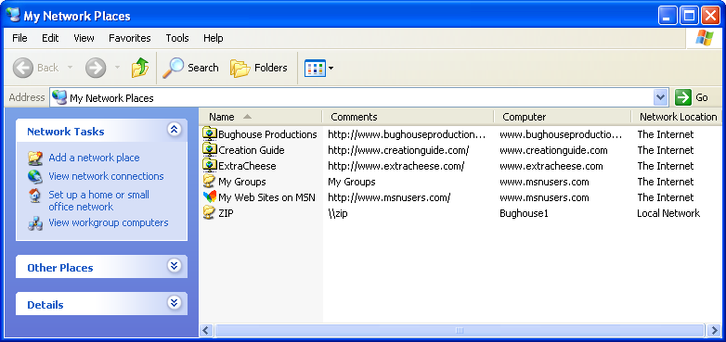
Figure 8-2.
You can access and configure network places and Web folders from within the My Network Places window.
When you open a network place folder and view its contents, you’ll see a list of online folders and files, along with their associated Web addresses (URLs), as shown in Figure 8-3. Within the Web folder, you can move, copy, rename, and delete folders and files as well as view folder and file properties. You can also drag files between Web servers (if you have multiple Web sites) and between a Web server and your hard disk or other storage device (such as a floppy disk). In other words, Web folders make Web site file management as straightforward as local file management.
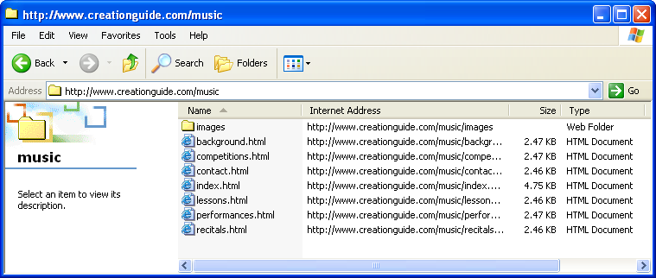
Figure 8-3.
Viewing the contents of a Web folder is similar to viewing the contents of desktop folders.
Now let’s take a quick look at two ways you can create network places on your system. In both instances, you’ll need the following information:
- Domain information, which is your Web site’s Internet address (such as www.creationguide.com)
- The username and password to access your server space

Creating a Network Place by Using My Network Places
To create a network place by using My Network Places, follow these steps:
1 On the Microsoft Windows XP desktop, double-click My Network Places or click My Network Places on the Start menu, and click the Add A Network Place link in the Network Tasks section.
2 In the Add Network Place wizard, click Next. The Add Network Place wizard accesses the Internet, and then provides an option to set up a network place on MSN or another network location. In most instances, you’ll be setting up a network place in a location other than the MSN Web site.
3 Select the Choose Another Network Location option and click Next.
4 In the Internet Or Network Address text box, enter the Internet address of your network location (such as www.creationguide.com).
5 Click Next. If your Web space requires you to enter a username and password, you’ll see a dialog box requesting this information, as shown in Figure 8-4.
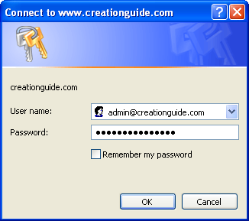
Figure 8-4.
In most cases you’ll need to enter your username and password when you create a network place.
6 Enter your username and password and click OK.
7 Enter a name for the network place item in the Type A Name For This Network Place text box (for example, Creation Guide). The name you enter here displays in your My Network Places window, so be nice to yourself and choose a name that will make sense to you down the road.
8 Click Next, and then click Finish to complete the process.
You should now see a network place link in your My Network Places folder. You can double-click the network place icon to access the network place’s Web space. If you have trouble setting up your connection, ensure that your Web server has the proper configuration to handle network places (as mentioned earlier in this lesson).
Now that you’ve created your Web folder, you can transfer files to your Web site by dragging them into your Web folder in your newly created network place or by saving files directly from any Office 2000 or later program. You’ll find that you can use network places to modify and maintain your Web pages in a number of ways. For instance, you’ll be able to open a network place and right-click filenames and folders to rename them, select and delete files and folders, replace files and folders with updated information, and otherwise modify your Web page documents and directories.

Creating a Network Place from within Word
To create a Web folder while you’re working within Word, you can click the Add Network Place in the New Document task pane (click New on the File menu) or you can create a network place using the Save As dialog box. In the following steps, we show you how to create a network place using the Save As dialog box, but the steps to create a network place from the Add Network Place item in the New Document task pane are very similar:
1 In Word, click File and then click Save As. The Save As dialog box displays.
2 In the Save As dialog box, click the My Network Places icon in the Save In pane to display the contents of the My Network Places window, as shown in Figure 8-5.
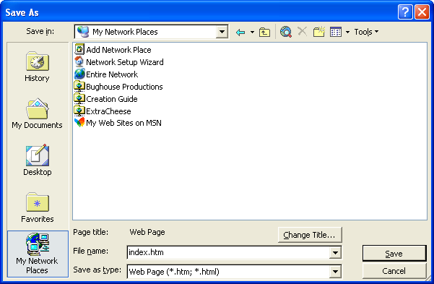
Figure 8-5.
You can use the Save As dialog box to create a network place.
3 In the Save As dialog box, double-click the Add Network Place icon (shown in Figure 8-5). The Add Network Place wizard opens, as shown in Figure 8-6.
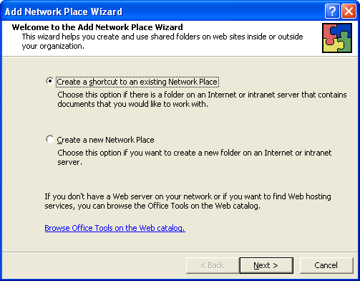
Figure 8-6.
You have the option of creating a link to a network place or creating a new folder in a network place.
4 Choose the Create A Shortcut To An Existing Network Place if you want to create a link to your Web space, and then click Next.
After you create a shortcut to a network location (as described in step 5), you’ll be able to access the network place in the Save As dialog box and My Network Places window by double-clicking the location’s icon.
5 In the Location text box, enter your Web site’s address (such as www.creationguide.com), and, in the Shortcut Name text box, enter a name for the connection, as shown in Figure 8-7, and click Finish.
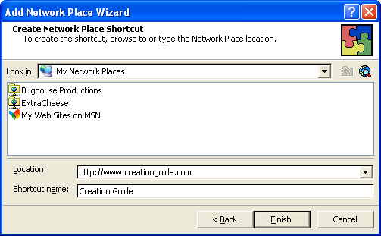
Figure 8-7.
In this procedure, you enter the network place’s Internet address and shortcut name in one dialog box.
6 Enter your username and password, and then click OK. The contents of the network place displays in the Save As dialog box.
At this point, you can save your Word document in a Web folder located in the network place (thereby uploading your Web page) in the same way that you save other Word documents.
7 In the Save As Type drop-down list box, specify Web Page or Web Page Filtered, specify the document’s name in the File Name text box, click the Change Title button if you want to specify the Web page’s title text, click the Web folder in which you want to post the HTML document, and then click Save.
You’ll need to establish an Internet connection before you can save a Web document in a network place.
After you save an HTML document in a Web folder in a network place, you can view the page online by entering the Web page’s address in your browser’s Address bar.

Other FTP Options
If you don’t want to install an FTP program on your computer or if you don’t want to configure My Network Places and Web folders, all hope is not lost. You can copy files to a Web server in other ways as well. Namely, you can use the FTP functions built into any of the following types of applications:
- Web publishing wizards, such as the Web Publishing wizard that comes with Windows
- ISP online services and HTML editors, such as FrontPage
- Browsers, such as Microsoft Internet Explorer

Web Publishing Wizards
The Web Publishing wizard offered in Windows XP mainly serves to provide file storage and file sharing capabilities. Therefore, this tool isn’t the ideal tool for publishing your Web pages (unless you’re working on your MSN group site). But you can easily upload and store Web documents and other files (including images) by using the Web Publishing wizard in Windows. You might want to use this feature while you’re creating documents as a backup storage medium or a means to share your working documents with others.
The Web Publishing wizard works in the same way as other wizards: It provides a series of dialog boxes that you complete to upload a folder or file to an online service provider, such as MSN or Xdrive. If you become a “serious” Web designer and you have your own Web space, you’ll quickly crave the greater flexibility (and simplicity) that FTP applications and the network places tool offer. To reiterate, the Web Publishing wizard can serve a viable purpose when it comes time to store and share files as well as possibly publish your first MSN Web site.
The best way to understand how the Web Publishing wizard works is to walk through the process. Because the process comes in wizard form, there’s no reason for us to show you the pages you can see on your computer. To access the wizard, complete the following steps:
The Web Publishing wizard is available in most versions of Windows; it was first added to Windows in the OSR2.5 release of Windows 95.
1 Open My Computer and select a file or folder that you want to publish to your Web space.
2 In the File And Folder Tasks section, click either Publish This Folder To The Web (if you’ve selected a folder) or Publish This File To The Web (if you’ve selected a file).
To kick off the wizard, click the Next button. Then work your way through each page, providing the proper information. When you select to publish a folder, the wizard displays a dialog box in which you can select the files you want to publish by checking or clearing check boxes, as shown in Figure 8-8. When you’ve completed all the wizard forms, you’ll need to click Finish to upload your files. If you have the correct information on hand, the process should flow smoothly without incident, and your newly added information will display in your browser by default.
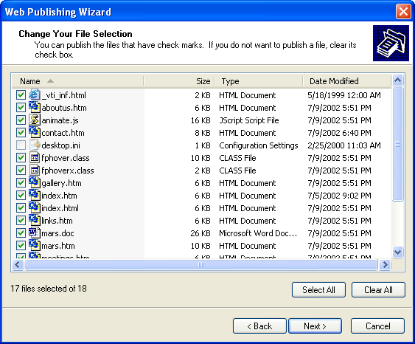
Figure 8-8.
The Web Publishing wizard provides the opportunity to pick and choose the files you want to upload within a selected folder.
Try This!
Select a file or folder to upload to the Web. Then work through the Web Publishing wizard to practice uploading a file or folder to an MSN personal folder.
When you place files in an MSN personal folder, the files can only be accessed with your .NET Passport. If you don't have a Passport, the .NET Passport wizard helps you to create one when you publish a file or folder to MSN. After you publish a file or folder, a link to the resource is added in your My Network Places window. Furthermore, you can access the files and folder from any Web browser in any computer, and you can add and delete files in your online folder (to access the folder’s contents, double-click the link in the My Network Places window) in the same manner you add and delete files in local folders.

ISP Interfaces and HTML Editor Features
Other resources for transferring files include ISP interfaces and HTML editors. Basically, these tools are variations or hybrids of FTP applications, the network places feature, and the Web Publishing wizard. The main benefits of ISPs and HTML editor features are that the tools are often easily accessible. For example, some ISPs offer online forms you can use to upload files from your computer to the server. In fact, the Creation Guide host provides a form, but we’ve found it to be cumbersome, so we never use it to manage the site’s files. If you’re shopping for a hosting service, look into the file management services the hosting service offers. Our hosting service provides a number of quality features—such as logging statistics (including tracking the number of page hits and visitor traffic) and lots of space—so we overlooked the somewhat lame file manager feature because we knew full well that we can whip a few pages across an FTP application interface pretty quickly. In our opinion, if you’re planning to use an ISP file transfer interface, make sure that the online tool is at least as intuitive as an FTP application or the Web Publishing wizard.
Similar to an ISP’s online FTP forms, a number of HTML editors, including FrontPage, offer automatic file uploading features (as discussed in Lesson 7). Using an HTML editor to upload files can be extremely convenient. The main concern is that you should be keenly aware of which files are uploading and where they’re going. Furthermore, know when you’re replacing existing online files (which is always a good practice no matter how you’re uploading files); otherwise, you might not be able to backtrack to a previous page if you decide you don’t want to keep your most recent modifications. To illustrate, if you’re using Internet Explorer and you have FrontPage installed, you can visit your Web site and then click the Edit button in the Internet Explorer toolbar to open a local version of your Web page in FrontPage. You can then make modifications to the page and click Save to save and upload the modified page directly to the server. When you do this, if you don’t rename the newly modified page, the existing page is replaced with the updated page. Therefore, we generally reserve this feature for very simple fixes, such as correcting typos or updating dates. When you modify and save a page using the online access feature in FrontPage, you overwrite your existing HTML document. That’s definitely something to keep in mind.
Tip
You should use the FrontPage Publish Web command to initially upload Web pages you’ve created in FrontPage. Using FrontPage’s publishing tool ensures that FrontPage features that rely on FrontPage Server Extensions are properly implemented. Even if you haven’t added advanced capability to your FrontPage Web pages, we highly recommend that you use the Publish Web command to upload your Web site—at least the first time you upload the site.
To learn how to use ISP forms or an HTML editor’s uploading features, refer to the application’s help files or published documentation. Too many variations exist among systems to adequately provide procedural descriptions in this lesson.

Browsers as FTP Clients
Last but not least, you can use some browsers as FTP clients (depending on your Web server’s setup). Most people know that you can download files from within a browser window, but few people know that you can also upload files and folders in some browser applications, Internet Explorer included. Keep in mind that your hosting service must support this feature—we’ve found that some sites work with browser uploads better than others. If your hosting service works well with this feature, the method is simple: You use the Address bar to display the contents of your server folder, and then you can drag files from local folders into the server folders displayed in your browser window. Furthermore, you can right-click existing online files and folders to access a shortcut menu that allows you to rename, move, and delete online files. To display your online folders, you enter the following information in the Internet Explorer Address bar: ftp://username:password@ftp.domain.com.
For example, an entry might look like the following: ftp:// mmail:coffee2@ftp.microsoft.com or ftp://mmail:coffee2@members.ISPname.com.
After your server space displays, open the folder containing your Web page files and drag the files and folders into your browser window to copy the Web page components. Figure 8-9 shows FTP access to a Web folder. You can upload, delete, and rename your Web files within Internet Explorer.
To access AOL’s file uploading feature, use the “myplace” or “myftpspace” keyword. If you’re creating a page on AOL, your Web page’s URL will be members.aol.com/screenname/filename.
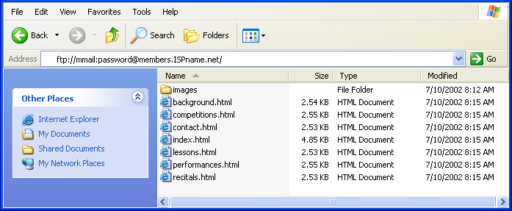
Figure 8-9.
Depending on your Web server’s setup, you can sometimes use Internet Explorer to transfer and manage Web files.
In this lesson we introduce a number of tools that you can use to transfer your local Web page files to a server. Try a few of the options, and see which works best for you. Because many variations exist within each category, we’d be embarking on an unrealistic task if we tried to describe every aspect of every means of transferring files to the Internet. Your best bet is to choose which uploading style you want to attempt and then give it a whirl. If you have questions, visit the application’s help files or printed documentation (or e-mail us if you really get stuck). If you’re uncomfortable with one process, try another approach. We’re confident that if you gather the appropriate connection information and enter the information properly, you’ll be able to connect to your Web space and get your pages online.

Reviewing Your Work
After you upload your Web pages, the first order of action is to surf to your pages and check your Web site’s presentation. As we discussed in Lessons 6 and 7, you should preview your Web pages throughout the creation process—and we consider uploading part of the creation process. So check your live pages. If you’ve been careful, you shouldn’t find too many surprises after your pages go live. Nevertheless, before you start calling all your friends and directing people to your Web site (unless you’re asking them to help you review your Web site), you should view your Web pages. After you display the home page, check for the following details:
- Ensure that all images display properly. You don’t want any broken image markers on your page.
- Click your links to ensure that they work, including the buttons on your navigation bar, linked logo graphics, text links, and image maps, if those appear on your page.
- Verify whether the page and its elements fit within the standard browser window. Remember—users report that having to scroll left and right to view a Web page is highly annoying.
- Complete and submit a test form to yourself if your site uses forms.
- Read each page title in the title bar for accuracy.
- Verify that text and text links are easy to read against the Web pages’ backgrounds.
Basically, take the time to scrutinize your site. Click everywhere, test each interactive element, and employ your critical eye. Better to take a little extra time after uploading to check your work than to have a viewer send you an e-mail message to tell you that your Web site is lame because it doesn’t display properly or respond as expected.
The last postproduction task we cover in this lesson is getting the word out that your Web site exists. The most common way to begin publicizing your site is to ensure that your Web page is readily recognizable by search engines and search directories.
Key Points
- You can use FTP applications to copy files from your computer to a server.
- You can transfer files and folders by using FTP applications, network places and Web folders, the Web Publishing wizard, ISP online forms, HTML editors, and browsers, such as Internet Explorer.
- If your server supports network places, you can use the My Network Places feature to easily upload and manipulate your Web site’s files and folders in the same manner you manage local folders.
- When uploading Web files to a server, retain your Web site’s file and folder structure, including using the exact naming and organizational parameters as the files and folders on your local computer.
- After you upload Web pages, always view them online to check for errors and broken links.
- To publicize your Web site, register with search engines.
- Consider adding META tags to your HTML documents to somewhat control how search engines categorize your site.
- Finally, let others know that your site is live—by word of mouth and other typical communication channels—and start the exchange of online information!

