Using Templates and Wizards
Lesson 3

After completing this lesson, you will be able to:
- Use a Word template.
- Create a template.
- Use a wizard to create a document.
When you use Microsoft Word templates and wizards, you save yourself a lot of time. For example, suppose that your boss has decided that you will be in charge of all the internal company correspondence. Your new job duties include sending out a weekly memo to all employees, faxing updates to various departments, and creating a monthly newsletter. Rather than having to recreate the layout and design for each memo or newsletter that you create or even having to retype standard information each time that you create a letter or fax, you can use a template. A template is a document that contains built-in text, styles, and other formatting that can be used to create other documents that will share the same basic formatting.
You can use an existing document to create a customized template. Creating a customized template is ideal when you’ve already spent significant time adding text, character and paragraph formatting, graphics, or styles to a document and want to use the same or similar formatting for other documents that you create. By creating a template from an existing document, you can avoid having to apply similar formatting to the other documents. You save the document as a custom template and modify it for further use.
You also use a wizard to create a document. A wizard prompts you for information one step at a time and then generates a formatted document based on your answers.
In this lesson, you will learn how to create a document using a template, create a template, and use a Word wizard to create a document.
To complete the procedures in this lesson, you will need to use a file named Contoso January 03 Flyer 03 in the Lesson03 folder in the Word Processing Practice folder that is located on your hard disk. You’ll use this file to create and save a custom template.

Using a Word Template
Every Word document is based on a template. The template determines the basic properties of the document, such as the margins and the layout (how text is displayed on paper). The template also defines the characteristics of the text, such as its font, font size, and font style. Most documents are generated from a generic template called the Normal template. The Normal template is the default template in Word. When you click the New Blank Document button on the Standard toolbar, a new blank document is created based on the Normal template.
Word has many built-in templates, each categorized by type. These templates allow you to create documents for specific uses such as fax sheets, memos, resumes, and letters. Templates contain both preformatted text and placeholder text. Preformatted text includes headings and other entries that you don’t need to change. For instance, a memo template might contain the title Memorandum, displayed in a particular font, font size, and font style. Other preformatted memo text includes To:, From:, and Re:. Placeholder text is temporary because you will either delete it or replace it with your own text. Placeholder text usually provides a brief explanation of what you can type to replace the placeholder text. For example, a memo template might contain the placeholder text [Your name here], which indicates that you should replace the placeholder text with your name.
A default is a setting that an application establishes when it is installed but which can be changed by a user at any time.
In this exercise, you use a ready-made Word template to create a fax sheet, enter text, and then save the new document.
In the following exercises, the Standard and Formatting toolbars have been separated.
1 On the File menu, click New.
The New Document task pane appears.
2 Click General Templates in the New from template section.
There are two basic types of templates: global and document. A global template, such as the Normal template, contains formatting that is available to all documents. Document templates, such as memo or fax templates, contain formatting available only to documents that are created using that template. For example, if you create a memo using a memo template, formatting is applied using both the Normal template (a global template) and the Memo template (a document template).
The Templates dialog box appears
3 Select the Letters & Faxes tab.
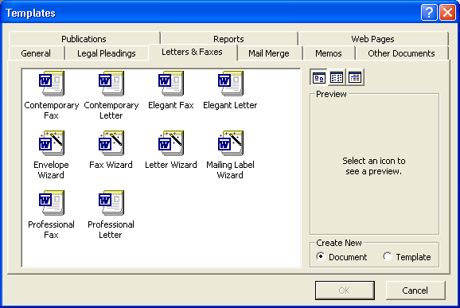
4 Double-click the Contemporary Fax icon.
The Contemporary Fax template appears.
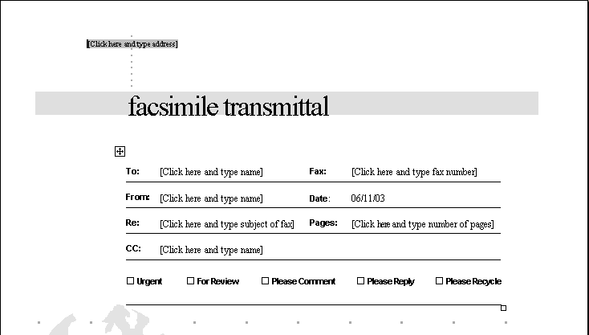
Use the Tab key instead of the mouse pointer to select all the placeholder text throughout the Contemporary Fax template.
5 In the upper-left corner of the document, click the placeholder text for the address.
You can select the text facsimile transmittal and replace it with different text. For example, you could put your name or your company’s name here to personalize the fax sheet. You could also insert clip art or a company logo on the fax sheet.
The placeholder text is selected and you can begin typing.
6 Type Contoso, Ltd., and press Enter.
7 Type 4567 Main Street, and press Enter.
8 Type Charlotte, VT 80227, and press Enter.
9 Click the placeholder text to the right of the word To:.
The placeholder text is selected and ready for your entry.
10 Type Mr. and Mrs. Berg.
Notice that the correct date is filled in by Word and will remain unless you select the date and type a new one.
11 Replace the rest of the placeholder text as follows:
Fax: 303-555-0100
From: Lisa Jacobson
Re: Services provided by Contoso, Ltd.
Pages: 2
CC: Jay Adams
12 Double-click the box to the left of the words For Review.
A check mark is inserted in the box.
13 Scroll down, if necessary, and select the paragraph to the right of the word Notes:.
14 Type the following:
Please see the attached letter for a summary of our services. Please feel free to contact me for more information.
15 On the Standard toolbar, click the Save button.
The Save As dialog box appears.
16 In the File name box, type Contoso Fax 03.
17 If necessary, click the Save in down arrow, and navigate to the Lesson03 folder in the Word Processing Practice folder on your hard disk.
You can save a new Word file as either a document or as a template.
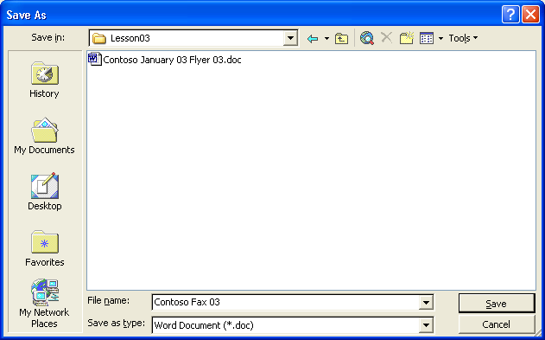
18 Click the Save button.
Word saves the document.
19 On the File menu, click Close to close the template. If you are prompted to save changes, click No.

Creating Your Own Template
Suppose that after the meeting coordinator at Contoso finished creating the monthly meeting announcement flyer, she realized she would save time with future flyers by creating a template from the existing flyer. Now, when she creates a new flyer, she can save herself time by basing the new flyer on this template.
A template created from a document has the same characteristics, format, and text as the original document. You create a template by saving a document as a template, modifying the template so that it is more generic in nature, and saving any modifications that you make. The next time that you open the template, it is ready for you to update.
tip
If your hard disk uses a letter other than C, substitute the appropriate drive letter in place of C.
If you save a template in the Templates folder, the template appears on the General tab of the Templates dialog box. To create custom tabs for templates in the Templates dialog box, create a new folder in the Templates folder and save your templates in that folder. The name that you give the folder will appear on a new tab. In Microsoft Windows 95 or Windows 98, the Templates folder is located by default in the [local hard drive]:\Windows\Application Data\Microsoft folder or the [local hard drive]:\Windows\Profiles\[User_name]\Application Data\Microsoft folder. In Microsoft Windows 2000, the Templates folder is located in the [local hard drive]:\Windows\Profiles\[User_name] folder. In Microsoft Windows XP, the Templates folder is located in the [local hard drive]:\Program Files\Microsoft Office folder. The user name refers to your own name or the name of the person logged on the computer when this folder is opened.
In this exercise, you create a template from a file. You then create a file from the template.
1 On the Standard toolbar, click the Open button.
The Open dialog box appears.
2 Click the Look in down arrow, click the icon for your drive, double-click the Word Processing Practice folder, and then double-click the Lesson03 folder.
The contents of the Lesson03 folder appear in the Open dialog box.
3 Click the file Contoso January 03 Flyer 03 and click the Open button.
The Open dialog box closes and the file Contoso January 03 Flyer 03 appears in Word.
4 On the File menu, click Save As.
The Save As dialog box appears.
5 In the File name box, type Contoso Flyer Template 03, click the Save as type down arrow, and click Document Template.
The file extension for document templates in Word is *.dot.
Notice that the Save in location for the template automatically changes to the Templates folder.
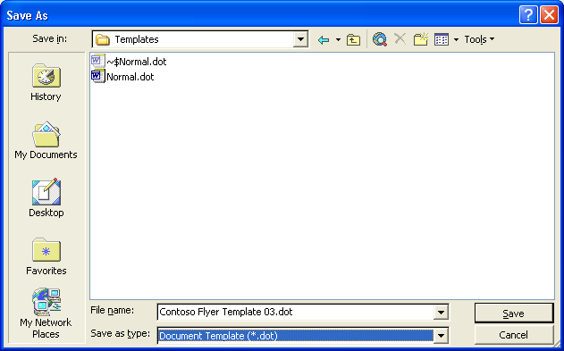
6 Click the Save button.
The template is created.
7 Select the word January in the third line of the main title, and type Month. Then select January 23rd, and type Date.
The month and the date are replaced with generic text.
8 Select the title Business Plans that Work!, and type Title.
9 On the Standard toolbar, click the Show/Hide ¶ button so that you can see the formatting marks in the document.
As you enter and edit text, Word inserts special formatting marks—such as spaces, tabs, and paragraph marks—into the document. These formatting marks do not appear on the screen and are not printed, unless you use the Options dialog box or click the Show/Hide ¶ button to display them.
10 Select the following text, but leave the paragraph symbol at the end of the sentence unselected, and then press Delete:
Lori J. Shea will demonstrate how to create, review, and adjust a business plan for a startup company.
11 Select the bulleted list, but leave the paragraph symbol at the end of the sentence of the last bullet unselected, and then press Delete.
12 Click the Show/Hide ¶ button to hide the formatting marks.
The flyer should look like the one shown here.
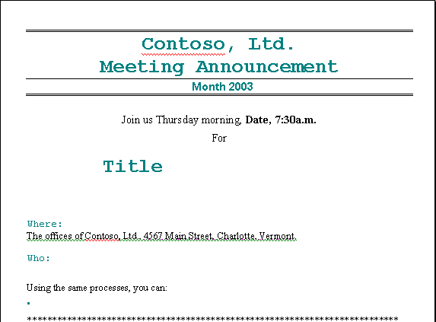
Showing the formatting marks is useful when you cut and copy text and want to be sure that you have selected all the appropriate tabs, spaces, and hard returns. You will learn more about showing formatting marks in Lesson 5, “Changing the Layout of a Document.”
13 On the Standard toolbar, click the Save button and close the template.
14 On the File menu, click New.
The New Document task pane appears.
15 Click the General Templates options and then, if necessary, click the General tab. Double-click the Contoso Flyer Template 03 icon.
When you no longer need one of your previously created templates, you can delete the template using the Templates dialog box. Right-click the template’s icon, and click Delete on the shortcut menu that appears.
A new document is created based on the template.
16 Double-click the word Month, and type February.
17 Double-click the word Date, and type February 20th.
18 On the Standard toolbar, click the Save button.
19 In the File name box, type Contoso February 03 Flyer. Click the Save in down arrow, and navigate to the Lesson03 folder in the Word Processing Practice folder on your hard disk. Click Save.
Notice that you didn’t need to use the Save As command to avoid altering the template. Word automatically created a new document and left the template unchanged.
20 Close the February flyer. If you are prompted to save changes, click No.

Creating a Template from a Template
The letterhead for Contoso, Ltd. doesn’t show the new company logo. You could create a letterhead template from a template so that you don’t have to insert the logo every time that you need to use the letterhead. To create a template from an existing template, on the File menu, click Save As, type the name of the template in the Save As dialog box, click the Save as type down arrow, click Document Template, and then click the Save button. Your newly saved template will appear on the General tab in the Templates dialog box.

Using a Wizard
You can also automate the creation of a document by using one of Word’s many wizards. You can use wizards to create memos, letters, faxes, and many other business documents. The major difference between a wizard and a template is that a wizard walks you through text entry for many parts of a document, whereas a template simply displays placeholder text that you replace on your own. After you create a document by using a wizard, you will still need to replace some placeholder text. However, you’ll notice much less placeholder text than if you had created the same document by using a template.
In this exercise, you create a document using the Memo Wizard, and you modify and save the memo.
1 On the File menu, click New.
The New Document task pane appears.
2 Click General Templates in the New from templates section of the task pane.
The Templates dialog box appears, as shown in the illustration on the following page.
3 Click the Memos tab.
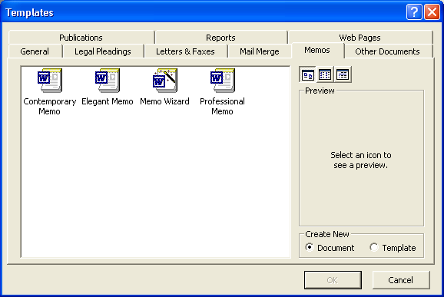
4 Double-click the Memo Wizard icon.
A new blank document opens and the first (Start) Memo Wizard dialog box appears.
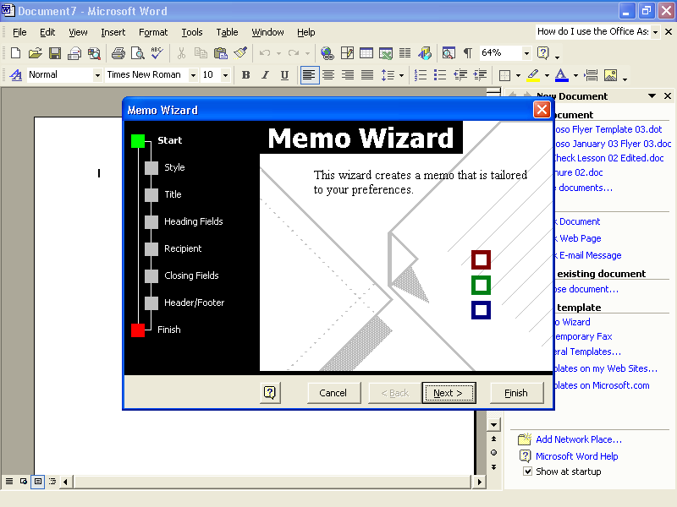
Notice the flowchart on the left side of the Wizard dialog box. The green square indicates the stage that you’re at in the wizard’s process. You can move to a specific step in the process by clicking a box on the flowchart. Or, if you make a mistake, click the Back button as many times as necessary to return to previous steps.
5 Click the Next button.
The next wizard dialog box appears, asking which style of memo that you would like to use.
6 Click the Elegant option, and then click Next.
The Style wizard dialog box appears. The Yes. Use this text option is already selected.
7 Type Contoso Memo 03 in the Title text box, and click Next.
The Heading Fields wizard dialog box appears.
8 In the From box, select the default text, and type Lisa Jacobson.
9 In the Subject box, type Expense Report Reminders.
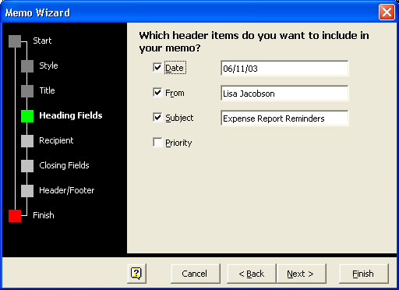
Because Word automatically enters today’s date in the Date section of the memo, your Memo Wizard dialog box will differ slightly from the one shown here. If you are using a wizard to create a document for future use, you can select the date and type the new date that you want.
10 Click Next.
The Recipient wizard dialog box appears.
11 In the To box, type All employees, and click Next.
The Closing Fields wizard dialog box appears.
12 Select the Writer’s Initials check box, and type LJ in the text box.
13 Click Next.
The Header/Footer wizard dialog box appears.
14 Clear the Confidential check box, and click Next.
The Finish wizard dialog box appears.
15 Click Finish.
If the Office Assistant appears, right-click it and click Hide to hide the Office Assistant. You can reopen the Office Assistant by clicking Show the Office Assistant on the Help menu.
The Memo Wizard closes. Your customized memo appears in a new document window.
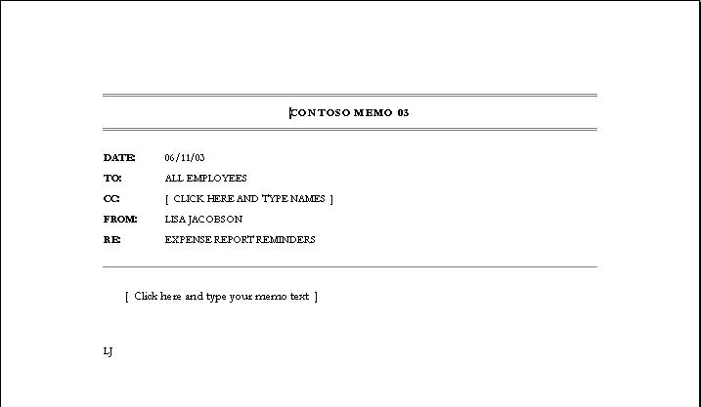
16 Click the placeholder text next to the CC: line.
17 Press Delete.
The unwanted line is deleted.
18 Click the placeholder text in the body of the memo and type: When filing your expense reports, be sure to attach your original receipts.

Lesson Wrap-Up
In this lesson, you learned how to create a document by using a template, how to create a template from a document and from another template, and how to use a wizard to create a document.
If you are continuing to other lessons:
1 On the Standard toolbar, click the Save button.
The Save As dialog box appears.
2 Navigate to the Lesson03 folder, and then save the memo as Contoso Memo 03.
Notice that the title that you entered into the wizard, Contoso Memo 03, is the default name in the File name box.
3 Click the Save button.
Word saves the document.
4 On the File menu, click Close. If you are prompted to save changes, click No.
Word closes the file.
If you are not continuing to other lessons:
1 On the Standard toolbar, click the Save button.
2 Navigate to the Lesson03 folder, and then save the memo as Contoso Memo 03.
Word saves the document.
3 In the upper-right corner of the Word window, click the Close button. If you are prompted to save the changes, click No.
Word closes the file and the Word program closes.

Quick Quiz
1 From what dialog box do you open a Word template?
2 What is the difference between a template and a wizard?
3 What are two built-in wizards that Word provides?
4 Under what circumstances would you want to create a template?
5 Name three of the built-in templates that Word provides.
6 When you create a document from a template, how can you be sure that you’re not saving the document as the template that you used to create the document?

Putting It All Together
important
In the Putting It All Together section below, you must complete Exercise 1 to continue to Exercise2.
Exercise 1: If necessary, start Word. Use the Fax Wizard and the following information to create a fax that contains just a cover sheet with a note and is set up to print so that it can be sent from a separate fax machine. Address the fax to Mr. and Mrs. Matt Berg, using the fax number 303-555-0188. Select the Professional cover sheet and include your name and the following address in the proper places:
Contoso, Ltd.
4567 Main Street
Charlotte, VT 80227
303-555-0100
Save the fax sheet as Berg Fax 03 in the Lesson03 folder in the Word Processing Practice folder.
Exercise 2: Create a template from the fax that you created in the previous exercise. Open the Berg Fax 03 document, and delete the information in the To: line and the Fax: line. Save the document as a template, name it Fax Template 03, and then close it.
Exercise 3: You decide that it would be a good idea to follow up your fax to the Bergs with a mailing of the same information. Create an envelope using the Envelope Wizard. Use the address below for the delivery address and the Contoso address given in Exercise 1 for the return address. Print the envelope and then close the document without saving.
Exercise 4: In this lesson, you used the Memo Wizard to create a memo in the Elegant style. There is also a template called Elegant Memo. Create a memo using this template instead of the wizard. Which method do you find easier? Which method do you prefer to use?
Exercise 5: Is there a wizard or a template that can help you create a Web page? Explore the Templates dialog box or use Word’s help to find out how you could quickly and easily create a Web page.

