Changing the Layout
of a Document
Lesson 5

After completing this lesson, you will be able to:
- Adjust page margin settings.
- Set paragraph indentation and spacing.
- Change indents and tab settings.
- Insert and clear tabs.
- Add page numbers to a document.
- Create headers and footers.
- Change page orientation.
Rather than using the default settings that Microsoft Word provides, you can use other settings and tools to change how your letters, lists, proposals, and general correspondence look. One way to quickly customize a document is by changing the way the text appears on the page by altering page margins, resetting paragraph alignments, changing tab settings, and creating headers and footers. When you create a document, you are doing more than just formatting text; you have the capability to change the page layout of the document by altering how text appears on the page.
You start this lesson by changing a page margin. A page margin is the amount of space at the top, bottom, or sides surrounding the text on a page. You can also use a header or a footer on a document with multiple pages. A header is the text that appears at the top of a page that usually includes the title of the work, the date, and page numbers. A footer is text printed at the bottom of the page, which might include the date, author’s name, and the title of the document.
You’ll also set tab stops for a particular paragraph within the document. A tab stop or tab is used to indent the first line of a paragraph or to align text or numbers in columns. You can also use Tabs to align columns of text within a paragraph. Other settings include indents and spacing. Indents determine the alignment of the paragraph in relation to the page margin setting, and spacing indicates the area above and below the paragraph as well as the space between the lines.
In this lesson, you will learn how to adjust page margin settings and set paragraph alignment, indentation, and spacing. You’ll also learn how to change indents, insert and clear tabs, and add page numbers to a document. In this lesson, you will also create headers and footers, and change the page orientation of a document.
To complete the procedures in this lesson, you will need to use the practice file named Salary Survey 05 in the Lesson05 folder in the Word Processing Practice folder that is located on your hard disk. This document was created to publicize the results of a salary and benefits survey administered to a random sampling of the members of Contoso, Ltd.’s public relations networking group.

Changing Page Margins Using the Page Setup Dialog Box
When you use the Page Setup dialog box, you determine how the document appears on the printed page. The Page Setup dialog box is most commonly used for setting page margins. Page margins affect the entire document because after the page margins are changed, the number of pages in the document might increase or decrease depending on how much text the page margin allows per page. To change the page margins in a document, you can use the ruler at the top of the document or the Page Setup dialog box, which is accessed by clicking Page Setup on the File menu.
By default, Word includes left and right page margins of 1.25 inches and top and bottom page margins of 1 inch. You use the Page Setup dialog box to adjust top, bottom, left, and right page margin settings, determine the placement of headers and footers, and select the amount of text that you want the settings to affect.
In the following exercises, the Standard and Formatting toolbars have been separated.
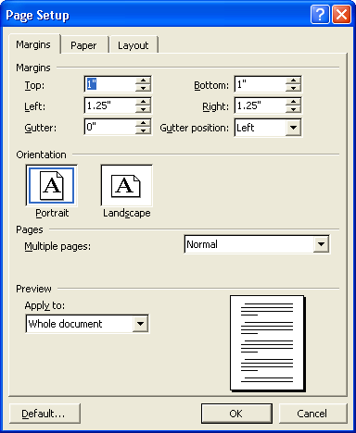
You can click the Apply to down arrow to define whether you want the setup changes to apply to the whole document, the selected text only, or from the position of the insertion point forward.
In this exercise, you change the page margin settings using the Page Setup dialog box.
1 On the Standard toolbar, click the Open button.
The Open dialog box appears.
2 Click the Look in down arrow, click the icon for your hard disk, double-click the Word Processing Practice folder, and then double-click the Lesson05 folder.
The contents of the Lesson05 folder appear in the Open dialog box.
3 Double-click the file Salary Survey 05.
The file Salary Survey 05 appears in Word, and the Open dialog box closes.
4 On the File menu, click Page Setup.
The Page Setup dialog box appears. The current top margin setting (1″) is selected.
5 In the Top box, type 1.5, and press Tab.
You can also use the up and down arrows to the right of the settings to select preset sizes. The up arrow increases the page margin size, and the down arrow decreases the page margin size.
In the Preview section at the bottom of the dialog box, the top page margin shifts down to show what the text will look like.
6 In the Bottom box, type 1.5, and press Tab.
In the Preview section, the bottom page margin shifts up.
7 Click OK.
The top and bottom page margins are now 1.5 inches instead of
1 inch.
8 On the File menu, click Save As.
There is no visible change to the text in Normal view, which is the currently selected view for the document.
The Save As dialog box is displayed.
9 In the File name box, type Salary Survey 05 Edited.
10 Click Save to save the file in the Lesson05 folder.
Word saves the document.
Keep this file open for the next exercise.

Changing Page Margins Using the Ruler
You can also change page margins using the ruler. The ruler is a scale shown in the document window that is marked in inches or other units of measurement. A horizontal ruler in Normal view and both horizontal and vertical rulers in Print Layout view are provided in Word.
To use the ruler, you should use Print Layout view, not the default setting of Normal view, so that you can see the page margin settings relative to the page borders. You use Normal view to edit and format the document, but Normal view doesn’t show the page margins relative to the page borders. You can also use Print Preview to view your document as it will be printed, and you can make changes to the margins in this view.
To turn the rulers on or off in Normal view and Print Layout view, on the View menu, click Ruler.
The horizontal ruler along the top of the document window shows the left and right page margins as well as the left and right paragraph indents, such as first line and hanging indents (you’ll learn more about these indents later in this lesson). Often, the paragraph indents and page margins are the same; however, it’s important to recognize that you can adjust the page margins or indents of paragraphs independent of the page margins. The vertical ruler along the left edge of the document shows the top and bottom page margin boundaries.
To change page margins using the ruler, you use Print Layout view, which is shown below. This view allows you to see the page margins on the vertical and horizontal rulers. When you position the mouse pointer over the page margin, the mouse pointer appears as a horizontal double-arrow. You can then drag the first line indent, hanging indent, left indent, or right indent marker to a new location to reset the page margin. You’ll learn more about these indents in this lesson.
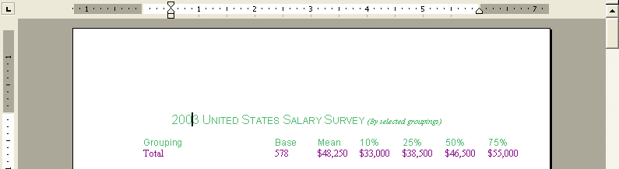
To display the page margin measurements as you adjust them, hold down the Alt key as you drag a marker. This technique also allows you to adjust the page margin in smaller increments.
In this exercise, you change the page margins of the document using the ruler.
1 On the View menu, click Print Layout.
You can also change the document view with the layout buttons along the lower-left edge of the document window.
The document is displayed in Print Layout view. The 1.5-inch top page margin setting is reflected on the vertical ruler.
2 Position the mouse pointer above the Left Margin marker on the horizontal ruler until the pointer is displayed as a double arrow.
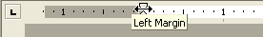
3 Hold down the Alt key.
The double arrow disappears.
4 Drag the marker to the left until the measurement of 6.5″ is displayed in the white portion of the ruler.
The left page margin shifts to the left, and all the text in the document is adjusted. Notice that the tabs and columns in the document are disrupted.
5 Release the Alt key.
6 Position the mouse pointer over the Right Margin marker until the pointer is displayed as a double arrow.
7 Hold down the Alt key, and drag the marker to the right until the measurement of 7″ is displayed in the white portion of the ruler.
The right page margin shifts to the right, and the text is adjusted. Both the left and right page margins are now set at .75 inch.
8 Release the Alt key when the page margin is set.
9 On the Standard toolbar, click the Save button.
Word saves the document.
Keep this file open for the next exercise.

Formatting a Paragraph
Word defines a paragraph as any amount of text that ends with a hard return. Each time you press Enter, a paragraph mark (a hidden formatting character that designates the end of a paragraph) is inserted into the document. Although you see the actual paragraph mark only if the display of nonprinting characters (or formatting marks) is turned on, the paragraph mark is still present. Even a blank line is considered to be a paragraph because it ends with a hard return.
As you enter and edit text, Word inserts special characters or formatting characters—such as spaces, tabs, and paragraph marks—into your document. These characters are not printed and do not appear on the screen unless you click the Tools menu, click Options, and select the Formatting Marks check boxes on the View tab or the Show/Hide ¶ button on the Standard toolbar. For more information on using the Show/Hide ¶ button, see Lesson 3, “Using Templates and Wizards.”
The formatting that you select for a paragraph is applied to the next paragraph that you type. This process occurs because all formatting associated with a paragraph is stored in the paragraph mark. When you begin a new paragraph, the paragraph takes on the formatting characteristics of the previous paragraph. Alternatively, when you delete a paragraph mark, the preceding paragraph takes on the formatting characteristics of the next paragraph.
Paragraphs are set by default to be single-spaced and left-aligned with no indentation. You change the default paragraph settings for single paragraphs or groups of paragraphs by using the Paragraph dialog box, as shown in the illustration on the following page. To access the Paragraph dialog box, on the Format menu, click Paragraph.
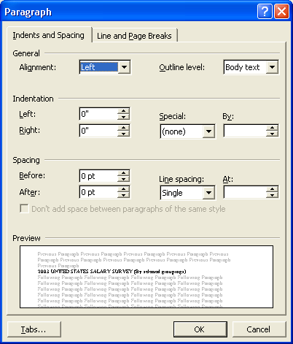
As with most Word formatting commands, you either select the paragraphs that you want changed and then apply formatting, or apply the formatting first and then type the desired text.
To format only one paragraph, click anywhere in that paragraph. To format multiple paragraphs, first select the paragraphs that will be affected.
You can use the Indents and Spacing tab of the Paragraph dialog box to use and modify alignment and indentation:
Alignment | The arrangement of text in fixed or predetermined positions. If the paragraph is left-aligned, all the text in the paragraph will begin on the left side of the document.
Indentation | Determines the position text is moved in from the page margin. You can also specify positions for hanging indents (indenting all but the first line of a paragraph to the same point) and first line indents (only indenting the first line of a paragraph) by clicking the Special down arrow and then selecting the desired indent type.
In this exercise, you change paragraph spacing and create hanging indents using the Paragraph dialog box.
1 Scroll to the heading Salary Percentiles and select the heading and all the text under the heading.
2 On the Format menu, click Paragraph.
The Paragraph dialog box appears.
3 Click the Indents and Spacing tab, if necessary.
4 In the Spacing section, in the After box, click the up arrow twice.
The paragraph spacing is changed to 12 points, and a preview of the change is shown in the Preview section.
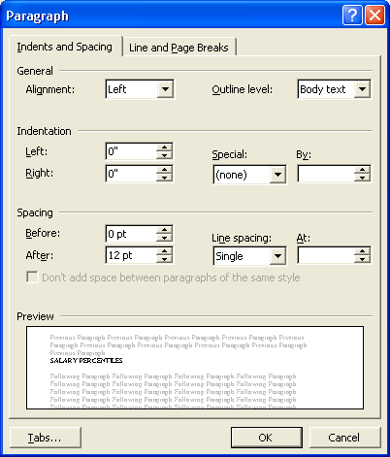
5 Click OK, and click anywhere to deselect the text.
The Paragraph dialog box closes, and 12 points of space are added after each paragraph in the document.
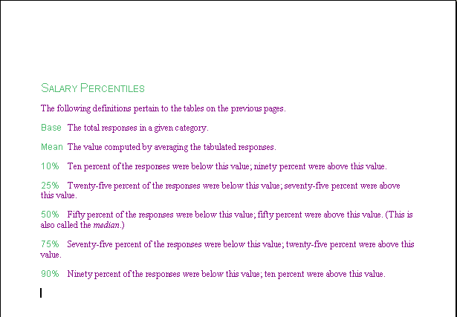
6 In the same section of the Word document, select the definitions under the text The following definitions pertain to….
7 On the Format menu, click Paragraph.
You don’t have to select all text in every paragraph before you apply a paragraph format. You need to include only part of the first and last paragraphs in the selection. The formatting that you apply still affects all the partially selected paragraphs.
The Paragraph dialog box appears.
8 Click the Special down arrow in the Indentation section, click Hanging, and then click OK.
Word creates a hanging indent for the definition paragraphs, where the first line hangs farther out from the following lines. The default value for a hanging indent is 0.5 inch, which is what you use for this exercise.
9 Click anywhere in the document to deselect the text.
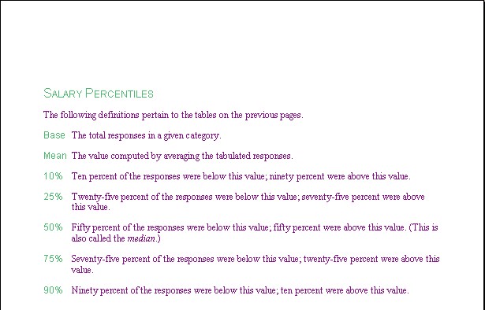
10 On the Standard toolbar, click the Save button.
Word saves the document.
Keep this file open for the next exercise.

Indenting Text Using the Ruler
To quickly create a hanging or first line indent, you can use the ruler. The ruler contains markers for both of these indents, as well as a right indent, as displayed here.
You begin indenting paragraphs by selecting the text and dragging the appropriate marker to the desired position on the ruler.
To | Do this
Fully indent a section  Be precise with the mouse while working with the ruler because it is easy to click and drag the wrong marker. Take your time and make sure that you grab the right marker by checking the ScreenTip. If you find that you dragged the wrong marker and your text is indented incorrectly, press Ctrl+Z to undo the change before you try again. | Drag the Left Indent marker. All three formatting markers move.
Indent only the first line | Drag the First Line Indent marker only.
Create a hanging indent | Drag the Hanging Indent marker only.
In this exercise, you change indent settings using the ruler.
1 Under the sentence The following definitions pertain to…, select the seven definition paragraphs.
2 Position the mouse pointer over the Hanging Indent marker on the ruler (the bottom triangle).
The ScreenTip Hanging Indent appears.
3 Hold down the Alt key, and drag the Hanging Indent marker to the right until a measurement of .75" appears to the left of the marker. Release the mouse button, but do not deselect the text.
The paragraphs are indented 0.75 inch from the first line of each paragraph.
Although you don’t need to hold down the Alt key when you drag one of the paragraph markers, doing so allows you to see the measurement that you want to set.
4 Release the Alt key.
5 With the definition paragraphs still selected, drag the Left Indent marker (the square) to the 2-inch mark on the ruler.
Notice that all three formatting markers move and the paragraphs are fully indented.
6 With the definition paragraphs still selected, drag the right Indent marker (the triangle on the lower-right side of the ruler) to the 5.5-inch mark on the ruler.
The right margin of the selected text moves to the left.
7 Click anywhere to deselect the text.
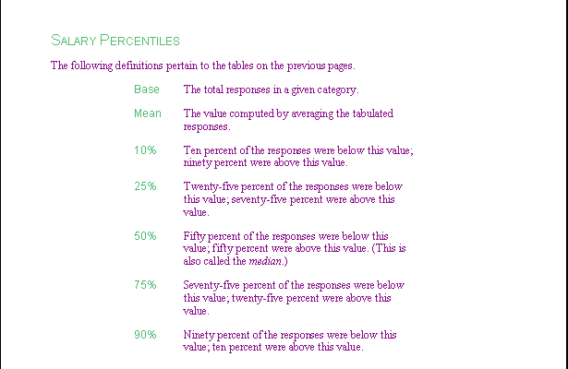
8 Scroll through the document to view the various paragraph formats.
9 On the Standard toolbar, click the Save button.
Word saves the document.
Keep this file open for the next exercise.

Changing Tab Settings
Word automatically left-aligns tab stops and spaces them at every half inch. Each time that you press the Tab key, the insertion point moves to the next tab stop on the current line. Unless you specify otherwise, Word inserts a left tab stop each time that you press Tab. A left tab aligns text at a specific distance from the left page margin. The following table explains the types of tabs that are available. You can change the tab alignment by clicking the Tab button to the left of the horizontal ruler or by clicking Tabs on the Format menu and clicking the desired alignment option in the Tabs dialog box.
Tab Type | Button | Effect
Left |  | Aligns text to the right of the tab.
Right |  | Aligns text to the left of the tab.
Center |  | Centers text on either side of the tab.
Decimal |  | Aligns numbers along a common decimal position.
Bar |  | Inserts a vertical bar at the tab stop.
While automatic spacing between tab stops might be acceptable for most documents that you create, you have the option of changing the spacing. For example, if you are working on a document that has several columns of data, you can change the tab settings so that the data is spaced evenly and is legible on the page. When you use tabs, you might find that the columns created are not always wide enough to accommodate your text.
In this exercise, you widen columns using the Tabs dialog box to change tab settings.
1 Scroll to the heading Median U.S. Salary by Two-Digit Zip Codes, and select all the zip code lines below the heading (from 01 through 98).
If you have problems selecting the text, click to the left of the first line 01 MA $51,920, hold down the Shift key, and then select this line. Release both the Shift key and the mouse button. Scroll down to line number 98. Notice that as you scroll, line 01 remains selected. When you reach line number 98, press Shift and select this line. Word automatically selects lines 02 through 97 for you.
2 On the Format menu, click Tabs.
The Tabs dialog box appears.
3 In the Tab stop position box, type 1.
4 Click the Set button.
The tab is set, and the tab position number appears in the Tab stop position list.
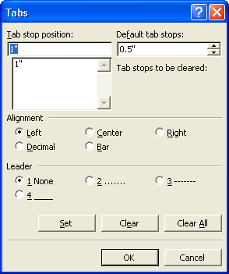
5 Type 2.5, and click the Set button.
The second tab is set, and the tab position number appears in the Tab stop position list.
6 Click OK to close the Tabs dialog box.
As shown in the illustration on the following page, the columns of information are neatly spaced and aligned according to the tab stops that you just inserted.
7 Click anywhere on the page to deselect the text.
Keep this file open for the next exercise.
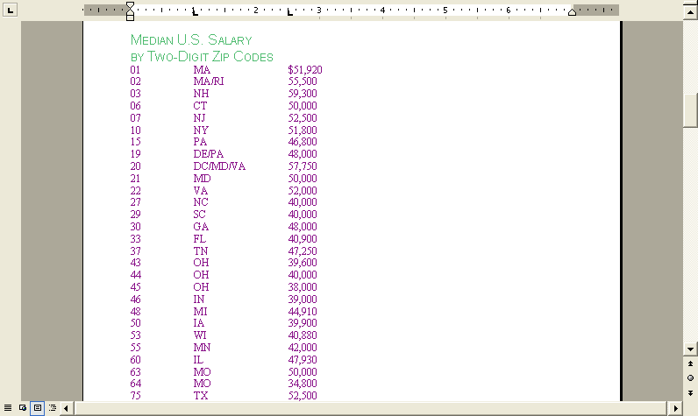

Setting and Clearing Specific Tab Stops
When making lists, charts, or other highly formatted sections of text, it can be helpful to create tabs at special intervals to break up information in a visually appealing way. The type of tab alignment that you select in the Alignment section of the Tabs dialog box determines how the text is aligned at that tab stop. There are five types of tab stops available in Word.
You can also create a leader tab, which is displayed as a row of dots from the insertion point to the next tab stop. Leader tabs can be left-aligned, right-aligned, centered, or decimal-aligned as well. You might have seen a leader tab before in a ledger or on a bill, where the total line has a row of dots leading to the total of the bill to distinguish it from other entries that are above the leader tab.
You can also select the type of tab and insert tab stops using the horizontal ruler, which is explained later in this lesson.
You set and clear tabs using the Tabs dialog box. Here you can set one or multiple tabs, determine the alignment of the text to the tab stop, or clear all existing tabs.
In this exercise, you set tabs using the Tabs dialog box. You then enter text to see the results of the tabs that you add, and you clear a tab setting.
1 Press Ctrl+End to move the insertion point to the end of the document.
2 On the Format menu, click Tabs.
If you intend to set a lot of custom tabs, it is best to clear the defaults first. To clear the defaults, in the Tabs dialog box, click the Clear All button before setting the custom tabs. If you leave the default tabs you have to press the Tab key more often.
The Tabs dialog box appears.
3 In the Tab Stop Position box, type 1, and click the Set button.
4 In the Tab Stop Position box, type 3, and click the Set button.
5 In the Tab Stop Position box, type 4.
6 In the Alignment section, click the Decimal option, click the Set button, and then click OK.
Two left-aligned tabs and a decimal tab are displayed on the ruler, and the Tabs dialog box closes.
7 Press Tab, type Employment Level, and press Tab again.
8 Type Base, and press Tab.
9 Type Mean, and press Enter.
The headings appear as you type.
10 To enter the first line of information, press Tab, and type the following, pressing Tab between each entry and Enter after the last entry.
Entry
52
$36,100.00
The information for the first line in the table is entered.
11 Press Tab, and type the following, pressing Tab between each entry and Enter after the last entry.
Mid Level
207
$42,410.00
The information for the second line in the table is entered. Notice that the number is aligned at the decimal point rather than at the default left.
12 Press Tab, and type the following, pressing Tab between each entry.
Senior Level
186
$55,500
Press Enter. Notice that even though you didn’t type a decimal point in the number, it is still aligned properly with the other numbers.
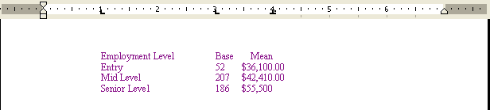
13 On the Format menu, click Tabs.
14 Click the 3" setting in the Tab stop position list, and click the Clear button.
The 3" tab setting is cleared.
15 Notice that Word automatically selected the 4" setting in the Tab Stop Position list. Now that the 4" setting is selected, click the 2 option in the Leader section.
16 Click the Set button, and click OK.
17 Press Tab, and type Average.
18 Press Tab, and type $44,670.
The space before the second tab is filled with leader dots.
19 On the Standard toolbar, click the Save button.
Word saves the document.
Keep this file open for the next exercise.

Using the Ruler to Set and Clear Tab Stops
You can also quickly set and clear tab stops using the ruler. This tactic works well when you want to set tab stops visually by lining them up with the text below, rather than specifying a set number at which to place the stops.
To set a tab stop using the ruler, you select the paragraph(s) to be affected. Then you click the Tab Align button at the far left side of the ruler to specify the tab alignment type. Click the ruler at the desired position to place the tab stop marker. A tab stop marker appears at that position.
In this exercise, you enter more text and set tabs using the ruler.
You can also use the Tab Align button to set the first line indent and the hanging indent. Click the Tab Align button until the First Line Indent or Hanging Indent symbol appears. Then on the ruler, click the position where you want to set the indent.
1 Click to position the insertion point after the last 0 in the number $55,500 and press Enter two times.
2 Type the following four lines of information, using the Tab key to move to each tab setting and press Enter after each line. Press Tab and type:
Age Base Mean
20-29 82 $37,800
30-44 178 $47,290
45 and over 200 $50,440
Now that there is more text on your screen, the results of the alignment settings are apparent.
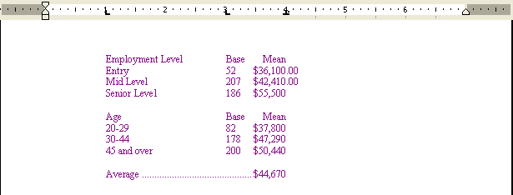
3 Select all the rows of text on this page, except for the row labeled Average, which is the last row.
4 Drag the second tab marker (located on the 3-inch mark) off the ruler.
The tab is cleared and the text shifts.
5 On the left side of the ruler, click the Tab Align button, which now appears as the Left Tab button on the ruler.
The Tab Align button changes to a Center Align button.
6 Click the ruler at the 3-inch mark.
A centered tab is set, and the text is realigned.
7 Click anywhere to deselect the text.
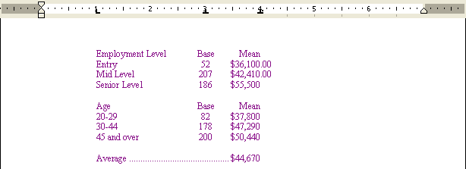
8 On the Standard toolbar, click the Save button.
Word saves the document.
Keep this file open for the next exercise.

Inserting a Page Number
When you create a document that has more than one page, you might consider using page numbers to mark each page. Using page numbers comes in handy when you are presenting the document to other people. The people reading your document do not know the information inside out, like you do. So instead of telling them to find the paragraph “under the picture toward the middle of the document,” simply tell them to “turn to page six and read the paragraph under the picture.” Page numbers also come in handy when you are creating a lengthy document. Page numbers allow you to keep the document in order, especially if you print random pages from the document or make edits. Page numbers remind you of where you are in the document.
You can add page numbers to a document using the Page Numbers command on the Insert menu. By default, page numbers are displayed at the lower-right corner of each page. You can change the page number position to either the top or bottom of the page, and then you can specify the left, right, or middle of the page. You also have the option to show a page number only on the first page.
If you are using Normal view, you won’t be able to view any page numbers that you insert. You can, however, view the page numbers in Print Preview or Print Layout view.
In this exercise, you add page numbers to the document.
1 Press Ctrl+Home to move the insertion point to the top of the document.
2 On the Insert menu, click Page Numbers.
The Page Numbers dialog box appears, and the page number’s current position is displayed in the Preview section.
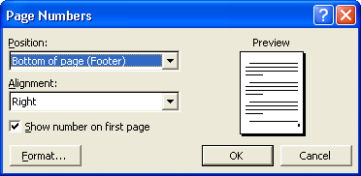
If you want to change the position of the page number, click the Position down arrow and select either the top or the bottom of the page.
3 Click the Alignment down arrow, and click Center.
The page number is centered in the sample in the Preview section.
4 Click OK, and scroll down to the bottom of the page to view the page number.
The document is switched to Page Layout view automatically, so that you can see the page number you have added to the footer.
Keep this file open for the next exercise.
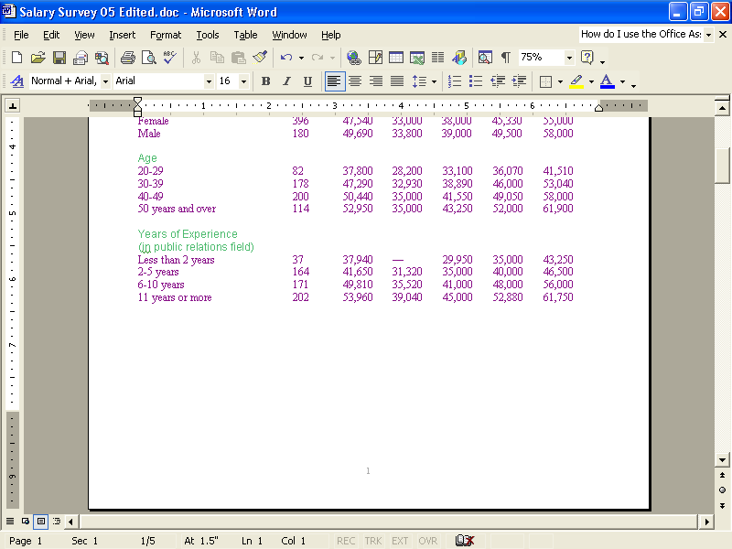

Creating Headers and Footers
Along with page numbers, headers and footers are great for documents that contain more than one page. Headers and footers work great in documents containing chapters or sections, because you can let the reader know where they are in the document by using the header or footer to show them what section they are reading.
You can add header or footer text to a document in the upper- or lower-page margins. This text can be a document identifier such as a file name, or perhaps a page number or information about the author.
In Normal view you cannot see the header and footer, but in Print Layout view you can.
In this exercise, you open the header, and then add text to the header.
1 On the View menu, click Header and Footer.
If the Header and Footer toolbar is in your way, drag the toolbar to move it.
The Header and Footer toolbar and the Header and Footer boxes appear, and you now have access to the header. Notice that the Header box is at the top of the page and the Footer box is at the bottom of the page.
2 On the Header and Footer toolbar, click the Switch Between Header and Footer button.
The insertion point moves from the header to the footer.
3 Click the Switch Between Header and Footer button again.
The insertion point is back in the header.
4 Type your name.
Your name appears in the upper-left corner of the header.
5 Scroll to the second page and look at the header.
Your name also appears there.
6 On the Header and Footer toolbar, click the Close button.
The Header and Footer toolbar closes.
Keep this file open for the next exercise.

Switching Page Orientation
You can lay out the text on a page in two ways: portrait orientation and landscape orientation. Text placed in portrait orientation appears horizontally on a vertical page. This is the default page orientation in Word. Text placed in landscape orientation appears horizontally on a page that is turned on its side. Diplomas and awards are usually oriented in this manner.
The following figures illustrate portrait and landscape orientation.
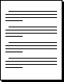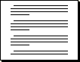
You can change orientation even after you’ve started creating a document.
In this exercise, you change the page orientation from portrait to landscape.
1 On the File menu, click Page Setup.
The Page Setup dialog box appears.
2 Click the Margins tab, if necessary.
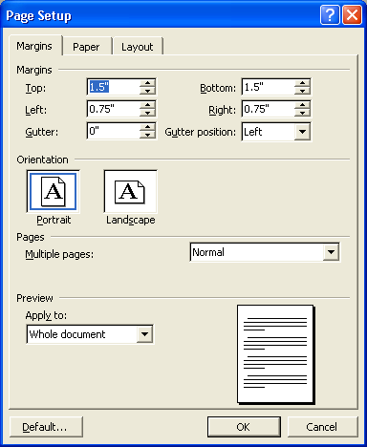
3 Click the Landscape option, view the Preview box, and click OK.
Notice in the Preview box that the page orientation changed from portrait (8.5″ x 11″) to landscape (11″ x 8.5″).
The text appears in landscape orientation.
4 On the Standard toolbar, click the Zoom down arrow, and click Whole Page.
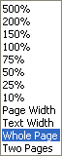
The first page of the document should now look similar to the following.
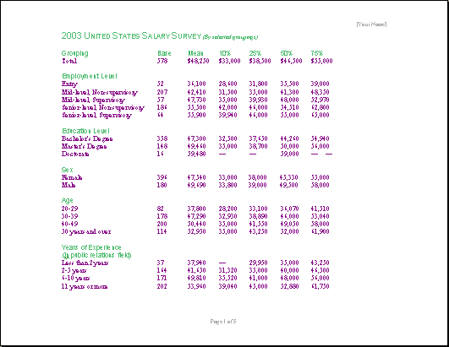

Lesson Wrap-Up
In this lesson, you learned how to change page margins, format paragraphs, and set and change tab stops. You also learned how to create headers and footers, insert page numbers, and change the orientation of a document.
If you are continuing to other lessons:
1 On the Standard toolbar, click the Save button to save changes made to the file that you edited.
Word saves the changes.
2 On the File menu, click Close to close the file.
Word closes the file.
If you are not continuing to other lessons:
1 On the Standard toolbar, click the Save button to save changes made to the file that you edited.
Word saves the changes.
2 In the upper-right corner of the Word window, click the Close button.
The Word program closes.

Quick Quiz
1 Name three ways in which you can change the page margins in Word.
2 How is vertical alignment similar and different from horizontal alignment?
3 How do you display the measurements of the page margins?
4 How do you display the Headers and Footers toolbar?
5 What’s the difference between the Left Indent marker and the Left Page Margin marker on the ruler?
6 How do you clear a tab stop?
7 How do you specify that you want to insert a page number in the upper-right corner of the document?
8 When the headers and footers boxes are displayed, what two ways can you switch between the header and the footer?
9 When you delete a paragraph mark, what formatting characteristics does that paragraph take on?
important
In the Putting It All Together section that follows, you must complete Exercise 1 to continue to Exercise 2.

Putting It All Together
Exercise 1: If necessary, start Word. Open a new, blank Word document. Adjust the left and right page margins to 2 inches and change the orientation
to landscape. Insert tab stops at 2 inches, 4 inches, 6 inches, and 8 inches. The 6-inch tab stop should be a decimal tab and the 8-inch tab stop should be a right tab. Type the following headings in the first line:
Years Experience, Base, Mean, and 90%.
Insert a new line, make heading text bold, and then save the document as Practice 05.
You will use Exercise 1 to complete the following exercise.
Exercise 2: Type the following information on the next two lines, pressing Tab between the entries.
Less than 2 years 37 $37,940 $43,250
2-5 years 164 $41,650 $55,000
Create a centered heading with the title Survey Results and a footer with the current date on the left and Page X of Y on the right (where X is the current page and Y is the number of pages). Save the file in the Lesson05 folder, and close the document.
Exercise 3: In the Header and Footer toolbar there is an Insert AutoText button. Open a new blank document and experiment with the various options available through this feature. Save the file in the Lesson05 folder, and close the document.
Exercise 4: In your open document, set up a list of your favorite musical artists. Set a Left tab at 1″ and enter the name of the group or musician. Set another Left tab and enter the name of a CD you own by this artist. If you own multiple CDs, press Enter and press Tab twice to enter each of the CDs you own in a separate line of text. Next to this information, set a Right tab at 5″ and rank each CD on a scale of 1 to 10 (least favorite to favorite). Fill in the information for several artists. Save the file in the Lesson05 folder, and close the document.
Exercise 5: In this lesson we adjusted the spacing after a paragraph. What other Spacing options are available for paragraphs and for lines? Explore the Paragraph dialog box or use Word’s help files to find out more about paragraph and line spacing.

