Using Editing and Proofing Tools
Lesson 6

After completing this lesson, you will be able to:
- Check spelling in a document.
- Use the Shortcut Menu for words and phrases.
- Check for grammatical errors.
- Find specific text.
- Replace specific text.
- Insert the date and time as text or as a field.
- Insert special characters.
- Add, view, and edit comments.
Before you deliver a Microsoft Word 2002 document to others, you should always proofread it carefully. Proofreading involves correcting all spelling and grammar errors and making any other final changes to the document. Fortunately, Word’s spelling and grammar capabilities can do some of this work for you.
The dictionary contains all words that Microsoft identifies as correct when you check the spelling of a document, including many proper nouns and acronyms. If you type Our plans is to send the document after it has been proofread, Microsoft will mark plans is as a grammatical error. On the other hand, if you type Too whom it may concern, Word will not mark the word Too as being a grammatical error. The bottom line: even after you use Word’s spelling and grammar checking features to make corrections in a document, you still need to read through the document carefully to look for any additional errors.
Additionally, once you give a document to others, they need a way to provide you with feedback. Word’s Comment feature allows them to give you this feedback and make suggestions without altering the content of the document.
In this lesson, you will check spelling and grammar in a document and find and replace specific text. You will insert date and time fields and special characters. Lastly, you will add comments to a document.
To complete the procedures in this lesson, you will use the files Brochure 06 and Ruffles Article 06 in the Lesson06 folder in the Word Processing Practice folder located on your hard disk. The first document explains the services provided by the public relations firm Contoso, Ltd.

Checking Spelling in a Document
There are three ways to check spelling in a document, depending on whether you want to correct errors as soon as Word identifies them or whether you want to wait and check spelling for the entire document after you have created it:
- Right-click a word that has a red wavy underline, and then select a suggested correction from the list.
- On the Standard toolbar, click the Spelling and Grammar button to check spelling and grammar in the entire document.
- On the Tools menu, click Spelling and Grammar to check spelling and grammar in the entire document.
When you check the spelling for a complete document, Word compares each word in the document with words in its standard dictionary. If an error is found, the word is selected in the document window, and alternative selections are listed in the Suggestions list. After a possible misspelled word has been located, the following options are available, some of which appear as buttons in the Spelling and Grammar dialog box.
Button | Function
Ignore Once | Ignores only that occurrence of the selected word.
Ignore All | Ignores all occurrences of the word.
Add to Dictionary | Adds the word to the custom dictionary.
Change | Replaces the selected word with the selected word in the Suggestions list.
Change All | Replaces all occurrences of the word with the selected word in the Suggestions list.
Suggestions | Lists alternative suggestions for the misspelled word in the list.
AutoCorrect | Adds the word to a list that Word uses to automatically correct spellings of the word as you type it.
Undo | Returns a spelling correction to its previous state.
Delete | Appears if a double occurrence of a word is detected (such as to to modify the document), and can be used to delete the second occurrence.
Options | Customizes spelling and grammar checking. For example, you can specify whether you want Word to ignore certain words with uppercase characters or words with numbers when Word checks spelling.
In this exercise, you correct a single spelling error, check a complete document for spelling errors, and then correct or ignore the potential errors that Word identifies.
To complete the following exercise, you should verify that the Check spelling as you type option is in use. On the Tools menu, click Options. In the Options dialog box, click the Spelling & Grammar tab, and verify that the Check spelling as you type check box is selected.
1 On the Standard toolbar, click the Open button.
The Open dialog box appears.
2 Click the Look in down arrow, double-click the icon for your hard drive, double-click the Word Processing Practice folder, and then double-click the Lesson06 folder.
The contents of the Lesson06 folder are displayed.
3 Double-click the file Brochure 06.
The file Brochure 07 appears in Word and the Open dialog box closes.
4 In the first line of the second paragraph, right-click the misspelled word aech, and click each in the list of possible corrections that appears.
The word is corrected in the document.
5 On the Standard toolbar, click the Spelling and Grammar button.
You can also start the spelling and grammar checker by pressing F7.
The Spelling and Grammar dialog box appears with the word CLnetworks selected in the document window.
Word has only one suggestion for this term and it is obviously not the correct substitution.
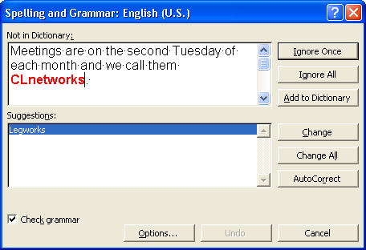
6 Clear the Check grammar check box if it is currently selected.
7 Click the Ignore All button.
The word and all future instances of it in the document are ignored, and the word an is selected. Because this is an occurrence of a double word and not a misspelling, no alternative spellings are offered.
8 Click the Delete button.
The second occurrence of the word an is deleted, and the capitalization error MEmbership is selected. The correct usage of the capitalized word is displayed and selected in the Suggestions list.
9 Click the Change button to change the capitalization to Membership.
10 Word continues to check the document for spelling errors. When an error occurs, choose the best choice in the Suggestions list and click the Change button. Continue making the necessary corrections in the document.
You can undo spelling corrections one-by-one immediately after closing the Spelling and Grammar dialog box. On the Standard toolbar, click the Undo button to undo the most recently corrected word. Click the Undo button again to undo the next corrected word. Repeat this procedure to undo any other spelling corrections.
When Word has finished locating all potential spelling errors, the Spelling and Grammar dialog box closes and the following message box appears.
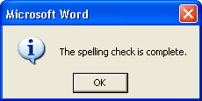
11 Click OK.
The message box closes.
12 On the File menu, click Save As, and Save the document as Brochure 07 Edited.
Word saves the document.
Keep this file open for the next exercise.

Using the Shortcut Menu for Words and Phrases
To identify the cause of a single grammatical error, you can right-click any word marked with a green wavy line to display a shortcut menu, and then make a selection from the shortcut menu as desired. The first item on the menu is a brief description of the error. If you click the About This Sentence item on the shortcut menu, Word displays a more thorough explanation of the grammatical problem and suggests ways to correct it.
If a red wavy line appears under a word that you know is spelled correctly (such as a proper name), you can add that word to the dictionary. To add a word to the dictionary and remove the red wavy line from all instances of that particular spelling, right-click the word to display a shortcut menu, and click Add to Dictionary.

Checking for Grammatical Errors
After you have typed your document, you can use Word to check the entire document for grammar and spelling errors. If an error is found, the word or phrase is selected in the Sentence box, and alternative words or phrases appear in the Suggestions list. You can ignore the error, check the grammar rule, or make changes to the existing document.
Normally Word checks for spelling and grammatical errors at the same time—with one exception. If you clear the Check grammar with spelling check box, Word checks only for spelling errors. You cleared this check box in the previous exercise to check for spelling errors only, so grammatical errors might still occur in your document. You can still check for grammatical errors at a later time.
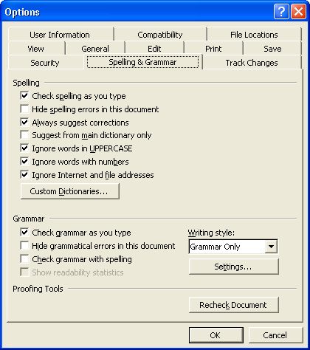
To turn on grammar checking after you have checked spelling in a document, you must use the Options dialog box.
To check grammar in a document (after you’ve turned on grammar checking), on the Standard toolbar, click the Spelling and Grammar button to display the Spelling and Grammar dialog box. Click the Ignore Once button to ignore an error; click the Ignore All button to ignore the error wherever it occurs; or click the Change button to make the suggested replacement that appears in the Suggestions list. Change All will review the document and find any other spellings that are the same and replace them with the text chosen in the Suggestions list.
If Word identifies a grammatical problem that can’t be corrected with a simple replacement (such as a sentence fragment or words that appear to be out of order), the Change button will be grayed out (made unavailable). However, the dialog box will suggest that you consider revising the sentence.
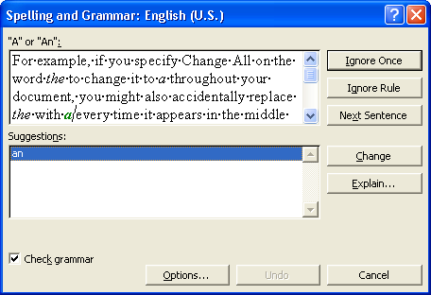
In this exercise, you check the grammar in a document.
1 Press Ctrl+Home to position the insertion point at the beginning of the document.
2 On the Tools menu, click Options.
The Options dialog box appears.
3 In the Options dialog box, click the Spelling & Grammar tab, if necessary.
4 In the Grammar section, select the Check grammar with spelling check box, and click OK.
5 Scroll down until you see the words that are underlined with a green wavy line (the sentence begins Membership open to individuals).
6 Right-click anywhere in the underlined area.
Word displays a shortcut menu that shows suggested corrections as well as provides access to further information.
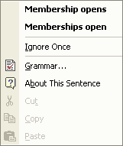
7 On the shortcut menu, click About This Sentence.
The Office Assistant appears and explains the meaning of subject-verb agreement and suggests ways to correct the grammatical error.
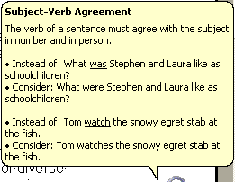
8 Click after the space following the word Membership, type is, and then press the spacebar.
The error is corrected by adding a verb to the sentence, and the green wavy line no longer appears.
Keep this file open for the next exercise.

Finding Specific Text
When you edit long documents, you might want to move quickly to a particular location in the document so that you can review or edit text at this location. If you know the location of the document contains a unique word or phrase, you can use Word’s Find and Replace dialog box to locate the word or phrase.
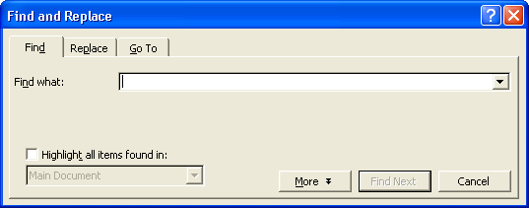
You can also display the Find and Replace dialog box by pressing Ctrl+F or by clicking the Select Browse Object button (lower-right corner of the Word window) and then clicking Find.
In the Find and Replace dialog box, you can click the More button to display additional search options. These search options allow you to define settings such as whether you are using wildcards or the Sounds like feature.
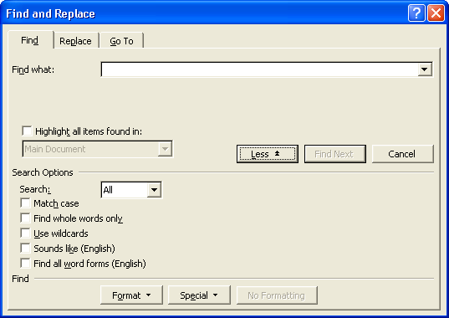
A wildcard character stands for any character that appears in one or more positions within a word or string of text. To use wildcards, in the Find and Replace dialog box, click the More button, and select the Use Wildcards check box. Use the question mark (?) wildcard symbol in a search string to represent any character in a single position within the word or text string. For example, the string h?t finds hat, hit, hot, and hut. Use the asterisk (*) wildcard symbol to represent any string of characters. For example, the string h*t finds hat, hurt, and even had sent.
A search string is a group or string of characters to be matched in the document when a search is performed.
You can use the Sounds like feature to find words that sound similar to the text string you are searching for, but which might be spelled differently. For example, when you use the Sounds like feature for the word meet, Word identifies meet, meat, and mete as matching the Sounds like rule.
In this exercise, you find a string of text within the current document, and you expand the Find and Replace dialog box to display additional search options.
1 Press Ctrl+Home to position the insertion point at the beginning of the document.
2 On the Edit menu, click Find.
The Find and Replace dialog box appears.
You don’t have to search for full words. You can also search for parts of words or phrases. For example, if you wanted to find the word envelope, you could shorten the search string by just searching for envel to find all words that have that set of characters in the text.
3 In the Find what box, type meetings, and click the Find Next button.
The word meetings at the beginning of the second paragraph is now selected. The Find and Replace dialog box remains unchanged.
4 In the Find and Replace dialog box, click the Find Next button to display the next occurrence of the word meetings.
The word meetings at the end of the second paragraph is now selected. The Find and Replace dialog box still remains unchanged.
You may need to drag the Find and Replace dialog box out of the way so that you can see the selections within the document.
5 Click the Find Next button again.
Word searches again for the word meetings and displays a message box indicating that Word has finished searching the document.
6 Click OK.
The message box closes.
7 In the Find and Replace dialog box, click the More button.
The dialog box expands to show the Search Options section.
8 In the Find and Replace dialog box, click the Cancel button.
The dialog box closes.
Keep this file open for the next exercise.

Replacing Specific Text
The Replace command allows you to quickly locate any string of characters, such as a word or phrase. The string of text, when found, can be replaced by a different string using the Find and Replace dialog box.
For example, the marketing department is revising a brochure about the organization and services provided by Contoso, Ltd. The company used to be commonly referred to as Contoso; however, now the company wants to use the full company name Contoso, Ltd. in all communications. The marketing manager now must find every instance of Contoso in the brochure and change it to Contoso, Ltd.
The marketing manager could scroll through the brochure to visually search for text and replace each instance of Contoso with Contoso, Ltd., but this task is time consuming and is not a foolproof way to guarantee that all corrections will be made. A better approach is to use Word’s feature for replacing specific text.
You can use Find and Replace in only a portion of a document by selecting text before you begin the replacement.
tip
Most fonts are called variable-width fonts because the spaces between characters can be adjusted to accommodate adjoining characters of different widths. For instance, in the word Wide, the width of the letter W is much greater than the width of the letter i. With most fonts, the space before the letter i is reduced so that the letter is “tucked in” closer to the letter W. When you use variable-width fonts, sentences look more professional when only one space follows a period. (The convention of typing two spaces after a period stems from the use of typewriters to create documents; most typewriters cannot adjust the widths between characters and words.) To make sure that only one space is used at the end of all sentences in a document, you can use Find and Replace. In the Find box, type a period (.) followed by two spaces. In the Replace box, type a period (.) followed by one space. Word searches for all the periods followed by a double space and replaces them with a period followed by a single space.
In this exercise, you find and replace text within the current document.
1 On the Edit menu, click Replace.
The Find and Replace dialog box opens with the Replace tab selected.
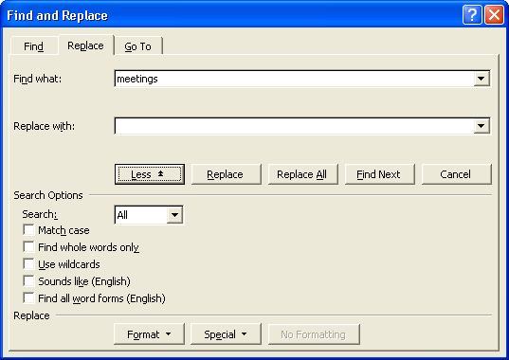
Word keeps track of the previous word or phrase that you searched for in case you want to perform the search again. Notice that the Find What box contains the word meetings, which you searched for in the previous exercise.
2 Press Delete.
The word meetings is removed from the Find what box.
3 In the Find what box, type Contoso.
4 Press the Tab key, or click in the Replace with box, and type Contoso, Ltd.
5 Click the Find Next button.
The first occurrence of Contoso is selected.
6 This first instance of Contoso already has Ltd. following it so click Find Next.
The next occurrence of Contoso is selected. This, too, already has Ltd. following it.
7 Click the Find Next button.
The next occurrence of Contoso is selected. This does not have Ltd. following it.
8 Click the Replace button.
The abbreviated company name is replaced with the full company name, and the next occurrence of Contoso is selected.
9 Continue clicking Replace or Find Next as appropriate.
You can use the Undo command to reverse the previous replacement (when confirming replacements) or to reverse all replacements (if you specified Replace All).
All additional occurrences of Contoso are replaced with Contoso, Ltd. After the last replacement, Word displays a message box indicating that it has completed the search and asks if you want to continue the search at the beginning of the document.
important
Be careful when you use Replace All, because you can accidentally replace things that you didn’t intend to. For example, if you are replacing the with a and you click Replace All, you might also accidentally replace the with a every time it appears in the middle of a word. For example, lithe becomes lia, and weather becomes weaar.
10 In the message box, click No.
The message box closes
11 In the Find and Replace dialog box, click Close.
The Find and Replace dialog box closes.
12 On the Standard toolbar, click the Save button.
Word saves the document.
Keep this file open for the next exercise.

Inserting the Date and Time
You can also use Word to insert the current date and time into a document. Occasionally, the Human Resources department of Contoso, Ltd. sends a document containing amended company policies to all resort employees. The date and time is inserted within the footers of the document so that the employees know that they are reading the most current version of the policies.
Date and time information is available in numerous formats and can be inserted as text or as a field. A field is a formula that generates specific results within your document. You add the field where you want the information to appear; the field inserts information when you open the document. For example, if the date or time is inserted as a field, it’s updated automatically when a particular action is performed, such as opening, saving, or printing the document.
In this exercise, you insert the current date into the document as text and as a field.
1 Press Ctrl+Home to position the insertion point at the beginning of the document.
2 On the View menu, click Header and Footer.
The Header and Footer toolbar is displayed.
3 On the Header and Footer toolbar, click the Switch Between Header and Footer button.
For more information on Headers and Footers, see Lesson 5, “Changing the Layout of a Document.”
The view of the document moves to the Footer box on the bottom of the first page.
4 On the Insert menu, click Date and Time.
The Date and Time dialog box appears, showing all the possible date and time formats in the Available formats list.
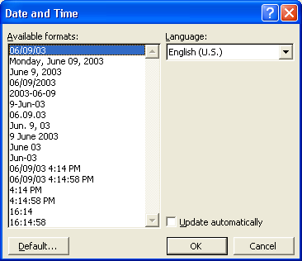
You can also insert the date or the time from the Headers and Footers toolbar by clicking the Insert Date or Insert Time button.
5 Click the third available format (the month that is spelled out, date, and the year), and click OK.
The current date is inserted, and the dialog box closes.
6 Press Tab twice to move to the right edge of the footer, type Last update on, and then press the spacebar.
7 On the Insert menu, click Field.
The Field dialog box appears.
8 Click Date and Time in the Categories list.
The Field names list displays the options that are available for the Date and Time category.
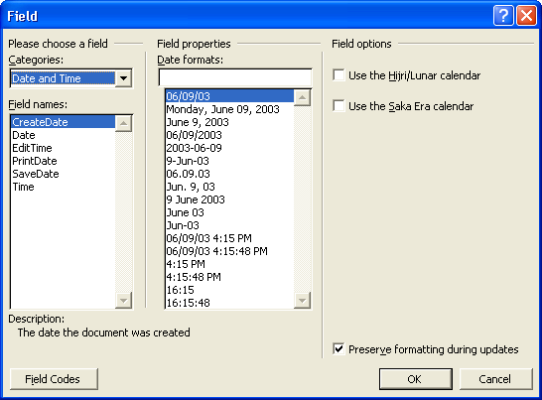
9 In the Field names list, click SaveDate, and click OK.
The dates that you insert in steps 5 and 9 show the current date, but only the date field in step 9 is automatically updated each time the document is saved.
The date and the time that the document was last saved is inserted on the right side of the footer. Every time this document is saved, the date field is automatically updated.
10 Click the Close button on the Header and Footer toolbar.
11 On the Standard toolbar, click the Save button.
Word saves the document.
Keep this file open for the next exercise.

Inserting Special Characters
Special characters are symbols and punctuation marks that do not have a key on most keyboards, such as an em dash (—), an ellipsis (...), a copyright symbol (©), or a trademark (™) symbol. You can insert these special characters by using the Symbol command on the Insert menu. Many symbols also have shortcut keys listed next to them in the dialog box.
The marketing manager at Contoso, Ltd. is putting together a brochure for a local toy store. Throughout the brochure are listings of various toys. The marketing manager uses Word’s special characters to insert the trademark symbol after the product name.
In this exercise, you insert the trademark symbol into the current document.
1 Press Ctrl+End to ensure that the insertion point is at the end of the document.
2 Click to position the insertion point between the t and the period in ICorrect.
3 On the Insert menu, click Symbol.
The Symbol dialog box appears.
4 Click the Special Characters tab.
The contents of the Special Characters tab appear.
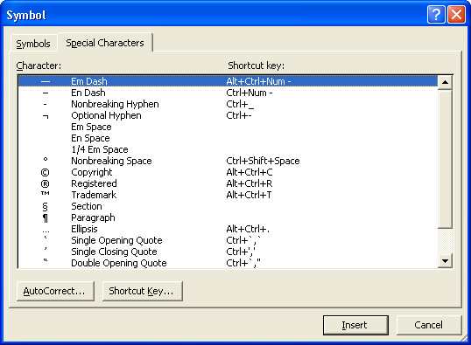
You can also find many common symbols on the Symbols tab. Click to position the insertion point in the document where you want to insert the symbol, on the Symbol tab, click the symbol, and click Insert. Word inserts the symbol in the document. Click Close to close the Symbol dialog box.
5 Click Trademark, and click the Insert button.
The trademark symbol is inserted in the document at the current position of the insertion point.
6 Click the Close button.
The dialog box closes.
Keep this file open for the next exercise.

Adding Comments
The marketing assistant wants to send the brochure to the general manager for review. The general manager wants to include notes explaining why he has suggested certain changes, but he doesn’t want his explanations to be part of the document, only his changes. He can use Word to add explanatory notes, called comments, without making changes to the body of the document. He inserts comments when he wants to explain a particular change that he has made.
To insert a comment, you select the text you want to comment on and then click Comment on the Insert menu. When you insert your first comment into a document, Word automatically opens the Reviewing toolbar if it is not already displayed. Type your comment in the comment balloon or the Reviewing Pane. Word inserts colored brackets around commented text and displays comments in a balloon in the margin of the document or in the Reviewing Pane.
You can also insert comments by displaying the Reviewing toolbar and then clicking the Insert Comment button.
To view comments, read the text in the comment balloons. You can also point to commented text to see a ScreenTip showing both the name of the person who made the comment and the date and time of the comment. To edit or delete a comment, you right-click the commented text and then click Edit Comment or Delete Comment. To review comments, you click the Next Comment and Previous Comment buttons to move from one comment to another. To respond to a comment, you click in the comment balloon or the comment text in the document and then click the New Comment button. Type your response in the new comment balloon that appears.
If Word cannot display the complete text of a comment in a balloon, you can open the Reviewing Pane to see the entire comment. If you find the comment balloons distracting, you can turn them off and work with comments only in the Reviewing Pane. To show or hide balloons, on the Tools menu, click Options to open the Options dialog box, click the Track Changes tab, and then select or clear the Use balloons in Print and Web Layout check box. To show or hide the Reviewing Pane, you click the Reviewing Pane button on the Reviewing toolbar. In addition to providing information about comments in the document, the Reviewing Pane tracks changes to the main part of the document, to headers and footers and their text boxes, to text boxes themselves, and to footnotes and endnotes.
In this exercise you add comments to the brochure, view the comments, and then edit them.
1 Press Ctrl+Home.
The insertion point is positioned at the beginning of the document.
2 In the first sentence of the second paragraph, select the text second Tuesday of each month.
3 Open the Insert menu and click Comment.
Word displays the Reviewing toolbar, puts colored brackets around the selected text, and places the insertion point inside the Comment balloon.
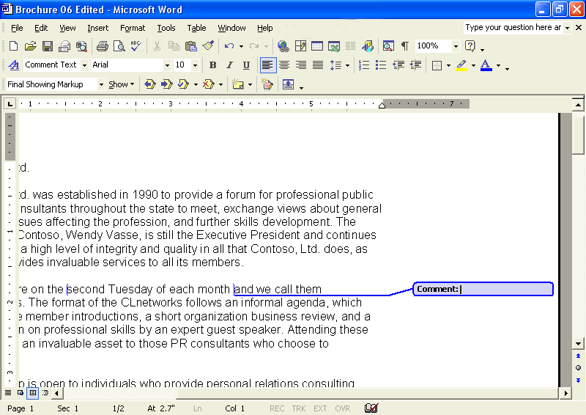
4 In the Comment balloon, type Are we going to change the monthly meeting day?.
Word adds the comment to the document.
5 Hold the mouse pointer over either the Comment balloon or over the text within brackets.
The name, date, and time that appear in the ScreenTip for your comment will reflect the User Information currently entered into Office XP and the current date and time.
A ScreenTip appears with the name of the reviewer and the date and time of the comment.
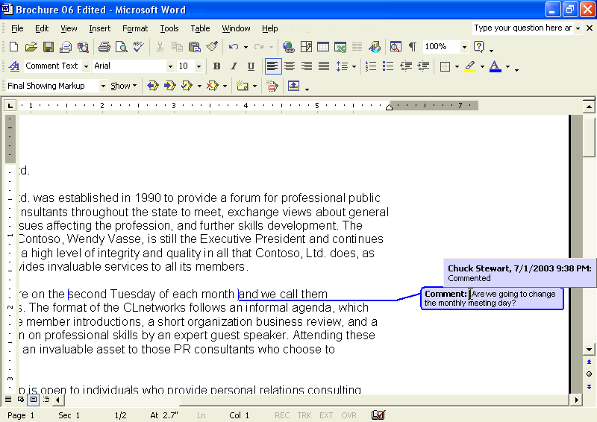
6 Move the mouse pointer away from the bracketed text or the Comment balloon.
The ScreenTip no longer appears.
7 Click the Reviewing Pane button on the Reviewing toolbar.
To change the size of the Reviewing Pane, point to the top edge of the Reviewing Pane until the pointer changes to a resize pointer, and then drag the edge.
The Reviewing Pane opens at the bottom of the screen.
8 Select the text personal relations consulting services in the first sentence of the third paragraph and then click the New Comment button on the Reviewing toolbar.
Colored brackets are placed around the selected text, the insertion point appears inside the Comment balloon, and a new comment line with the name of the reviewer and the date and time of the comment appear in the Reviewing Pane.
9 Type Is there a better term for this or a better way of phrasing this?.
The text you type appears in the balloon and in the Reviewing Pane simultaneously.
10 Click anywhere in the word ICorrect in the last paragraph of the document and then click New Comment on the Reviewing toolbar.
A single bracket is placed at the location of the insertion point, the Comment balloon opens, and a new comment line appears in the Reviewing Pane.
11 Click in the space under the new comment line in the Reviewing Pane and type I think this item should be included in the list of services.
The text you type appears in the balloon and in the Reviewing Pane simultaneously.
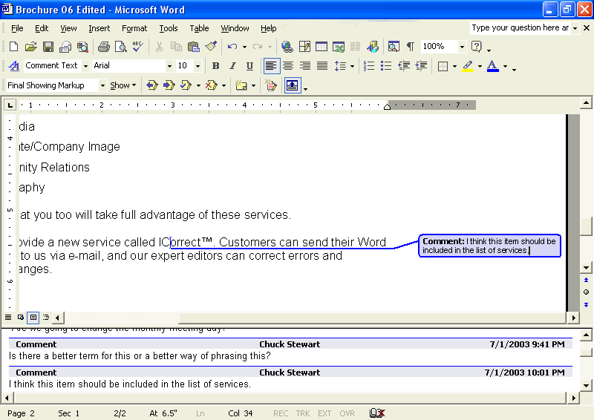
12 Click the Reviewing Pane button on the Reviewing toolbar to close the Reviewing Pane.
The Reviewing Pane closes.
13 Scroll up to the first comment you inserted into the document and click inside the Comment balloon at the end of the question you had typed there.
The insertion point is inserted in the Comment balloon at the end of the existing text.
14 Press the Spacebar and type Ask Tom about this.
The comment is edited to include this additional text.
15 Scroll down if necessary, click in the second comment to select it, and then click the Reject Change/Delete Comment button on the Reviewing toolbar.
You can also delete a comment by right-clicking on it and then choosing Delete Comment from the shortcut menu.
The comment is deleted and the brackets are removed from the text.
16 On the Standard toolbar, click the Save button, then close the document.
Word saves the document and then closes it.

Lesson Wrap-Up
In this lesson, you learned how to use some of Word’s editing and proofing tools, such as how to check spelling and grammar in a document; find and replace text; and insert dates, times, and special characters.
If you are not continuing to other lessons:
- In the upper right corner of the Word window, click the Close button.
The Word program closes.

Quick Quiz
1 How do you specify a date format when you insert the current date into a document?
2 When searching for a string of text, how can you specify that you want to search for a word that sounds like the one for which you are searching?
3 If you commonly use a word that is interpreted as a spelling error, what command on the shortcut menu allows you to enter this word in the custom dictionary?
4 In a document, what do red and green wavy underlines indicate?
5 How do you replace a text string throughout a document without having to confirm it each time?
6 How can you use the Find and Replace dialog box to display a specific page in the current document?
7 How would you insert the registered trademark symbol (®) in a document?

Putting It All Together
Exercise 1: If necessary, start Word. Contoso, Ltd. has a client who sells fabric and wants to publish an article to help promote sewing. The operations manager at Contoso, Ltd. has agreed to edit the article.
Open the Ruffles Article 06 document located in the Lesson06 folder in the Word Processing Practice folder on your hard disk. Check the spelling and grammar and correct any errors. Use your judgment about which errors you want to ignore and which ones you want to change. Then search for the word material and replace all instances of the word with fabric.
important
Exercise 2 builds upon Exercise 1. The exercises work best if they are completed consecutively.
Exercise 2: To the last sentence in the second paragraph that ends with purchasing your fabric, add the following text: Then when you place an order, you’ll be sure to purchase the correct amount. Select the sentence that you just added and insert a new comment that reads I added this sentence to clarify how the correct amounts are achieved. Search for any instances where there is a period with two spaces after it and replace it with a period and only one space. (Hint: You may need to search the document more than once if there are any instances where more than two spaces were inserted.) Save the document.

