Working with Graphics
Lesson 7

After completing this lesson, you will be able to:
- Insert pictures from files.
- Insert pictures from the Microsoft Clip Gallery.
- Resize and reposition a picture.
Documents that contain only text can certainly provide a wealth of information to readers, but they usually aren’t very visually interesting. Fortunately Microsoft Word 2002 makes it easy to insert pictures and other graphics into your text documents. A picture is any graphical image that is created by another program, captured from a scanner or digital camera, or downloaded from the Web. Pictures include drawings, photographs, and all of the clip art stored in the Microsoft Clip Gallery.
In this lesson, you will learn how to insert and edit pictures and graphical objects in a document.
To complete the procedures in this lesson, you will need to use the files Tailspin Toys 07 and Balloon in the Lesson07 folder in the Word Processing Practice folder located on your hard disk.

Inserting a Picture from a File
You can choose from dozens of programs for creating and editing pictures on your computer. A few examples are Adobe Photoshop, Adobe Illustrator, Microsoft Paint, Paint Shop Pro, and Microsoft PhotoDraw. These and other programs allow you to create, edit, and save pictures. A scanner or digital camera is also useful when you want to capture and then store pictures as files on disk. And, of course, millions of picture files are available for downloading on the Web.
Contoso, Ltd. has a client who owns a chain of recreational sporting goods stores. The president of the company wants a brochure with picturesque views of mountains, rivers, trails, forests, and so on. The marketing manager, armed with her digital camera, went into the wilderness and took several scenic pictures. She can store the pictures on a disk and later insert them into the brochure.
In the following exercises, the Standard and Formatting toolbars have been separated.
If you have picture files available on your hard disk, on a floppy disk, or on a CD-ROM, you can insert them easily into your Word documents. A picture is inserted at the location of the insertion point. To work with pictures, you must use Word’s Print Layout or Web Layout views; pictures do not appear in Normal view.
You can also switch to Print Layout view from the status bar in the bottom of the Word window by clicking the Print Layout View button.
In this exercise, you insert a picture into a Word document from a file stored on your hard disk.
1 On the Standard toolbar, click the Open button.
The Open dialog box appears.
2 Click the Look in down arrow, click the icon for your hard disk, double-click the Word Processing Practice folder, and then double-click the Lesson07 folder.
3 Double-click the file Tailspin Toys 07.
Word opens the Tailspin Toys 07 document.
4 Click the blank line above the line that reads Fly up, up, and away.
5 On the Insert menu, point to Picture, and click From File.
The Insert Picture dialog box appears.
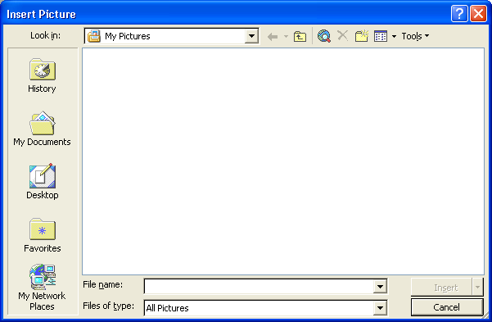
6 Click the Look in down arrow, and navigate to the Lesson07 folder in the Word Processing Practice folder.
Picture files in the folder appear in the Insert Picture dialog box.
7 Select Balloon, if necessary, and click the Insert button.
Rather than clicking the Insert button, you can double-click the file name in the list to insert the picture.
The picture is inserted at the insertion point.
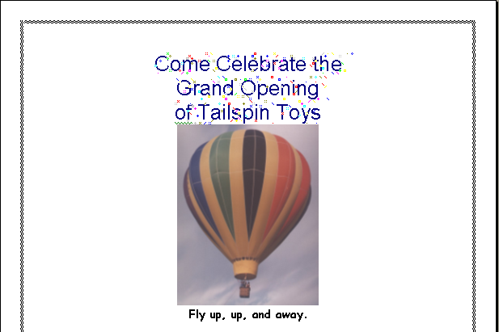
The picture is inserted where the insertion point was positioned. The blank line that you clicked prior to inserting the picture has already been formatted as a centered paragraph. If the insertion point had been in a paragraph that was left-aligned, the picture would have been inserted along the left margin of the page.
8 On the File menu, click Save As, and save the document as Tailspin Toys 07 Edited.
Word saves the document.
Keep this file open for the next exercise.

Inserting a Picture from the Clip Gallery
Microsoft Office 2002 includes hundreds of ready-made pictures that are available from the Microsoft Clip Gallery. Word refers to these pictures as
clip art. The Clip Gallery includes a wide variety of pictures, from scenic backgrounds to maps, buildings, people, and some photographs that you can insert into any Word document. Depending on how Word was installed on your computer, as many as several hundred or as few as 144 pictures might be installed on your hard disk. Use clip art pictures to add visual excitement to a document, to break up document text, or to help illustrate key points within a document.
You can also use the Clip Gallery to preview and insert sounds and video clips into a document.
The marketing manager at Contoso, Ltd. created a company memo reminding co-workers of the upcoming holiday office party. She used a picture of snowflakes and a picture of a snowman in the memo to make the appearance of the document more fun. She found these pictures in the Clip Gallery.
To insert a clip art picture, you must use Print Layout View.
Many clip art pictures are stored in the WMF (Windows Metafile) graphic format, which means that you can ungroup the image. When you ungroup a clip art picture, each component (or individual part) of the picture is defined as a separate drawing object and can be modified independently. Suppose you insert a WMF picture that shows several balloons and streamers. If you right-click the picture and then click Edit Picture, you can edit different parts of the picture individually. For example, you could delete or move a streamer or change the color of a balloon.
In this exercise, you preview clip art pictures in the Clip Gallery’s Insert ClipArt window and then insert a clip art picture into the current document.
Before the Insert Clip Art task pane opens, you may see a message box asking if you want to add clips to the organizer. If you see this dialog box, click Later.
1 Press Ctrl+Home.
The insertion point moves to the top of the document.
2 On the Insert menu, point to Picture, and click Clip Art.
You can also access the Insert ClipArt window by clicking the Insert Clip Art button on the Drawing toolbar.
The Insert Clip Art task pane appears.
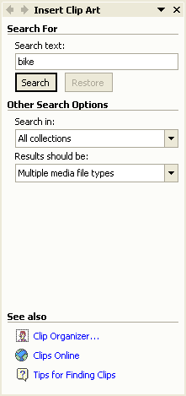
3 Click the down arrow in the Results should be box and deselect all media types except for Clip Art.
4 In the Search text box, type fireworks and click the Search button.
The Insert ClipArt task pane displays small versions of the pictures available that match this keyword search.
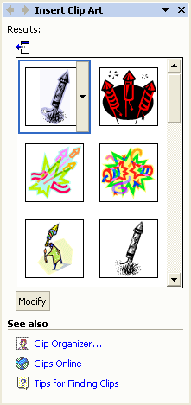
Depending on how Word was installed on your computer, your Insert ClipArt window might display more or fewer pictures than the illustration shown.
To see more pictures at once, click the left-pointing arrow near the top of the task pane to expand the pane
5 Point to an image of a firework and then click the down arrow that appears to the right of the picture.
You can also drag a picture from the Clip Gallery into your document or simply click on the picture to insert it.
A menu of options appears.
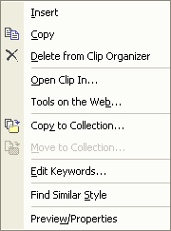
6 Click the Insert option on the menu.
7 In the upper-right corner of the Insert ClipArt task pane, click the Close button.
The picture is inserted in the upper-left corner of the document and the task pane is closed.
Notice that the text on the invitation is displaced where the picture was inserted and has moved down the page.
8 On the Standard toolbar, click the Save button.
Word saves the document.
Keep this file open for the next exercise.

Resizing a Picture
After inserting a picture into a Word document, you can easily increase or decrease the size of the picture. You begin by selecting the picture. When selected, a picture displays eight sizing handles (small white or black boxes) around its perimeter.
To resize a picture using the sizing handles, click the picture to select it. You can drag the left or right sizing handles to change the horizontal width of the picture, the top or bottom sizing handles to change the vertical height of the picture, or a corner handle to simultaneously change the width and height.
Sizing a picture vertically or horizontally can distort it because the original proportions of the picture are changed. To avoid distortion, use the corner sizing handles to resize a picture so that the original proportions are kept intact.
You can also use the Format Picture dialog box to size a picture to a specific height and width. To size a picture using the Format Picture dialog box, double-click the picture that you want to resize, and click the Size tab, if necessary. Click the Height and Width arrows in the Scale section to the desired percentage.
Often when you insert a picture, you’ll discover that text wraps around (or surrounds) the picture in a way that you didn’t intend. You can change the text wrapping style by using either the Picture or Drawing toolbar. The Picture toolbar appears whenever you select a picture.
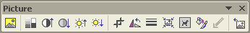
To display the Drawing toolbar, point to Toolbars on the View menu, and click Drawing or click the Drawing button on the Standard toolbar. To change the text wrapping style, click the Text Wrapping button on the Picture toolbar and select the desired wrapping style, or click the Draw button on the Drawing toolbar, point to Text Wrapping, and then click the desired wrapping style on the menu.
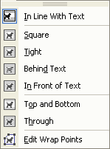
These text wrapping styles are available on the Drawing and Picture toolbars:
Text Wrapping Style  You can also change text wrapping by double-clicking the picture and clicking the Layout tab in the Format Picture dialog box. Additional text wrapping styles are available in this dialog box by clicking the Advanced button. | Button | Effect
In Line With Text |  | Places the object at the insertion point in a line of text in the document.
Square |  | Wraps text around all four borders of the picture.
Tight |  | Wraps text around the picture itself, often within the borders of the picture.
Behind Text |  | Allows text to be displayed on top of the picture.
In Front of Text |  | Allows the picture to be displayed on top of text.
Top and Bottom |  | Allows text to wrap above and below the picture, but not around the left and right borders of the picture.
Through |  | Wraps text in the same way as the Tight text wrapping style, but also wraps text into any open areas of the graphic.
Edit Wrap Points |  | Allows access to adjusting the specific wrap points of the object.
tip
Watermarks are dimmed pictures or text that appear faintly in the background of your printed document. You can use a picture such as a company logo as a watermark, or you can use words such as ASAP, Confidential, or Draft.
In this exercise, you reduce the size of the clip art picture by using the sizing handles, and then you change the text wrapping style for the picture.
1 Click the firework picture in the upper-left corner of the document.
The picture is selected, and eight black sizing handles appear around the perimeter of the picture.
2 Position the mouse pointer over the lower-right sizing handle until it becomes a diagonal two-headed resizing arrow and drag up and to the left until the firework is about half its original size, as shown in the next figure.

Pictures often look better if you shrink them rather than if you enlarge them. For example, just as photographs will become grainy if they are enlarged, pictures can become blurry if you enlarge them too much beyond their original size.
3 On the Picture toolbar, click the Text Wrapping button.
A menu of text wrapping styles appears.
4 Click the In Front of Text button.
The text returns to the top of the document, and the firework picture remains in the same position.
5 Click anywhere outside the picture to deselect it.
The top portion of your document should look similar to the illustration shown on the following page.
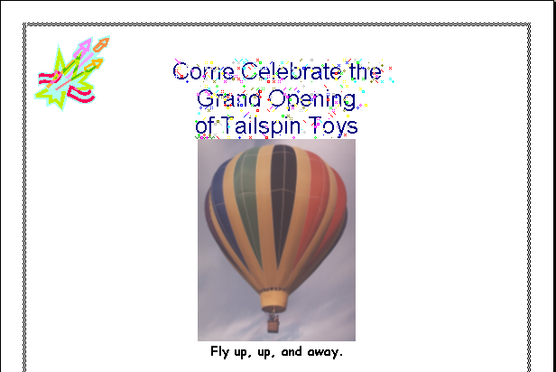
You can create the sparkle text effect, as well as other text effects, by selecting the text, clicking Font on the Format menu, clicking the Text Effects tab, and select-ing one of the animation effects that appear in the list. These text effects do not appear in a printed document.
6 On the Standard toolbar, click the Print Preview button.
The document appears in the Print Preview window, showing how the document will look when it is printed.
7 On the Print Preview toolbar, click the Close button.
The document returns to Print Layout view.
8 On the Standard toolbar, click the Save button.
Word saves the document.
Keep this file open for the next exercise.

Repositioning a Picture
You can select multiple drawing objects or pictures at once and then reposition them or resize them at the same time. To select multiple items, click the Select Objects button on the Drawing toolbar. The pointer changes to a left-pointing arrow. Drag the pointer to draw a box around all the items that you want to select.
The marketing manager at Contoso, Ltd is reviewing a brochure layout created by one of her assistants. Inadvertently, the assistant has transposed several pictures. Rather than deleting the current pictures and reinserting them in the appropriate spots, the marketing manager can save time and just drag the pictures to the new locations. You can also attach, or anchor, a picture to a paragraph mark so that if you move the paragraph, the picture automatically moves with it. Additionally, you can move or “nudge” pictures in small increments by selecting the picture and pressing the arrow keys. If you want to move an item only horizontally or vertically, press Shift as you drag.
To position a picture in relation to the page, a paragraph, or another anchor, select the item that you want to reposition. On the Format menu, click Picture. In the Format dialog box, click the Layout tab, and click the Advanced button. You can use this method to position other objects, including WordArt and AutoShapes.
The Layout tab of the Format Picture dialog box includes several options for adjusting the placement of a picture on a page and for controlling the way text wraps around a picture. (Some of these options are available only by clicking the Advanced button on the Layout tab.)
In the Advanced Layout dialog box, click the Picture Position tab, and select the options that you want for the horizontal and vertical positioning. For example, you can align the picture horizontally relative to the margin, the page, the column, or a character. You can also specify a precise numeric position for the picture relative to the page, the paragraph, and so on.
To ensure that a picture moves up or down with the paragraph to which it is anchored, in the Advanced Layout dialog box, select the Move object with text check box. To ensure that a picture remains anchored to the same paragraph when you move the paragraph, in the Advanced Layout dialog box, select the Lock anchor check box.

Lesson Wrap-Up
In this lesson you learned how to insert and resize pictures from a file and from the Clip Gallery.
If you are continuing to other lessons:
- On the File menu, click Close. If Word prompts you to save any changes, click No.
Word saves and closes the file.
If you are not continuing to other lessons:
- On the File menu, click Exit. If Word prompts you to save any changes, click No.
The file closes and the Word program closes.

Quick Quiz
1 Identify two methods that you can use to resize a picture.
2 From the Insert Clip Art dialog box, what two ways can you use to insert a picture?
3 When you select a picture, small boxes surround the perimeter. What are these boxes used for?
4 What menu command do you use to insert a picture that exists in another file and isn’t a clip art picture?
5 Which command do you use to insert a clip art picture?

Putting It All Together
Exercise: Open a new blank document and create an invitation for the grand opening of a coffee house. Type the following text in the invitation. Use the Clip Gallery to add a clip art picture related to coffee or a bakery, and place the picture below the invitation.
You’re invited to celebrate
The grand opening of
Fourth Coffee
5678 Main Street, Burlington, Vermont
On Saturday, November 06, 2004, beginning at 6:30 p.m.
Entertainment and dinner provided.
Save the document as Coffee House Opening.

