Working with Columns
Lesson 8

After completing this lesson, you will be able to:
- Create columns.
- Adjust column width.
- Adjust column spacing.
- Insert a column break.
Open a dictionary, a newspaper, or an issue of your favorite magazine, and you’ll usually see text displayed in columns. In word processing, columns are two or more blocks of text on a page in which text flows to the top of the next column when the first column is filled. (Columns can also contain pictures and objects.) Numerous readability studies show that people are more likely to read text carefully when the widths of lines are short. That’s why most newspapers and magazines format text into columns that are usually no more than three inches wide.
You can use Microsoft Word 2002 to easily format text into columns. Although columns aren’t always appropriate (you probably wouldn’t use them in letters, memos, or many business reports), they work well for newsletters, brochures, indexes, and lists. At times, columns can even help to make a document shorter, typically when most lines of text are short. For example, if you typed the names of all the glossary terms in this book and pressed Enter after each entry, you would have dozens of pages of text, but a lot of empty space on the right side of the document. If you typed the terms using two or three columns per page, the glossary would occupy far fewer pages.
Depending on how margins are set in a Word document, you can create up to 12 columns per page, although you’ll rarely need more than four or five columns per page. After you define columns in a document and type text so that it flows into the columns, you’ll often discover that you can improve formatting by manually changing where some columns break at the bottom, especially when a column ends in the middle of a sentence. You might also want to customize columns by changing the width, length, or spacing between the columns. You can perform all of these column formatting tasks in Word. You can even add a vertical line between columns to enhance your document’s appearance.
In this lesson, you will learn how to convert the text in a brochure to columns and adjust the formatting for different sections of the brochure.
To complete the procedures in this lesson, you will need to use the file Brochure 08 in the Lesson08 folder in the Word Processing Practice folder located on your hard disk. This document was created to explain the public relations services provided by Contoso, Ltd.

Creating Columns
Before you begin modifying a document to create columns, it’s important to think about how you want the columns to look on the page, how many columns you want, and how you want them to be formatted. The following is a list of items that you should consider when using columns.
- The width of the page minus the left and right margins.
- If the right and left page margins are two inches each, the width of the document becomes much smaller. Remember that you’ll also have to include space between the columns. The wider you want the page to be, the smaller the page margins should become to accommodate the text and columns.
- The number of columns that you want to appear across the page.
- Most documents that use columns have between two and three columns per page. The more columns you have on one page, the narrower the columns become. Narrower columns increase the number of hyphenated words and make the document harder to read.
- The length of each column.
- The length of each column determines how far the text extends to the bottom of the page.
- The amount of space between columns.
- Standard space between columns is .5 inch. If you have less space between the columns, the page becomes difficult to read. The greater the space between the columns, the smaller the columns become, and again, the harder the document is to read.
You can quickly create columns of equal width by using the Columns button on the Standard toolbar. When you click the Columns button, Word displays a graphical menu that you can use to specify the number of columns you want. You can also use the Columns dialog box to create columns of equal or unequal width, or you can customize each column with a specific column measurement. After you define the column formatting, you can modify the columns using either the Columns dialog box or the ruler. If you define columns in an existing document but don’t select any text, Word flows the entire document into columns using the formatting that you’ve specified.
To arrange text into more than four columns, you must use the Columns dialog box. On the Format menu, click Columns, and type the number of columns that you want.
If you want only certain sections of a document to be formatted into columns, you first select the text that you want formatted into columns and then apply column formatting to the selection. Word automatically inserts section breaks at the beginning and end of the selected text and flows the text into columns. In Word, a section break is a portion of a document that can have its own page formatting, independent of the formatting in other sections of the same document.
In the following exercises, the Standard and Formatting toolbars have been separated.
To create columns of equal width, select the text that is to be formatted into columns. On the Standard toolbar, click the Columns button to display the Columns menu, and click the number of columns you want.
You can also use Word to create columns of unequal width. You might want to do this to create a unique appearance or to accommodate different types of text (for example, a list of topics in a narrow column and topic descriptions in a wider column).
To create columns of unequal length, select the text to be formatted and on the Format menu, click Columns to display the Columns dialog box. To create two columns of unequal width, in the Presets section, click Left to make the left column narrower, or click Right to make the right column narrower.
To create customized columns using the Columns dialog box, type the desired number of columns in the Number of columns box, clear the Equal column width check box, and then type the desired measurements in the Width boxes. (You’ll customize column widths in a later exercise.)
The marketing manager at Contoso, Ltd. decided that she wants to reformat a brochure that describes the services that the company provides. Specifically she wants the text to appear in columns.
In this exercise, you format the entire Contoso, Ltd. brochure into columns by using the Columns button, and then you format a selection of text into uneven columns by using the Columns dialog box.
1 On the Standard toolbar, click the Open button.
The Open dialog box appears.
2 Click the Look in down arrow, navigate to the Word Processing Practice folder on your hard disk, and then double-click the Lesson08 folder.
3 Double-click the file Brochure 08.
To learn more about formatting marks see Lesson 5, “Changing the Layout of a Document.”
The Open dialog box closes and the file Brochure 09 appears in Word.
4 On the Standard toolbar, click the Show/Hide ¶ button if necessary, to show the formatting characters.
Formatting characters appear in the document.
5 On the Standard toolbar, click the Columns button.
You aren’t limited to four columns, as the Columns menu seems to indicate. To create more than four columns, drag to the right on the Columns menu to expand the menu to up to six columns and select the desired number of columns you want.
The Columns menu appears. Unlike most menus, the Columns menu is a graphical representation that you can use to specify the number of columns for a document or section of a document.
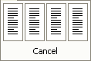
6 Click the third column in the menu.
The text in the entire document is arranged into three columns. The WordArt object appears over some of the text at the top of the page.
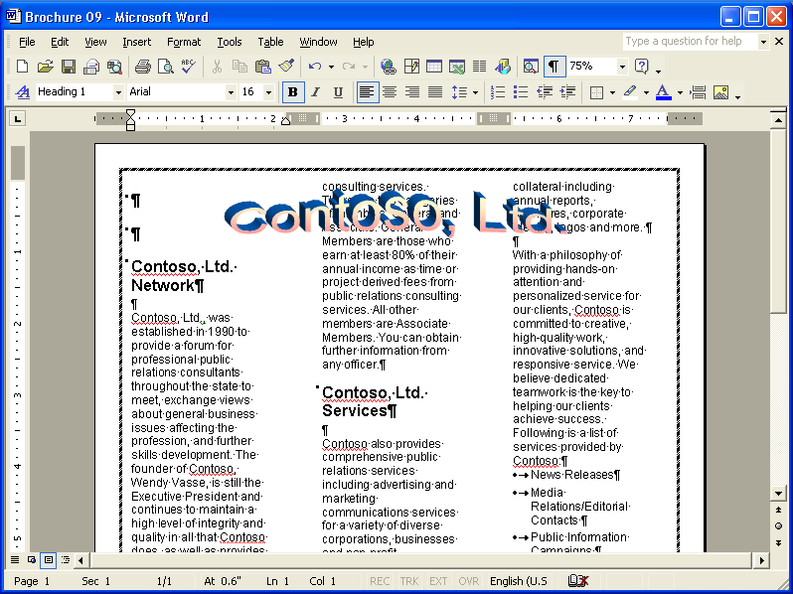
7 On the Standard toolbar, click the Undo button.
The document returns to its original layout.
8 Position the insertion point to the left of the paragraph mark under the subheading Contoso, Ltd. Network.
9 Select the paragraph mark and all the text under the Contoso, Ltd. Network subheading. Be sure to select the last paragraph mark in this section, but do not select the subheading Contoso, Ltd. Services or any text under this heading.
To select large blocks of text, click to position the insertion point at the beginning of the text, hold down the Shift key, and then click to the right of the last word that you want to select.
10 On the Standard toolbar, click the Columns button, and in the Columns menu, click the second column.
The selected text is formatted into two columns.
11 Click anywhere in the document to deselect the text.

12 On the Standard toolbar, click the Zoom down arrow, and click Whole Page.
13 Select all the text under the subheading Contoso, Ltd. Services (including the bulleted list), but do not select the subheading.
Make sure that you select text to the end of the document on the second page, not just to the end of the first page.
14 On the Format menu, click Columns.
The Columns dialog box appears.
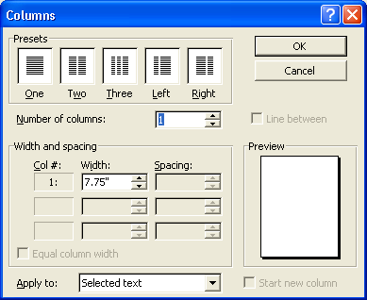
15 In the Presets section, click Right, and click OK.
The selection of text is formatted into two columns, and the left column is wider than the right column.
16 Click anywhere in the document to deselect the text.
The document should look similar to the following illustration.
17 On the Standard toolbar, click the Zoom down arrow, and click 75%.
The document layout appears at 75 percent of its actual size.
The zoom percentage that appears in the Zoom box can vary depending on the size of your monitor and the number and arrangement of toolbars that are open.
18 On the File menu, click Save As, and save the document in the Lesson08 folder as Brochure 08 Edited.
Word saves the document.
Keep this file open for the next exercise.

Specifying Column Width
In the previous exercise, you saw how to use the Presets section of the Columns dialog box to create columns of unequal widths. You can also modify the widths of columns using either the ruler or width settings in the Columns dialog box. Depending on how wide or narrow you make the columns, the space between the columns might automatically become wider or narrower.
For example, if you specify in the Columns dialog box that you want five columns, Word automatically formats the columns with equal width and spacing. If you make one of the columns wider in the Width box, all the subsequent column widths become narrower to accommodate the wider column. If you want to customize column widths, you should check the Preview area in the Columns dialog box as you change the settings to see how the other columns are affected by the modifications.
You can also use the up and down arrows to the right of the Width box to change the column width in increments of .5 inch.
In this exercise, you customize column widths using both the Columns dialog box and the ruler.
1 Click anywhere under the subheading Contoso, Ltd. Services.
2 On the Format menu, click Columns.
The Columns dialog box appears.
3 In the Width box for the first column, select the contents, type 4.5, and press Tab.
The width for column 2 automatically changes to 2.5 inches to accommodate the available space for this column after the left and right margin widths, the column width for column 1, and the space between columns have been calculated.
4 Click OK.
The column widths are adjusted based on the measurement that you enter.
5 On the ruler, position the mouse pointer on the Move Column marker until the pointer turns to a double-headed arrow. Hold down the Alt key, and drag the marker to the left so the left column is 4.25 inches wide (at which point the right column will be 2.75 inches wide).
It isn’t necessary to hold down the Alt key when you drag the Move Column marker; however, doing so allows you to view the measurements for the column widths so that you can be more precise.
6 Release the Alt key.
The column widths are adjusted.
7 On the Standard toolbar, click the Save button.
Word saves the document.
Keep this file open for the next exercise.

Adjusting Column Spacing
If you want to change the spacing between columns, you can use the ruler or the Columns dialog box to adjust the spacing. If you use the Columns dialog box, be sure to preview how the changes affect the columns.
For example, while creating the brochure, the marketing manager specifies in the Columns dialog box that she wants two columns. Word displays a preview of the columns, both set to 3.5 inches wide. The spacing between columns is set to .5 inch. The marketing manager decides to do some experimenting and sets the spacing to 2.5 inches; however, when she does this, the first column’s width automatically changes to 1.5 inches, and the second column’s width remains at 3.5 inches. Dissatisfied with the results, the manager sets the second column’s width to 1.5 inches, which automatically changes the first column’s width to 2.5 inches. She likes the preview, so she applies the settings to the brochure.
The measurements in the Spacing boxes identify the blank space that appears after each column. Be sure to look in the Preview area to see how the modifications affect other columns.
To change column spacing using the ruler, click anywhere in the section that contains the columns that you want to modify. The ruler displays the Move Column markers. Position the mouse pointer on the right edge of the Save the Move Column marker until you see the ScreenTip Left Margin, and drag the marker to the new position.
In this exercise, you change the spacing between columns by using the Columns dialog box.
1 Click anywhere in the section under the subheading Contoso, Ltd. Network.
2 On the Format menu, click Columns.
The Columns dialog box appears.
3 Clear the Equal column width check box, if necessary.
4 Select the measurement in the Spacing box for column 1, type .1, and press Tab.
The width of the second column changes to 3.9 inches.
5 Select the measurement in the Width box for the first column, type 3.7, and press Tab.
The width of both columns is adjusted to 3.7 inches.
6 Click OK.
The Columns dialog box closes, and the spacing between the columns changes.
7 On the Standard toolbar, click the Zoom down arrow, and click Whole Page.
The document layout is displayed as an entire page on your screen.
8 Click anywhere in the two-column section under the subheading Contoso, Ltd. Services.
9 On the Format menu, click Columns.
The Columns dialog box appears.
10 Select the measurement in the Spacing box, type .1, and press Tab.
The width of the second column changes to 3.15 inches.
11 Click OK.
The Columns dialog box closes, and the spacing between the columns changes.
You can also insert a manual column break by pressing Ctrl+Shift+Enter.
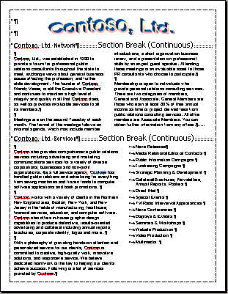
12 Click the Zoom down arrow, and click 75%.
The document appears at 75 percent of its actual size.
13 On the Standard toolbar, click the Save button.
Keep this file open for the next exercise.

Inserting a Column Break
When text in a column reaches either the bottom margin of a page or the next section break, the text flows into the next column on that page or section. When the text reaches the bottom of the last column on a page, the text flows into the first column on the next page. You can override an automatic column break that Word creates by inserting a manual column break.
To insert a manual column break, position the insertion point at the location where you want to insert the break. On the Insert menu, click Break. In the Break dialog box, click the Column break option, and click OK.
To delete a column break, make sure the Show/Hide ¶ button is selected on the Standard toolbar, click the Column Break marker, and press Delete.
In this exercise, you create a column break in the second column to view the results, and then you delete the column break.
1 In the last section, click to position the insertion point at the beginning of the third paragraph (which begins With a philosophy…).
2 On the Insert menu, click Break.
The Break dialog box appears.
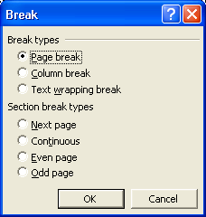
3 Click the Column break option, and click OK.
The first column ends at the location of the column break.
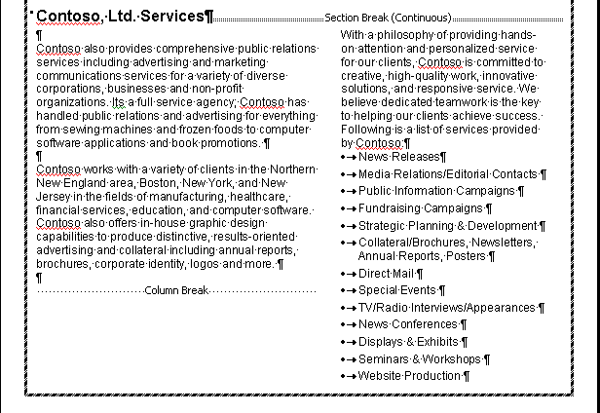
Notice that the column break moves two of the bulleted items to the second page, which is an undesirable result.
4 Click the Column Break marker, and press Delete.
The column break is removed, and the columns are formatted the way they were before you inserted the column break.
5 On the Standard toolbar, click the Save button.
Word saves the document.
Keep this file open for the next exercise.

Lesson Wrap-Up
In this lesson, you learned how to use Word’s column formatting features. You learned how to create columns, how to adjust column width and spacing, and how to insert manual column breaks.
If you are continuing to other lessons:
1 On the Standard toolbar, click the Save button.
Word saves the file.
2 On the File menu, click Close to close the document.
Word closes the file.
If you are not continuing to other lessons:
1 On the Standard toolbar, click the Save button.
Word saves the file.
2 On the File menu, click Exit.
The Word program closes.

Quick Quiz
1 What is the fastest way to create columns of equal width?
2 If you want to define columns of varying widths, what check box do you need to clear in the Columns dialog box?
3 What two ways can you use to customize the column widths in a document?
4 If you format a document into columns and later decide you don’t want the columns, how could you remove the column formatting?
5 How do the left and right page margins affect how you define the columns in a document?
6 When you change the spacing between two columns, how are the columns affected?
7 What happens if you define columns in an existing document but don’t select any text?

Putting It All Together
Exercise 1: Open the Industries Services 08 document in the Lesson08 folder in the Word Processing Practice folder. Format the first portion of the document to two columns of equal width, excluding the title at the beginning and the last section (the part under the subheading We Know Your Message). Save the document as Industries Services 08 Edited.
important
You must complete Exercise 1 to continue to Exercise 2.
Exercise 2: Using the file Industries Services 08 Edited, adjust the widths of the columns that you just created so that the left column is about twice as wide as the right column (4 inches for the first column and 2 inches for the second), and change the spacing between the two columns to .1. Format the final section of the document into four columns excluding the subtitle from the columns, and change the spacing between the four columns to .1.
Exercise 3: Open a new blank document and create a newsletter for an organization in which you are involved. This newsletter should tell about upcoming events, important dates, and perhaps contain an article recapping a past event. Use the tools you have learned about in this lesson as well as in other lessons (i.e., inserting pictures or graphics) to enhance your newsletter. Save and close the newsletter.
Exercise 4: Create a brochure to advertise your lawn maintenance services. This brochure should be set to print in landscape and should have 3 equal-width columns (so that the brochure can easily be folded in thirds). Make sure there is plenty of space between each column so that it is very easy to read. Content should include, among other things, the name of your company, areas in which your service is available, range of prices for your services, and a number where you can be reached. Enhance the brochure with graphics. Save, print, and close the brochure.
Exercise 5: Word offers another feature to assist with the layout of text on a page. This feature is called column boundaries. Type Column in the Ask A Question box and then select Display or hide newsletter-style column boundaries. Read the information provided by Word’s help file to learn how to turn on/off this feature. Open one of the documents you have created in these Exercises, turn on the boundaries feature, and explore using these text boundaries. Observe how they can assist with the placement of text, graphics, and objects. When you have finished, close your document without saving.

