Creating a Presentation
Lesson 1

After completing this lesson, you will be able to:
- Start Microsoft PowerPoint.
- Explore the PowerPoint window.
- Choose a method to start a presentation.
- Create a presentation using a wizard.
- Save a presentation.
With Microsoft PowerPoint, you can create overhead slides, speaker notes, audience handouts, and outlines—all in a single presentation file. PowerPoint offers powerful tools to help you create and organize a presentation step by step.
As an example, suppose that you are the vice president of sales for the public relations firm Contoso, Ltd. and are responsible for developing a new employee training program. The president of Contoso has asked you to create a brief presentation to describe the project at the annual stockholders’ meeting.
In this lesson, you will learn how to start PowerPoint, explore the PowerPoint window, choose a method to start a presentation, create a presentation using the AutoContent Wizard, and save your work.
You will not need any practice files for this lesson. Instead, you will create all of the files and folders that you need during the course of the lesson.

Starting Microsoft PowerPoint
After you install PowerPoint and the practice files, you are ready to start PowerPoint. As with other programs, there are several ways to start PowerPoint. One way is to use the Start button on the taskbar.
In this exercise, you start PowerPoint.
1 On the taskbar, click Start.
The Start menu appears.
2 On the Start menu, point to All Programs.
The Programs menu appears, displaying all the programs on your hard disk drive, including Microsoft PowerPoint. A portion of the Programs menu should look like the illustration on the following page.
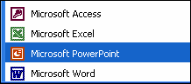
If you have installed PowerPoint 2002 as a separate program, your menu might look different.
3 Click the Microsoft PowerPoint icon to start PowerPoint.
tip
You can also start PowerPoint by creating a shortcut icon on the Windows desktop. Simply double-click a shortcut icon to start its associated program. To create a shortcut, click the Start button, point to All Programs, right-click Microsoft PowerPoint, point to Send To, and then click Desktop (create shortcut).
A desktop shortcut is represented by an icon with a curved arrow in the left corner.

Exploring the PowerPoint Window
When Microsoft PowerPoint opens, it displays the program window. A window is an area of the screen that is used to display a PowerPoint program or presentation window. The presentation window is the electronic canvas on which you type text, draw shapes, create graphs, add color, and insert objects. As with any Microsoft Windows XP program, you can adjust the size of the PowerPoint and presentation windows with the Minimize and Restore Down/Maximize buttons, and you can close PowerPoint or the presentation window with the Close button.
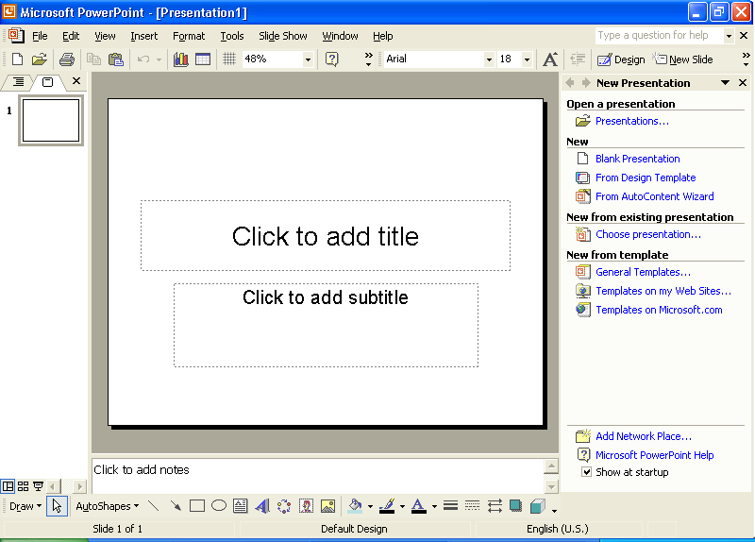
Along the top of the PowerPoint window are the menus and buttons you use to perform the most common presentation tasks. Another row of buttons might appear along the left side and on the bottom of the screen. The menus are lists of commands or options available in PowerPoint. The buttons you see are organized on toolbars. Toolbar buttons are shortcuts to commonly used menu commands and formatting tools. You simply click a button on the appropriate toolbar for one-step access to tasks such as formatting text and saving a presentation.

Toolbar Options
The Standard and Formatting toolbars are located directly below the menu bar. When PowerPoint is first started, the Standard and Formatting toolbars appear on the same row to save window space. Only the most commonly used commands appear on the toolbars. The toolbars on your computer might display buttons different from the ones shown in the figures in this lesson. To see the rest of the commands on either toolbar, click the Toolbar Options down arrow, shown in the margin. Once you use a button on the Toolbar Options list, it replaces a less frequently used button on the visible part of the toolbar. In this book, if you are instructed to click a button and you don’t see it, click the Toolbar Options down arrow to display all of the buttons on a toolbar.
When the Standard and Formatting toolbars share one row, you can’t see all the buttons, but you can access other buttons by clicking the Toolbar Options down arrow at the end of the toolbar.
PowerPoint uses personalized menus and toolbars. When you click a menu name, a short menu appears, containing the most frequently used commands. To make the complete long menu appear, you can leave the pointer over the menu name for several seconds, you can double-click the menu name, or you can click the menu name and then click the small double arrow at the bottom of the short menu. When the long menu is displayed, the commands that did not appear on the short menu are in light gray.
You can turn off the personalized menus feature so that all commands appear all the time on the menus. On the Tools menu, click Customize, click the Options tab, clear the Menus Show Recently Used Commands First check box, and then click Close.

Outline/Slides Pane
The default view, Normal, is made up of three panes: Outline/Slides, Slide, and Notes. The Outline/Slides pane has tabs that allow you to alternate between an outline of the slide text (the Outline tab) and a list of the presentation’s slides displayed as thumbnails (Slides tab). The Slide pane shows the slide as it will appear in the presentation. The Notes pane is where you enter speaker notes. You can resize any of the panes by dragging the gray bar that separates them.

Task Pane
At the right side of the PowerPoint window is the task pane, as shown in the illustration on the following page. The task pane displays commands and features you use often in working with presentations. Task panes let you work with commands without having to display menus or use toolbar buttons. Some task panes display automatically. For example, the New Presentation task pane opens along with PowerPoint each time the program starts. Other task panes display in response to a specific request. For example, when you tell PowerPoint you want to insert a clip art picture, the Insert Clip Art task pane opens to help you find a picture.
You can quickly switch from one task pane to another by clicking the Other Task Panes down arrow on any task pane to display the other task panes. When you’re finished with a task pane, click its Close button to hide it.
To open the task pane manually, click Task Pane on the View menu. This command opens the task pane if it is hidden or closes it if it is open.
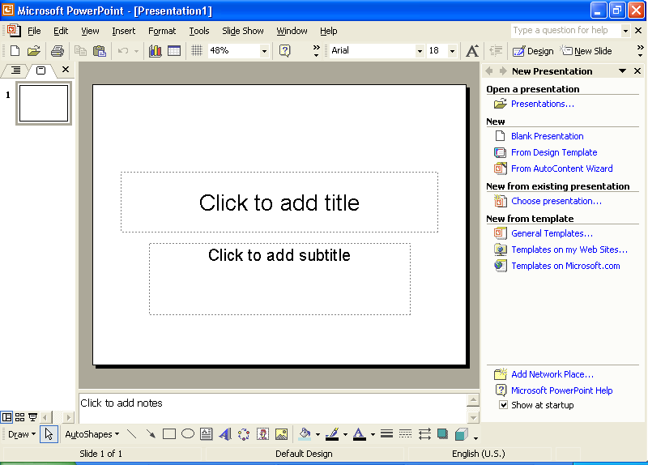
At the bottom of the Outline/Slides pane are view buttons that allow you to display the presentation’s slides in different ways. When you first open PowerPoint, the presentation is displayed in Normal view.
Messages appear at the bottom of the window in an area called the status bar. These messages describe what you are seeing and doing in the PowerPoint window as you work.
To find out about different items on the screen, you can display a ScreenTip. Click the What’s This? command on the Help menu, and then click the item about which you want information. A box appears, telling you more about the item. To display a ScreenTip for a toolbar button, you simply place the pointer over the button without clicking it, and a ScreenTip appears, telling you the name of the button, as shown in the margin.
You can turn toolbar ScreenTips on and off. On the Tools menu, click Customize, click the Options tab, clear the Show ScreenTips on toolbars check box, and then click Close.

ScreenTip
In this exercise, you personalize the Window menu and display a ScreenTip for a button.
1 On the menu bar, click Window.
The Window menu appears.
2 Click the arrows at the bottom of the Window menu to view the expanded menu.
You can also view the expanded menu by clicking the menu and waiting a few seconds for the expanded menu to appear.
The expanded menu appears.
3 Click Next Pane.
4 On the menu bar, click Window again.
Notice that the Next Pane is now displayed on the Window menu. PowerPoint has personalized the Window menu for you.

Slides Tab
In this exercise, you look at the Slides tab and use the Other Task Panes menu.
1 Position the pointer on the slide icon in the Slides tab of the Outline/Slides pane.
A ScreenTip appears when you position the pointer over the icon.
2 Click the Other Task Panes down arrow.
The Other Task Panes menu opens.
3 Click an empty place anywhere in the PowerPoint window.
The Other Task Panes menu closes, leaving the New Presentation task pane open.

Choosing a Method to Start a Presentation
The New Presentation task pane can help you work with existing presentations as well as create new ones. If you have already created a presentation, you will find its name listed in the Open a presentation section of the task pane. If you want to create a new presentation, you can simply start adding text to the blank presentation in the Slide pane or use the options in the New section of the task pane.
- Click Blank Presentation to start a new presentation from scratch.
- Click From Design Template to apply one of PowerPoint’s design templates to a new, blank presentation.
- Click From AutoContent Wizard to let PowerPoint help you with both presentation content and a design.

Creating a Presentation Using a Wizard
Creating a presentation with the AutoContent Wizard can save you time by helping you organize and write the presentation. The wizard takes you through a step-by-step process, prompting you for presentation information, beginning with the title slide, which is the first slide in the presentation.
In this exercise, you create a presentation using the AutoContent Wizard.
1 In the New Presentation task pane, click From AutoContent Wizard under New.
The New Presentation task pane closes and the AutoContent Wizard dialog box opens, displaying the Start screen. On the left side of the dialog box is a list of the screens in the wizard.
tip
If the Office Assistant appears, click No, don’t provide help now in the help screen.
2 Read the introduction, and then click Next.
The second screen in the AutoContent Wizard appears, and the square next to Presentation type on the left of the dialog box turns green to indicate that this is the current screen. The AutoContent Wizard prompts you to select a presentation type. To help you identify presentation types quickly, the wizard organizes presentations by category.
3 Click Projects.
4 In the list on the right, click Project Overview.
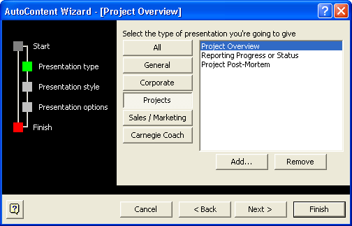
5 Click Next.
The AutoContent Wizard now prompts you to select a media type for the presentation.
6 Click the On-screen Presentation option if necessary to select that presentation type.
7 Click Next.
The AutoContent Wizard now prompts you to enter information for the title slide and for footer information to be included on each slide.
In the steps throughout this book, bold type indicates text that you should type exactly as it appears. If you make a mistake as you type the information, press Backspace to delete the error, and then type the correct text.
8 Click in the Presentation title box, type New Employee Training Program and then press Tab.
9 In the Footer box, type Contoso, Ltd.
10 Verify that the Date last updated and the Slide number check boxes are selected.
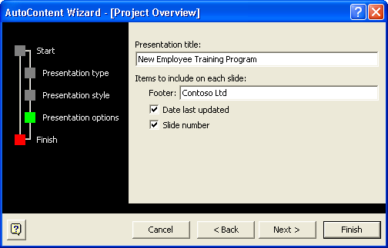
11 Click Next, and then click Finish.
If you want to change any
of the information you previously entered, click the Back button.
The PowerPoint presentation window appears with content provided by the AutoContent Wizard in outline form in the Outline tab of the Outline/Slides pane and the title slide in the Slide pane. The name on the title slide is the name of the registered user.

Saving a Presentation
The work you have completed so far is stored only in your computer’s temporary memory. To save your work for further use, you must give the presentation a name and store it on your computer’s hard disk drive.
The first time you save a new presentation, the Save As dialog box opens when you choose the Save command. In the Save As dialog box, you can name the presentation and choose where to save it. Once you name a presentation, you can save the changes you just made by clicking the Save button on the Standard toolbar or by selecting Save on the File menu. In other words, the newer version overwrites the original version. If you want to keep both the original file and the new version, you can choose the Save As command on the File menu to save the new version with a new name.
Almost every dialog box includes a question mark button in the upper-right corner of its window. When you click this button and then click any dialog box control, a Help window appears that explains what the control is and how to use it.
In this exercise, you save a presentation.
1 On the Standard toolbar, click the Save button.
PowerPoint displays the Save As dialog box, as shown in the illustration on the following page. The text in the box next to the label File name is selected so that you can type a presentation name.
The Places Bar along the left side of the Save As dialog box provides convenient access to commonly used locations for saving files.
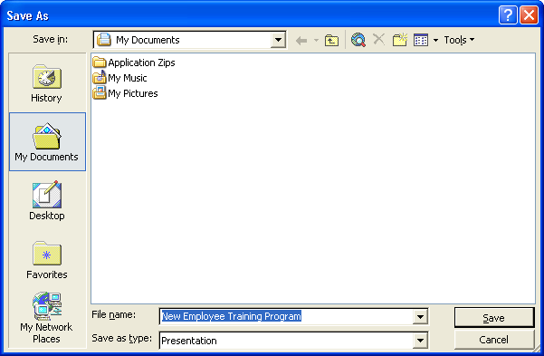
To create a new presentation from existing slides, click File on the menu bar, click Save As, type a new name in the File name box, and then click Save.
2 In the File Name box, type Contoso Employee Training Report Pres 01.
The word Pres in the file name is an abbreviation for Presentation.
3 Click the Save In down arrow, and then click drive C.
If your hard disk uses a letter other than C, substitute the appropriate drive letter in place of C.
4 In the list of file and folder names, double-click the Presentation Fundamentals Practice folder, and then double-click the
Lesson01 folder.
5 Click Save or press Enter to save the presentation.
The title bar name changes from Presentation1 to Contoso Employee Training Report Pres 01.
tip
PowerPoint saves presentations for recovery in case the program stops responding or you lose power. PowerPoint saves the changes in a recovery file based on the settings in the AutoRecover save features. On the Tools menu, click Options, click the Save tab, select the Save AutoRecover info check box, specify the period of time in which to save, and then click OK.

Lesson Wrap-Up
This lesson covered how to start PowerPoint, explore the PowerPoint window, choose a method to start a presentation, create a presentation using the AutoContent Wizard, and save a presentation.
If you are continuing to the next lesson:
- On the File menu, click Close. If PowerPoint prompts you to save changes, click Yes.
PowerPoint saves any changes and closes the presentation.
If you are not continuing to other lessons:
- Click the Close button in the top-right corner of the PowerPoint window. If PowerPoint prompts you to save changes, click Yes.
PowerPoint saves any changes, closes the presentation, and then exits.

Quick Quiz
1 What are the options for beginning a PowerPoint session?
2 How do you create a presentation using a wizard?
3 How do you save two versions of the same file?

Putting It All Together
Exercise 1: Your manager asks you to create a business plan. To help you get started, use the AutoContent Wizard to create the new presentation. Create an on-screen business plan presentation with the title Business Plan and the footer Contoso, Ltd. Save the presentation as Business Plan in the Lesson01 folder that is located in the Presentation Fundamentals Practice folder.
Exercise 2: You work for a computer services company named A. Datum Corporation that customizes systems for small businesses. Your company was counting on winning a contract to supply 25 new computers to a local school but was underbid by a new firm in your area. Use the AutoContent Wizard’s Communicating Bad News template to break the news to your other employees. Modify the suggested content of the slides to fit your situation. Save the presentation as Badnews in the Lesson01 folder that is located in the Presentation Fundamentals Practice folder.
Exercise 3: A. Datum Corporation, your company, wants to avoid losing more contracts. Your boss has scheduled a sales meeting and wants you to put together a presentation that will help the sales force focus on A. Datum Corporation’s services and strengths. Use the AutoContent Wizard’s Selling a Product or Service template and then customize the slides to explain the needs of A. Datum Corporation’s clients and how A. Datum Corporation can meet them with customer service and price strategies. Save the presentation as Selling in the Lesson01 folder that is located in the Presentation Fundamentals Practice folder and leave it open for the next exercise.

