Working with a Presentation
Lesson 2

After completing this lesson, you will be able to:
- Create a new presentation using a design template.
- Enter text in the Slide pane.
- Create a new slide.
- Enter text in the Outline tab.
- Insert slides from other presentations.
- Rearrange slides in Slide Sorter view.
- Create a folder to store a presentation.
- Show slides in Slide Show view.
- Customize PowerPoint.
To work efficiently with Microsoft PowerPoint, you need to become familiar with the important features of the product. In the previous lesson, you learned how to create a presentation using the AutoContent Wizard, change title and paragraph text, change views, move from slide to slide, save a presentation, and use PowerPoint help options.
After creating a progress report presentation for the employee training program at Contoso, Ltd, you decide to use PowerPoint to develop the program content. The next step is to start a new presentation and develop the content for the first training session, “Recruiting New Clients.” Your sales manager has given you several slides to include in the presentation.
In this lesson, you will learn how to start a new presentation using a design template, enter slide text, create new slides, enter text in the Outline tab, insert slides from other presentations, and rearrange slides.
To complete the procedures in this lesson, you will need to create a new presentation using a design template. Use a file named 02 PPT Lesson in the Lesson02 folder in the Presentation Fundamentals practice folder that is located on your hard disk.

Creating a New Presentation Using a Design Template
In addition to starting a presentation with sample text from the AutoContent Wizard as you did in Lesson 1, you can also start a new presentation without having PowerPoint insert any sample text. You can choose a design template or a blank presentation. A design template is a presentation with a professionally designed format and color scheme to which you need only add text. You can use one of the design templates that come with PowerPoint, or you can create your own.
In this exercise, you start a new presentation with a design template.
1 If you quit PowerPoint at the end of the last lesson, restart PowerPoint now.
2 On the View menu, click Task Pane, if necessary, to display the New Presentation task pane.
3 In the New Presentation task pane, click From Design Template.
The Slide Design task pane appears with a variety of design templates listed in alphabetical order.
tip
To create a blank presentation or a presentation using the AutoContent Wizard, open the New Presentation task pane, and then click Blank Presentation or AutoContent Wizard. The templates listed in the Slide Design task pane are the same ones that the AutoContent Wizard uses.
4 In the Slide Design task pane, point to a design template.
The name of the design template appears as a ScreenTip, and a down arrow appears on the right side of the design.
5 In the Slide Design task pane, click the down arrow on the right side of the design template.
A menu appears with commands that let you apply the design template to the entire presentation or to selected slides or change the size of the preview design templates in the Slide Design task pane.
6 In the Slide Design task pane, drag the scroll box down until the Maple slide design appears in the task pane, and then click the Maple slide design.
The Maple slide design is applied to the blank slide in the Slide pane.
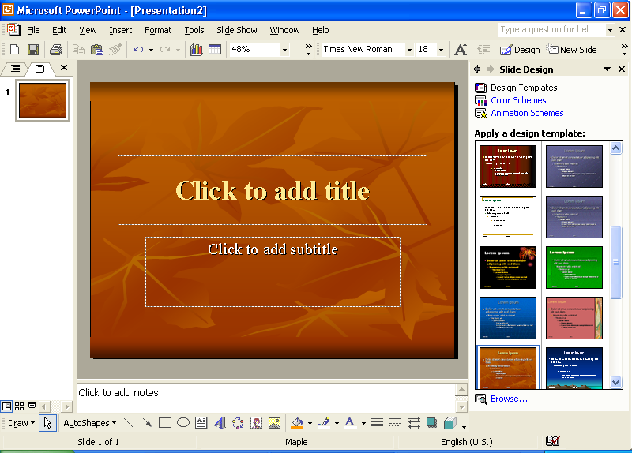
7 Close the Slide Design task pane by clicking its close button.

Entering Text in the Slide Pane
To add text to a presentation, including titles and subtitles, you can enter text into either the Slide pane or the Outline tab in Normal view. The Slide pane allows you to enter text on a slide using a visual method, while the Outline tab allows you to enter text using a content method. The Slide pane displaying the Title Slide layout includes two text boxes called text placeholders. The upper box is a placeholder for the slide’s title text. The lower box is a placeholder for the slide’s subtitle text. After you enter text into a placeholder, the placeholder becomes a text object, a box that contains text in a slide.
In this exercise, you title a slide and add a subtitle.
1 Click the Outline tab if necessary in the Outline/Slides pane.
2 In the Slide pane, click the text placeholder Click to add title.
A selection box surrounds the placeholder, indicating that the placeholder is ready for you to enter or edit text. The placeholder text disappears, and a blinking insertion point appears.
3 Type Recruiting New Clients.
If you make a typing error, press Backspace to delete the mistake, and then type the correct text.
Notice that the text appears in the Outline tab at the same time.
4 Click the text placeholder Click to add subtitle.
The title object is deselected, and the subtitle object is selected.
5 Type Your Name and then press Enter.
6 Type Contoso, Ltd.
Your presentation window should look like the following illustration:
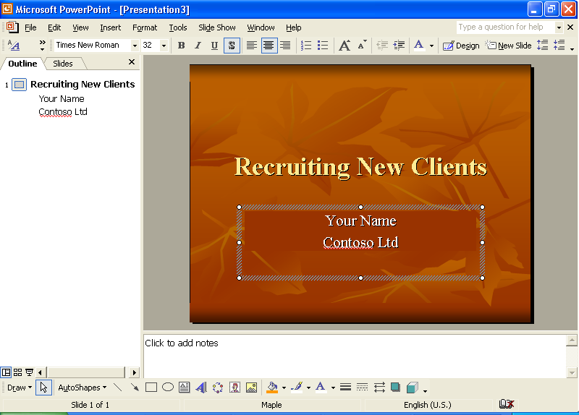

Creating a New Slide
You can quickly and easily add more slides to a presentation in two ways: by clicking the New Slide button on the Formatting toolbar directly above the task pane or by clicking the New Slide command on the Insert menu. When you use either of these methods, PowerPoint inserts the new slide into the presentation immediately following the current slide, and the Slide Layout task pane appears with twenty-seven predesigned slide layouts, any of which you can apply to your new slide. You select a layout by clicking it in the Slide Layout task pane. The layout title for the selected slide layout appears as you roll the mouse over each choice.
Slide layouts allow you to create slides with specific looks and functions. For example, you can choose a layout that displays only a title on a slide, or a layout that provides placeholders for a title and a graph.
In this exercise, you create a new slide and then enter text in it.
1 On the Formatting toolbar, click the New Slide button.
The Slide Layout task pane appears. PowerPoint adds a new, empty slide after the current slide in the Slide pane and creates a new slide icon in the Outline tab. PowerPoint applies the default Title and Text slide layout (a title and bulleted list) to the new slide. The status bar displays Slide 2 of 2.
If you start typing on an empty slide without first having selected a placeholder, PowerPoint enters the text into the title object.
2 Type Develop a Plan.
Notice that the new slide and the new title appear in the Outline pane when you create them in the Slide pane. PowerPoint lets you work directly in the Slide pane and Outline tab to enter your ideas.
3 Close the Slide Layout task pane.

Entering Text in the Outline Tab
The Outline tab shows the presentation text in outline form just as if you had typed the text using Outline view in Microsoft Word 2002. The outline pane allows you to enter and organize slide title and paragraph text for each slide in a presentation. In the Outline tab, the slide title text appears to the right of each slide icon, and the paragraph text appears underneath each title, indented one level. To enter text in the Outline tab, you click where you want the text to start, and then you begin typing. While working in the Outline tab, you can also create a new slide and add title and paragraph text by using the New Slide command or the Enter key.
In this exercise, you enter paragraph text in an existing slide, and then create a new slide and add text to that slide in the Outline tab.
1 Position the pointer—which changes to the I-beam pointer—to the right of the title in slide 2 in the Outline tab, and then click the blank area.
A blinking insertion point appears.
2 Press Enter.
PowerPoint adds a new slide in the Slide pane and a new slide icon in the Outline tab, with the blinking insertion point next to it.
To add paragraph text to slide 2 instead of starting a new slide, you need to change the outline level from slide title to a bullet.
3 Press Tab.
Pressing Tab indents the text to the right one level and moves the text from slide 3 back to slide 2. The slide icon changes to a small gray bullet on slide 2 in the Outline tab.
4 Type Develop a list of contacts and then press Enter.
PowerPoint adds a new bullet at the same indent level. Notice that once you press Enter after typing bulleted text, the bullet becomes black. Also note that the text wraps to the next line in the Outline tab without your having to press Enter.
5 Type Schedule periodic phone calls to prospective clients and then press Enter.
6 Type Re-evaluate your strategy regularly and then press Enter.
7 On the Outlining toolbar, click the Promote button.
important
If the Outlining toolbar is not visible on your screen, click the View menu, point to Toolbars, and then click Outlining.
PowerPoint creates a new slide with the insertion point to the right of the slide icon.
8 Type Make the Client Number One and then press Enter.
9 Press Tab.
PowerPoint creates a new indent level for slide 3.
10 Type Be creative and then press Enter.
A new bullet appears.
11 Type Stay positive, press Enter, and then type Be tenacious.
12 Hold down Ctrl, and then press Enter.
A new slide appears.
13 Type Summary, press Enter, and then press Tab.
PowerPoint creates a new indent level for slide 4.
14 Type Create a plan suitable to your temperament and then press Enter.
15 Type Try to avoid cold calls and then press Enter.
16 Type Keep current with the client’s industry trends.
Your presentation window should look like the following illustration:
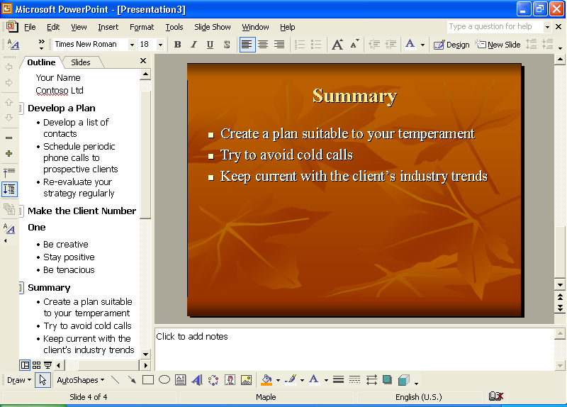

Inserting Slides from Other Presentations
You can save time while creating a presentation by using slides that you or someone else has already made. When you insert slides from one presentation into another, the slides conform to the color and design of the current presentation, so you don’t have to make many changes.
In this exercise, you insert slides from one presentation into another.
1 On the Insert menu, click Slides from Files.
The Slide Finder dialog box appears.
2 Click the Find Presentation tab if necessary, and then click Browse.
The Browse dialog box appears.
3 In the Look in box, verify that your hard disk is selected.
4 In the list of file and folder names, double-click the Unlimited Potential folder.
5 Double-click the Presentation Fundamentals Practice folder, and then double-click the Lesson02 folder.
6 Click the file titled 02 PPT Lesson, and then click Open.
The Slide Finder dialog box reappears.
7 Click Display, if necessary.
8 Click slide 2, click slide 3, click the right scroll arrow, and then click slide 4 to select the slides you want to insert.
If you use one or more slides in several presentations, you can click Add to Favorites to save the selected slides in the List of Favorites tab in the Slide Finder dialog box.
The Slide Finder dialog box should look like the following illustration:
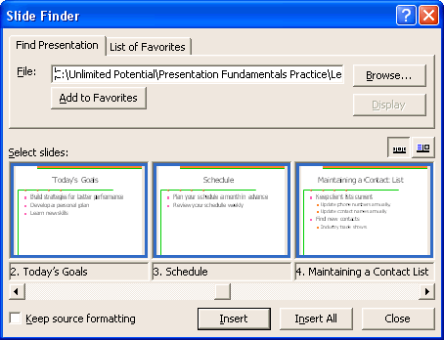
9 Click Insert.
PowerPoint inserts the slides into the new presentation after the current slide.
10 Click Close.
The last inserted slide appears in the Slide pane.

Rearranging Slides in Slide Sorter View
After you insert slides from another presentation into the current one, you may need to rearrange the slides into the order that most effectively communicates your message. This is best done in Slide Sorter view, where you can drag one or more slides from one location to another.
In this exercise, you rearrange slides in Slide Sorter view.
1 Click the Slide Sorter View button.
Notice that the Slide Sorter toolbar appears above the presentation window.
2 Click slide 4 (“Summary”), and then drag it to the empty space after slide 7 (“Maintaining a Contact List”).
Notice that the pointer changes to the drag pointer when you begin to drag (see illustration below). When you release the mouse button, slide 4 moves to its new position, and PowerPoint repositions and renumbers the other slides in the presentation.
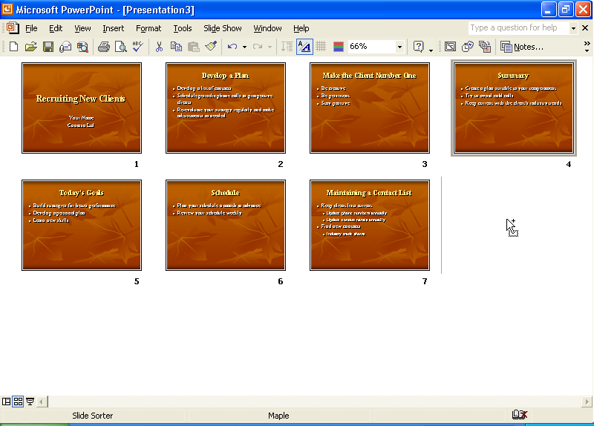
In Slide Sorter view, you can also move slides between two or more open presentations. Open each presentation, switch to Slide Sorter view, and then click Arrange All on the Window menu. Drag the slides from one presentation window to another.
3 Drag the scroll box to the top of the vertical scroll bar, and then click the current slide 4 (“Today’s Goals”).
4 Drag slide 4 between slides 1 and 2.
5 Double-click slide 1 to return to the previous view, Normal view.

Creating a Folder to Store a Presentation
To keep your presentations organized and easily accessible, you can store them in separate folders that you create and name. For example, you could store all training presentations for Contoso, Ltd in a folder named Training. If, after a time, there are too many files in the Training folder, you can create subfolders within the Training folder with names such as Recruiting and Techniques.
Use the Create New Folder button provided in the Save As dialog box to create a new folder. Before clicking the Create New Folder button, you might need to click the Save in down arrow to locate the drive on which you want to store the new folder. You can use the Places Bar to move to another location in your computer. The Places Bar on the left side of the Save As and Open dialog boxes provides quick access to commonly used locations in which to store and open files.
In this exercise, you create a folder and save the current presentation in the new folder.
1 On the Standard toolbar, click the Save button.
PowerPoint displays the Save As dialog box, in which you can type a new name for the presentation as well as create a new folder to store it in.
2 In the Save in box, verify that your hard disk is selected.
3 In the list of file and folder names, double-click the Presentation Fundamentals Practice folder, and then double-click the Lesson02 folder.
4 Click the Create New Folder button.
The New Folder dialog box appears. Note that the folder you are creating is a subfolder of the PowerPoint Practice folder.
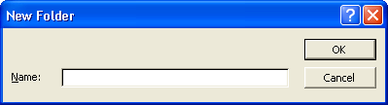
5 Type Recruiting as the new folder name and click OK.
Recruiting becomes the current folder in the Save As dialog box.
6 In the File name box, type Contoso Recruiting Pres 02.
The “02” at the end of the presentation file name matches the lesson number.
7 Click Save.
PowerPoint saves the presentation with the new name Contoso Recruiting Pres 02, which now appears in the presentation window title bar, in the Recruiting folder.

Showing Slides in Slide Show View
At any time during the development of a presentation, you can quickly and easily review the slides for accuracy and flow in Slide Show view. Slide Show view displays the slides in order by slide number, using the entire screen on your computer.
In this exercise, you display slides in Slide Show view.
1 In the Outline pane, click the slide 1 icon, if necessary.
2 Click the Slide Show button.
PowerPoint displays the first slide in the presentation.
3 Click the screen to advance to the next slide.
4 Click one slide at a time to advance through the presentation. After the last slide, click to exit Slide Show view.
To end a slide show before you reach the last slide, press Esc.
PowerPoint returns to the current view.

Customizing PowerPoint
You can customize PowerPoint to the way you work best by changing different options. You can view these options by clicking the Options command on the Tools menu. For example, you can open recently used files by accessing them on the File menu. With the Options command, you can change the number of recently used files that appear on the File menu.
In this exercise, you customize a PowerPoint option.
1 On the Tools menu, click Options, and then click the General tab.
The Options dialog box appears with the General tab open.
2 Click the Recently Used File List up arrow or down arrow to reach six entries.
3 Click OK.
4 Click the File menu to see the expanded list of recently used files, and then press Esc to cancel the menu.

Lesson Wrap-Up
This lesson covered how to create a new presentation using a design template, enter slide text, create new slides, enter text in the Outline tab, insert slides from other presentations, and rearrange slides.
If you are continuing to the next lesson:
1 On the Standard toolbar, click the Save button.
PowerPoint saves any changes to the presentation.
2 On the File menu, click Close.
PowerPoint closes the presentation.

If you are not continuing to other lessons:
1 On the Standard toolbar, click the Save button.
PowerPoint saves any changes to the presentation.
2 Click the Close button in the top-right corner of the PowerPoint window.
PowerPoint closes the presentation, and then exits.

Quick Quiz
1 How do you start a new presentation using a design template with PowerPoint already running?
2 How do you add title text to a slide?
3 What are the ways you can create a new slide?
4 How do you change a paragraph text indent level?
5 How do you move an entire line of text?
6 How do you view the slides you want to insert from another presentation?
7 How do you move a slide in Slide Sorter view?

Putting It All Together
Exercise 1: Your sales team has nominated you to choose the new design template for the monthly sales reports. You decide to use the following text to create a new presentation using a design template with a title slide, and a new slide with a title and bullets.
Southwest Sales Review Agenda {title}
Today’s Date {subtitle}
Agenda {title}
Introduction {bullet}
Discussion {bullet}
Summary {bullet}
Save the presentation as SW Sales in the Lesson02 folder in the Presentation Fundamentals Practice folder.
Exercise 2: Your supervisor has asked you to help with a motivational presentation. You begin by creating a new presentation using a design template with the following slides:
Personal Strategic Planning {title}
Sales Force {subtitle}
Topics {title}
Planning for Change {bullet}
Identifying Barriers to Success {bullet}
Getting the Right Skills and Knowledge {bullet}
Insert slide 2 (“Today’s Goals”) at the end of the presentation from the file 02 PPT lesson in the Lesson02 folder in the Presentation Fundamentals Practice folder. Move the slide so that it becomes the second slide.
Save the presentation as Motivate in the Lesson02 folder in the PowerPoint Practice folder.
Exercise 3: The personnel department at A. Datum Corporation wants to create several presentations to remind employees of company policies. Begin by creating a new presentation using a design template with the following slides:
A. Datum Corporation {title}
Holidays and Personal Time {subtitle}
Holidays {title of Title Only slide}
Standard Holidays {title of Title and Text slide}
New Year’s Day {bullet}
Memorial Day {bullet}
Independence Day {bullet}
Labor Day {bullet}
Thanksgiving Day {bullet}
Christmas Day {bullet}
In the Outline tab, create a new slide with the title Expanded Holidays. Then type the following bullet items in the Outline tab:
Available to senior staff only
Six standard holidays
Day after Thanksgiving
Christmas Eve
New Year’s Eve
Move the first bullet to be the last bullet on the slide. Save the presentation as Holidays in a new folder named Personnel that you create in the Lesson02 folder in the Presentation Fundamentals Practice folder.
Exercise 4: Create another new presentation for A. Datum Corporation’s personnel department. Use the same design template as for the previous exercise and save the presentation as Vacation in the Personnel folder. Create slide content as follows:
A. Datum Corporation {title}
Vacation Policies {subtitle}
Administration Staff {title}
Less than 1 year, 0 days {bullet}
From 1 to 5 years, 7 days {bullet}
From 6 to 10 years, 14 days {bullet}
Exercise 5: Create a new presentation using a design template for your company’s cafeteria. The cafeteria staff want to inform the company’s employees about new “lite” entrees and a coffee bar that offers coffee drinks such as those sold at chain coffee establishments. Develop the slide content and modify slide order as desired. Then view the slides in Slide Show view.

