Creating a Multimedia Presentation
Lesson 8

After completing this lesson, you will be able to:
- Insert sounds in a presentation.
- Insert movies in a presentation.
- Play sounds or movies in a slide show.
- Set slide timings.
- Record a narration in a slide show.
- Create a self-navigating presentation.
With Microsoft PowerPoint, you can transform a slide show into a self-running multimedia presentation by adding sounds and movies, creating links to other slides, and setting slide timings. You can set PowerPoint to play the sounds and movies automatically, or you can play them manually.
As vice president of sales at Contoso Ltd, you have been working on a company presentation. After adding transitions and animations, you decide to add sounds and movies to slides, set slide timings, and rehearse the presentation.
In this lesson, you will learn how to insert sound and a movie into a presentation, play sounds and movies in a slide show, add slide timings, record narration, and set up a self-navigating presentation.
To complete the procedures in this lesson, you will need to use a file named 08 PPT Lesson in the Lesson08 folder in the Presentation Fundamentals Practice folder that is located on your hard disk.
1 Start PowerPoint, if necessary.
2 On the Standard toolbar, click the Open button.
3 Navigate to the Lesson08 folder in the Presentation Fundamentals Practice folder, and then open the 08 PPT Lesson file.
4 On the File menu, click Save As, type Contoso Pres 08 in the File name box, and then click Save.

Inserting Sounds in a Presentation
With PowerPoint, you can make a presentation more interesting by adding sounds to play during a presentation or to accompany slide transitions. You can insert sounds from the Microsoft Clip Organizer or from a file by double-clicking a media placeholder or by clicking the Movies and Sounds command on the Insert menu. To play sounds, you need sound hardware (such as a sound card and speakers) installed on your computer. To play a sound, you double-click the sound icon in the Slide pane in Normal view, or during the slide show.
PowerPoint inserts sounds as objects, which you can then change and edit. After you insert a sound object, you can change the way it plays by modifying the play options.
In this exercise, you add sound to a slide transition and insert a sound in a slide.
1 Verify that slide 1 is visible in the Slide pane, and then on the Slide Show menu, click Slide Transition.
The Slide Transition task pane appears.
2 Click the Sound down arrow, and then click Applause.
tip
For additional sound selections, click Other Sound in the Sound list. In the Add Sound dialog box, enter the location of the sound file you want to add.
PowerPoint applies the sound to the first slide.
3 Click the Slide Show button.
The sound plays during the transition of the first slide.
4 Press Esc.
5 Drag the scroll box to slide 10.
6 On the Insert menu, point to Movies and Sounds, and then click Sound from Clip Organizer.
The Insert Clip Art task pane appears with a selection of sounds.
7 In the Insert Clip Art task pane, scroll down the Results list, and then click any appropriate sound.
If you don’t find an appropriate sound, you can point to Movies and Sounds on the Insert menu, click Sound from File, navigate to the Lesson08 folder in the Presentation Fundamentals folder, and then double-click the Thrash.wav file.
tip
You can preview a sound by clicking its down arrow and selecting Preview/Properties.
A message box appears, asking if you want the sound to play automatically in the slide show.
8 Click Yes.
A small sound icon appears in the middle of the slide. The sound icon is small, but you can enlarge it for easier access by dragging a resize handle.
tip
If you are connected to the Internet, you can click the Clips Online button in the Insert Clip Art task pane to open your browser and go to Microsoft’s Design Gallery Live Web site to access hundreds of clip art images, photos, sounds, and movies.
9 Drag the sound icon to the lower-right corner of the slide.
10 Double-click the sound icon.
The sound plays.
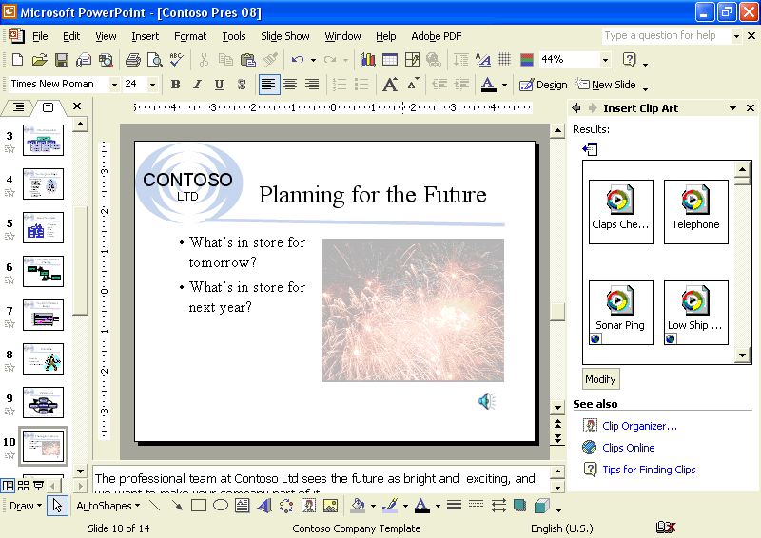

Inserting Movies in a Presentation
With PowerPoint, you can also play movies during a presentation. Movies operate the same way as sounds. You can insert movies from the Microsoft Clip Organizer or from a file by double-clicking a media placeholder or by clicking the Movies and Sounds command on the Insert menu. To play a movie, you double-click the movie object. To pause the movie, you click the movie object again.
PowerPoint inserts movies as objects, which you can then change and edit. After you insert a movie, you can change the way it plays by modifying custom animation effects and movie options.
In this exercise, you insert and play a movie and change the movie playback settings.
1 Drag the scroll box to slide 13.
2 On the Insert menu, point to Movies and Sounds, and then click Movie from Clip Organizer.
The Insert Clip Art task pane appears with a selection of movie clips.
tip
Most of the movies in the Clip Organizer are actually animated pictures, also known as animated GIF files. Just like movies, animated GIF files add interest to your presentation, but you edit them more like an inserted picture than an inserted movie.
3 In the Insert Clip Art task pane, scroll down the Results list and click an appropriate business-related movie clip about an arrow hitting a target.
If you don’t find an appropriate movie, try clicking the Modify button and then specify a keyword such as arrow. Or, you can point
to Movies and Sounds on
the Insert menu, click Movie from File, navigate to the Lesson11 folder in the Presentation Fundamentals Practice folder, and then double-click the Arrowhit.avi file.
4 If necessary, click No on an alert box that asks if you want the movie to play in the slide show.
The movie appears on the slide.
5 Drag the movie to the blank area on the right side of the slide and enlarge the clip if necessary.
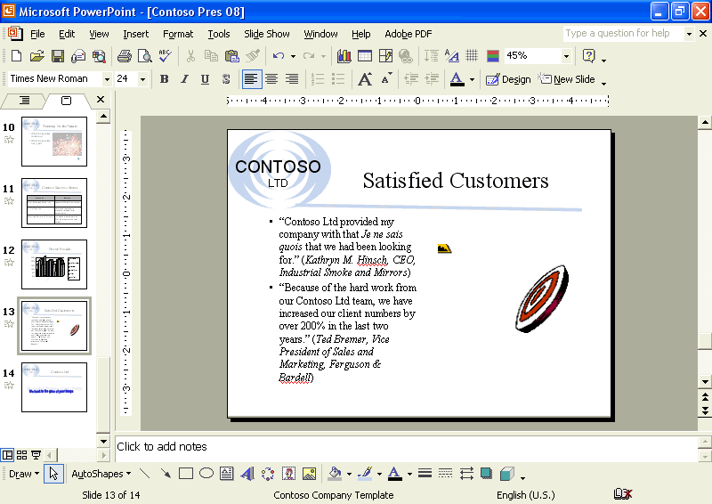
6 In the Insert Clip Art task pane, click the Close button to close the task pane.

Playing Sounds or Movies in a Slide Show
After you insert a sound or movie object, you can change the way that it plays by modifying the animation or action settings. You can adjust the play settings so that PowerPoint plays the movie with the playback options that you set in the Movie Options dialog box. You can also change the action settings to play a movie or sound by moving the mouse over the object instead of clicking the object. Additionally, you can change the animation order so that the movie plays either before PowerPoint animates the text or at the same time as PowerPoint animates the text.
In this exercise, you change the play settings and change action settings to play in Slide Show view.
1 In the Slides tab, click slide 2.
2 Right-click the movie object, and then click Edit Movie Object.
The Movie Options dialog box appears, displaying movie play options and the total playing time of the movie.
3 Select the Loop until stopped check box.
Now when the movie object plays, the media clip continues to play until you stop it.
4 Click OK to close the Movie Options dialog box.
5 Right-click the movie object again, and then click Custom Animation on the shortcut menu.
The Custom Animation task pane appears.
6 In the Custom Animation task pane, click Add Effect, click Entrance, and then click Dissolve In.
To be consistent with the other objects on the slide, you need to set the movie object to be animated on the slide during a slide show.
The movie object appears in the Animation Order list.
7 Click the Start down arrow, and then click With Previous.
8 With the movie object still selected, click Add Effect, click Movie Actions, and click Play.
9 Click the Start down arrow, and then click After Previous.
10 Click the Text 2 item in the Animation Order list and click the Re-Order up arrow at the bottom of the Custom Animation task pane one time.
The text item is now the first item in the list.
11 Click the first Cogs.avi item in the Animation Order list, and click the Re-Order up arrow one time.
12 Click the second Cogs.avi item, and click the Re-Order up arrow one time.
The movie objects are now below the text item, as shown in the following illustration:
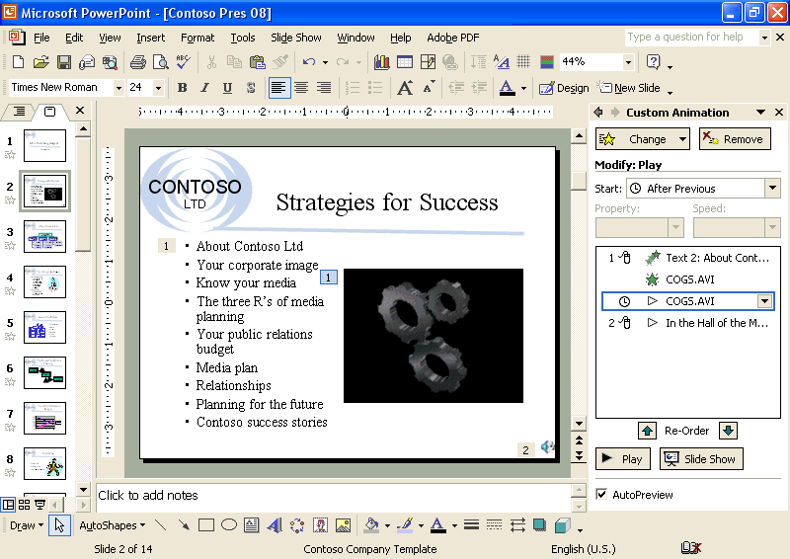
13 Click the sound icon on slide 2 to select the object.
14 On the Slide Show menu, click Action Settings.
The Action Settings dialog box appears.
15 Click the Mouse Over tab, and then click the Object action option.
The Play option appears in the list.
16 Click OK, and then click the Slide Show button.
17 Move the pointer over the sound icon to play the sound, and then click the mouse to advance through the slide animations.
18 Press Esc to stop the sound and the movie, and then press Esc again to stop the slide show.

Setting Slide Timings
Slide timing refers to the length of time that a slide appears on the screen. As with transitions, you can set slide timings for one slide or a group of slides, depending on how many slides are selected when you apply the slide timing.
You advance the slide show in one of two ways: automatic advance, which you set with the timing feature; or manual advance, which you operate with the mouse. The automatic advance-timing feature moves slides through the slide show by itself, keeping each slide on the screen for the length of time that you designate beforehand. The mouse click-timing feature manually moves slides through the slide show.
In this exercise, you apply slide timings in Slide Sorter view.
1 Click the Slide Sorter View button.
2 On the Slide Sorter toolbar, click the Slide Transition button, or on the Slide Show menu, click Slide Transition.
The Slide Transition task pane appears.
3 In the Advance slide area, select the Automatically after check box, click the up arrow twice to show 00:02.
Because both check boxes in the Advance slide section are selected, the slides advance after two seconds or when you click the mouse.
tip
In Slide Show view, a mouse click always advances a slide, even if the timing that is set in the Slide Transition task pane has not elapsed. Conversely, holding down the mouse prevents a timed transition from occurring until you release the mouse, even if the set timing has elapsed.
4 Click Apply to All Slides.
It does not matter which slide is selected when you click Apply to All Slides.
PowerPoint applies the current Slide Transition settings, including the new slide timing, to all of the slides and places the 00:02 timing under each slide in the Slide Sorter view.
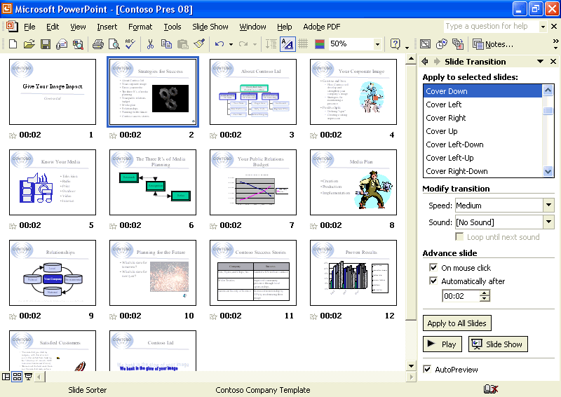
5 Scroll up (if necessary), and then click Slide 1.
6 Click the Slide Show button.
PowerPoint runs the slide show in the presentation window, using the slide timing that you set using the Slide Transition task pane.
tip
Applying animations to multiple slides may affect how long the slide will stay on the screen during a slide show. Slide timings are divided equally among the animations for each slide, and you might need to adjust the slide timing to adequately show the animated items.

Recording a Narration in a Slide Show
You can add voice narration or sound in a slide show when creating a slide show for individuals who can’t attend a presentation or during a meeting so that presenters can review it later and hear comments made during the presentation. To record a narration, your computer needs a sound card and a microphone. You can record a narration before you run a slide show, or you can record it during the presentation and include audience comments. As you record the narration, you can pause or stop the narration at any time. You can delete a voice narration, as with any other PowerPoint object.
If you don’t have sound recording and playing hardware installed on your computer, the Record Sound command on the Movies and Sounds submenu on the Insert menu and the Record Narration command on the Slide Show menu are grayed out. If these commands are grayed out on your computer, skip this section.
You need to have a sound card or internal sound hardware, a microphone, and speakers installed on your computer to record and play a narration in a slide show.
In this exercise, you record a sound or comment on a single slide, delete the sound or comment, and record a voice narration during the presentation.
1 Double-click slide 1 to switch to Normal view.
2 On the Insert menu, point to Movies and Sounds, and then click Record Sound.
The Record Sound dialog box appears, as shown in the following illustration:
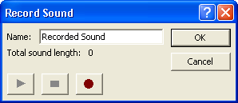
3 Select the text in the Name box, and then type Slide 1 Welcome.
4 Click the Record button, and then say, “Welcome to Contoso Ltd, your experienced, complete PR firm!”
5 Click the Stop button, click the Play button, and then click OK.
A sound icon appears on the slide.
6 Click the sound icon, and then press Delete.
The sound recording on slide 1 is deleted.
7 On the Slide Show menu, click Record Narration.
The Record Narration dialog box appears, showing the amount of free disk space and the number of minutes that you can record, as shown in the following illustration:
You can pause or stop voice narration during recording.
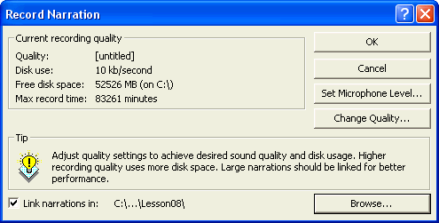
important
You can insert narration into slides in one of two ways. Embedding the narration adds the sound objects to the presentation (increasing the size of the file), while linking the narration stores the sound objects in separate files. To insert the narration in slides as an embedded object and to begin recording, click OK. To insert the narration as a linked object, select the Link narrations in check box, and then click OK to begin recording. Notice that while you are recording, you won’t hear the other sounds that you inserted in the slide show.
8 Click OK.
9 Use the rehearsed slide timings, or click to advance through the slide show and add voice narration (your own explanation of the slides) as you go.
10 Right-click anywhere on the screen, and then click Pause Narration.
The voice narration pauses during the recording.
11 Right-click anywhere on the screen, and then click Resume Narration.
The voice narration recorder resumes, and you can step through the rest of the slide show, adding narration. At the end of the slide show, a message appears, asking if you want to save the new slide timings along with the narration.
12 Click Save.
A sound icon appears in the lower-right corner of each slide that has narration.
tip
To show a presentation with narration on a computer without sound hardware installed, click Set Up Show on the Slide Show menu, and then select the Show without narration check box to avoid problems running the presentation.
13 Click the Slide Show button.
The narration plays with the slide show.

Creating a Self-Navigating Presentation
Self-running slide shows are a great way to communicate information without needing someone to run the show. You might want to set up a presentation to run unattended in a kiosk at a trade show or place it on your company’s intranet to run at the user’s convenience. A self-navigating show turns off all navigation tools except action buttons and other action settings available to the user.
In this exercise, you set up a self-running slide show.
1 On the Slide Show menu, click Set Up Show.
The Set Up Show dialog box appears.
2 Click the Browsed at a kiosk (full screen) option.
When you click this option, the Loop continuously until ‘esc’ check box turns on and grays out. If you have recorded narration sound, it plays unless you choose to turn it off.
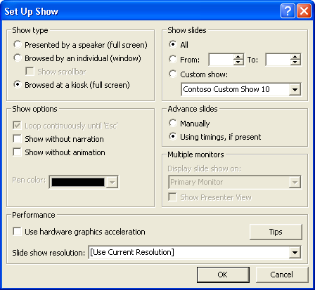
3 Click OK.
4 In Slide Sorter view, click the slide icon for slide 13, and then click the Slide Show button.
Slide Show runs the presentation continuously, using the slide times that you set in the previous section. The transitions that you set in the previous lesson stay the same.
5 Press Esc.
tip
Normally, you open a presentation in PowerPoint and click the Slide Show button to start a show. You can skip a step by saving a presentation as a PowerPoint Show that will launch directly into a slide show when opened. Open the presentation you want to save as a PowerPoint show, click the Save As command on the File menu, click the Save as type down arrow, click PowerPoint Show, and then click Save.

Lesson Wrap-Up
This lesson covered how to insert sounds and movies into a presentation, play sounds and movies in a slide show, add slide timings, record narration, and set up a self-navigating presentation.
If you are continuing to the next lesson, close and save the presentation:
1 On the Standard toolbar, click the Save button.
PowerPoint saves any changes to the presentation.
2 On the File menu, click Close.
PowerPoint closes the presentation.
If you are not continuing to other lessons, save and exit PowerPoint:
1 On the Standard toolbar, click the Save button.
PowerPoint saves any changes to the presentation.
2 Click the Close button in the top-right corner of the PowerPoint window.
PowerPoint closes the presentation, and then exits.

Quick Quiz
1 How do you insert a sound from the Clip Organizer?
2 How do you use slide timings and the mouse to advance a slide show?
3 How do you delete a sound object in a slide?
4 How do you record a comment on a single slide?
5 How do you set up a slide show to run continuously?

Putting It All Together
Exercise 1: Open the Contoso Pres 08 file in the Lesson08 folder that is located in the Presentation Fundamentals Practice folder. Change the slide transition sound, set all the slide timings to 4 seconds, set rehearsed slide timings, play the slide show, and then save and close the presentation.
Exercise 2: Open the Contoso Pres 08 file in the Lesson08 folder that is located in the Presentation Fundamentals Practice folder. Delete the graphic on slide 5, insert a movie or sound from the Microsoft Clip Organizer related to the slide content, change the animation settings to play during a slide show, create a self-navigating presentation, play the slide show, and then save and close the presentation.
Exercise 3: Open 08 Marx from the Lesson08 folder that is stored in the Presentation Fundamentals Practice folder. Save the presentation as 08 Marx in the Lesson08 folder. If possible, record a greeting on slide 1 that welcomes Marx and Fellows employees to their five-star cafeteria and will play automatically. Display slide 6 and insert on the slide an animated picture that you locate in the Clip Organizer using the keyword coffee. Set up the show to run by itself. Save changes and close the presentation.

