Creating Tables
Lesson 2

After completing this lesson, you will be able to:
- Create a database.
- Create a table using the Table Wizard.
- Create and modify a table in Design view.
- Add fields to tables.
- Add and edit records.
- Move and delete fields.
- Delete records.
Tables are the foundation of Microsoft Access databases because they store the data used by all other Access objects. The organization of the tables in a database determines how efficient the database is and how easy it is to access the information in the database. Before you create a database, you should consider the information that the database will contain and how the tables in the database will organize that information.
After you’ve planned the tables that you want to include in your database, you can create them using the Table Wizard, which walks you through making a new table, or you can make a more customized table on your own without the help of the wizard.
In this lesson, you’ll learn how to create tables and then use Design view to modify them by creating new fields, rearranging existing fields, and deleting unwanted fields. You’ll also learn how to add new records and change the information in records.
You will create all the practice files used in this lesson.

Creating a Database
Creating a database requires some preparatory work. Before you even start Access, you should plan how the database will be organized and what tables you will need to create in the database. At a minimum, you should:
- Decide what information you want to store in the database and determine the most logical way to arrange the tables. Typically, you create a table for each general category of information to avoid putting the same information in more than one table.
- Gather all the information that will become part of the database, such as other computer documents, spreadsheets, files, pieces of paper, ledger books, and so on.
- Decide what information you want to store in each table. The different types of information will become the different fields for your table. For example, in a table listing reservation information for Adventure Works, you might want to include information such as the reservation number, the guest identification number, the check-in and check-out dates, the number of guests, the suite that they are staying in, and whether they are eligible for a group discount.
- Interview the people who will use the database. Let them know what tables you plan to create and the fields you plan to put in the tables. The users might have suggestions, such as particular categories of information that they would find useful.
- Using these techniques to plan your database will help you figure out the purpose of the database and whether you can use a database template to create it. Access has several database templates, which are ready-made databases containing all the formatting required to build a special-use database. For example, if you need a database to track time and billing, you can use the Access database template with features specific to time and billing. Access has database templates for asset tracking, contact management, event management, expenses, inventory control, ledgers, order entry, resource scheduling, service call management, and time and billing.
tip
When you plan a database, you might find it helpful to sketch out your ideas on paper. Draw boxes to represent the tables, queries, forms, and reports in the database, and draw lines between the boxes to show on which tables the other objects are based. You should also include a list of the fields in each table so that you can be sure that you aren’t storing the same information in more than one place.
When you start Access to begin creating your database, the New File task pane appears, which gives you the choice of using a Database Wizard or creating your database from scratch. If you select one of the New from template options, you will select a template to use for your database, and then the Database Wizard will walk you through the creation of your database by asking you a series of questions. Based on your responses, the wizard creates the database objects (such as forms, queries, or reports) that your database needs.
Creating a database is very similar to opening an existing one. Opening an existing database is discussed in Lesson 1, “Understanding Databases.”
If you create your database without the help of the wizard, as you do in the following exercise, you need to create each database object yourself.
In this lesson, you will create a database and two tables without using the Database Wizard.
In this exercise, you create a new database named Database Fundamentals 02.
If the New File task pane is not visible, you can open it by clicking the New button on the Access toolbar, or by clicking the New option on the File menu.
To create a database by using a template, click one of the options in the New from template section of the task pane, and select the template that you want to use from the Databases tab of the dialog box that appears.
1 With Access open, and the New File task pane visible, click the Blank Database option in the New section of the task pane.
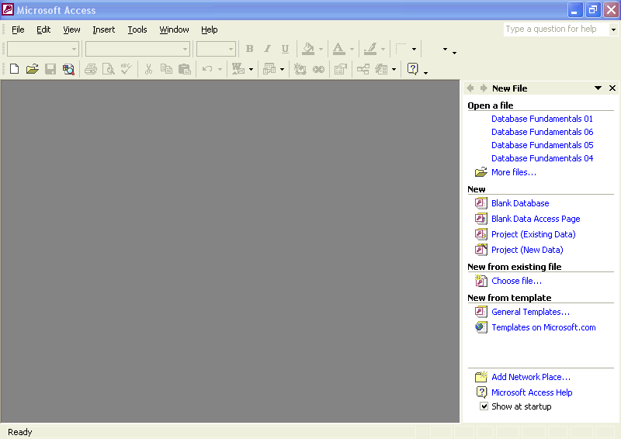
The File New Database dialog box appears.
2 Click the Save In down arrow, click the icon for your hard disk, and double-click the Database Fundamentals Practice folder.
Access will save the new database in the Database Fundamentals Practice folder.
3 In the File Name box, delete the existing text, and type Database Fundamentals 02.
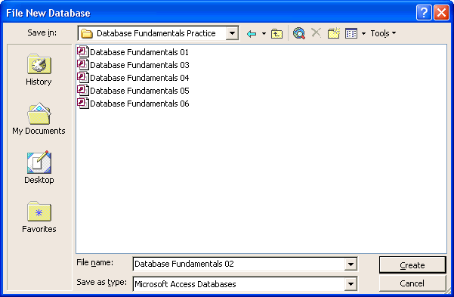
4 Click Create.
Access saves the Database Fundamentals 02 database in the Database Fundamentals Practice folder. The Database window for the Database Fundamentals 02 database appears with Tables already selected on the Objects bar.
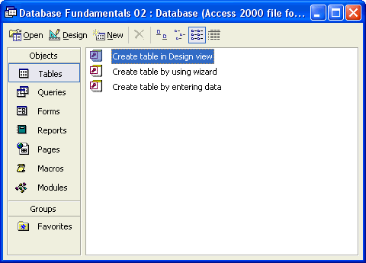
tip
Naming conventions for an Access database file follow those for Microsoft Windows files. A file name can contain up to 215 characters including spaces, but creating a file name that long is not recommended. File names cannot contain the following characters: \ / : * ? “ < > |. The extension for an Access database file is .mdb.

Creating a Table Using the Table Wizard
After you’ve created a database, you’ll need to create some tables to hold the data in the database. The easiest way to create a table is to use the Table Wizard, which steps you through the process of creating a table.
When you use the Table Wizard to create a table, you can select fields from a number of different sample tables.
The Table Wizard offers two categories of tables: Business and Personal. The Business category contains templates for common tables such as Customers, Employees, and Products. Among the options in the Personal category are Household Inventory, Recipes, Plants, and Exercise Log. Each sample table contains many fields that you can use for the table. For example, in the Addresses table, you can select from fields for first name, last name, postal code, home phone, work phone, and e-mail address. To add a field to your table, you just click the field that you want.
The Table Wizard also prompts you to select a primary key field for the table. A primary key is a field that uniquely identifies each record in a table. For example, a social security number in an employee database could serve as a primary key because it uniquely identifies each employee; no two employees can have the same social security number.
To understand the value of a primary key, consider the employees at Adventure Works. It is quite possible that the resort could hire two people with exactly the same name, such as John Smith. With a primary key field, each John Smith will have his own employee identification number. One might have employee ID H110 and the other could have employee ID M220. You would then use the employee ID instead of the last name to keep track of data for each John Smith.
In this exercise, you create a table called tblSuppliers, which will contain information about the companies that supply materials and services to Adventure Works.
1 Double-click Create table by using wizard.
The first Table Wizard dialog box appears.
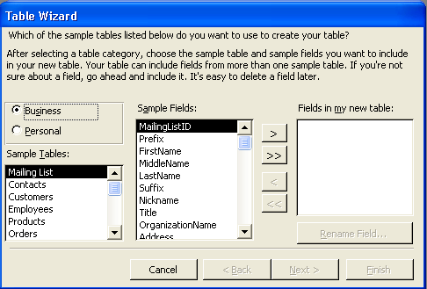
2 In the Sample Tables list, scroll down, and click Suppliers.
The possible fields for the Suppliers table appear in the Sample Fields list, with the SupplierID field already selected.
3 Click the > (Add) button.
Click the >> (Add All) button to add all the fields in the Sample Fields list to the Fields in my new table list.
The SupplierID field moves to the Fields in my new table list, and Access selects the SupplierName field, as shown in the illustration on the following page.
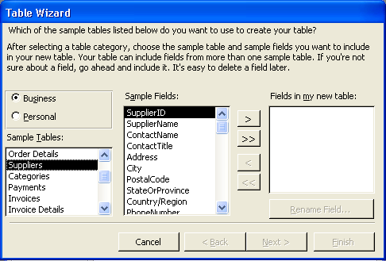
4 Click the > (Add) button.
The SupplierName field moves to the Fields in my new table list.
5 Click Address, and click the > (Add) button.
The Address field moves to the Fields in my new table list, and Access selects the City field.
6 Click the > (Add) button.
The City field moves to the Fields in my new table list, and Access selects the Postal Code field.
7 Repeat step 6 to add the PostalCode and StateOrProvince fields to the Fields in my new table list.
If you want the StateOrProvince field to appear before the PostalCode field in the finished table, add the StateOrProvince field to the Fields in my new table list before adding the PostalCode field.
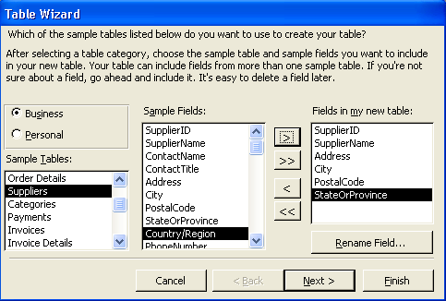
8 Click Next.
The next Table Wizard dialog box appears.
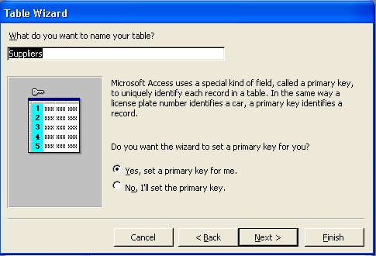
If you want to manually choose the primary key field for your table, click the No, I’ll set the primary key option. The next Table Wizard dialog box that you see will help you choose the primary key.
9 In the What do you want to name your table? box, delete the existing text, type tblSuppliers, and then verify that the Yes, set a primary key for me option is selected.
10 Click Next.
The next Table Wizard dialog box appears.
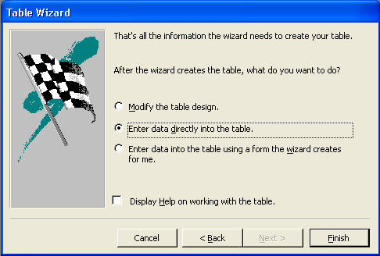
If the Display Help on working with the table check box is selected, Access Help will open when the table is created.
11 Verify that the Enter data directly into the table option is selected and the Display Help on working with the table check box is cleared.
The Supplier ID field is the primary key field that was created by Access. The AutoNumber data type is discussed in the next section of this lesson.
12 Click Finish.
The new table, tblSuppliers, appears in Datasheet view.
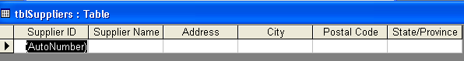
13 On the Table Datasheet toolbar, click the View button.
The table appears in Design view.
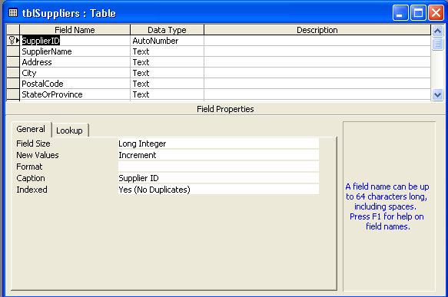
Access places a key icon next to the SupplierID field name to indicate that it is the primary key field.
The field names that appeared from left to right in Datasheet view appear from top to bottom in the Field Name column.
14 Click the Close button in the top-right corner of tblSuppliers.
The table closes. Note that tblSuppliers appears in the list of table names in the Database window.
About Spaces in Field Names
In the previous exercise, you might have noticed that in Datasheet view, field names appear with spaces and in Design view, field names do not have spaces. Why is this?
In general, Access allows spaces in field names, but not all database programs do. Therefore, in case you ever need to transfer data from Access to another application, you should avoid spaces in field names. You should also avoid spaces if you plan to use macros, programs, or Microsoft Visual Basic with your Access database. Because of these limitations, this book doesn’t use spaces in field names.
Although most of the captions used in this book are similar to the field names (SupplierID versus Supplier ID), captions can contain up to 2048 characters and don’t have to contain any of the same information as the field name. For example, the field name could be Data1 and the caption could be Results for May 1999.
The reason that you see spaces in the field names in Datasheet view is because each field also has a caption, which is used instead of the field name. Fields do not need captions, but if there is a caption, it appears at the top of the field column—instead of the field name—when the table is in Datasheet view. For example, in the illustration for step 13 of the previous exercise, the field name SupplierID doesn’t have spaces, and if you look in the Field Properties section of the Table Design view window, you’ll see that the caption for the field is Supplier ID, with a space. When the table appears in Datasheet view, as it does in step 12, the caption (with a space) appears instead of the field name.
When you create a table by using the Table Wizard, the wizard creates captions that include spaces. When you create a table from scratch, as you will in the next exercise, captions appear only if you create them.

Creating and Modifying a Table in Design View
Although the Table Wizard provides a simple way to create a table, you might need to create a table from scratch if the wizard does not provide the fields that you need. For example, to create a table that keeps track of the suites at Adventure Works, you need to build the table from scratch because there isn’t a template in the Table Wizard that contains the fields that you will need, such as the type of suite or the suite price. When you create a table from scratch, you determine the field names.
Certain characters are not permitted in field names. They are:
. Period
! Exclamation point
[ ] Left and right brackets
‘ Left single quotation mark
Field names can be up to 64 characters long, but you should avoid using particularly long field names. Long field names are harder for users to read because the entire field name isn’t visible without resizing the column. In addition, long field names make the table difficult to fit on one screen when viewed in Datasheet view.
You must also give each field a data type, which controls the type of data that can be entered into the field and helps to prevent inaccurate entries in a field. For example, if you have a telephone number field and give it the data type Number, users will be able to enter only numbers, not letters or symbols, into that field. Some data types automatically format the data in a field. For example, if you give a field the data type Currency, Access formats numbers entered into that field as monetary values with two decimal places and a dollar sign.
The data type AutoNumber is a special kind of data type that can be used to create a primary key field for a table. The data in an AutoNumber field is generated by Access whenever a new record is added to a table. For example, if you number each resort reservation as it comes in, you could use the AutoNumber field to automatically generate the number for the next reservation.
The following table lists the available data types for each field, the type of data that can be entered into each field, and the number of allowable characters. Text is the default data type for new fields.
A bit represents a single binary digit (a 1 or 0 value) that is used to represent data and program instructions internally within a computer’s memory and processor. Typically, 8 bits (for example, 00101011) equal 1 byte, which numerically represents a single character of data, such as the letter “A” or the number “5.”
Hyperlinks are discussed later in this lesson.
The Lookup Wizard is discussed in Lesson 3, “Working with Tables.”
Data Type | Allowable Field Values | Character Storage
Text | Alphanumeric characters (letters of the alphabet and numbers) | Up to 255 characters
Memo | Alphanumeric characters (similar to the Text data type, but with more characters) | Up to 64,000 characters
Number | Numeric values | 1, 2, 4, or 8 bytes, depending on the numeric format
Date/Time | Numeric values | 8 bytes
Currency | Numeric values | 8 bytes
AutoNumber | Sequential numbers that Access automatically creates each time a new record is added | 4 bytes
Yes/No | Yes/No, True/False On/Off values | 1 bit (1/8 byte)
OLE Object | OLE (Object Linking and Embedding) objects that interact with Visual Basic | Up to 1 gigabyte
Hyperlink | Web addresses, Internet addresses, or links to other database objects or applications | Up to 64,000 characters
Lookup | Values from another table or list | Typically 4 bytes
When you create or modify fields, a row selector appears to the left of the field. If the field is the primary key field for the table, a key symbol appears next to the row selector. To make a field the primary key, click the Primary Key button on the Table Design toolbar. You can choose only one primary key field per table.
In this exercise, you create a new table, tblSuites, to keep track of the suites at Adventure Works.
1 Double-click Create table in Design view.
A blank table appears in Design view, with the insertion point already in the first cell in the Field Name column.
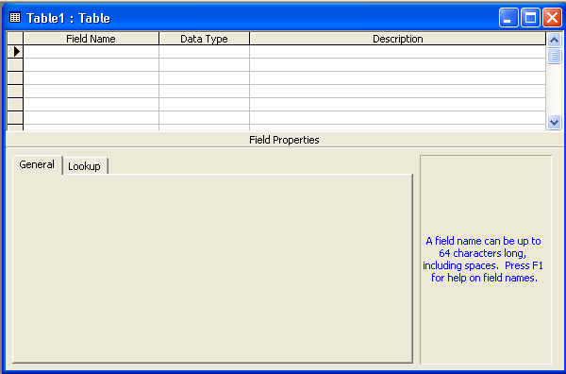
2 Type SuiteID.
3 On the Table Design toolbar, click the Primary Key button.
To remove the primary key designation from a field, click in the row for the field, and click the Primary Key button.
A primary key symbol appears to the left of the SuiteID row, designating SuiteID as the primary key field. Text appears as the default data type.
4 In the Data Type column, click in the first cell, click the down arrow that appears, and then click AutoNumber.
The numbers in the SuiteID field will be generated by Access.
5 In the Field Name column, click in the next blank cell, type SuiteType, and then press Tab.
Access selects the next blank cell in the Data Type column, a down arrow appears, and Text appears as the default data type. Text is the correct data type for this field.
6 In the Field Name column, click in the next blank cell, type SuiteRate, and then press Tab.
Access selects the next blank cell in the Data Type column, a down arrow appears, and Text appears as the default data type.
7 Click the down arrow, and click Currency.
Access will format data entered into the SuiteRate field as currency, with a dollar sign and two decimal places.
8 On the Table Design toolbar, click the Save button.
The Save As dialog box appears.
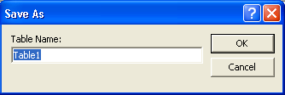
9 Type tblSuites, and click OK.
Access saves the table as tblSuites.
10 On the Table Design toolbar, click the View button.
The table appears in Datasheet view.
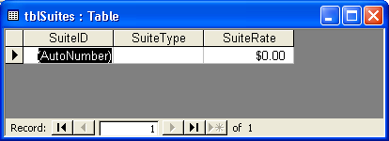
Adding Hyperlinks to a Table
One of the choices for the data type for a field is a hyperlink. A hyperlink lets table fields hold links to sites or Web pages on the Internet or a company intranet. When a user clicks a hyperlink, his or her Web browser starts and displays the page to which the link points. For example, if Adventure Works has a table that keeps track of the vendors that it regularly uses, the table could include a hyperlink to each vendor’s Web site.
To place a hyperlink in a field, you must set the field’s data type to Hyperlink, and type the Web or intranet address—such as www.microsoft.com—into the table in Datasheet view. To add a hyperlink to a table:
When typing the Web or intranet address, you don’t have to include http:// at the beginning of the address.
1 With the table open in Design view, click in the Data Type cell for the field where you want the hyperlink.
2 Click the down arrow that appears, and click Hyperlink.
3 On the Table Design toolbar, click the View button to display the table in Datasheet view. When you are prompted to save changes, click Yes.
4 Click in the first record for the field set to Hyperlink.
5 Type the Web or intranet address.

Adding Fields to Tables
After creating tblSuites, which keeps track of the guest suites at Adventure Works, you decide to add three new fields to the table: a Building field (which will designate the name of the building that the suite is in), a #ofOccupants field (which will specify how many people can stay in the suite), and a Notes field (which will hold notes about the suites, such as repairs that need to be made). The process for adding fields to an existing table is similar to the process for adding fields to a new table, which you did in the previous exercise.
In this exercise, you add the Building, #ofOccupants, and Notes fields to tblSuites.
1 On the Table Datasheet toolbar, click the View button.
tblSuites appears in Design view.
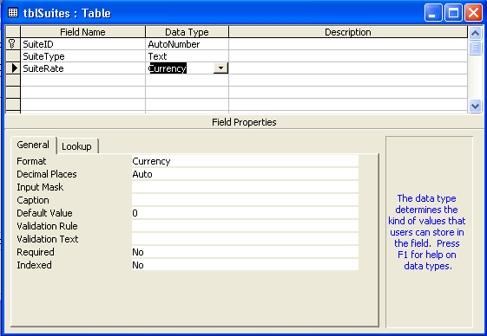
If you want to add a field between fields that already exist, click in the row for the field that you want the new field to precede, and click the Insert Rows button on the Table Design toolbar.
2 In the Field Name column, click in the first blank cell, type Building, and press Tab.
Access selects the next blank cell in the Data Type column, a down arrow appears, and Text appears as the default data type. Text is the correct data type for this field.
3 In the Field Name column, click in the next blank cell, type #ofOccupants, and press Tab.
Access selects the next blank cell in the Data Type column, a down arrow appears, and Text appears as the default data type.
4 Click the down arrow, and click Number.
Number is the data type for the #ofOccupants field.
5 In the Field Name column, click in the next blank cell, type Notes, and press Tab.
Access selects the next blank cell in the Data Type column, a down arrow appears, and Text appears as the default data type.
6 Click the down arrow, and click Memo.
Memo is selected as the data type for this field because Memo fields are not limited to 255 characters, as Text fields are.
The Notes field has the data type of Memo.
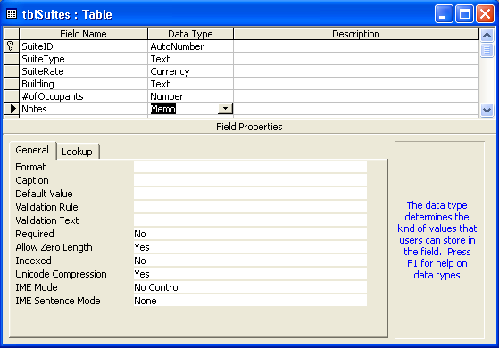
7 On the Table Design toolbar, click the Save button.
Access saves tblSuites.
8 On the Table Design toolbar, click the View button.
The table appears in Datasheet view with the field names SuiteID, SuiteType, SuiteRate, Building, #ofOccupants, and Notes. There is no data in the table.
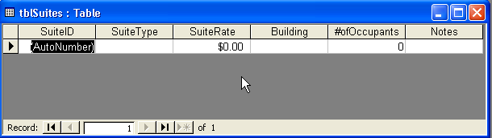

Adding and Editing Records
So far in this lesson, you created a database, two tables for that database, and the fields for those tables. Now you need to put some data in the tables that you created. Data is entered into a table in Datasheet view by clicking in the cell where you want the data to go and typing the data into that cell.
To edit existing data in a table, click in the cell that you want to change, use traditional editing keys such as the Backspace key to delete text to the left of the insertion point and the Delete key to delete text to the right of the insertion point, and then type the new data. You can also select part or all of the entry with the mouse pointer and type, which deletes the selected data and replaces it with the new data.
When you select any part of a record to create or change, a record selector appears to the left of the record to show the current status of the record.
If the record selector box is empty, it means that no users are currently modifying the record. Individual records, instead of entire pages, are locked when another user edits them
Record Selector | Status
 | The current record is selected, and the record has been saved as it appears.
 | This is a new record, into which you can enter data.
 | You are editing this record, and changes aren’t saved yet.
 | This record is locked by another user; you cannot edit it. Records become locked in a multi-user environment—meaning more than one person can use the database at a time—when another person is editing the record.
Access is different from most other Microsoft Office applications when it comes to saving changes. In most applications, you need to manually save your work as you go along. When entering data in Access objects, however, your work is saved by Access whenever you move to another record. This means that when you close a table, you will not be prompted to save changes because your changes will have already been saved. However, if you create a new object or make structural changes (such as adding new fields) to an existing object, you will need to manually save your work. Access will prompt you to save if you attempt to close an object to which you have done more than enter data.
In this exercise, you add three records to tblSuites and change the data in one of these records.
1 In the SuiteType field, click in the first empty record, type 2BR, and then press Tab.
Notice that the AutoNumber data type in the Suite ID field automatically gives the first record the Suite ID of 1.
Access selects the SuiteRate field in the first record.
2 Type 75, and press Tab.
Access selects the Building field in the first record.
Notice that Access automatically formats the data in the SuiteRate field in currency format as $75.00.
3 Type Lake View, and press Tab.
Access selects the #ofOccupants field in the first record.
4 Type 4, and press Tab.
Access selects the Notes field in the first record.
5 Type Corner room.
The first record is complete.
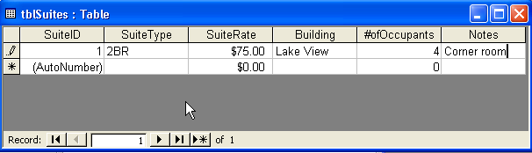
6 In the SuiteType field, click in the first blank record, and follow the previous steps to enter the following information into the record:
Each time you start a new record, the data in the previous record is saved.
SuiteType: 3BR
SuiteRate: 99
Building: Lake View
#ofOccupants: 6
Leave the Notes field blank.
7 In the SuiteType field, click in the first blank record, and follow the previous steps to enter the following information into the record:
SuiteType: 3BR
SuiteRate: 99
Building: Mountain View
#ofOccupants: 8
Notes: Has bunk beds in one bedroom
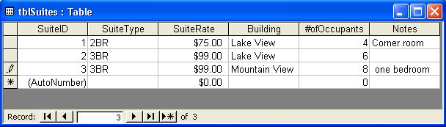
You will not be able to see all the text in the Notes field because the column is not wide enough. You will learn how to resize columns in Lesson 3, “Working with Tables.”
8 In the first record, click in the SuiteType field, delete the existing text, type 1BR, and then press Tab.
Access selects the text on the SuiteRate field.
9 Delete the existing text, and then type 69.
If you want to cancel your changes to one field in a record, press Esc. To cancel your changes to the whole record, press Esc twice.
10 In the first record, click in the #ofOccupants field, delete the existing text, and then type 2.
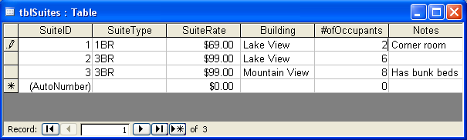

Moving and Deleting Fields
After you start using a table, you might realize that you included some unnecessary fields in the table, or that data entry would be more efficient if the fields were in a different order. Deleting fields, which appear in columns in Datasheet view, is different from deleting individual records, which appear in rows. If you delete a field, you lose all the data in the field for every record in the database.
You can delete or rearrange fields by displaying the table in Design view and then deleting or rearranging the rows. Each row in Design view represents one of the fields that appears as a column in Datasheet view. So, if you delete a row in Design view, you delete a field in Datasheet view. When you move and delete rows in Design view, you use the row selector to select all the cells in
the row.
In this exercise, you change the order of the fields in tblSuites and delete the #ofOccupants field.
1 On the Table Datasheet toolbar, click the View button.
The table appears in Design view.
2 In the Field Name column, click in the Building row.
The row selector appears to the left of the word Building.
3 Click the row selector for the Building row.
Access selects the Building row.
4 Drag the row selector up to just below the primary key symbol that is to the left the SuiteID row.
The Building row moves below the SuiteID row.
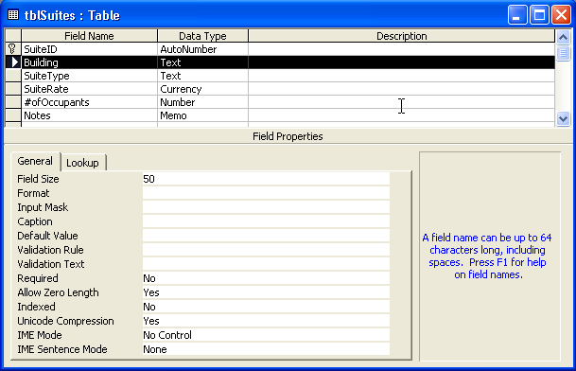
5 In the Field Name column, click in the #ofOccupants row.
The row selector appears to the left of the word #ofOccupants.
6 Click the row selector for the #ofOccupants row.
Access selects the #ofOccupants row.
7 On the Table Design toolbar, click the Delete Rows button.
To delete a row, you can also click Delete Rows on the Edit menu or right-click the field name and click Delete Rows on the shortcut menu that appears.
An alert box appears, asking if you want to permanently delete the field(s).
8 Click Yes.
Access deletes the #ofOccupants row from the table.
9 On the Table Design toolbar, click the Save button.
Access saves the table.
10 On the Table Design toolbar, click the View button.
If you try to switch to Datasheet view without saving changes, Access prompts you to save changes.
The table appears in Datasheet view.
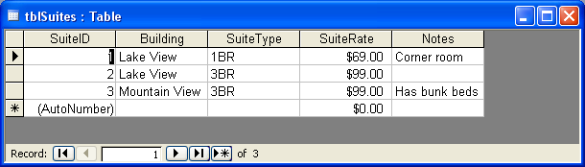

Deleting Records
Deleting a record, an individual row of data containing information from many fields, is a simple procedure that should be done carefully. Once a record is deleted, it cannot be restored. Therefore, make sure that you are removing the correct records. If you plan to delete several records, it is a good idea to create a backup of the entire database in case you accidentally delete the wrong records. Unlike fields, records are deleted in Datasheet view.
You decide that tblSuites should be limited to records of suites in the Lake View building. In this exercise, you delete the record for the suite in the Mountain View building.
1 Click anywhere in the record for the suite in the Mountain View building.
You do not have to select the entire record to delete it.
The record selector appears to the left of the record.
2 On the Table Datasheet toolbar, click the Delete Record button.
An alert box appears, asking if you want to delete the record(s).
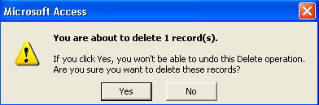
To delete a record, you can also click Delete Record on the Edit menu or right-click the record and click Delete Record on the shortcut menu that appears.
3 Click Yes.
Access deletes the record.
4 Click the Close button in the top-right corner of tblSuites.
The table closes.

Lesson Wrap-Up
This lesson covered how to create a new database, create a table in Design view and using the Table Wizard, add fields to tables, add data to tables, edit data in tables, move and delete fields, and delete records.
If you are continuing to the next lesson:
- Click the Close button in the top-right corner of the Database window.
The Database Fundamentals 02 database closes.
If you are not continuing to the next lesson:
- Click the Close button in the top-right corner of the Access window.
Access and the Database Fundamentals 02 database close.

Quick Quiz
1 How do you add a field to a table?
2 How do you delete a record?
3 What techniques might help you plan a database?
4 How do you move a field?
5 What is a primary key?
6 What are the two ways to create a table?
7 How do you create a database?
8 How do you enter a record in a table?
9 What does the AutoNumber data type do?

Putting It All Together
Exercise 1: Create a new table in Design view that lists conferences that will be held at Adventure Works. Create fields for:
ConferenceDate with the Date/Time data type
#OfDays with the Number data type
#OfParticipants with the Number data type
#OfRooms with the Number data type
Move the #OfRooms field so that it appears above #OfDays, and delete the #OfParticipants field. Close the table without saving changes.
Exercise 2: Open tblSuppliers in Design view and delete the Address, City, PostalCode, and StateOrProvince fields. Add a field for TypeOfBusiness and enter the following two records:
Supplier Name: Party Eternal
TypeOfBusiness: Entertainment supplies
And
Supplier Name: Ritzy Restaurant Supply
TypeOfBusiness: Restaurant décor items
Print the table, delete the record for Party Eternal, and then close the table.
Exercise 3: While Adventure Works has many built-in attractions and fine restaurants, the guests frequently would like to know about other restaurants, entertainment, and other attractions within a short driving distance of the resort. Add a new table to the Database Fundamentals 02 database and name it tblAttractions. The table should contain the name of the attraction, the location or address of the attraction, the approximate distance in miles from the resort, a phone number, a link to the attraction's Web site if available, and a short description of what it has to offer. Include any other fields that you think may be useful for this table. When you have finished creating the table, save it and close the database.
Exercise 4: Open the Database Fundamentals 02 database and open the tblAttractions table that you just created. Switch to Datasheet view if necessary, and enter at least five attractions. Types of attractions that guests would be interested in might include a cinema, a golf course, hot-air balloon rides, historic homes or buildings, or anything else you might think of. Create the data for your five attractions and close the table and the database.
Exercise 5: Create a new database and save it in your practice folder. This database will contain information about your personal music collection. Name the database MYMusic_XXX, where the XXX is replaced with your initials. Create a table to contain the information about your music collection. Include any fields you think are appropriate, but at the very least it should include the name of the artist, the record company, the year it was released, what format it is (CD, mini-CD, MP3, vinyl, etc.), and some rating value to be assigned by you according to how much you like it (one to five stars for example). When you have created the table, save it and switch to Datasheet view and add at least ten items to the table.

