Creating and Using Queries
Lesson 4

After completing this lesson, you will be able to:
- Create and run a query.
- Specify criteria in a query.
- Create a calculated field.
- Create a multiple-table query.
- Print a query.
Queries give Microsoft Access the ability to deliver information to people in a virtually unlimited number of ways. A query is a database object that allows you to extract fields and records from tables, based on criteria that you provide. Creating a query is like asking Access a question. When you run the query, Access provides the answer.
The most basic type of query in Access is the select query, which extracts data from one or more tables and displays the results in a format almost identical to Datasheet view for tables. The select queries that you create are limited only by the data in the database and your own ingenuity. You can create select queries that use fields from more than one table, reorder data in tables, and perform calculations on the data in tables. For example, the employees at the reservation desk of Adventure Works outdoor vacation resort use a query that, when run, extracts records for all rooms occupied during the current month, sorts the records by room number, and calculates the total charges for each room. All the queries created in this lesson are select queries.
Queries and the tables that they are based on are interactive. If you change the data in the query results datasheet, the data in the table(s) that the query is based on will also be changed. Alternatively, if you change the data in the table(s), the query results will also change.
To complete the procedures in this lesson, you will need to use a file named Database Fundamentals 04 in the Database Fundamentals Practice folder that is located on your hard disk.

Creating and Running a Query
In Access, you can create a query either in Design view or by using the Simple Query Wizard. If you know the information that you want to extract and want to create the query without using or knowing the conventions for creating a query, the Simple Query Wizard is the easier approach. After you understand how queries are composed and structured, you might find it easier and more powerful to create queries in Design view. A query can be modified in Design view after being created, regardless of how it is created.
The exercise in the following section shows you how to create a query without using the wizard.
After you create a query, you run it by clicking the Run button on the Query Design toolbar.
In this exercise, you open the Database Fundamentals 04 database, and use the Simple Query Wizard to create a query that extracts the FirstName, LastName, and HomePhone fields from tblEmployees.
1 With Access open, click the Open button on the Database toolbar.
The Open dialog box appears.
2 Click the Look in down arrow, click the icon for your hard disk, and then double-click the Unlimited Potential folder.
3 Double-click the Database Fundamentals Practice folder.
4 Click the Database FundamentalsDatabase Fundamentals 04 database, and click Open.
The Database window for Database Fundamentals 04 appears.
5 On the Objects bar, click Queries.
The options to Create query in Design view and Create query by using wizard appear. There are no queries in the Database Fundamentals 04 database.
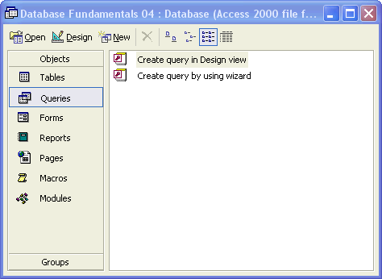
6 Double-click Create query by using wizard.
The first Simple Query Wizard dialog box appears, as shown in the illustration on the following page.
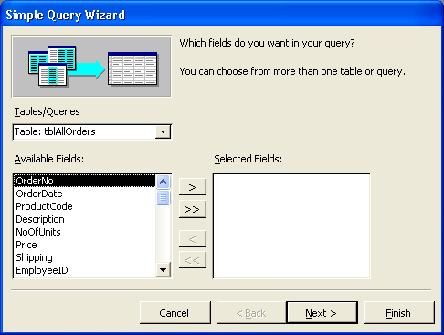
To select fields from more than one table, the fields in the different tables must first be in a relationship. Multiple-table queries are discussed later in this lesson.
7 Click the Tables/Queries down arrow, and click Table: tblEmployees.
The fields in tblEmployees appear in the Available Fields list.
8 Click FirstName in the Available Fields list, and click the > (Add) button.
You can also double-click the field name to move it to the Selected Fields list.
Access adds the FirstName field to the Selected Fields list.
9 Click LastName in the Available Fields list, and click the > (Add) button.
Access adds the LastName field to the Selected Fields list.
10 Click HomePhone in the Available Fields list, and click the > (Add) button.
Access adds the HomePhone field to the Selected Fields list.
11 Click Next.
The next Simple Query Wizard dialog box appears.
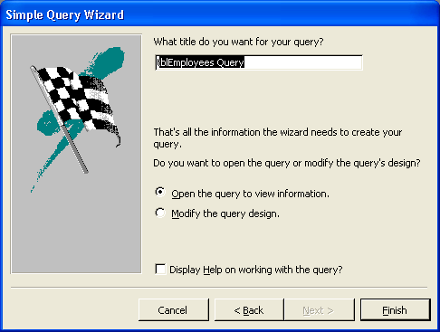
If you click the Modify the query design option, the query will appear in Design view when you click Finish.
12 In the What title do you want for your query? box, type qryEmployeePhoneList, verify that the Open the query to view information option is selected, and then click Finish.
The query appears in Datasheet view.
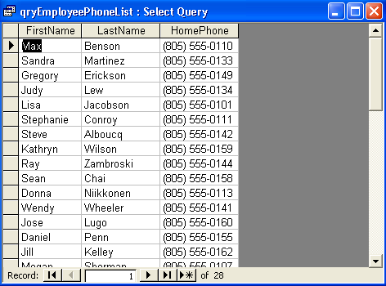
Only the FirstName, LastName, and HomePhone fields from tblEmployees appear in qryEmployeePhoneList.
13 Click the Close button in the top-right corner of qryEmployeePhoneList.
The query closes. Note that qryEmployeePhoneList now appears in the list of queries in the Database window.

Specifying Criteria in a Query
You can refine query results by setting criteria for the query. Query criteria are the rules that the query follows to determine what information to extract. When you set criteria for a query, Access extracts only fields and records that match your criteria.
When a query is displayed in Design view, you see the Criteria row in the design grid section.
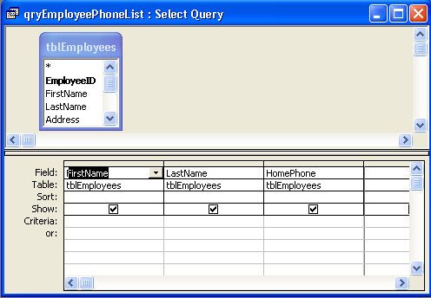
You use the Criteria row to specify criteria that limit query results. An alphabetical phrase, such as CH, is one kind of criterion that you can specify in a query. For example, suppose that you have a table that tracks orders placed by Adventure Works. You want to view all orders placed with the Erewhon Children’s Store, which has the vendor code CH. If you create a query with the letters CH entered in the Criteria row of the Vendor Code column, only orders for the Erewhon Children’s Store would appear in the query result.
You can also customize criteria by using a wildcard. A wildcard is a character, such as an asterisk or question mark, that can be used in place of one or more characters in a criterion. The following table shows the wildcards that you can use in the Criteria row to restrict query results.

Wildcard  Wildcards are usually used in fields with a Text data type, but they can also be used with other data types. For example, you could type 2/*/96 to extract records for any date in February 1996. | Usage | Example
* | Matches any one or more character(s). | wh* finds what, white, and wh2gH.
? | Matches any one alphabetic character. | w?ll finds wall, will, and well.
[*] | Matches any character(s) within the brackets. | m[ae]ll finds mall and mell, but not mill.
[!*] | Matches any character(s) not in the brackets. | m[!ae]ll finds mill and mull, but not mall or mell.
[*-*] | Matches any character in a range. The range must be in ascending order (A to Z, not Z to A). | m[a-c]d finds mad, mbd, and mcd.
# | Matches any single numeric character. | 10# finds 100 - 109.
Wildcards are a convenient way to extract information that follows a pattern or for which you remember only part of the value. For example, an asterisk instructs Access to find fields with one or more characters in that part of the field. Entering A* as the criterion for a FirstName field will locate records containing first names that begin with A; Amy, Alice, Alex, Andrew, and A (by itself) all meet the criterion. You can also use an asterisk at the beginning or middle of a criterion statement. For example, to find all first names that contain the letter a, you would type *a*.
You can specify criteria for more than one field in a query at a time. If you enter a criterion in more than one column in the Criteria row, the query results will include only records that match both criteria. For example, you can create a query that extracts records from tblEmployees for employees whose last names begin with B and who began work in 1996.
In this exercise, you use tblHumanResourcesData to create a query in Design view that generates a list of all employees who have the word Marketing in their job titles and were hired in 1993.
To create a new query in Design view, you can also click the New button on the Database window toolbar and click Design View in the New Query dialog box that appears.
1 Double-click Create query in Design view.
The Query Design view window and the Show Table dialog box appear.
2 In the Show Table dialog box, click tblHumanResourcesData, and click Add.
You can also double-click the table name to add it to the Query Design view window.
A field list displaying the fields in tblHumanResourcesData appears at the top of the Query Design view window.
3 In the Show Table dialog box, click Close.
The Show Table dialog box closes, and the Query Design view window becomes completely visible.
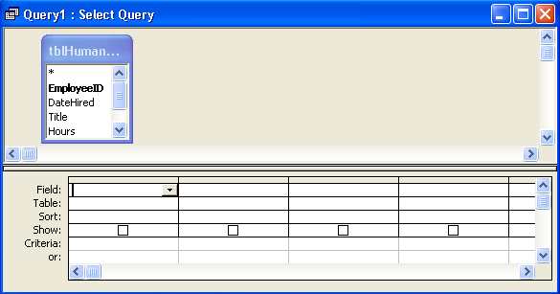
4 In the tblHumanResourcesData field list, click EmployeeID, and drag the field name to the first blank cell in the Field row in the design grid.
You can also double-click the field name in the field list to add it to the first blank cell in the Field row.
5 Repeat step 4 to add the DateHired, Title, and Salary fields to the blank cells in the Field row.
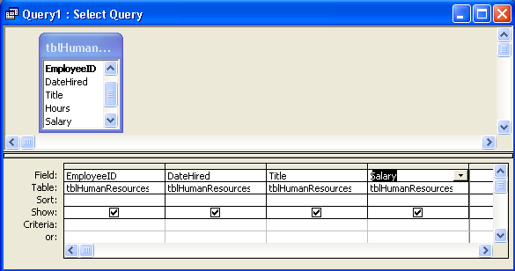
If you don’t see another blank cell in the Field row, use the scroll bar at the bottom of the design grid to scroll to the right.
6 In the DateHired column, click in the Criteria row, and type */*/93.
For step 6 to work, set your computer to show two-digit years (00) instead of four-digit years (2000).
The query will find only records for employees hired during 1993.
7 In the Title column, click in the Criteria row, type *Marketing*, and then press Enter.
The query will find only records for employees hired during 1993 and whose job title includes the word Marketing.
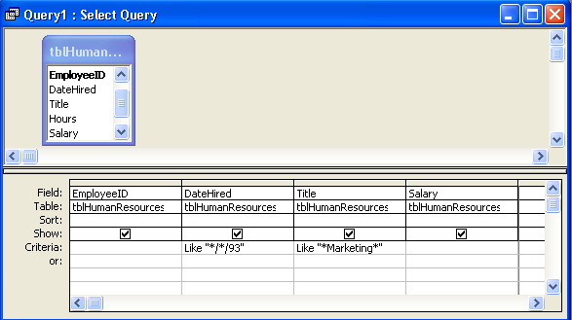
When you move the insertion point to another cell, the word Like and a pair of quotation marks appear in the cell with the criterion. The word Like is inserted before any criterion that uses a wildcard, and the quotation marks are placed around the string of characters that Access will use to restrict data.
8 On the Query Design toolbar, click the Run button.
The query results appear, displaying records for any employee hired during 1993 whose job title includes the word Marketing.
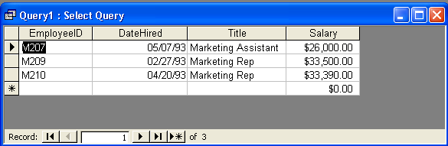
9 Click the Close button in the top-right corner of the query window.
An alert box appears, asking if you want to save changes.
10 Click No.
The query closes without saving changes.

Creating a Calculated Field
In the previous exercise, you created a query that extracts all orders for items with a price more than $100 and for more than one unit. However, the query doesn’t tell you what the total cost for each order is. You can set the query to calculate the total cost by creating a calculated field.
Calculated fields combine one or more fields with one or more operators to perform calculations for which you might otherwise use a calculator. This combination of operators and fields is called an expression and is used to tell Access what calculations to perform on the data.
In expressions, all field names are surrounded by square brackets ([]), and the operators used are the same characters used in most mathematical calculations: + (addition), - (subtraction), * (multiplication), and / (division). Expressions follow the same order of operations that you probably learned in high school math.
- Calculations surrounded by parentheses are calculated first. For example, (6 + 3) * 2 will equal 18, not 12.
- Multiplication and division are calculated before addition and subtraction. For example, 3 + 2 * 5 equals 3 + 10, or 13, not 5 * 5, or 25.
- For expressions containing only addition and subtraction or only multiplication and division, Access makes the calculations from left to right. For example, 6 / 3 * 2 equals 2 * 2, or 4, not 6 / 6, or 1.
To create a calculated field, click in the first blank column in the Field row in the design grid, type the name for the new field, and then type the expression for the calculation. For example, to create a calculated field named TotalCost that multiplies the Price and NoOfUnits fields to find the total cost of the order, you would type TotalCost:[Price]*[NoOfUnits].
You do not have to include spaces in expressions.
In this exercise, you create a calculated field that determines the hourly wage of the employees at the Adventure Works resort. The calculated field will calculate the number of hours that each employee works each year and divide the employee's salary by that number.
1 Double-click Create query in Design view.
The Query Design view window and the Show Table dialog box appear.
2 In the Show Table dialog box, click tblHumanResourcesData, click Add, and then click Close.
The Show Table dialog box closes, and a field list displaying the fields in tblHumanResourcesData appears in the top section of the Query Design view window.
3 In the tblHumanResourcesData field list, double-click EmployeeID.
The EmployeeID field appears in the first blank cell in the Field row in the design grid.
4 Repeat step 3 for the Hours and Salary fields.
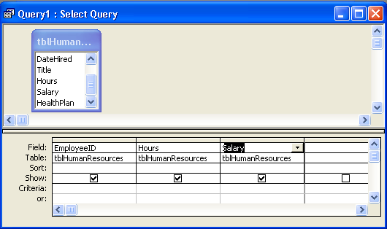
5 In the Field row, click the first blank cell, and type HourlyWage:[Salary]/([Hours]*52).
The Hours field contains the number of hours worked weekly by employees. The expression in step 5 calculates the number of hours that employees work per year by multiplying the number of hours worked per week by 52. The parentheses around [Hours]*52 ensures that Access performs that calculation first.

6 In the Show row for the new field, select the check box.
A check appears inside the check box.
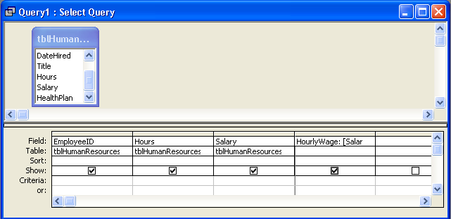
The check box in the Show row determines whether a field is displayed in the query result. If the check box is selected, the field will appear in the query results.
7 On the Query Design toolbar, click the Run button.
The query results appear, with the results of the calculation in the HourlyWage field.
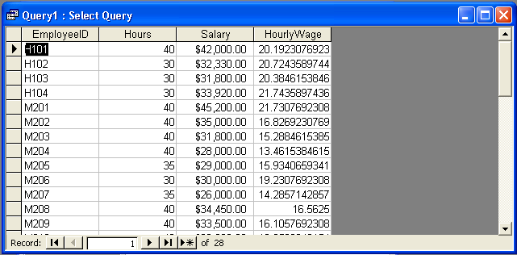
You cannot change the data in the HourlyWage field when the query is in Datasheet view. Access will perform the calculation using the current data in tblHumanResourcesData each time that you run the query.
8 On the Query Datasheet toolbar, click the View button.
The query appears in Design view.
9 In the HourlyWage column, click in the Sort row, click the down arrow that appears, and then click Descending.
Access will sort the query results in descending order by the values in the HourlyWage field.
10 On the Query Design toolbar, click the Run button.
The query results appear. The record for the employee making the highest wages per hour appears at the top of the table.
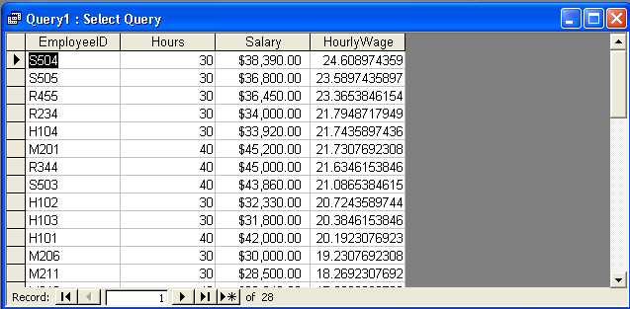
11 On the Query Datasheet toolbar, click the Save button.
The Save As dialog box appears.
12 Type qryHourlyWage, and click OK.
Access saves the query as qryHourlyWage.
13 Click the Close button in the top-right corner of qryHourlyWage.
The query closes.

Creating a Multiple-Table Query
The ability to create a multiple-table query is one of the more powerful features of Access. With multiple-table queries, you can extract fields from two or more tables, which allows you to combine information that can’t be found in any individual table. For example, tblHourly provides data about how much each employee earns per hour, but it does not include the employee’s names. Employee names are listed in tblEmployees, which does not include wage information for the employees. You could combine the information found in both of these tables by using a multiple-table query.
To use fields from more than one table, you must first join, or create a relationship, between fields in different tables. If the two fields that you want to join contain identical data, and at least one of the fields is a primary key, Access automatically joins the fields, using a setting called AutoJoin. For example, tblEmployees and tblHourly have identical EmployeeID fields that can be used to create a query that will show hourly wage information and names—data from two separate tables.
Multiple-table queries can also be used to extract data from two queries or a combination of tables and queries. Relationships are discussed in Lesson 3, “Working with Tables.”
If one of the fields is not a primary key—even if both fields contain identical data—Access does not automatically join the fields; you have to do it manually. To join the two fields manually, you click the field in the first field list and drag it until it is on top of the corresponding field in the second field list. A join line appears.
Primary keys are discussed in Lesson 2, “Creating Tables.”
If you create a query in Design view and add tblEmployees and tblHourly to the Query Design view window, Access automatically joins the EmployeeID fields, and a join line appears between the joined fields. Although a join line looks like the line that appears when two tables are in a relationship, a join line indicates that two of the fields in the tables are in a relationship, not that the tables themselves are in a relationship. If you display the Relationships window for the database, two tables with joined fields do not appear unless the tables are also in a relationship. You can see the join line between joined fields only in the Query Design view window.
If you do not want Access to automatically join related fields, you can turn off AutoJoin by clicking Options on the Tools menu, clicking the Tables/Queries tab, and clearing the Enable AutoJoin check box.
In this exercise, you perform a query that extracts employee names from tblEmployees and employee salary information from tblHourly.
1 Double-click Create query in Design view.
The Query Design view window and the Show Table dialog box appear.
2 In the Show Table dialog box, click tblEmployees, and click Add.
The tblEmployees field list appears in the top section of the Query Design view window.
3 In the Show Table dialog box, click tblHourly, and click Add.
To use an existing query as a source for a multiple-table query, click the Queries tab or Both tab in the Show Table dialog box.
The tblHourly field list appears in the top section of the Query Design view window.
4 In the Show Table dialog box, click Close.
The Show Table dialog box closes. The join line between the EmployeeID fields in tblEmployees and tblHourly indicates that the two fields are joined.
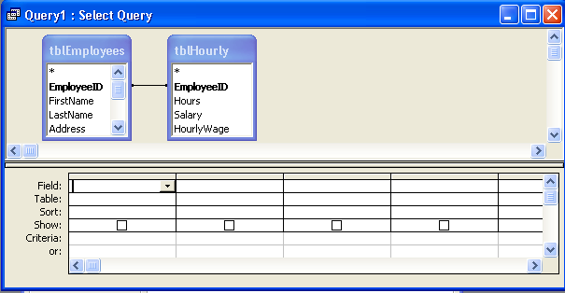
Access joined the two fields automatically because both fields contain the same information, and in this case, both of them are the primary key fields for their respective tables.
5 In the tblEmployees field list, double-click the LastName field.
The LastName field appears in the first blank cell in the Field row in the design grid.
6 Repeat step 5 for the FirstName field in tblEmployees and the Hours, Salary, HourlyWage, and EmployeeID fields in tblHourly.
7 In the HourlyWage column, click in the Sort row, click the down arrow that appears, and then click Descending.
Access will sort the query results in descending order by the values in the HourlyWage field.
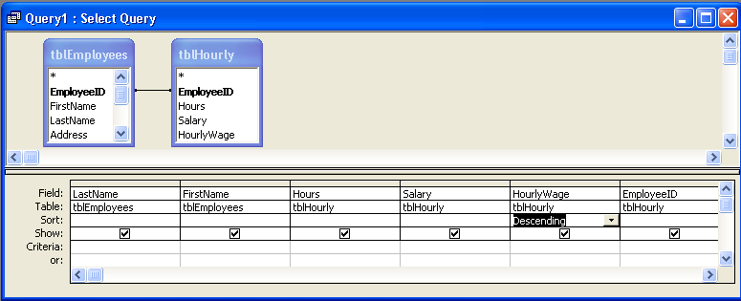
The Table row displays the source table for the fields in the Field Row.
8 On the Query Design toolbar, click the Run button.
The query results appear, sorted in descending order by hourly wage.
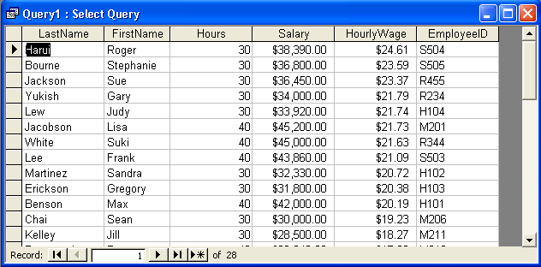
9 On the Query Datasheet toolbar, click the Save button.
The Save As dialog box appears.
10 Type qryHourlyWithNames, and click OK.

Printing a Query
The method for printing a query is essentially the same as the method for printing a datasheet. Because query results often extend several pages, you might want to preview a query first by clicking the Print Preview button on the Query Design or Query Datasheet toolbar. Print Preview shows you what the query will look like and how many pages it will fill after it is printed. You can print a query:
- From Print Preview by clicking the Print button on the Print Preview toolbar.
- From Datasheet view by clicking the Print button on the Query Datasheet toolbar.
- From any view by clicking Print on the File menu.
In this exercise, you preview qryHourlyWithNames in Print Preview and then print it.
1 On the Query Datasheet toolbar, click the Print Preview button.
The query appears in Print Preview.
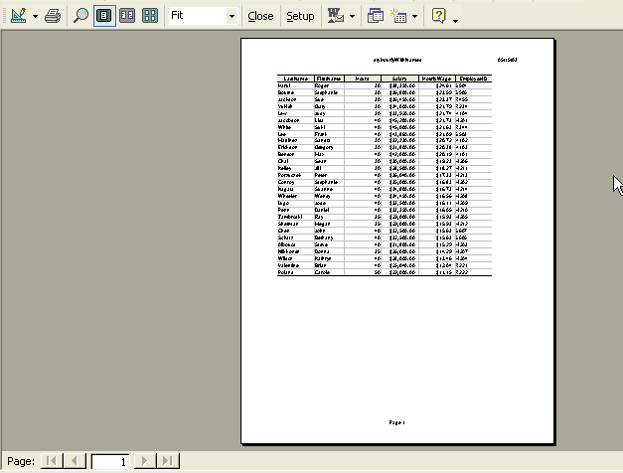
If the query appears on more than one page, you can use the buttons in the bottom-left corner of the Print Preview window to view the other pages.
2 On the Print Preview toolbar, click Close.
Print Preview closes.
3 On the Query Datasheet toolbar, click the Print button.
A message box indicates that qryHourlyWithNames is printing.
4 Click the Close button in the top-right corner of qryHourlyWithNames.
The query closes.

Lesson Wrap-Up
This lesson covered how to create and run a query, specify query criteria, create a calculated field, create a multiple-table query, and print a query.
If you are continuing to the next lesson:
- Click the Close button in the top-right corner of the Database window.
The Database Fundamentals04 database closes.
If you are not continuing to the next lesson:
- To quit Access for now, click the Close button in the top-right corner of the Access window.
Access and the Database Fundamentals 04 database close.

Quick Quiz
1 What are the two ways to create a query in Access?
2 What is a multiple-table query?
3 How can you sort query results?
4 What is a wildcard?
5 How do you print a query in Datasheet view?
6 What view do you use to modify a query?
7 How do you specify criteria for a query?
8 How do you run a query?

Putting It All Together
Exercise 1: Create a query in Design view that extracts the VendorName field from tblVendors and the Code and Description fields from tblProducts. (Hint: Join the VendorID fields in the two tables.) Run the query. Restrict the query results to just those products with KH in their product codes, and run the query again. Close the query without saving changes.
Exercise 2: Select the Create query in Design view option from the Database window. From the Show Table window select the tblEmployees, tblHuman-ResourcesData, and the tblInsurance table to be included in the query. Access will automatically join the Employee ID fields in the employee and human resources tables. Create a join from the HealthPlan field in tblHuman-ResourcesData to the PlanID field in the tblInsurance table. Add the EmployeeID, LastName, FirstName and Title fields from the employee table, the HealthPlan field from the human resources table, and the PlanType and Rate fields from the insurance table. Sort the query on the HealthPlan field. Run the query and save it as qryInsByType.
Exercise 3: Create a query using the Wizard or in Design view that shows which of the resort’s suites were occupied during the June, July, and August for the year 2000. List the suite numbers, the check-in and check-out dates, and sort the query on the check-in date field. Save the query as qryCheckInDate.
Exercise 4: Open the MyMusic_XXX (where XXX represents your initials) database that you created in Lesson 2. Open the table you created for your music collection data and switch to Design view if necessary. If your table does not already have a field to describe the category, or genre, of the music (i.e., Rock, Pop, Classical, etc.) add such a field to the table. Switch to Datasheet view and add values for each record in the table that describes what category each entry falls into. Create a query using the wizard or Design view, and use all of the fields in the table. Enter selection criteria to retrieve all entries that are on a CD and are in any category of your choice. Run the query and examine the results. Modify the query to select all records that are NOT on CD but are in the same category you used for the first query. Close the query without saving it, and close the database.

