Formatting Cells
Lesson 3

After completing this lesson, you will be able to:
- Format text.
- Format numbers as currency.
- Use Format Painter.
- Add borders to cells.
- Add shading to cells.
- Use AutoFormat.
- Create and apply styles.
- Merge cells.
Some of the major benefits of using Microsoft Excel include the ability to organize data in row-and-column format and then perform calculations on specific rows, columns, and cells. These features are helpful whether you’re creating a worksheet for your eyes only, you’re mainly interested in viewing budgets or forecasts, or you’re recalculating data based upon different projections.
Excel provides dozens of ways to format labels and values in a worksheet to provide a more attractive design and layout. If your worksheet or workbook will be printed or viewed by others, especially if it is part of a report or presentation, you’ll want your worksheet to look as attractive as possible. For example, to improve the design you can enlarge the text for headings and format the headings and labels in bold, italics, or both. You can also format text in different fonts (type styles) and in different colors.
In this lesson, you will learn how to format text and numbers (including headings, labels, and values) that appear in cells on the screen and when the data is printed. You will learn how to use Excel’s Format Painter feature, which allows you to quickly pick up all of the formatting for selected text and then apply the same formats to different text. You will also learn how to add borders and shading around selected cells. Then you will learn how to apply one of Excel’s built-in worksheet designs to add colors and design effects to a worksheet using only a few mouse clicks. Next you will learn how to create a style, which is a collection of formatting characteristics that can be applied at any time simply by clicking the name of the style in a list. Finally, you will learn how to combine multiple cells into a single cell.
To complete the procedures in this lesson, you will need to use the files Lodging Analysis03 and AW Guest Supplies in the Lesson03 folder in the Spreadsheet Fundamentals Practice folder located on your hard disk.

Formatting Text
One of the easiest ways to add attractive formatting to a worksheet’s contents is by changing the font and font size for selected headings, labels, and values. A font is the general appearance of text, numbers, and other character symbols. The different characters of a particular font all have a similar design to provide a consistent look and feel. Excel’s default font is 10-point Arial. In typography, one point is 1/72 inch. So characters in a 10-point font are about 1/6 inch high. You don’t have to rely on the Arial font or the default size of 10 points in your worksheets, though. You can change to different fonts and different font sizes to add visual interest to a worksheet and call attention to specific data. The Font tab of the Format Cells dialog box contains options to change the font, as well as the style (such as bold or italics) and the point size of a cell entry. Some of the formatting features in Excel also appear on the Formatting toolbar. You’ll use this toolbar throughout this lesson.
In this exercise, you format text in a worksheet.
1 Open the Lodging Analysis03.xls workbook stored in the Lesson03 folder located in the Spreadsheet Fundamentals Practice folder on your hard disk.
2 Click cell B1, and on the Formatting toolbar, click the Bold button.
The title appears in bold.
3 Select the range B3:E3, and on the Formatting toolbar, click the Center button.
You can customize the Formatting toolbar by placing buttons on it that you use frequently and removing those you don’t. To customize your toolbar, click the Toolbar Options button, and click Add or Remove Buttons. Click menu options to select or deselect the buttons on the list.
The year labels are centered.
4 Click the Bold button on the Formatting toolbar.
The year labels appear in bold.
5 Right-click the area you’ve selected, click Format Cells on the shortcut menu, and then click the Font tab.
The Font tab of the Format Cells dialog box appears.
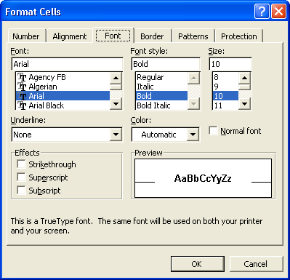
6 On the Font list, scroll down, and click Times New Roman.
7 On the Size list, scroll down, and click 12.
8 Click the Color down arrow, click the Red square (third row, first square), click OK, and then click a blank area of the worksheet.
The range is deselected and appears in 12-point, red, Times New Roman text.
9 Select the range A4:A8, and click the Bold button.
The row labels appear in bold.
10 On the Format menu, click Cells, and click the Alignment tab.
The Format Cells dialog box appears with the Alignment tab on top.
11 Double-click in the Indent box, type 1, and click OK.
The sales categories in the selected cells are indented one character to the right.
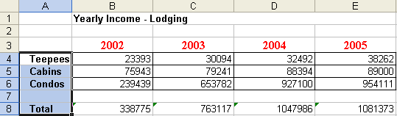
12 On the File menu, click Save As, type Lodging Analysis, and then click Save.
You can also change the file name by selecting only the numbers 03 at the end of the current file name, deleting them, and then clicking the Save button.
The workbook is saved with the new name.
Keep this file open for the next exercise.

Formatting Numbers as Currency
When you type numbers into worksheet cells, Excel formats the cells in the General format by default—which means all text and numeric entries appear exactly as you’ve entered them. You can use the Number tab of the Format Cells dialog box to change the way numbers appear. For example, you can display large numbers with comma separators between thousands digit positions, you can display numbers as currency with dollar signs and decimal positions for fractions of a dollar, or you can display numbers as fractions or even percentages.
Some common number formats can be applied to selected cells more easily by using the Formatting toolbar. The following table shows some of the buttons on the Formatting toolbar that you can click to format numbers.
Button | Button Name | Description
 | Currency Style | Formats numbers with dollar signs, comma separators for thousands, and two decimal places.
 | Percent Style | Multiplies numbers by 100 and displays them with percent signs.
 | Comma Style | Inserts commas between groups of thousands.
 | Increase Decimal | Adds one decimal position each time you click the button.
 | Decrease Decimal | Removes one decimal position each time you click the button.
In this exercise, you use the Formatting toolbar to format numbers as currency and to remove decimal positions.
1 Select the range B4:E8, and on the Formatting toolbar, click the Currency Style button.
The numbers in the selected cells appear with dollar signs, comma separators, and two decimal positions. Notice that none of the numbers includes fractions of a dollar, so the decimal positions are not necessary.
2 Click the Decrease Decimal button twice, and click an empty cell in the worksheet.
The decimal positions are removed from the selected range of numbers and the range is deselected. Your worksheet should look similar to the following illustration.
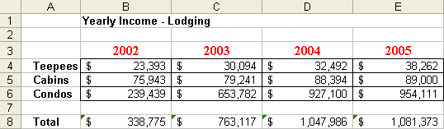
Keep this file open for the next exercise.

Using Format Painter
The Format Painter button allows you to copy formatting from a cell or a range of cells and apply it to another cell or range of cells. This button can save you time and help ensure formatting consistency.
In this exercise, you use the Format Painter button to copy a format from one cell to a range of cells.
If the Format Painter button doesn’t appear on the Standard toolbar, click the Toolbar Options button to display the rest of the buttons, and then click the Format Painter button.
1 Click cell B3.
The first column label cell is selected.
2 Click the Format Painter button on the Standard toolbar.
A flashing marquee appears around the selected cell and the mouse icon changes to a plus sign with a paintbrush next to it.
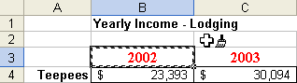
3 Select the range A4:A8 (the row labels).
Excel copies the formatting in cell B3 to the range you selected. The row labels now appear in red, bold, and 12-point Times New Roman font.
4 On the Standard toolbar, click the Save button.
The workbook is saved with the current name.
Keep this file open for the next exercise.

Adding Borders to Cells
Adding borders to a cell or a range of cells can enhance the visual appeal of your worksheet, make it easier to read, and highlight specific data. You can put a border around one cell, a range of cells, or an entire worksheet. Borders can also clearly separate sections of a worksheet, such as row or column labels or totals.
Excel provides more than a dozen border styles—including single lines of varying widths, dotted lines, and dashed lines. You can also change the color of a border. When you create a border for a cell or a range of cells, you don’t have to apply the border to all four sides. You can specify that the border be applied to any side or combination of sides. For instance, you can apply a double-line border to only the bottom border of the first row of a worksheet to separate the title from the rest of the worksheet.
In previous versions of Excel, you could select the cell or cells to which you wanted to add the border and use the options available under the Formatting toolbar’s Borders button to assign a border to cells. For example, you could select a group of cells and then choose the border type you wanted. That method of adding borders is still available in Excel, but it has some limitations. The most important limitation is that, while creating a simple border around a group of cells is easy, creating complex borders makes you select different groups of cells and apply different types of borders to them. The current version of Excel makes creating complex borders easy by letting you draw borders directly on the worksheet.
To use the new border-drawing capabilities, you display the Borders toolbar.
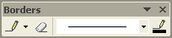
To draw a border around a group of cells, click the mouse pointer at one corner of the group and drag it to the diagonal corner. You will see your border expand as you move the mouse pointer. If you want to add a border in a vertical or horizontal line, drag the mouse pointer along the target grid line. Excel will add the line without expanding it to include the surrounding cells. You can also change the characteristics of the border you draw through the options on the Borders toolbar.
In this exercise, you add borders to the cells in your worksheet that contain totals and to the column headings of your worksheet.
1 Select the range B8:E8.
2 On the Formatting toolbar, click the down arrow to the right of the Borders button.
A menu of border line styles and locations appears.
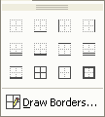
3 Click the Thick Box Border button (fourth button, third row).
A thick border is added around all sides of the selected cells.
4 Select the range A3:E3.
5 On the Format menu, click Cells, and click the Border tab.
The Format Cells dialog box appears with the Border tab on top.
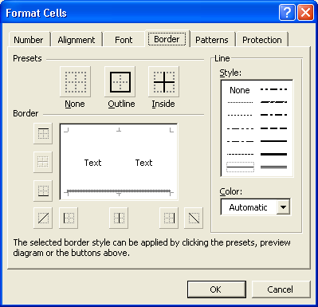
6 On the Line, Style list, click the second line style in the second column.
7 Click the Color down arrow, and click the Blue square (second row, sixth square).
8 In the Border section of the dialog box, click the bottom border.
In the dialog box Excel shows a preview of what the chosen border will look like.
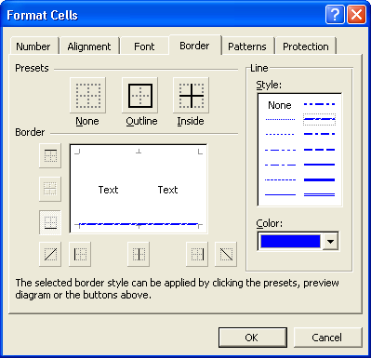
9 Click OK, and click a blank cell in the worksheet.
The Format Cells dialog box closes, and the blue border is added to your worksheet.
10 Point to Toolbars on the View menu and click on Borders to open the Borders toolbar.
11 Click the down arrow on the Line Style button and select the double line.
The mouse pointer changes to a pencil with a line next to it and the Line Style button reflects the selection you have made.
12 Click and drag under the text in cell B1. Then click the Draw Border button on the Borders toolbar to toggle the mouse icon back to the regular selection arrow.
A double line is drawn under the text and your worksheet should look similar to the illustration on the following page.
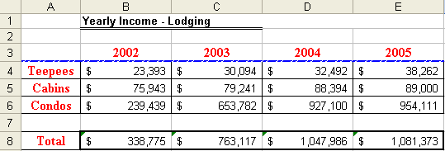
Keep this file open for the next exercise.

Adding Shading to Cells
As with borders, you can add shading and patterns to one cell or a range of cells to set off the selection. Shading can be a shade of gray or a color. Although colors can add significantly to the appearance of a worksheet, colors will appear in a printed worksheet only if you are using a color printer. A pattern is a set of lines or dots that fill selected cells. Applying patterns is especially useful if you want to call attention to one or more cells in a printed worksheet but you do not have a color printer. If you have a color printer or plan to view your worksheet only on the screen, you can combine color shading with a pattern in selected cells. But if you do so, make sure the text in the cells is still easy to read.
You can click the down arrow to the right of the Fill Color button on the Formatting toolbar and click a shade of gray or a color from the color palette that appears.
In this exercise, you add shading to cells in the worksheet, and you preview the patterns that you can apply to cells.
1 Select the range B8:E8.
You will add shading to the cells that show total projected income for each year.
2 On the Format menu, click Cells, and click the Patterns tab.
The Format Cells dialog box appears with the Patterns tab on top, as shown on the following page.
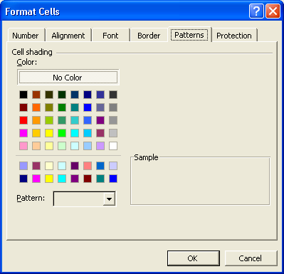
3 In the Color area, click the Yellow square in the bottom row of colors.
4 Click the Pattern down arrow.
The fill patterns that you can add to cells appear, as shown in the illustration on the following page.
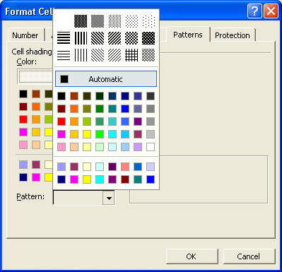
Patterns work best with row and column labels—especially for labels that are in a large font size or are bold. When a pattern is applied to cells that contain numbers, the numbers can often be difficult to read.
5 Click the Pattern down arrow again.
The Pattern list closes without a pattern selected.
6 Click OK, and click a blank area of the worksheet.
Colored shading appears as a shade of gray if you print the worksheet on a black and white printer.
The cells are deselected and appear with yellow shading.
7 On the Standard toolbar, click the Save button.
The workbook is saved with the current name.
Keep this file open for the next exercise.

Using AutoFormat
With the AutoFormat feature, you can format the data in your worksheets using a professionally designed template. The AutoFormat feature attempts to identify row and column labels, totals, and other worksheet elements. It then adds different colors, shading, and font effects to provide clarity and visual appeal to the worksheet. The AutoFormat feature doesn’t work as well for more complex worksheets that might have different levels of labels and totals. If you apply an AutoFormat and don’t like the effects of the design, you can easily undo the design by clicking the Undo button on the Standard toolbar.
In this exercise, you explore the AutoFormat dialog box, and you format a worksheet area with AutoFormat.
1 Select the range A3:E8.
All the row labels, column labels, and data cells are selected.
2 On the Format menu, click AutoFormat.
The AutoFormat dialog box appears.
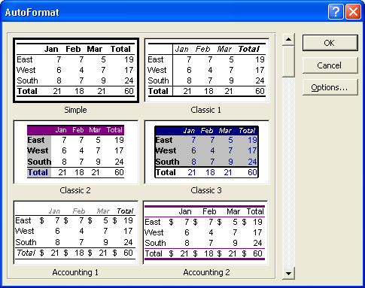
3 Scroll down on the formats list to view all the available formats.
4 Scroll back to the top of the formats list, click the Classic 2 format preview, click OK, and then click a blank area of the worksheet.
The range is deselected and appears in the Classic 2 format.
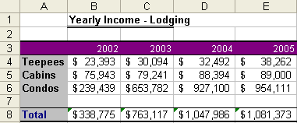
When an AutoFormat is applied, Excel removes any existing formatting in the selected cells so that the AutoFormat can be applied correctly.
5 On the Standard toolbar, click the Save button.
The file is saved with the current name.
Keep this file open for the next exercise.

Creating and Applying Styles
A style, as explained earlier, is a set of formatting attributes that you can apply to a cell or a range of cells more easily than setting each attribute individually. Excel comes with six ready-made styles that you can use to format numbers quickly: Comma, Comma [0], Currency, Currency [0], Normal, and Percent. A style can combine the following types of attributes:
- Number
- Alignment
- Font
- Border
- Patterns
- Protection
An attribute is a formatting characteristic of a cell (such as a dotted line border) or text (such as a font or font size). You can modify the attributes of any of these styles, or you can create your own styles. If you do this, you must base the new style on an existing style; however, you don’t need to keep any of the formatting that composes the original style. You can also change the formatting of a style you’ve already applied to quickly reformat all cells with that style.
By default, Excel applies the Normal style to all cells. Changing the attributes of the Normal style changes the appearance of all cells to which you’ve applied no other style.
In this exercise, you create a style that applies a font, font size, alignment, and font style to the contents of selected cells. You then apply the new style to other cells.
1 Click cell B1, and on the Format menu, click Style.
The Style dialog box appears, with Normal as the default style.
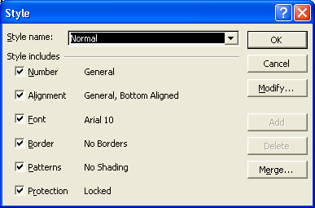
2 Click in the Style name box at the end of the word Normal, type 2, and then click the Add button.
A style named Normal2 is created.
3 Click the Modify button.
The Format Cells dialog box appears. In this dialog box, you define the attributes of the style.
4 Click the Font tab, click Times New Roman on the Font list, click Bold on the Font style list, and then click 14 on the Size list.
The contents of any cell to which you apply the Normal2 style will appear in 14-point Times New Roman bold text.
5 Click OK.
The Style dialog box reappears, showing the changes you made to the Normal2 style.
6 Click OK again.
The contents of cell B1 appear with the formatting you specified for the Normal2 style.
7 Click cell A8, and on the Format menu, click Style.
The Style dialog box appears.
8 Click the Style Name down arrow, click Normal2, and then click OK.
The contents of cell A8 appear with the formatting you specified for the Normal2 style.
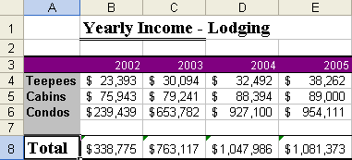
You can apply styles more easily if you add the Style list to the Formatting toolbar. To do so, on the Tools menu, click Customize to display the Customize dialog box. Click the Commands tab, click Format on the Categories list, and drag the Style list box from the Commands list to the Formatting toolbar.
9 On the Edit menu, click Undo Style.
The contents of cell A8 appear with the previous formatting.
10 On the Standard toolbar, click the Save button.
The file is saved.
11 On the File menu, click Close.
The workbook closes.

Merging Cells
You already know that you can adjust the width of a column so that the longest number or text entry in the column fits within the column width. You can also merge cells to support additional formatting capabilities. Merging cells combines two or more cells into a single cell so that the text or value within the cell can be formatted more easily. For example, you might want to merge several cells in the title row of a worksheet so that the title fits within a single cell. Then you could align the title so that it’s centered within the larger, merged cell.
You can also merge cells in adjoining rows so that you can have more control over the alignment and placement of text in the cells. For example, suppose several of the column labels for your worksheet are lengthy. If you widen the columns to fit the lengthy column labels, the columns might be much longer than the longest value in the column. For example, suppose you have a column label called Quantity Ordered. This label occupies 16 character positions. Now consider that the largest order amount is 9,999—five character positions. If you widen the Quantity Ordered column to fit the column label, the column is much wider than necessary. You’ll see how this technique works in the following exercise.
A better approach is to merge the Quantity Ordered cell with the cell below it. After you’ve merged the cells, you can then use the Format Cells dialog box to format Quantity Ordered so that the text wraps from the top line into the line below it and is centered both horizontally and vertically in the merged cell. You can then narrow the column so that the values fit better within the column.
In this exercise, you merge cells both horizontally (multiple cells in the same row) and vertically (multiple cells in the same column), and you reformat the merged cells.
1 Open the file AW Guest Supplies stored in the Lesson03 folder located in the Spreadsheet Fundamentals Practice folder on your hard disk.
2 Click cell A1 to select it, if necessary.
Although you can click and drag to select any range of cells, the technique used in steps 2 and 3 provides an easier way to select a lengthy range of cells.
3 Hold down the Shift key, and click cell F1.
The range A1:F1 is selected.
4 Click the Merge and Center button.
The selected cells are merged into one cell, and the text is centered in the cell.
5 Click cell A3, hold down the Shift key, and then click cell F3.
The range A3:F3 is selected.
6 Click the Merge and Center button.
The selected cells are merged into one cell, and the text is centered in the cell, as shown in the illustration on the following page.
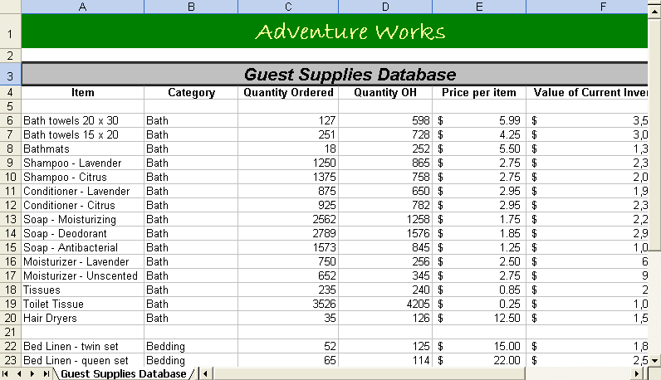
7 Select the range C4:C5, right-click the selected cells, and on the shortcut menu, click Format Cells.
The Format Cells dialog box appears.
8 Click the Alignment tab.
The Alignment tab of the Format Cells dialog box appears on top.
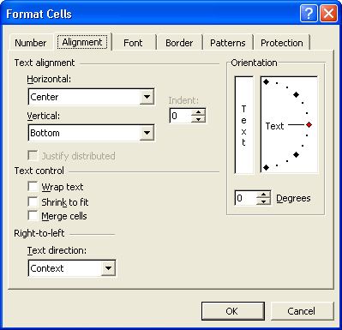
9 Click the Vertical down arrow, and click Center.
The selected cells will be centered vertically in the merged cell.
10 In the Text control section of the dialog box, select the Wrap text check box.
The text in the selected cells will wrap to two or more lines if the text does not fit on one line.
11 In the Text control section of the dialog box, select the Merge cells check box, and click OK.
You can unmerge a merged cell at any time by selecting the cell, displaying the Alignment tab of the Format Cells dialog box, and then clearing the Merge Cells check box.
The cells are now merged into a single cell, and the text is centered both vertically and horizontally in the merged cell.
12 Click the right edge of the column selector for column C until the move pointer (two-headed arrow) appears.
13 Drag the column selector for column C to the left until it is about 9 characters in width.
The column width, measured in the number of characters, appears and changes as you drag the column selector.
The text in the merged cell wraps to a second line.
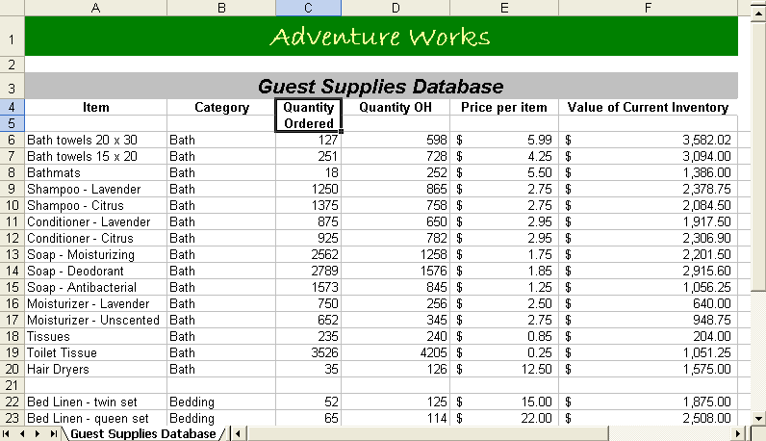
14 On the Standard toolbar, double-click the Format Painter button, and select the range D4:D5.
Excel copies the merge formatting to the selected cells.
15 Select the range E4:E5.
Excel copies the merge formatting to the selected cells.
16 Select the range F4:F5, and click the Format Painter button.
17 Excel copies the merge formatting to the selected cells, the Format Painter is no longer activated, and the cell selection marquee around cell C4 disappears.
18 On your own, use the column selectors to reduce the width of columns D, E, and F so that the text in the merged cells wraps to two lines for each column.
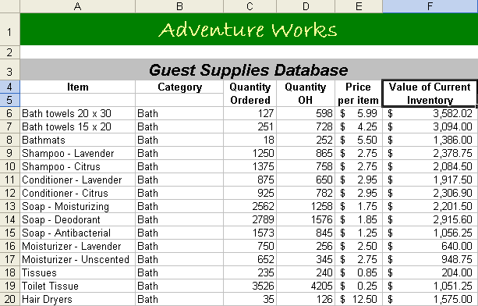
19 On the File menu, click Save As, type AW Guest Supplies 03, and then click the Save button.
The file is saved with the new name.

Lesson Wrap-Up
In this lesson, you learned how to format text within cells, how to use the Formatting toolbar to apply currency formats to numbers, how to copy formatting by using the Format Painter, how to add borders and shading to selected cells, how to apply an AutoFormat design to a range of cells, how to create and apply styles, and how to merge cells.
If you’re continuing to other lessons:
- Close the AW Guest Supplies 03 workbook.
If you’re not continuing to other lessons:
1 Save and close all open workbooks.
2 Click the Close button in the top-right corner of the Excel window.

Quick Quiz
1 What is the easiest way to convert selected cells to currency format?
2 What are two ways to apply shading to selected cells?
3 How can you display a button that isn’t showing on a toolbar?
4 What purpose do styles serve?
5 How can you apply a border to a cell or a range of cells you’ve selected?

Putting It All Together
Exercise 1: Open the Lodging Analysis03.xls workbook. Left-align the title text, and right-align the column headings. Change the column headings to a size, font, and style that you like. Then use the Format Painter to copy the format of the column labels to the row labels.
Exercise 2: Using the Lodging Analysis03.xls workbook, select the labels and data in the worksheet. Apply different AutoFormats to see how they look. Then create a style, and apply it to the Totals row.
Exercise 3: Create a worksheet in which you can log your daily physical activities. (If you created this worksheet in the previous lesson, you can continue to use that worksheet.) This worksheet should contain a list of your regular physical activities in column A and there should be a column for each day of the week. In a row above the days of the week, insert a heading that reads Minutes per Day. Merge and center this heading. Change the heading format to 14-point, Arial, bold. Select the entire range that includes all of the days of the week and all of the activities (do not include the heading) and apply the Colorful 1 AutoFormat.
Exercise 4: In reviewing the worksheet that you created in Exercise 3, you decide that you like the basic Colorful 1 format, but you’re not fond of the colors and you think you would like the borders to be somewhat different. What methods could you use to alter these features? Which method do you like the best? Write a brief answer to these questions.
Exercise 5: While learning to format cells in a worksheet, we have selected individual cells as well as ranges of cells. Use Excel’s Help files to determine if there is a quick way to select an entire worksheet and apply formatting changes to all of the cells at once. Write a brief explanation of your findings.

