Working with Charts
Lesson 6

After completing this lesson, you will be able to:
- Create charts using the Chart Wizard.
- Move, resize, and delete charts.
- Modify chart titles and add axis labels.
- Move and format chart elements.
- Change chart types and organize source data.
- Update data and format the axes.
- Add gridlines and arrows.
- Preview and print charts.
Microsoft Excel allows you to track and work with substantial amounts of data. At times, it might be difficult to understand the larger picture from looking only at the details. With Excel charts, you can summarize, highlight, or reveal trends in your data that might not be obvious when looking at the raw numbers.
At the outdoor vacation resort Adventure Works, the sales manager records expense data and estimates future revenue in the Five Year Sales workbook. He intends to use charts to summarize the annual sales projections and quickly see which business area has the highest percentage of expenses. The activities coordinator tracks the pledges collected from members at resort events, and she uses charts to analyze the trend in pledge rates at various levels over the year.
In this lesson, you will learn about the types of charts available in Microsoft Excel and how to create them. Then you will learn how to modify, move, and format charts and chart elements. Finally, you will learn how to preview and print your charts.
To complete the procedures in this lesson, you will need to use the files Five Year Sales.xls and Member Pledges.xls in the Lesson06 folder in the Spreadsheet Fundamentals Practice folder located on your hard disk.

Creating Charts Using the Chart Wizard
The Chart Wizard guides you through the process of creating a chart. As you complete each step, the wizard prompts you for your next selection. To start, you select the type of chart you want.
Excel offers 14 types of charts, with each type having two or more subtypes. Using the Chart Wizard, you can preview the chart types and choose the chart that best suits your data. For example, revenue and sales projections are easily summarized with a column, bar, or line chart, while expenses might be best represented as a pie chart.
The following table gives a brief description of each chart type.
Icon | Chart Name | Function
 | Column | Compares individual values across time or other categories. Represents values as vertical bars.
 | Bar | Compares individual values across time or other categories. Represents values as horizontal bars.
 | Line | Shows the trend of values across time or other categories. Represents values as points along a line.
 | Pie | Shows values as parts of a whole. Represents values as sections of a circular pie.
 | XY (Scatter) | Compares the values of two sets of data across time or other categories. Values are represented as data points, which might be connected by lines.
 | Area | Shows the trend of values across time or other categories. Represents values as shaded areas.
 | Doughnut | Shows values as parts of a whole. Represents values as sections of a circular band.
 | Radar | Shows the trend of values relative to a center point. Represents values as points that radiate from the center. Each category has its own axis. Lines connect all the values in the same series.
 | Surface | Shows the trend of values across two sets of data. Values are represented as a 3-D surface that illustrates the relationship between the sets.
 | Bubble | Compares three sets of values.
 | Stock | Shows the trend of sets of values across time. Often used to illustrate stock price changes with markers for High, Low, Close, and Open values. Represents values as points, lines, or columns.
 | Cylinder | Compares individual values across time or other categories. Represents values as vertical or horizontal cylinders.
 | Cone | Compares individual values across time or other categories. Represents values as vertical or horizontal cones.
 | Pyramid | Compares individual values across time or other categories. Represents values as pyramidal shapes.
In preparation for a budget meeting, the sales manager for Adventure Works wants to create a chart to show the projected trend in each of four revenue categories over the next five years. A line chart clearly shows that the largest increase is expected in lodging sales.
In this exercise, you open a workbook and create a chart using the Chart Wizard.
1 Open the Five Year Sales workbook from the Lesson06 folder in the Spreadsheet Fundamentals Practice folder.
2 Select cells A2:F6 in the Sales Projections worksheet.
3 On the Standard toolbar, click the Chart Wizard button.
The Step 1 of 4 – Chart Type dialog box appears.
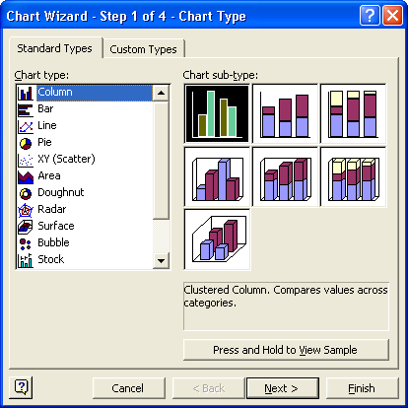
In the Step 1 of 4 – Chart Type dialog box, you can click the Press and Hold to View Sample button to see a preview of your chart.
4 On the Chart type list, click Column, if necessary.
5 In the Chart sub-type box, click the Stacked Column sub-type in the center of the top row, and click Next.
The Step 2 of 4 – Chart Source Data dialog box appears with a preview of your chart.
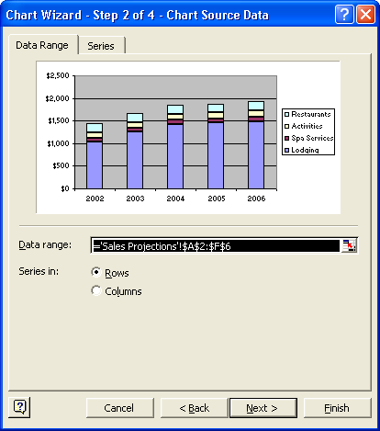
6 On the Data Range tab, verify that the Rows option is selected, and click Next.
The Step 3 of 4 – Chart Options dialog box appears.
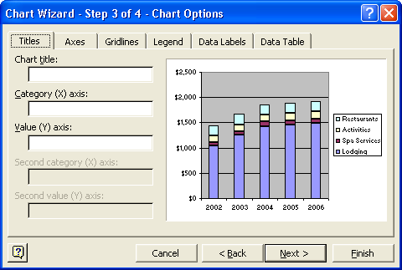
7 In the Chart title box, type Yearly Sales, and click Next.
The Step 4 of 4 – Chart Location dialog box appears.
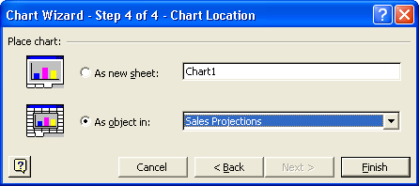
important
Charts are either embedded as objects in an existing worksheet or placed in a separate sheet. Embedded charts appear on a worksheet with other data. A chart sheet appears on a separate sheet tab in the workbook.
8 Click the As object in option, if necessary, and click the Finish button.
To quickly create a chart with the default chart options, select a range of cells, and then press F11. The chart will be created in a new worksheet.
The chart appears in the worksheet.
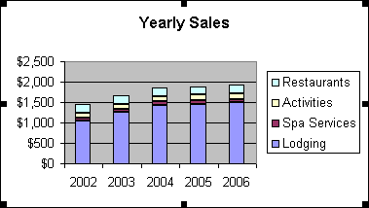
Keep this file open for the next exercise.

Moving, Resizing, and Deleting Charts
Once a chart is created, you can position it where you want in the worksheet, change its size, or delete it altogether. It is often useful to place the chart just before or immediately after the data it summarizes. For readability, detailed or complex charts might need to be larger, while simple charts can be smaller.
To move, resize, or delete a chart, you must select the chart. You select a chart by clicking in the Chart Area, which is the background or blank area of a chart. Clicking in other areas of the chart might select an element or elements of the chart. You will work with chart elements later in this lesson.
In this exercise, you move, resize, delete, and restore a chart.
1 Click a blank area of the chart to select the chart if necessary.
2 Drag the chart to a position below the data and along the left edge of the worksheet.
When selecting or dragging a chart, be sure to click the Chart Area and not the legend, labels, or Plot Area itself. To find the Chart Area, point to different parts of the chart to display the ScreenTips.
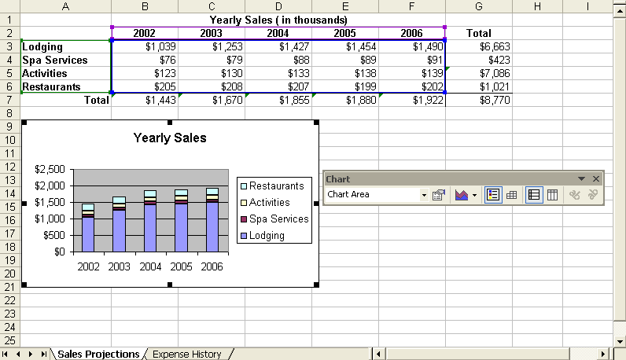
3 Drag the sizing handle on the right edge of the chart to the right side of column F to make the chart wider.
4 Drag the bottom sizing handle to the bottom of row 27 to make the chart longer.
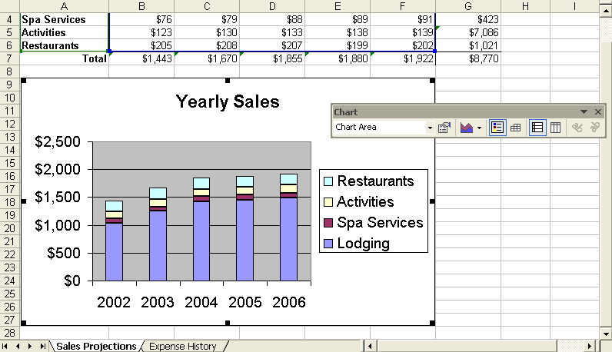
5 Click the Chart Area, and press the Delete key.
The chart disappears from the worksheet.
6 On the Standard toolbar, click the Undo button.
The chart reappears on the worksheet.
7 Save the workbook with the current name.
Keep this file open for the next exercise.

Modifying Chart Titles and Adding Axis Labels
Charts are useful for displaying statistical data in an eye-catching manner. A meaningful title and labels can clarify the meaning of a chart and enhance its impact. When you create a chart using the ChartWizard, category labels and a legend are added to the chart if the selected range of cells includes the necessary information. You can also add a title and axis labels during the wizard operation, or you can add them later by changing the chart options.
For example, the sales manager at Adventure Works can add a label to the value axis to make it clear that revenue figures are reported in thousands of dollars. He can also rephrase the chart title.
In this exercise, you change the title of the chart and add axis labels.
1 Right-click a blank area of the chart, and click Chart Options.
The Chart Options dialog box appears with the Titles tab displayed.
If the Titles tab is not displayed, click it.
2 In the Chart title box, select Yearly Sales, and type Five-Year Revenue Projection.
The new title appears in the chart preview.
3 In the Category (X) axis box, type Fiscal Year.
The axis title appears in the chart preview.
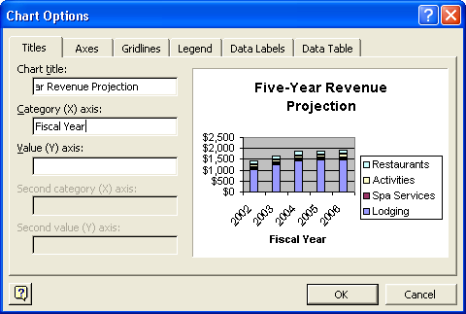
4 In the Value (Y) axis box, type Revenue (in thousands), and click OK.
The chart appears with the new title and axis labels.
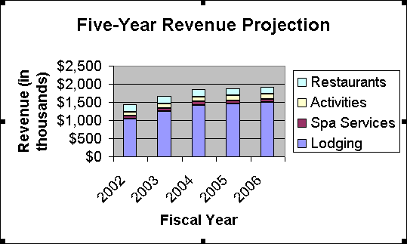
5 Right-click the chart title, and click Format Chart Title.
The Format Chart Title dialog box appears.
6 Click the Font tab, if necessary, and on the Size list, click 12. Click OK.
The chart title appears smaller.
tip
You can also edit the chart title and axis labels like other text. Simply click the title or label to place your insertion point and begin typing. You can also format the chart title or axis labels by selecting the text and using the Formatting toolbar.
7 Save the workbook with the current name.
Keep this file open for the next exercise.

Moving and Formatting Chart Elements
There are many ways to customize the appearance of your charts. To make the best use of the Chart Area, you can reposition the title or legend. To emphasize certain values, you can add labels to each data point on a line chart. To draw attention to a crucial piece of a pie chart, you can move that piece away from the rest of the chart. Other types of charts offer different formatting options.
The sales manager at Adventure Works has created a chart to represent data he needs for the budget meeting. Using a pie chart, he is able to show the percentage of costs spent in each business area for the past five years. To set the legend apart from the rest of the chart, he adds a border to it. He repositions other chart elements to highlight the least costly business area.
In this exercise, you reposition and format the legend, and you draw out pieces of the pie chart.
1 Click the Expense History sheet tab.
The sheet contains a pie chart.
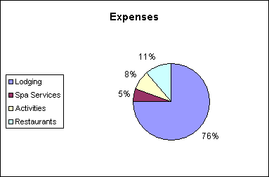
2 Drag the chart legend to the lower-left corner of the Chart Area.
3 Right-click the chart legend, and click Format Legend.
The Format Legend dialog box appears.
4 Click the Patterns tab, select the Shadow check box, and then click OK.
The legend appears with a shadowed border.
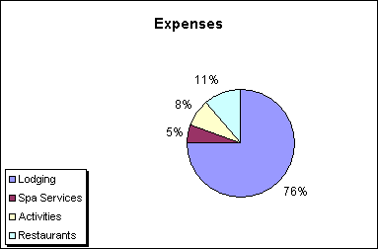
tip
On the Placement tab of the Format Legends dialog box, you can choose from a list of predetermined locations for the legend. You can place the legend at the top, bottom, right, left, or in the corner of the chart.
5 Click the pie area, and click the smallest piece of the pie.
Sizing handles appear around the piece.
6 Drag the piece a short distance away from the pie.
The piece appears separated from the rest of the pie.
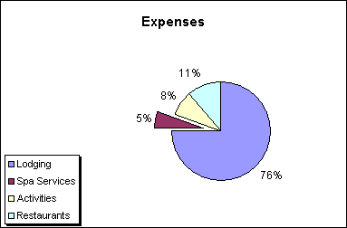
7 Save and close the workbook.

Changing the Chart Type and Organizing the Source Data
Excel offers a wide variety of chart types. Because each type emphasizes a particular aspect of the source data, several types might be useful for representing the same set of data. For budget discussions, a pie chart shows the proportion of expenses allocated to each category. For income projections, a column chart shows the trend of expenses over the past five years. You select a chart type when using the ChartWizard. After the chart is created, you can choose a different chart type.
When you create a chart, the ChartWizard interprets the source data as being organized in rows or columns. The organization of data in a chart depends on the range selected when creating the chart. If you select a range of cells with the same number of rows and columns, or more columns than rows, the data is plotted by rows. If you select a range that contains more rows than columns, the data is plotted by columns. For different chart types, it might be necessary to change the way the organization of the data is interpreted. In other words, you may need to indicate whether the data is organized in rows or columns. Also, when changing the chart type, you might want to exclude certain data (like a column of totals), or you might want to include additional data.
By changing a column chart to a stacked area chart, the activities coordinator at Adventure Works can show the trend of member pledges collected at her events over the past year. Also, she has just recorded the final contributions for December, so she can include those figures in her chart.
In this exercise, you change the chart type and organize the source data.
1 Open the Member Pledges workbook from the Lesson06 folder in the Spreadsheet Fundamentals Practice folder, and click the Chart sheet tab.
The sheet contains a column chart showing pledges collected in each category.
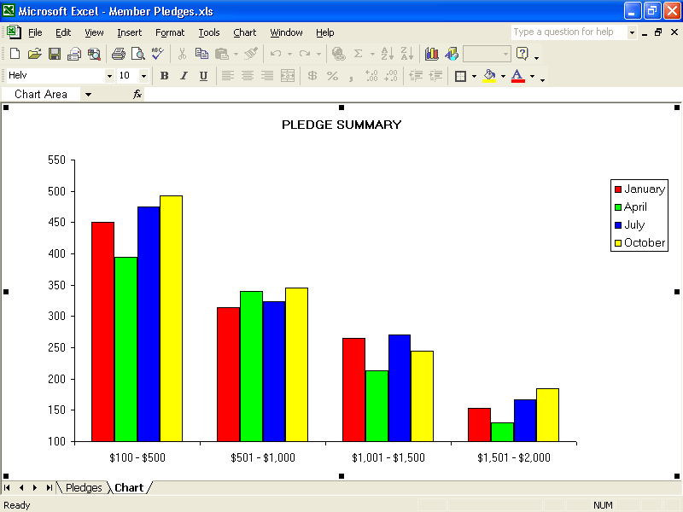
2 Right-click the Chart Area, and click Chart Type.
The Chart Type dialog box appears.
3 On the Chart Type list, click Area.
4 Click the Stacked Area chart sub-type in the center of the first row.
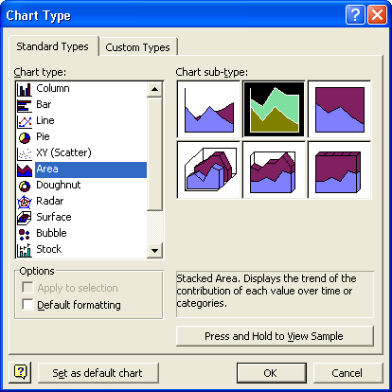
5 Click OK in the Chart Type dialog box.
A stacked area chart appears.
6 Right-click the Chart Area, and click Source Data.
The Source Data dialog box appears and the worksheet from where the data was taken opens with a flashing marquee around the range of the source data.
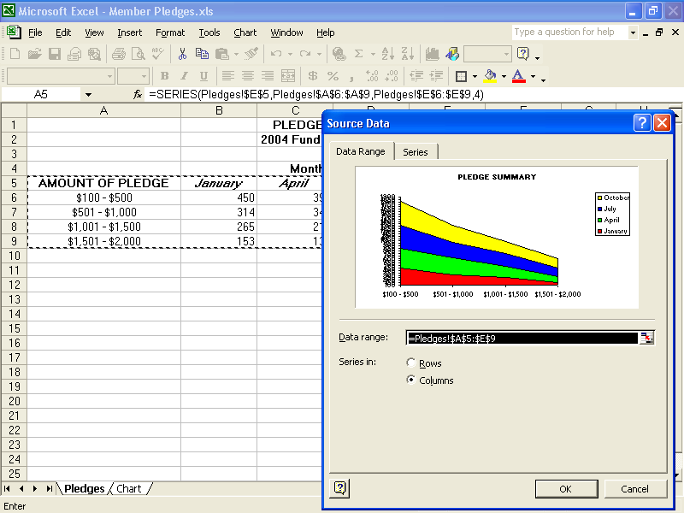
7 On the Data Range tab, click the Rows option, and click OK.
The updated chart appears.
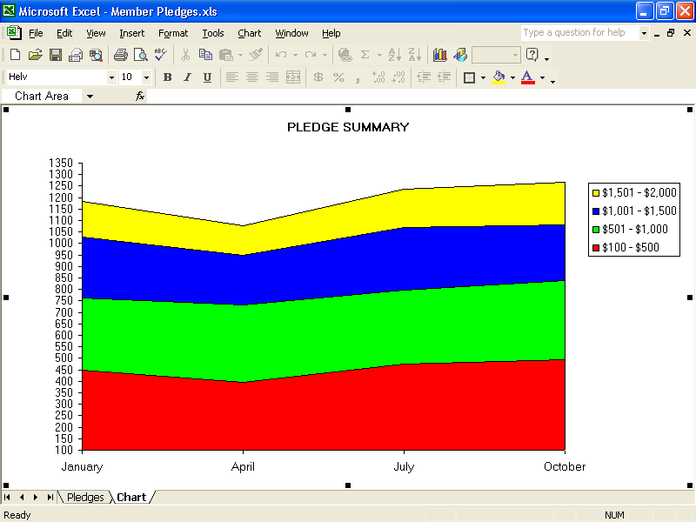
8 Right-click the Chart Area, and click Source Data.
You might need to move the Source Data – Data Range dialog box in order to see the entire range of cells to be selected.
The Source Data dialog box appears and the source data worksheet opens.
9 On the Data Range tab, in the Data Range box, click the Collapse Dialog button.
10 Select A5:F9, and click the Expand Dialog button in the Source Data – Data Range dialog box.
11 In the Source Data box, click OK.
The chart appears with the added data.
12 Save and close the workbook.

Updating Data and Formatting the Axes
Typically, the data stored in Excel worksheets requires periodic updating. If you change source data, the corresponding chart updates automatically.
At Adventure Works, the sales manager learns that the new marketing campaigns are expected to increase restaurant revenues by 50% and spa revenues by 60%. When he enters the new figures on the Sales Projections sheet, the Five-Year Revenue Projection chart changes to reflect the new data.
As data values change, you might need to change various aspects of the axes in a chart. Using Scale options, you can format the Value axis (Y axis) to display a meaningful range of values for your data. Scale options for the Category axis allow you to control the display of category labels.
For example, the sales manager can set the minimum and maximum dollar values displayed on the Expected Annual Sales chart to be sure that the new values are properly represented.
In this exercise, you update the source data for a chart and format the axes.
1 Open the Five Year Sales.xls workbook.
2 Switch to the Sales Projections sheet and type the following values.
Cell | B4 | C4 | D4 | E4 | F4
Value | 122 | 126 | 141 | 142 | 146

Cell | B6 | C6 | D6 | E6 | F6
Value | 308 | 312 | 311 | 299 | 303
The chart updates to reflect the new values.
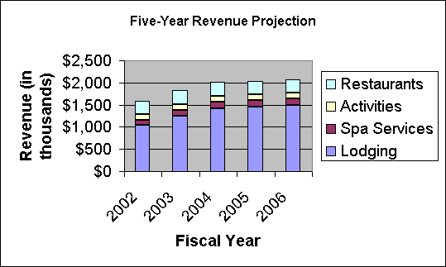
3 Right-click the Value axis, and click Format Axis.
The Y axis is the Value axis, and the X axis is the Category axis.
The Format Axis dialog box appears.
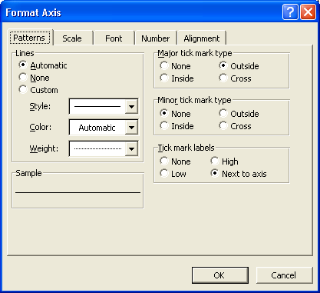
4 On the Scale tab, in the Minimum box, type 500.
5 In the Maximum box, type 2100, and click OK.
The Auto check box clears when you change the default values in the Minimum and Maximum boxes. To use the default value, simply select the Auto check box to restore that value.
The chart appears with the updated axis.
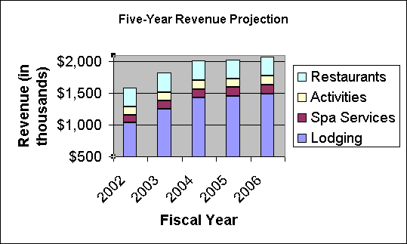
Keep this file open for the next exercise.

Adding Gridlines and Arrows
Horizontal and vertical gridlines can help identify the value of each data marker in a chart. Arrows can be used to highlight a particular data marker or call attention to certain information in a chart.
You can add gridlines to correspond with values on one or both axes in a chart. Major gridlines display at each primary category or scale value. Minor gridlines display at each intermediate category or scale value. You add gridlines using the Chart Options dialog box.
Using the Drawing toolbar, you can add picture objects, such as lines or arrows, to your chart. A well placed arrow clearly indicates the most important piece of data in your chart.
You can also add a picture to the worksheet by clicking Picture on the Insert menu. This will display a submenu that lists several sources from which you can choose to add a picture including an existing file or clip art.
Once you’ve added a graphic element (picture, clip art, arrow, line, etc.) to your worksheet, you can change the graphic’s location on the worksheet by dragging it to the desired location. You can change the graphic’s size by right-clicking the picture and choosing Format Picture from the shortcut menu that appears. You can also resize a graphic by clicking the picture and then dragging one of the handles that appears on the graphic. However, using the Format Picture dialog box ensures that the aspect ratio (the relationship between the picture’s height and width) doesn’t change.
The sales manager would like to draw attention to the effects of the new marketing campaigns. Adding gridlines will more clearly define the impact of the new revenue levels. An arrow emphasizes the largest change in revenue.
In this exercise, you add gridlines to the chart and add, move, and remove an arrow.
1 Right-click the Chart Area, and click Chart Options.
The Chart Options dialog box appears.
2 In the Value (Y) axis section on the Gridlines tab, select the Minor gridlines check box, and click OK.
The chart appears with major and minor horizontal gridlines.
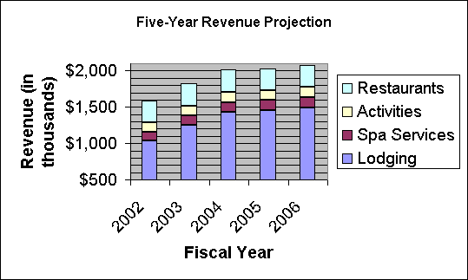
3 Click the Drawing button on the Standard toolbar.
The Drawing toolbar appears.
4 Click the Arrow button. Click a blank area of the chart, drag the mouse pointer to the top of the tallest column on the chart, and then click away from the chart.
An arrow appears on the chart.
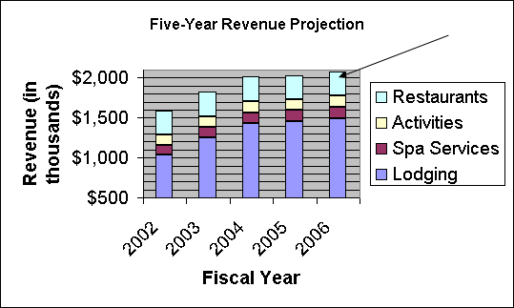
important
When you select a chart or any element of a chart that contains picture objects, the chart will move to the front, causing the picture objects to seemingly disappear. To bring the picture objects back to the front, simply click outside of (deselect) the chart and any of its elements.
5 Click the arrow to select it and drag the arrow so it points to the top of the center column on the chart.
6 On the Drawing toolbar, click the Text Box button.
7 Click a blank area of the chart at the tail of the arrow, and drag to draw a rectangular text box.
8 In the text box, type Largest Projected Increase!
If the text box isn’t big enough, you can drag the resize handles to increase its size.
The text appears in the text box.
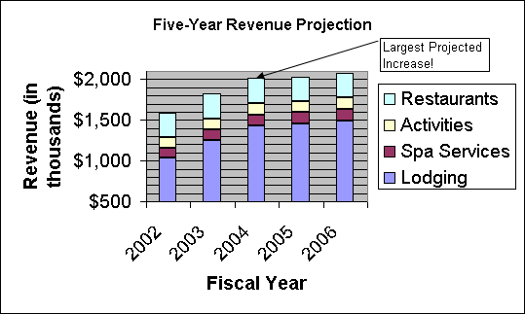
9 On the Standard toolbar, click the Drawing button.
The Drawing toolbar disappears.
10 Save the workbook.
Keep this file open for the next exercise.

Previewing and Printing Charts
You can preview and print Excel charts in the same way that you preview and print worksheets. Whether the chart is embedded or on a chart sheet, the Print Preview command displays the chart just as it will be printed, allowing you to verify the appearance and layout of your chart before printing.
Page Setup and Print commands appear as buttons across the top of the Print Preview window. The current page number and total number of pages appear in the bottom-left corner of the window. To zoom in or out, click the previewed page. To close the Preview window, click the Close button.
When you’re ready to print, you can decide to print the entire workbook, a single sheet in a workbook, a selected range of data, or a selected chart. If your chart appears as an object in a worksheet and you want to print a selected range of data, be sure to select the cells that include your chart. If your chart appears as an object in a worksheet and you want to print only the chart, select the chart before choosing the Print command. If your chart is on a chart sheet, simply go to the chart sheet and choose the Print command.
important
You must have a printer to complete the following exercise.
In this exercise, you preview and print charts.
1 Click a blank area of the Sales Projections worksheet, and click the Print Preview button on the Standard toolbar.
The worksheet and embedded chart appear in the Preview window.
2 Click the Print button on the Preview toolbar.
The Print dialog box appears, and the Preview window closes.
3 Review your print settings, and click OK to print the chart.
4 Click a blank area of the chart, and then click the Print Preview button.
Only the chart appears in the Preview window.
5 Click the Close button.
6 With the chart still selected, on the File menu, click Print.
7 Review your print settings, and click OK to print the chart.

Lesson Wrap-Up
In this lesson, you learned how to use the ChartWizard to create charts. You also learned how to move, resize, edit, format, and delete charts and chart elements. Finally, you learned how to organize and update chart data, customize charts with picture objects, and preview and print charts.
If you are continuing to other lessons:
- Save and close all open workbooks.
If you are not continuing to other lessons:
1 Save and close all open workbooks.
2 Click the Close button in the top-right corner of the Excel window.

Quick Quiz
1 What are five types of charts you can create with the Chart Wizard?
2 How do you move a chart in a worksheet?
3 How do you move individual elements within a chart?
4 How can you format an axis of a chart?
5 How can you change the title of a chart?
6 How can you change the type of a chart?

Putting It All Together
Exercise 1: Open the Five Year Sales.xls workbook. On the Expense History worksheet, change the pie chart to a doughnut chart comparing the percentage of expenses allocated to each category in 1997–2001. View the ScreenTips to see what year the outer ring represents.
important
You must complete Exercise 1 in order to complete Exercise 2. You don’t need to complete Exercise 1 in order to do Exercises 3-5.
Exercise 2: Using the same workbook that you used in Putting It All Together Exercise 1, move the legend to the left side of the chart. Change the chart title to read Cost Allocation, 1997–2001. Add a text box to the chart explaining which ring represents which year. Preview and print the chart.
Exercise 3: In this lesson, we included Value (Y) axis major and minor gridlines in a chart for the Five Year Sales worksheet. Would major or minor Category (X) axis gridlines have been useful in this chart? Why or why not? In what types of charts are X axis gridlines likely to be most useful?
Exercise 4: In the Five Year Sales worksheet, we pulled a section of the expenses History pie chart apart from the rest of the pie. This is often referred to as an “exploded view.” Is there a way to “explode” the entire pie without having to click and drag each component after the pie chart is made? Explore Excel’s chart types or use Excel’s Help files to find the answer.
Exercise 5: Most companies have a company logo—something that identifies them to their customers. To be effective, these logos need to be visible in as many locations as possible. This includes any worksheets that the company may produce to provide to customers, shareholders, or business partners. How would you include an existing logo into a worksheet?

